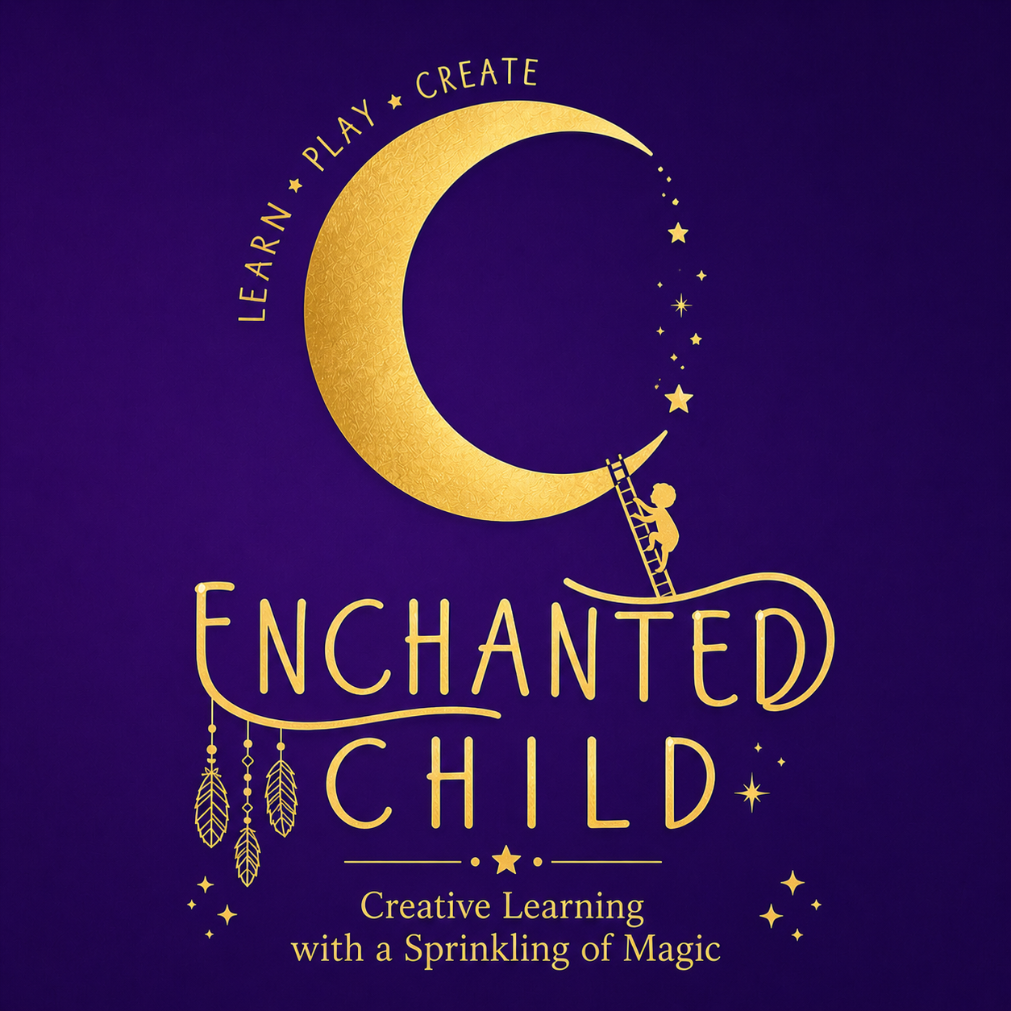

Enchanted Child – Parent/Guardian Consent & Participation Agreement
I give permission for my child to participate in Enchanted Child music, movement, drama, and performing arts sessions held at their nursery setting.
I understand that all activities are designed to be age-appropriate and delivered by qualified staff. While every reasonable care is taken to ensure the safety and wellbeing of all children, participation in physical activities carries an inherent risk of minor injury.
I acknowledge that Enchanted Child, its staff, and contractors shall not be held liable for any injury, loss, damage, or expense arising from participation in activities, except where such liability cannot be excluded by law.
I confirm that I have informed the nursery and Enchanted Child of any medical conditions, allergies, additional needs, or other relevant information that may affect my child's participation.
In the event of an accident or illness during a session, I authorise nursery staff to administer appropriate first aid and seek emergency medical treatment if required.
I understand that children remain under the overall supervision and safeguarding procedures of the nursery during Enchanted Child sessions.
Child's Name: __________________________
Parent/Guardian Name: __________________________
Signature: __________________________
Date: __________________________

