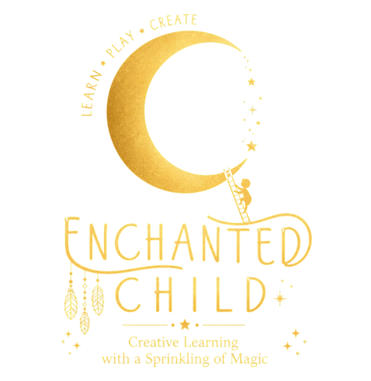

COMPLIMENTS AND COMPLAINTS POLICY

Aim

Enchanted Child aims to provide quality specialist music, dance and drama education through its classes. Any feedback from the parents/carers/guardian will enable us to consider improvements to better our service for all.

Principle
Enchanted Child welcomes and values feedback whether it be in the form of compliments or complaints, as a tool to improve the quality of service. Enchanted Child understand that all children are individuals and we aim to work strongly in partnership with parents/carers/guardian, the school and other agencies to provide the best experience.

Enchanted Child ensure that parents/carers/guardians are informed of this policy and of the compliments and complaints procedure before their child starts using our services. We ensure that staff and contractors are provided with the training required to implement this policy and its Code of Practice.

Code of Practice
Enchanted Child has developed a robust procedure for receiving and dealing with complaints. We will attempt to resolve any complaints effectively and constructively as soon as possible. If a parent/carer/guardian or another member of the public is dissatisfied with any aspect of our service, the following procedure will be followed:

- Parents/carers/guardians/members of the public will be asked to contact the Director to voice the complaint verbally. We will then attempt to resolve the matter, and the complainant will be informed within 3 working days of a resolution or complaint progress.

- In the unlikely and unfortunate case that the complaint cannot be satisfactorily resolved, or if the parents/carers/guardians/members of the public wish to progress to submit the complaint in writing the matter will be referred formally and in writing to the Director. A full investigation will be conducted at once and the complainant will receive a full response within 14 working days.

- In the event that investigation has not been completed within the 14 working days response time, a progress report will be given to the complainant, together with an explanation of why more time is required to compete the investigation. If both parties are in agreement the full report will be presented within a further 14 day period

- The investigation will be completed and a written report produced within 28 days.

- All correspondence including notes, witness testimonies and reports relating to a complaint will be kept in accordance with our Data Protection Policy.

If the complaint involves an accusation of child abuse, we will act immediately by following our Child Protection Policy.
1

The following procedure will be followed providing information received is of an injury of accidental nature and not due to suspected abuse.

Procedure (Transition existing injuries form)
- Enchanted Child staff or contractor will record anything the child/school staff may have said as soon as possible.
- Enchanted Child staff or contractor will complete the transition existing injuries form in its entirety.
- The form will be stored in the child's personal file.
- A parent/carer will be informed of the situation via phone call/email prior to the child leaving the activity.

Change in behaviour or minor but inexplicable physical injury or existing injuries
If the Director, staff member or contractor has any concerns about a change in a child’s behaviour or any minor but inexplicable physical injury, they will discuss the situation with the parents/carers/guardian, as long as this does not endanger the child in any way and will seek an explanation for any injury or unusual behaviour. In some instances, it may be necessary to complete and existing injuries form and body map. The following steps will be taken.

Procedure
- Enchanted Child staff or contractor will record anything the child may have said as soon as possible.
- Enchanted Child staff or contractor will discuss with the Director of the Company the concerns.
- Enchanted Child staff or contractor will record in the individual child's records of concerns document.
- The Director and/or child's key worker will discuss concerns with parents/carers/guardians if this does not endanger the child in anyway, with another staff member, if possible, ideally not alone.
- Discuss with the parents/carers/guardians if further steps need to be taken.
- Record any comments/explanation by parent/carer in child individual concerns records document.

Suspicion of abuse or claims/disclosure by persons outside of the setting
If a Director and other members of staff, contractors, including students or work experience placement suspects that a child is being abused as a result of physical marks on the child, behavioural signs, or that the child themselves makes such claims or a disclosure, the following steps will be taken:

Procedure
- Discuss the matter at once with the Director.
- The Director will take immediate action by contacting the emergency Social Services Duty Officer, and/or Police.
- The Director will follow any advice steps, requested by Social Services, and/or Police.
- The reporting staff will reassure the child, staff will not prompt the child to talk or make any promises to the child.
- The initial person reporting the concern will record all discussed/disclosed/witnessed, as soon as possible, including times and situation/circumstances leading to this.
- The Director will confirm in writing within 48 hours.
- The Director will inform Care Quality Commission (CQC) within 48 hours.

Suspicion of abuse by a staff member, contractor, student or work experience placement
If a member of staff, contractor, student or work experience placement is concerned that another member of staff, contractor, student or work experience placement who carries out work for and on behalf of Enchanted Child is behaving inappropriately towards a child or is abusing a child the following steps will be taken:

Procedure
- The staff member, contractor, student or work experience placement will be immediately suspended pending an urgent inquiry into the allegation.
- The Director will contact, Social Services, The Child Protection and Safeguarding Services and/or Police.
- The Director will inform the parent/carer of the child.
- The Director will record the concern/abuse witnessed or informed of.
- The Director will ask reporting person, if witnessed by more than one person or person other than the Director to record concern/abuse.
- The Director will follow any advice steps, requested by, Social Services, Child Protection, Police.
- The Director will contact the training provider if the allegation is against a student or school/collage/university if work experience placement.
- The Director will confirm all in writing within 48 hours.
- The Director will inform Care Quality Commission (CQC) within 48 hours.
- The accused worker/s will remain suspended until a conclusion is reached by Social Service and/or Police and Child Protection and Safeguarding Services.

A full, confidential record will be kept of any concern or allegation of abuse of a child who participates in our services, as well as a full record of any investigation conducted and the steps which were taken. These records will be kept in confidence according with our Data Protection policy until the child is 26 years and 1 day old.

Contact details for all mentioned persons / organisations / services are as follows:

Social Services Department:
https://www.surreycc.gov.uk/children/contact-childrens-services
Address:
Phone:
Email:

Care Quality Commission:
https://www.cqc.org.uk/
Address:
Phone:
Email:

Local Authority Child Protection and Safeguarding Coordinator
Address:
Phone:

Company Director:
Kelly Hart – Owner/Director
Address: 4 Betts Way, Long Ditton, Surrey, KT6 5HT
Email: kellyhart@scalesandtales.org
Phone: 07779637408

Police
Phone: 999

