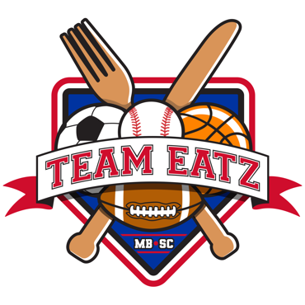

HOT SANDWICH ORDER LUNCH BOX

INCLUDES CHIPS, COOKIE, AND WATER

SPRING TRAINING- WHOLE TEAM MUST ORDER FROM HOT MENU OPTION

PLEASE CIRCLE CHOICE ONLY AND PUT AN X THROUGH WHAT YOU DO NOT WANT

PHILLY CHEESESTEAK- STEAK OR CHICKEN PROVOLONE CHEESE GREEN PEPPERS SWEET ONIONS (SIDE OF CHEESE SAUCE)

ROASTED CHICKEN- PANINI OR SUB ROLL MOZZARELLA CHEESE BACON RANCH DRESSING

CHICKEN PARM SUB- MOZZARELLA CHEESE MARINARA SAUCE

HOMEMADE PRESSED BURGERS- LETTUCE TOMATO CHEESE CONDIMENTS ON SIDE

PULLED PORK OR PULLED CHICKEN (CIRCLE PORK OR CHICKEN) BBQ SAUCE TOPPED WITH MAC AND CHEESE AND ADDED SHREDDED CHEDDAR

HOT ROAST BEEF- caramelized onions cheddar cheese