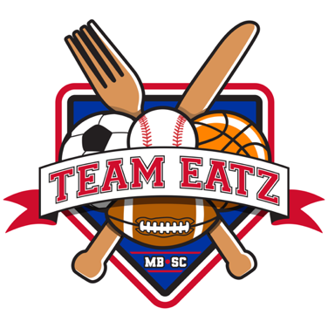
BREAKFAST MENU ORDER FORM

$10 INCLUDES GRANOLA BAR, BANANA, ORANGE JUICE, OR MILK PLEASE SPECIFIY ANY ALLERGIES.
(Includes 11.5% tax)

INSTRUCTIONS- CIIRCLE WHAT U WANT ON IT AND X THROUGH SOMETHING YOU DO NOT

TEAM NAME-________________________________________
YOUR NAME & JERSEY NUMBER

DATE FOR DELIVERY-________________________________

BREAKFAST BAGEL OR CROISSANT - BAGEL CROISSANT EGGS BACON SAUSAGE CHEESE Milk Orange juice

BREAKFAST BURRITO- SAUSAGE BACON CHEESE Milk Orange juice

BREAKFAST BOWL- SAUSAGE BACON CHEESE Milk Orange Juice

FRENCH TOAST STICKS- SAUSAGE OR BACON Milk Orange Juice

WAFFLE OR PANCAKES SAUSAGE OR BACON Milk Orange Juice

Chicken Biscuit - Milk Orange Juice

–We also offer Bagel Assortment boxes for teams includes Bagels, Cream Cheese, Whipped Butter, Jelly - Fresh Fruit and Drink- $7.00 per person

