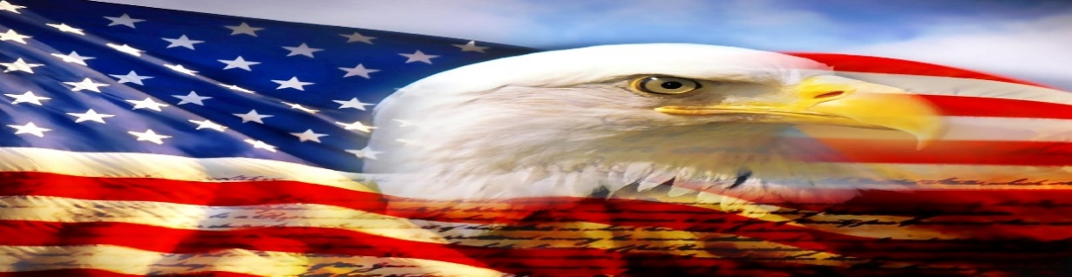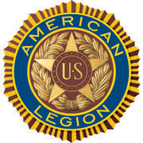

AMERICAN LEGION POST-105 SUNRISE NEWSLETTER
651 El Camino Real, Redwood City, CA 94063 www.americanlegionpost105rwc.org – Vol. 00027 January 2021

COMMANDER GREETINGS

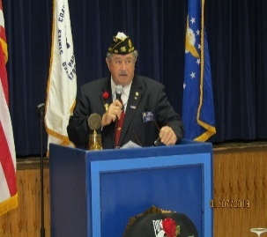
Hoping all Post 105 legionnaire members with their families are doing fine and Happy New Year with prosperity! Last year has been challenging with therein COVID-19 pandemic and sharing my gratitude, and appreciation to all post members for their honorary contribution to diversified communities. Because our AL Post 105 continues to make a difference in society during tough times for God and Country! Our post continues to stay closed until further notice to prevent more COVID-19 infections.
Romie Bassetto, Commander Always many THANKS to our proactive members and comrades for their ongoing
support of our post mission for success!

Our post newsletter continues to provide resources to help veterans and their families when necessary, and please let us know if any veteran needs help. Because it’s our post legionnaire mission with 100+ awesome years of patriotic services for God and Country – STAY SAFE & HEALTHY!

Happy Birthdays, Anniversaries, etc. to all Post 105 legionnaire members in January 2021 and many more!!!

POST EVENTS & INFORMATION SHARING

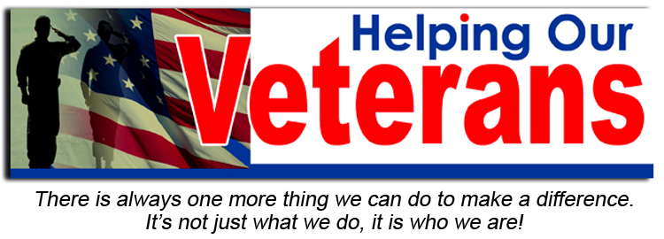

Hiring Veterans  Real Produce International Market  501 Oxford Avenue (corner of El Camino Real),  Palo Alto, CA 94306  Phone Number: (415) 910 – 1289  Website Address: www.realproducemarket.com | Hiring Local Veterans  FedEx Office Print & Ship Center  1194 El Camino Real,  Menlo Park, CA 94025  Phone Number: (650) 321 – 4202  Website Address: www.local.fedex.com

Page – 1
IMPORTANT RED ALERT: PLEASE CONTACT IDENTIFIED PHONE NUMBER AND/OR EMAIL FOR EACH EVENT TO ENSURE IT’S STILL HAPPENING BECAUSE OF THEREIN COVID-19 HEALTH PANDEMIC.

Roll Call Partners – FREE Veterans Job Seeking Skills  Tuesday, January 5, 2021 @ 3:30 PM – 6:30 PM PST  Chicagoland Premier Veterans Network  Virtual Online Event  Contact Email: info@rollcallchicagoland.org  Website Address: www.rollcallchicagoland.org | FREE Veterans Entrepreneur Training  Thursday, January 7, 2021 @ 3 PM (10 Weeks Coursework)  SBDC – The Entrepreneur Center  Virtual Online Event  Phone Number: 937 – 281 – 0118  Website Address: www.sbdctec.com
FREE Veterans Steps To Start The Small Business  Monday, January 11, 2021 @ 7 AM – 8 AM PST  U.S. Small Business Administration  Virtual Online Event  Contact Email: maribel.reigstad@sba.gov  Website Address: www.sba.gov | Post 105 General Meeting – NEED rsvp for dinner  Wednesday, January 13, 2021 @ 7 PM CANCELLED  651 El Camino Real,  Redwood City, CA 94063  Phone Number: (650) 365-1337 (FREE DINNER @ 6 PM)
FREE Veterans Bidding Contract With California  Thursday, January 14, 2021 @ 10 AM – 11 AM PST  NorCal PTAC  Virtual Online Webinar  Phone Number: 707 – 267 – 7561  Website Address: www.norcalptac.org | FREE Veterans Benefits Seminar  Tuesday, January 19, 2021 @ 9 AM – 10 AM PST  Memory Care Of Westover Hills  Virtual Online Event  Phone Number: 210 – 633 – 6263 (Karen Dooley)  Website Address: www.memorycarewestoverhills.com
Veterans & First Responders Mental Health Program  Thursday, January 21, 2021 @ 10 AM – 11 AM PST  Diversified Rehabilitation Group  FREE Virtual Online Webinar  Phone Number: 888–402–8222  Website Address: www.diversifiedrehab.ca | FREE Veterans Mental Health Workshop  Friday, January 29, 2021 @ 11 AM – 12 PM PST  TELACU Veterans Upward Bound Program  Virtual Online Workshop  Phone Number: 323– 721– 1655  Website Address: www.telacu.com

IMPORTANT NOTICE: The veterans can contact American Legion Post 105 and/or American Legion District 26 with information below, for assistance with veteran’s resources regarding how to secure appropriate assistance when necessary. The American Legion Post-105 and/or District-26 will align veterans with available resources for supportive services.

American Legion Post 105  651 El Camino Real,  Redwood City, CA 94063  Contact Phone: 650-365-1337  Website: www.americanlegionpost105rwc.org | American Legion District 26  1159 Bush Street,  San Carlos, CA 94070  Contact Phone: 650-349-7146  Website: www.ALDistrict26.org

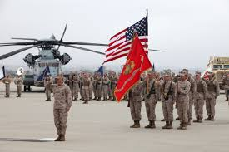

Page – 2
MEMBERSHIP VETERAN STORIES

Post membership and/or all military veterans can share stories about the war (all wartimes) during their veteran services, community services to help veteran families, etc. and many THANKS to veterans for sharing.

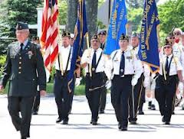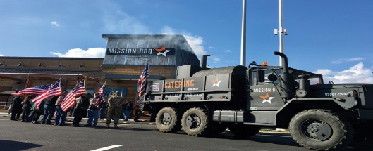

The newsletter story this month is about our honorary veteran comrade SP4 William Lewis who served in the U.S. Army military services. His father also served in the military during WWII onboard the Battleship Texas, and was injured during his honorary military services. He was drafted in December 1969 for his military services and respects previous veterans for their sacrifice. He enlisted in the U.S. Army and entered basic training at Fort Dix, New Jersey and Fort Carson, Colorado. He received his military service orders for Vietnam during January 1971, and he was assigned to 173rd Airborne as the PLL (Prescribed Load List) Clerk for the engineering unit. He worked closely with his comrades to ensure vehicles repairing parts are in good shape, and managing the unit vehicles to properly operate without problems.

SP4 William Lewis successfully completed his military services with honorary regards, and focusing more with lighter memories of his military experience. His return trip home thereafter serving in Vietnam was hard because of antiwar information circulating for resistance. His soldier friends with him would not acknowledge their military services with honor when they returned home, and finally were able to admit their military services in Vietnam thereafter many years have passed. He would like to help veterans when necessary because of his respect for their sacrifice during military services.

THANKS to Kalidev Choudhury for sharing the veterans lost stories on his website www.theloststories.org

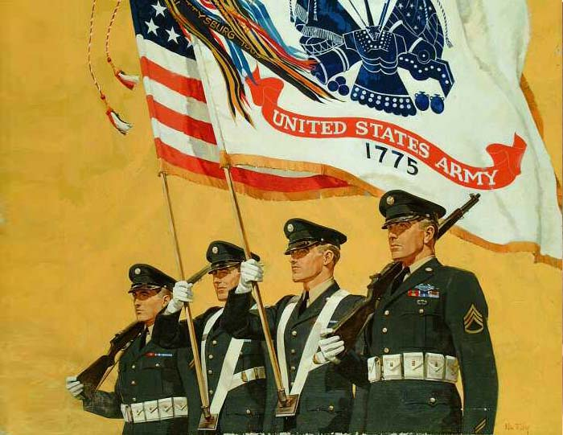

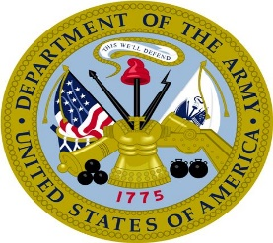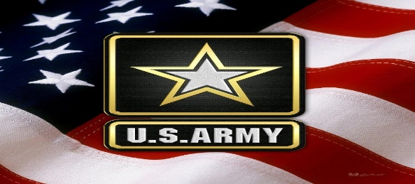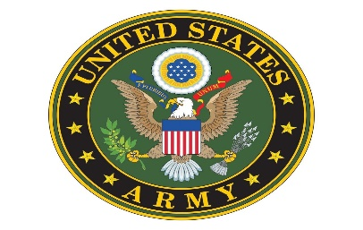

Page – 3
POST EVENTS PICTORIAL LAYOUT

The Post 105 participates in various local and state veteran events for supportive services for veterans and their families. The following pictures illustrating examples of Post 105 supportive services for veterans and their families during an event in local communities. It’s the post commitment for quality services supporting our veterans and their families – exemplifying by action throughout communities! (THANKS to the photographer!)

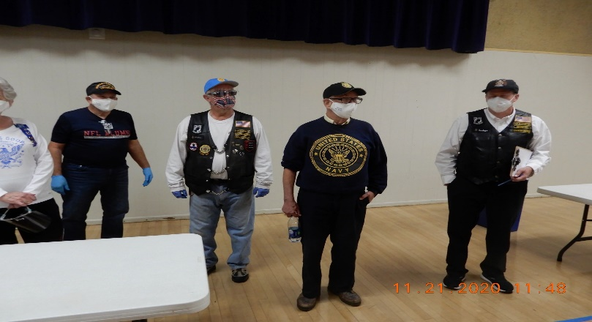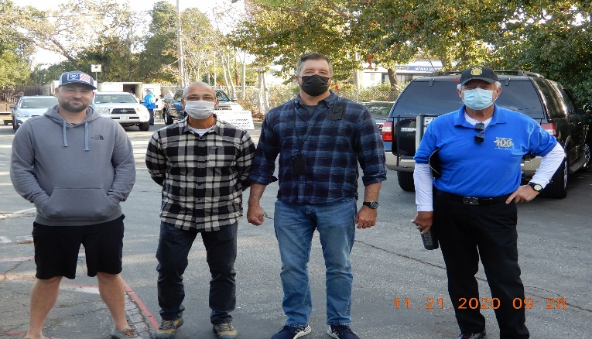
Carol, George Silva, Andrew, Mike, and Tom at George Smith and Ed Kiryczun with Matt and Michael
American Legion Post 105 COVID-19 testing activities. during therein COVID-19 testing partnership.

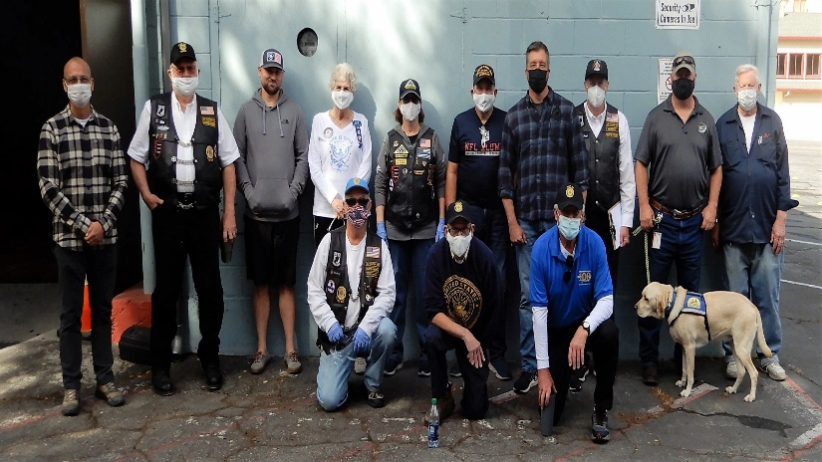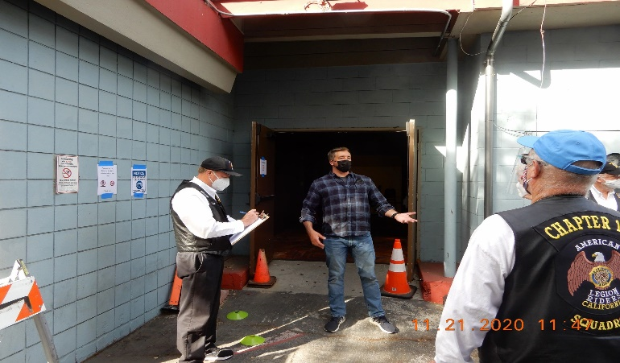
John, Tom, Ed, George Smith, Mike, George Silva, Andrew, Ed is presenting instructions for therein COVID-19 testing
Carol, Matt, and Michael with other volunteers and Veterans activities at American Legion Post 105, and Tom is Guiding Dog during therein COVID-19 testing preparation. taking notes with Andrew paying attention.

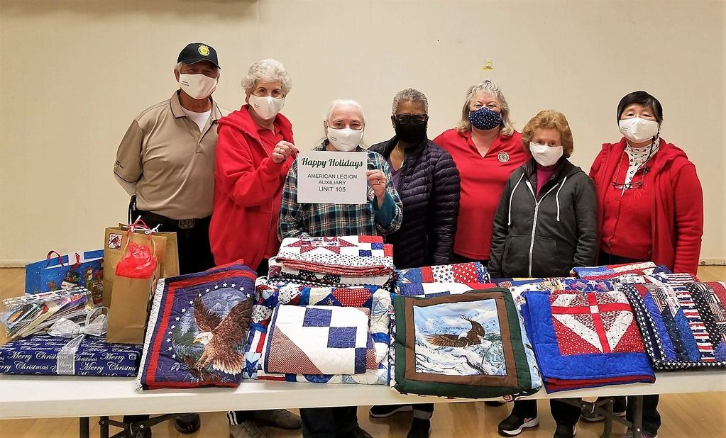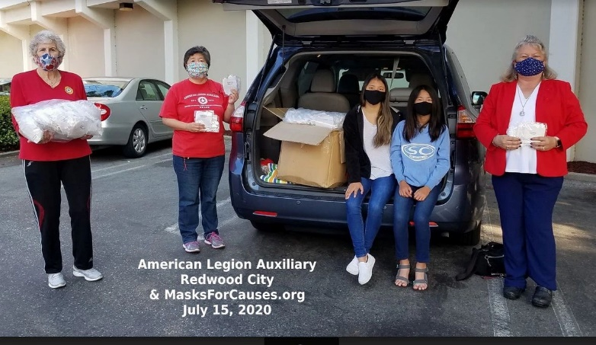
George, Carol, Pauline, Patricia, Brenda, Arlene, and Carol, Peggy, sisters Lindsey with Ana and Brenda
Peggy with Christmas gift bags and quilt blankets for accepting therein COVID-19 facial covering masks
veterans at the Menlo Park VA Hospital. contribution by sisters Lindsey and Ana Yang.

Page – 4

- COVID-19 PREVENTION RED ALERT: Our Post 105 continues to remain closed to uphold therein order for prevention of therein COVID-19 until further notice. The three identified CDC (Centers for Disease Control) and Prevention healthy standards have been proven to stop therein COVID-19 virus. It’s consistent with local, state, and federal health guidelines – just follow herein three protective healthy standards: 1) Wear Face Covering Masks, 2) Maintain Social Physical Distance, and 3) Wash Your Hands.

- Our Post 105 Commander, Romie Bassetto and therein comprehensive DDA/Development Agreement (“Agreement”) has been signed appropriately by all involved parties and moving forward for next steps, and the development status letter was sent to our post membership. The next steps may take one year or more because of development permits and/or project assessments for therein project execution. We have to work closely with local municipal agencies regarding therein post development project next steps, and it may take approximately two years before construction begins. The EBoard continues to meet virtually online because of therein COVID-19 pandemic and to adhere with government orders – NO meeting for December 2020.

We’re requesting letters of support from our membership and/or agencies supporting our Redwood City Station Post Development project. Please contact our post directly and/or contact our post commander at 650-207-0426 or by email at post105rc@aol.com for more info.

- Our AL Post 105 and County of San Mateo Veterans Services Office sponsored a COVID-19 testing location at our post on Saturday, November 21, 2020. The event was very successful with many volunteers and great service for our local veterans and their families. A total of 97 participants were tested with a free mouth swab test and results were available within 2 working days. It’s a great approach to protect our veterans and their families as well as protecting our local communities.

Please contact Ed Kiryczun, San Mateo County Veteran Services Officer at 650– 802–6598 if you want to host a local COVID-19 testing site. The COVID-19 testing is free and welcoming walk-in veterans with proof of military services i.e. VA Card, DD214, Military ID Card. Please visit our website for more information www.americanlegionpost105rwc.org and/or COVID-19 free testing scheduling.

- The District 26 First Vice Commander congratulated Post 105 (78%) and Post 238 (79%) for exceeding 75% of therein identified membership goal within the district. The following identified numbers reflect thereby updated status information shared by District 26 membership report.

AL Department of California  2021 District 26 (Area 2) Membership Report |  |  |  | Post 105 Redwood City  Update Membership Status Date: 11/25/2020
New  Members  1 | PUFL  43 | Paid Online  36 | Paid By Mail  92 | Transfers  5 | Total Members  177 | Membership Goal  228 | Achieved  Percentage  78%

Page – 5
- Many THANKS to all members with their membership renewals and looking forward to 100% positive effort this year! Please visit our website www.americanlegionpost105rwc.org for more membership information with accessible forms. You can also contact our First Vice Commander, Mr. George Smith by phone at 650-349-7146 or email at 1stvice105@gmail.com – THANK YOU for your support! The more members we have and the more members renewing their membership, provides us with that much more money to help our veterans – be safe and we hope to see you soon!

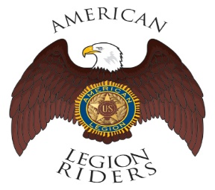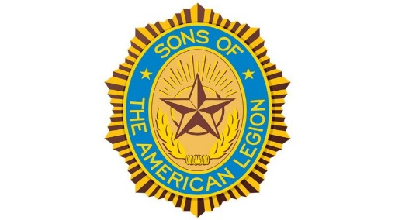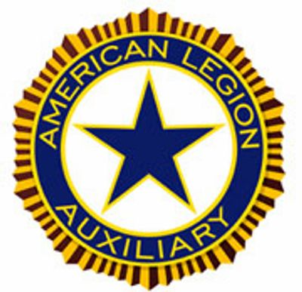

- The American Legion Riders Chapter 105 President, Mr. George Smith submitted herein following progressive activities. American Legion Riders Chapter 105 has participated in 18 missions supporting our deceased veterans by participating on Firing Details, and driven many miles and donated volunteer hours. Including celebration of a WWII veteran’s birthday with 100 years young with life experience! Thanks to other post members for their support and participation to make a successful mission. If you own a freeway legal motorcycle, are a member of the American Legion, American Legion Auxiliary or Sons of the American Legion and would like to join us, please drop me an email at ALRChapt105@gmail.com or call me at 650-349-7146, we would love to have you helping us serving the Veterans in our community.

- The SAL Unit 105 Commander, Andrew Trapani reported 11 members in their unit and will continue to help veterans and their families when necessary. The SAL Unit 105 worked closely with ALR Post 105 and Auxiliary Unit 105 to coordinate free COVID-19 testing activities at our post. He also shared what makes a person eligible to become a SAL member because somebody at therein COVID-19 testing event asked him. The following are eligibility qualifications: A male descendants adopted sons, and stepsons of members of The American Legion, and such male descendants of veterans who died in service during the period of April 6, 1917. Through November 11, 1918, or any time from December 7, 1941, to date, who served honorably, as set forth in Article IV, Section 1, of the National Constitution of The American Legion, or who died subsequent to their honorable discharge from such service, shall be eligible for membership in the Sons of The American Legion.
- The Auxiliary Unit 105 President, Carol Rael continues to meet monthly via Zoom with her team – Veterans Day at Atria went well. The Auxiliary delighted in volunteering on Nov. 21 with Blue Star Moms to assemble 210 care packages for in-need veterans. Ladies also assisted at the Post’s COVID-19 testing event. Thanks go to Post 105 for permitting Aux District 26 to stage/store their holiday gifts onsite. Correction: Piecemakers by the Bay donated quilts for long-term patients. Blue Star Moms donated toiletries towards D26’s 30 gift bags and will also receive sets of mittens, scarves & hats. On Dec 9, Unit 105 members will deliver holiday gifts to VA-Menlo Park Bldg. 331. Contact bsmavolunteer@gmail.com,
AuxUnit105secy@gmail.com or ALAUnit105rwc.com. Current membership stands at 25 with a few officer openings (vice president & sgt.-at-arms) and website www.alaunit105rwc.com

- Please contact our post if anyone else of our Post 105 membership is aware of any other Everlasting Post members, and/or anyone in the hospital because of his/her illness. Please contact our Post Chaplain Dennis Lopez at 650-346-9825 for assistance when necessary regarding logistical matters.

Page – 6
- The San Mateo County AMVETS Post 53 sponsored Cub Scout Pack 565 Holiday Cheer to help veterans during the holiday season. Including holiday cheering songs for veterans at the Menlo Park VA Hospital, and sharing wonderful joyful holiday songs! The participants of Cub Scout Pack 565 could not visit veterans at the VA hospital this year because of therein COVID-19 pandemic. Please go online and click onto this following linkage https://www.youtube.com/watch?v=65u7A5hWw0k to view therein holiday video.

- The statewide Women Veterans Affairs is growing rapidly and advocating for effective services throughout California. The CalVet women organization is having online webinar sessions by clicking to the following link. https://www.calvet.ca.gov/WomenVets/Pages/Monthly-Statewide-Webinars.aspx

- We know how critically IMPORTANT to help our veteran comrades and families with many ongoing human service challenges in life. Because many veterans may not be able to find appropriate help for assistance with health, safety, and human services including crisis matters. If a veteran is NOT sure where to start looking for help, please contact the Veterans Crisis Hotline at 1-800-273-8255. Copy and click online following linkage http://www.knowavet.org and/or text 838255 for more informational resources.

- The U.S. Department of Veterans Affairs (VA) provides outreach information to help veterans with their families and children when necessary. The VA also tries to keep veterans updated with new regulations aligned with eligible veteran benefits. Go online with herein following linkage below to help you with VA claims when necessary: https://www.calvet.ca.gov/veteran-services-benefits/va-claims

- Great Food Plates Delivered is a food delivery program within San Mateo County to help local senior veterans and their families. It’s a state food delivery program to help local older adults and seniors during the COVID-19 health crisis. Please go online to the following linkage https://cmo.smcgov.org/press-release/county-san-mateo-launches-great-plates-delivered for accessibility and more information.

- UCSF Health Care opens the new clinic within San Mateo County to help veterans and their families locally, and make it easier for them especially during the COVID-19 health crisis. We want the best health care providers to help our veterans and their families for appropriate protection, and UCSF is one of the best health care providers – local veterans don’t have to travel long distance for health care. Please go online to the following linkage https://www.ucsf.edu/news/2020/01/416536/ucsf-health-opens-new-clinics-peninsula for more information and accessible threshold contact – AL Post 105 advocated for therein local clinic.

- The returning veterans to their families and local communities can become challenging thereafter their wartime service. Some veterans are continually serving during their civilian life and facing many challenging elements in life. Our veterans need a great transitioning phase back to civilian life and Veteran’s Path approach is good, and having a positive pathway is critical for veterans. The Veteran’s Path is one agency that can certainly help veterans create a meaningful pathway for returning veterans with compelling results – visit website www.veteranspath.org for more information.

Page – 7
- The food programs in San Mateo County can help people with nutrition meals during these challenging times for veteran families and children. The CalFresh Program can help provide healthy nutritional food for local communities. It can help veteran families and children with low-income household as well as meeting income guidelines. Please go online with herein linkage https://www.cdss.ca.gov/food-nutrition/calfresh for more information and access – contact email at antorres@smcgov.org and phone number 650–802–6575.

- The Daly City Partnership is a collaboration effort to help local veteran families and children with accessible healthy food to promote well-being communities. Please go online to the partnership following website https://www.dcpartnership.org/covid19/ for more information and free meals for students, and contact email at mike@dcpartnership.org and phone number 650–301–3300. The partnership program have local drive-thru food banks for veteran families and children during the COVID-19 challenging times.

- The Second Harvest Food Bank offers food pickup locations within San Mateo County on their website at https://www.shfb.org/get-food/ – contact phone number 800–984–3663 or text GETFOOD at 408–455–5181.

- Our veteran families and children needs discount programs during these challenging times with therein COVID-19 pandemic. Please go online at www.legion.org/benefits for all essential discounting programs to help local veterans and their families. Especially with health and dental discounting programs as well as financial assistance with medical bills.

- Please keep in mind, many veterans have lost their homes and/or personal belongings because of online scams, and having your personal information unprotected doesn’t help. HIPAA (Health Insurance Portability and Accountability Act) federal regulation was established for enactment and protection. The HIPAA legislative regulation has been updated to protect personal information more since it was signed into the legislature during 1996. Please follow herein linkage: https://www.calvet.ca.gov/Pages/HIPAA.aspx for more information and protection.

- The COVID-19 is making it hard for small businesses nationwide to survive and paying their business bills, as well as regular payment for staffing salaries as necessary. Including veterans small business challenges and entrepreneurship can be hard without support from state and/or federal agencies. The federal CARES Act relief funding grants have been signed by President Trump thereafter adoption by U.S. Congress. Including supportive funds for small businesses nationwide and go online to www.sba.gov for more information and/or business financial assistance.

NEWSLETTER EDITOR NOTICE

Our post newsletter is offering this opportunity to reach out and work closely with our membership legionnaires and all veterans! The post members can provide future newsletter articles and/or “appropriate” newsletter posting information. Including stories and comments about post activities, veteran’s insight views and information sharing, pictures, etc. Please send information by email mfcpalesoo@gmail.com or phone call at 650-365-1337 for informational message.

American Historical Quote: “Injustice anywhere is a threat to justice everywhere.”

Dr. Martin Luther King Jr.

Page – 8

