 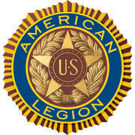

**AMERICAN LEGION POST-105 SUNRISE NEWSLETTER**

651 El Camino Real, Redwood City, CA 94063 [www.americanlegionpost105rwc.org](http://www.americanlegionpost105rwc.org) – Vol. 00031 May 2021

**COMMANDER GREETINGS**

|  |
| --- |
| https://lh3.googleusercontent.com/ZS__yIXCw11ALUKzKOraH3i_Br4aomk-BVKdzyQBJ8m0G7Hm41_ymJzsl2eVltclO1dAZ6ZEYlBgHjweH3ltmlYRRLROv-D1w_zoYh5z_FW-yRsfhw4CmERb4goeOOxiA0PsC-uTfQ=w1072-h804-no |

My great hopes all AL Post 105 legionnaire members are doing fine with their families during these challenging times. Sharing my gratitude and appreciation to all **Asian Pacific American** veterans and **Jewish American** veterans of our post for their military services. Honoring **Asian Pacific Islander American** heritage month and **Jewish American** month of **May 2021.** Including ALL post veterans for their military services contribution to our diverse society and thank you for your services! Our post

*Romie Bassetto, Commander* continues to stay closed until further notice, and continues to provide resources for

veterans and their families. Many THANKS to our **proactive members** for their ongoing support, and our family of legionnaires for a SUCCESSFUL mission!

My gratitude and support to ALL veteran mothers for their honorary military services, and their contribution in society to make a difference with resources to help veterans and their families. Because it is our legionnaire mission with **100+ awesome years** of patriotic services for **God and Country** – STAY SAFE & HEALTHY!



**Happy Mother’s Day, Birthdays, Anniversaries, etc.** to all Post 105 legionnaires in **May 2021 and more!!!**

**POST EVENTS & INFORMATION SHARING**



|  |  |
| --- | --- |
| **Hiring Local Veterans**  Mountain Mike’s Pizza  390 El Camino Real, Belmont, CA 94002  Phone Number: (650) 508–1100  Website Address: [www.mountainmikespizza.com](http://www.mountainmikespizza.com) | **Hiring Local Veterans**  Jiffy Lube  2517 S. El Camino Real, San Mateo, CA 94403  Phone Number: (650) 349–7222  Website Address: [www.jiffylube.com](http://www.jiffylube.com) |

Page – 1

IMPORTANT **RED ALERT:** *PLEASE CONTACT IDENTIFIED INFORMATION FOR EACH EVENT TO ENSURE IT’S STILL HAPPENING BECAUSE OF THEREIN COVID-19 PANDEMIC.*

|  |  |
| --- | --- |
| **San Francisco National Cemetery**  Tuesday, May 4, 2021 @ 12 PM  Presidio of San Francisco  1 Lincoln Blvd., San Francisco, CA 94129  Phone Number: 650–589–7737  Website Address: [www.cem.va.g](http://www.cem.va.g)ov | **Skylawn Memorial Day Ceremony**  Saturday, May 8, 2021 @ 9 AM  Hwy. 92 and Hwy. 35, San Mateo, CA 94402  Phone Number: 650–227–3142  Website Address: [www.skylawnmemorialpark.com](http://www.skylawnmemorialpark.com) |
| **Post 105 General Meeting – NEED rsvp for dinner**  Wednesday, May 12, 2021 @ 7 PM CANCELLED  651 El Camino Real,  Redwood City, CA 94063  Phone Number: (650) 365-1337 **(FREE DINNER @ 6 PM)** | **FREE Veterans Drive-Thru Spaghetti Dinner**  Thursday, May 13, 2021 @ 4 PM – 6 PM  Keller Williams RED-DAY’S/American Legion Hall  1960 N. Tracy Boulevard, Tracy, CA 95376  Phone Number: 209–835–7404  Website Address: [www.americanlegionpost172.com](http://www.americanlegionpost172.com) |
| **Golden Gate National Cemetery**  Friday, May 14, 2021 @ 1 PM  1300 Sneath Lane, San Bruno, CA 94066  Phone Number: 650–589–7737  Website Address: [www.cem.va.gov](http://www.cem.va.gov) | **Girls State Delegates Tea**  Sunday, May 16, 2021 @ 1 PM  American Legion Post 105  651 El Camino Real, Redwood City, CA 94063  Phone Number: 650–365–1337  Website Address: [www.americanlegionpost105rwc.org](http://www.americanlegionpost105rwc.org) |
| **Annual Trip-Tip Fundraising Dinner – Drive Thru**  Saturday, May 22, 2021 @ 4 PM – 6:30 PM  Kiwanis Club of Delta-Antioch – Support VFW Veterans  815 Fulton Shipyard Road, Antioch, CA 94509  Phone Number: 925–204–5482 ask for Antwon Webster  Contact Website: [www.delta-antioch.kiwanis.org](http://www.delta-antioch.kiwanis.org) | **Golden Gate National Cemetery**  Monday, May 31, 2021 @ 10 AM  Memorial Day Dedication Ceremony  1300 Sneath Lane, San Bruno, CA 94066  Phone Number: 650–589–7737  Website Address: [www.cem.va.gov](http://www.cem.va.gov) |

**IMPORTANT NOTICE:** The veterans can contact American Legion Post 105 and/or American Legion District 26 with information below, for assistance with veteran’s resources regarding how to secure appropriate assistance when necessary. The American Legion Post-105 and/or District-26 will align veterans with available resources for supportive services.

|  |  |
| --- | --- |
| **American Legion Post 105**  651 El Camino Real,  Redwood City, CA 94063  Contact Phone: 650-365-1337  Website: [www.americanlegionpost105rwc.org](http://www.americanlegionpost105rwc.org) | **American Legion District 26**  1159 Bush Street,  San Carlos, CA 94070  Contact Phone: 650-349-7146  Website: [www.ALDistrict26.org](http://www.ALDistrict26.org) |

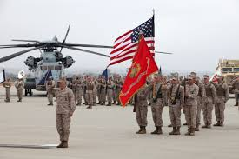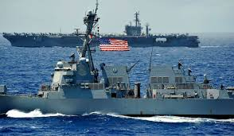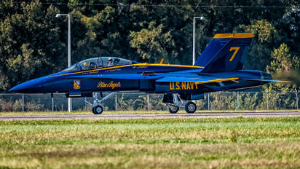



Page – 2

**MEMBERSHIP VETERAN STORIES**

Post membership and/or all military veterans can share stories about the war (*all wartimes*) during their veteran services, community services to help veteran families, etc. and many THANKS to veterans for sharing.

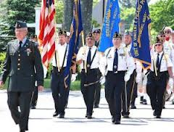 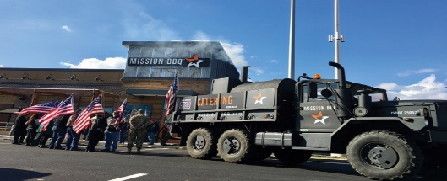 

The newsletter story this month is about our honorary veteran comrade Corpsman Frank Hendershott who served in the U.S. Navy as the Hospital Corpsman. He entered the military to get himself going through his life and decided the U.S. Navy is good to join during the Vietnam War. He prefers to patch people and help them rather than shooting them down and he wants to become a doctor while studying medicine. He served in San Diego and Balboa Naval Hospital, and transferred to Camp Pendleton with good friendship relations among his comrades and adapted well. He finds his military career was good for him and finding himself a better man, and nowadays he gets more respect for his military. His military career helped him with his education with the GI Bill where he attended college and graduated with success!

His military services really helped him and assisted him through his life, and finds that the military is a real help in life and done so much for himself. He is very proud of serving his country and having fun, and would help veterans and their families in our communities.

*THANKS to Kalidev Choudhury for sharing the veterans lost stories on his website* [*www.theloststories.org*](http://www.theloststories.org)

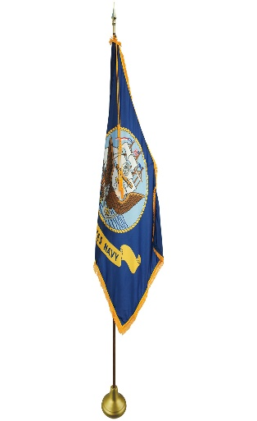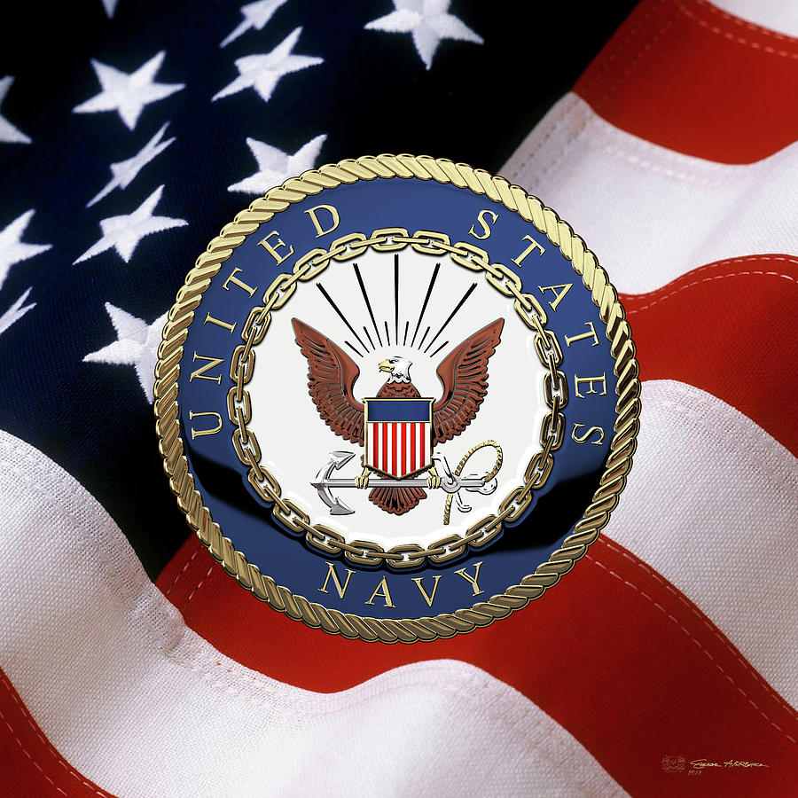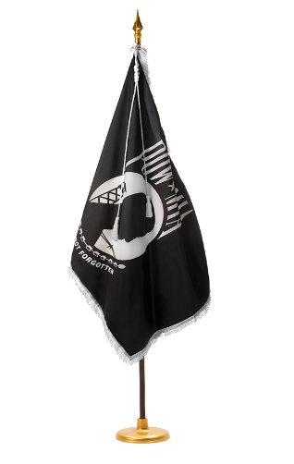

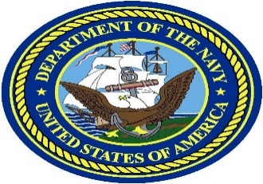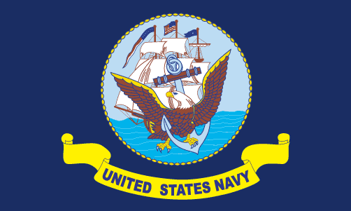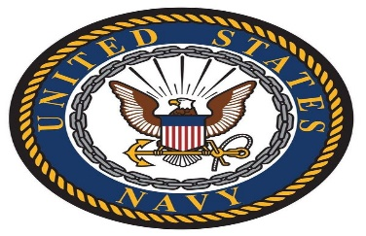

Page – 3

**POST EVENTS PICTORIAL LAYOUT**

The Post 105 participates in various local and state veteran events for supportive services for veterans and their families. The following pictures illustrating examples of Post 105 supportive services for veterans and their families during an event in local communities. It’s the post commitment for quality services supporting our veterans and their families – exemplifying by action throughout communities! (*THANKS to George Smith for pictures!)*

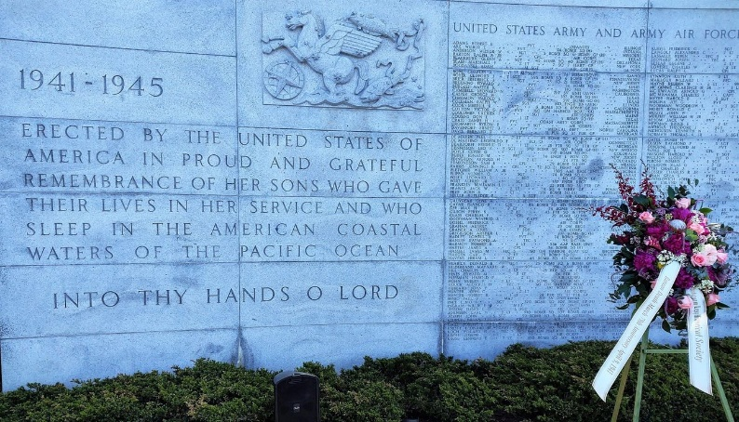 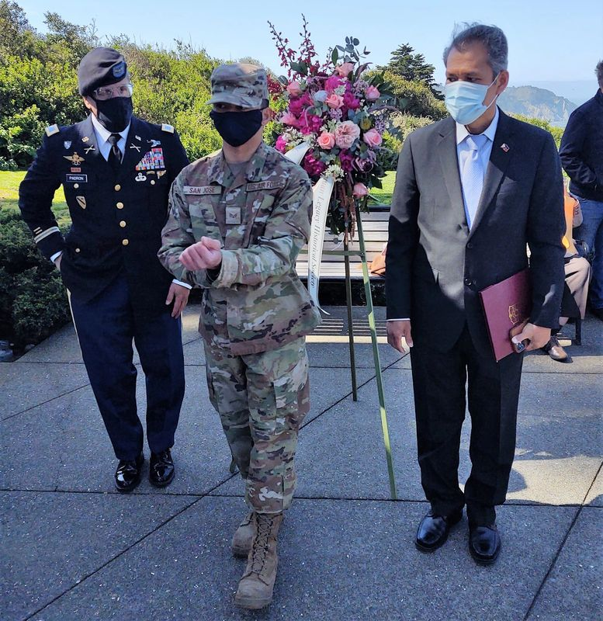

Wreath in front of the West Coast WWII Memorial Wall US Army Coronal Padron and colleague of 91st Training

during the 79th commemoration of the Baatan Death Division with Philippine Consul General preparing for

March event. therein event.

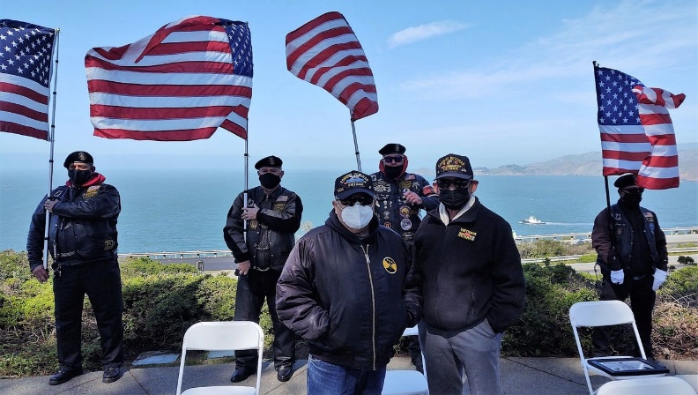 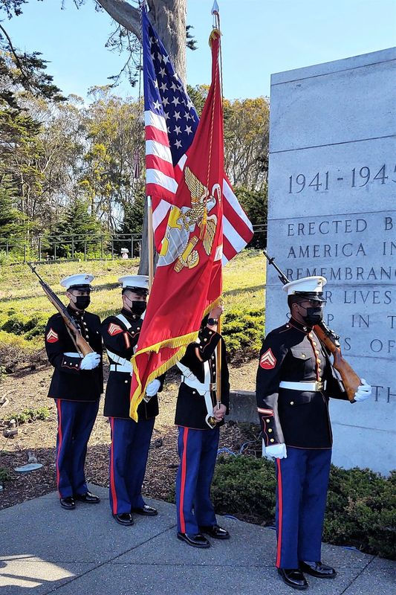

VFW veterans with SAL Unit 105 Commander, Andrew, 23rd Regiment US Marine Corps Honor Guard preparing

with ALR members Larry, Ken, and Johnny D. preparing for therein commemoration event and ceremony.

for therein event.

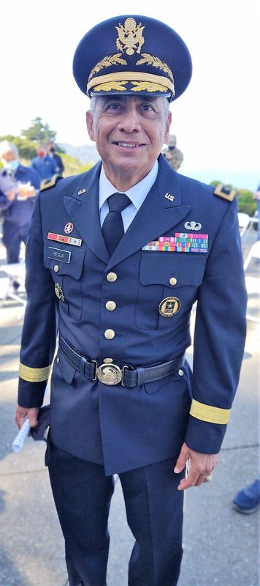 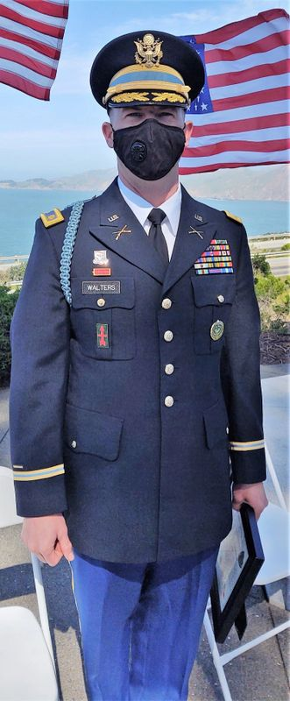 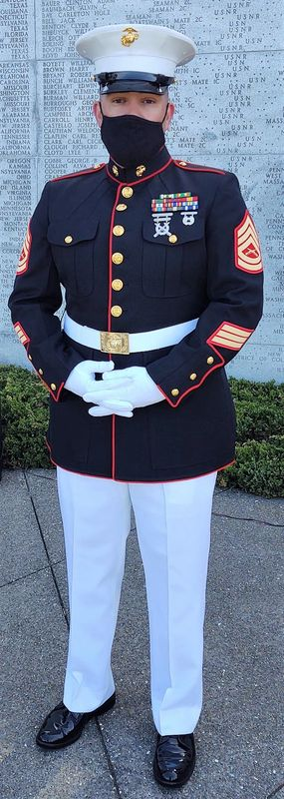

US Army Major General Regua US Army Major Walters US Marine Corps GySgt Tena

Page – 4

  

* COVID-19 PREVENTION **RED ALERT:** Our AL Post 105 continues to remain closed until further notice with a vaccine under distribution. The three identified CDC (Centers for Disease Control) and Prevention healthy standards have been proven to stop therein COVID-19 virus effectively. It’s consistent with local, state, and federal health guidelines – just follow herein **three protective** healthy standards: **1)** Wear Face Covering Masks, **2)** Maintain Social Physical Distance, and **3)** Wash Your Hands.
* Our Post 105 Commander, Romie Bassetto and therein comprehensive DDA/Development Agreement (“Agreement”) has been signed appropriately by all involved parties and moving forward for next steps, and the development status letter was sent to our post membership. The next steps may take one year or more because of development permits and/or project assessments for therein project execution. We have to work closely with local municipal agencies regarding therein post development project next steps, and it may take approximately two years before construction begins. The EBoard continues to meet virtually online because of therein COVID-19 pandemic and to adhere with government orderly guidelines – stay tuned!
* We have three of the boys for Boys State completed the training course and another one is scheduled during time for therein same type of training course – 4 boys total. All four boys turned in their completed packets with training elements as well as financial sponsorship funding. A dinner dance will be happening at our Post 105 on Saturday, June 12, 2021 with entertainment by Joanie Brandt, and with delicious catering food available – stay tuned!
* The District 26 First Vice Commander congratulates various AL posts including Post 105 for exceeding 85% of therein district membership goal during last month. The following identified numbers reflect thereby updated status information shared by District 26 membership report.

|  |  |  |  |  |  |  |  |
| --- | --- | --- | --- | --- | --- | --- | --- |
| **AL Department of California**  2021 District 26 (Area 2) Membership Report | | | | **Post 105 Redwood City**  Update Membership Status Date: 3/26/2021 | | | |
| New  Members  1 | PUFL  43 | Paid Online  45 | Paid By Mail  111 | Transfers  7 | Total Members  252 | Membership Goal  228 | Achieved  Percentage  91% |

* Many THANKS to all members with their membership renewals and looking forward to **100%** positive effort this year! Please visit our website [www.americanlegionpost105rwc.org](http://www.americanlegionpost105rwc.org) for more membership information with accessible forms. You can also contact our First Vice Commander, Mr. George Smith by phone at 650-349-7146 or email at [1stvice105@gmail.com](mailto:1stvice105@gmail.com) – THANK YOU for your support!
* Our post has a calendar identifying daily and/or monthly events as well as specified holidays, and other national calendar dates for recognition, etc. Please visit herein following linkage below to review our <https://americanlegionpost105rwc.org/calendar> calendar of events and for more information.

Page – 5

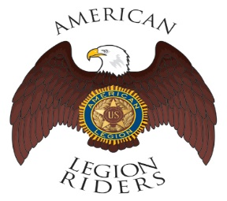 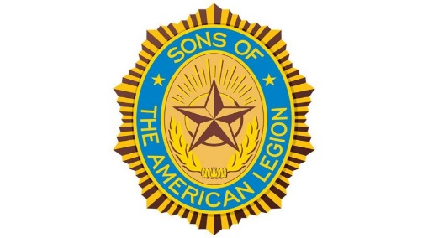 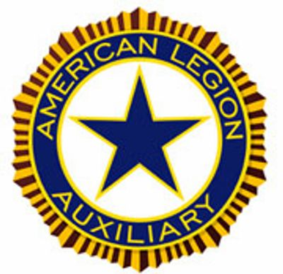

* The **American Legion Riders Chapter 105** President, Mr. George Smith submitted herein following progressive activities. American Legion Riders Chapter 105 has participated in 14missions supporting our deceased veterans by participating on Firing Details during the month of March 2021. They had a successful mission at Moffett Field and received $1000 donation to help veterans. They have driven 1249 miles and donated 180 volunteer hours. If you own a freeway legal motorcycle, are a member of the American Legion, American Legion Auxiliary or Sons of the American Legion and would like to join us, please drop me an email at [ALRChapt105@gmail.com](mailto:ALRChapt105@gmail.com) or call me at 650-349-7146, we’d love to have you helping us serving the Veterans in our community.
* The **SAL Unit 105** Commander, Andrew Trapani reported another new member and elevated their membership to 13 total members in their unit, and will continue to help veterans and their families when necessary. The SAL Unit 105 worked closely with ALR Post 105 and Auxiliary Unit 105 to coordinate free COVID-19 testing activities at our post. They continue to work closely with ALR Post 105 with several missions and events during April 2021, and scheduled with many Memorial Day missions and events this month of May 2021. The following are eligibility qualifications for SAL Unit 105: A male descendants adopted sons, and stepsons of members of The American Legion, and such male descendants of veterans who died in service during the period of April 6, 1917. Through November 11, 1918, or any time from December 7, 1941, to date, who served honorably, as set forth in Article IV, Section 1, of the National Constitution of The American Legion, or who died subsequent to their honorable discharge from such service, shall be eligible for membership in the Sons of The American Legion.
* The **Auxiliary Unit 105** President, Carol Rael continues to meet monthly via Zoom with her team. Auxiliary U105 members strive to assist our community despite the pandemic restrictions. Hooray! Unit 105 will host its first in-person meeting at the Post on Wednesday, May 12 @ 6pm; social distancing & face mask enforced. **Shoe Drive**: Auxiliary & SM County Blue Star Moms hosting a Shoe Drive. Proceeds go toward care pkgs for active-duty soldiers abroad & veterans. Shoes are shipped to underprivileged countries where locals learn to refurbish shoes for use in their community. Dropoff @ Post: **call before to confirm** the Post is open M-F 9-10am (650-365-1337). [**Parking Lot Sale**](https://www.facebook.com/photo?fbid=4154447994588793&set=a.222387747794857) (June 5, 9am-3pm) hosted by San Mateo County Blue Star Moms & the Auxiliary--donated goods encouraged. **Elections**: Officers were re-elected for the 2021-22 term: President Carol Rael, Secretary Peggy Toye, and Treasurer Brenda Ternullo. Other officers/chairs remain: Chaplain & Poppy Chairman Amy Walsh, VA&R Deputy Arlene Muller, and Girls State Chairman Peggy Toye. Open position: Vice President. **Ongoing**: Our Unit continues to deliver weekly food donations to Samaritan House. Please click onto herein linkage below for the Parking Lot Sale <https://www.facebook.com/photo?fbid=4154447994588793&set=a.2223877477948577> and for more information.
* The **American Recovery Plan** will cancel many VA copayments for medical care and/or prescriptions. If you’re a veteran receiving health care through the VA Hospital, and you may be eligible for copayment debts to be cancelled and/or receive copayment refunds. Please visit herein linkage online to find out your status <https://www.myhealth.va.gov/mhv-portal-web/web/myhealthevet/ss20210323-copayment-debt-refunds-forgiveness> and for more information.

Page – 6

  

* Please contact our post if anyone else of our **Post 105** membership is aware of any other Everlasting Post members, and/or anyone in the hospital because of his/her illness. Please contact our **Post Chaplain Dennis Lopez** at 650-346-9825 for assistance when necessary regarding logistical matters.

* Our Auxiliary Unit 105 is having a **Year-Round Fundraiser** as a delicious way to support, and enjoying premium coffees, teas, snacks, and more! Please visit following linkage below online for more fundraising info. <https://www.givingbean.com/store/home.php?partner=ed83d#.YBoDxYuJiM9> and viewing Auxiliary timeline with following linkage below for more information as necessary. <https://drive.google.com/file/d/14JPl8aIpD4Im9jFB0r7RqR5QJWiZCJZt/view?usp=sharing>
* The statewide **Women Veterans Affairs** is growing rapidly and advocating for effective services throughout California. The CalVet women organization is having online webinar sessions by clicking to the following link. [https://www.calvet.ca.gov/WomenVets/Pages/Monthly-Statewide-Webinars.aspx](http://r20.rs6.net/tn.jsp?f=0015STogUg_VIxOBYVssmtPypmC2GvcnD9ZgGhmrtottoNinTHGb5RUvwCXFQgU9szwmaTdBBfxw04XWYtXyp0R7nRfvI9BVGff0h5Barz4dgT-rmd80BwkwIiI1ouWLQoeMDxG0Qsna0Xxk0N4eUa8EGHFXYJq6uHCUFyF9Q4k4v1p64MFvoLqGkDPmShCjpyj0fveFv7oQ4cVAKjiNJKNvQ==&c=WT-cH0OnWIOLoTKqhacONB6VGdI75SwNSjVrcG9q2QYNAuPfRNJJ_g==&ch=KzA0Ptk4eQmVURV8W5NUxxCcQuQswDjMdsCySzTQWpW1oN7QuhPbKg==)
* We know how critically IMPORTANT to help our veteran comrades and families with many ongoing human service challenges in life. Because many veterans may not be able to find appropriate help for assistance with health, safety, and human services including crisis matters. If a veteran is NOT sure where to start looking for help, please contact the Veterans Crisis Hotline at 1-800-273-8255. Copy and click online following linkage <http://www.knowavet.org> and/or text 838255 for more informational resources.

The COVID-19 pandemic has taken a toll on mental health for veterans and their families, as well as increasing isolation with loneliness, anxiety, depression, and substance abuse among youth and young adult Americans. It’s been reported that 80% are with significant symptoms of depression, 45% with moderate levels of anxiety, and 17% with severe anxiety. These high levels of mental health issues can lead into high levels of substance abuse and severe drug use with harmful levels of alcohol drinking. Please contact and/or visit the Veterans Crisis Hotline immediately when you need HELP quickly for assistance.

* **The U.S. Department of Veterans Affairs** (VA) provides outreach information to help veterans with their families and children when necessary. The VA also tries to keep veterans updated with new regulations aligned with eligible veteran benefits. Go online with herein following linkage below to help you with VA claims when necessary: <https://www.calvet.ca.gov/veteran-services-benefits/va-claims>
* **Great Food Plates Delivered** is a food delivery program within San Mateo County to help local senior veterans and their families. It’s a state food delivery program to help local older adults and seniors during the COVID-19 health crisis. Please go online to the following linkage [https://cmo.smcgov.org/press-release/county-san-mateo-launches-great-plates-delivered](https://smcgov.us10.list-manage.com/track/click?u=30117c826a4caf5ae611c4918&id=480a85072f&e=691370fd4d) for accessibility and more information.
* The CalFresh Program food programs in San Mateo County can help people with nutrition meals during these challenging times for veteran families and children. Please go online with herein linkage [https://www.cdss.ca.gov/food-nutrition/calfresh](https://smcgov.us10.list-manage.com/track/click?u=30117c826a4caf5ae611c4918&id=d5c989abb9&e=691370fd4d) for more information and access – contact email at [antorres@smcgov.org](https://smcgov.us10.list-manage.com/track/click?u=30117c826a4caf5ae611c4918&id=4d046dfcc1&e=691370fd4d) and phone number 650–802–6575.

Page – 7

* The Daly City Partnership is a collaboration effort to help local veteran families and children with accessible healthy food to promote well-being communities. Please go online to the partnership following website [https://www.dcpartnership.org/covid19/](https://smcgov.us10.list-manage.com/track/click?u=30117c826a4caf5ae611c4918&id=c63061bf9f&e=691370fd4d) for more information and free meals for students, and contact email at [mike@dcpartnership.org](https://smcgov.us10.list-manage.com/track/click?u=30117c826a4caf5ae611c4918&id=0e23981c12&e=691370fd4d) and phone number 650–301–3300. The partnership program have local drive-thru food banks for veteran families and children during the COVID-19 challenging times.
* The Second Harvest Food Bank offers food pickup locations within San Mateo County on their website at [https://www.shfb.org/get-food/](https://smcgov.us10.list-manage.com/track/click?u=30117c826a4caf5ae611c4918&id=35ca7221b5&e=691370fd4d) – contact phone number 800–984–3663 or text GETFOOD at 408–455–5181. The Second Harvest Food Bank is partnering with other food agencies in San Mateo County to make it happen and getting food items to families in need.
* Our veteran families and children needs discount programs during these challenging times with therein COVID-19 pandemic. Please go online at [www.legion.org/benefits](http://www.legion.org/benefits) for all essential discounting programs to help local veterans and their families. Especially with health and dental discounting programs as well as financial assistance with medical bills.
* Please keep in mind, many veterans have lost their homes and/or personal belongings because of online scams, and having your personal information unprotected doesn’t help. **HIPAA** (Health Insurance Portability and Accountability Act) federal regulation was established for enactment and protection. The HIPAA legislative regulation has been updated to protect personal information. Please follow herein linkage: <https://www.calvet.ca.gov/Pages/HIPAA.aspx> for more information and protection.
* The **National Poppy Day** this year is Friday, May 28, 2021 to honor and keeping the memories of our fallen heroes alive and well. Our post Auxiliary Unit 105 will reach out to our family membership for support of their annual fundraising drive during the month May being the annual poppy month.
* The President Biden Administration is supporting veterans during therein COVID-19 pandemic, and by signing thereby national legislation to allow VA Hospitals and/or local clinics to vaccinate all veterans and spouses. Please visit herein linkage online <https://www.military.com/daily-news/2021/03/24/biden-signs-sweeping-new-law-allowing-va-vaccinate-all-veterans-spouses.html> for more information.
* The **COVID-19 vaccinations** are available at Menlo Park and Palo Alto VA Hospitals for veterans 55 years or older. We were able to open more clinics this week and have availability as early as tomorrow for Menlo Park and as early as Friday for Palo Alto! Please give us a call at (650) 496-2535. This scheduling line is open from 8:00 am to 6:00 pm, and will only be able to schedule those who fall within this category!

**NEWSLETTER EDITOR NOTICE**

Our post newsletter is offering this opportunity to reach out and work closely with our membership legionnaires and all veterans! The post members can provide future newsletter articles and/or “appropriate” newsletter posting information. Including stories and comments about post activities, veteran’s insight views and information sharing, pictures, etc. Please send information by email [mfcpalesoo@gmail.com](mailto:mfcpalesoo@gmail.com) or phone call at 650-365-1337 for informational message.

**American Historical Quote: “***Do not pray for easy lives, and pray to be stronger men!”*

***President John F. Kennedy***

Page – 8