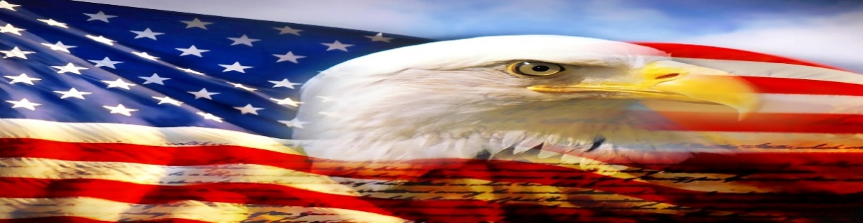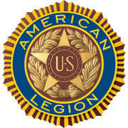

AMERICAN LEGION POST-105 SUNRISE NEWSLETTER
651 El Camino Real, Redwood City, CA 94063 www.americanlegionpost105rwc.org – Vol. 00038 December 2021

COMMANDER GREETINGS
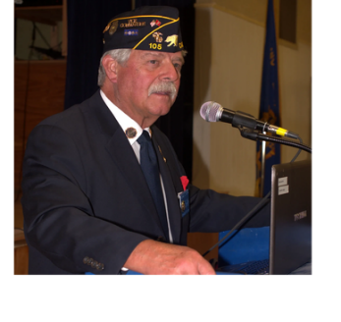

Hoping all our Post 105 legionnaire members and their families are doing fine and WISHING every family a joyful Merry Christmas and Happy New Year! It’s a great feeling of openly having a great Holiday Season with our families and friends again! It’s my gratitude to share my respect and honor all our post veterans for their honorary military services, and our successful Veterans Day celebration last month exhibited therein respect for ALL veterans who served. Our post is here to assist veterans and their families when necessary – please let us know when you need help. Always many
THANKS to our proactive membership and comrades with their ongoing support of
George Smith, Commander our post mission in life to serve our local communities for God and Country!

Encouraging our Post 105 members to join our membership meetings on the second Wednesday of each month at 6 PM. The meeting veteran participants can enjoy a FREE dinner meal and possibly WIN a cash monetary prize! The winner MUST be present at therein general membership meetings, to personally accept the cash monetary prize from the raffle tickets as required.

Because our freedom in America is NOT free like it appears within our social environments, and many THANKS to our military veterans for their services! It is our post legionnaire mission in life with 100+ years of patriotic services for God and Country with the ability to strengthen America. Our Post 105 family team is always WELCOMING new veteran legionnaires for our post mission! STAY SAFE & HEALTHY!

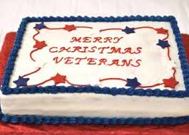

Merry Christmas, Happy New Year, Happy Birthdays, Anniversaries, etc. to all legionnaire members in December 2021 and many more! Enjoy and have fun at your celebrations – STAY SAFE & HEALTHY!

Page – 1
POST EVENTS & INFORMATION SHARING

Hiring Local Veterans  Les Schwab Tire Center,  260 El Camino Real,  San Carlos, CA 94070  Phone Number: 650-551-1091  Website: www.lesschwab.com | Hiring Veterans  FedEx Office Print & Ship Center,  3600 S. El Camino Real,  San Mateo, CA 94403  Phone Number: 650–525–0215  Website: www.fedex.com
Auxiliary District 26 VA Holiday Gift Assembling  Saturday, December 4, 2021 @ 10 AM  AL Post 105 – McDonald/McGarvey House,  651 El Camino Real, Redwood City, CA 94063  Website: www.americanlegionpost105rwc.org | AL Post 105 General Meeting – NEED dinner RSVP  Wednesday, December 8, 2021 @ 6 PM  651 El Camino Real, Redwood City, CA 94063  Contact Phone: 650–365–1337  Website: www.americanlegionpost105rwc.org
Toys for Vets Wrapping Gifts  Thursday, December 16, 2021 @ 8 AM – 12 PM  VA Menlo Park  795 Willow Road, Menlo Park, CA 94025  Building #334 in the gym and parking behind the building is available. Wrapping holiday gifts for veteran’s children. | Wreaths Across America  Saturday, December 18, 2021 @ 8:45 AM  Golden Gate National Cemetery  1300 Sneath Lane, San Bruno, CA 94066  Phone Number: (650) 589–7737  Website: www.cem.va.gov
Veterans Farmers Market  Wednesday, December 29, 2021 @ 10 AM – 2 PM  San Francisco VA Medical Center,  4150 Clement Street, San Francisco, CA 94121  Phone Number: 415–221–4810  Website: www.sanfrancisco.va.gov | 2021 New Years Eve “Blast From The Past”  Friday, December 31, 2021 @ 6 PM – 12 AM Midnight  American Legion Post 105,  651 El Camino Real, Redwood City, CA 94063  Phone Number: (650) 365–1337  Website: www.americanlegionpost105rwc.org

IMPORTANT NOTICE: The veterans can contact American Legion Post 105 and/or American Legion District 26 with information below, for assistance with veteran’s resources regarding how to secure appropriate assistance when necessary. The American Legion Post-105 and/or District-26 will align veterans with available resources for supportive services.

American Legion Post 105  651 El Camino Real,  Redwood City, CA 94063  Contact Phone: 650-365-1337  Website: www.americanlegionpost105rwc.org | American Legion District 26  1159 Bush Street,  San Carlos, CA 94070  Contact Phone: 650-349-7146  Website: www.ALDistrict26.org

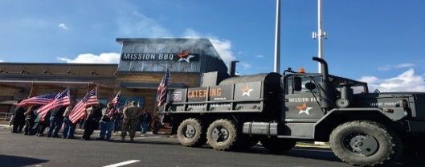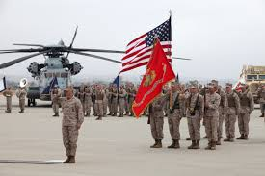

Page – 2
MEMBERSHIP VETERAN STORIES

Post membership and/or all military veterans can share stories about the war (all wartimes) during their veteran services, community services to help veteran families, etc. and many THANKS to veterans for sharing.

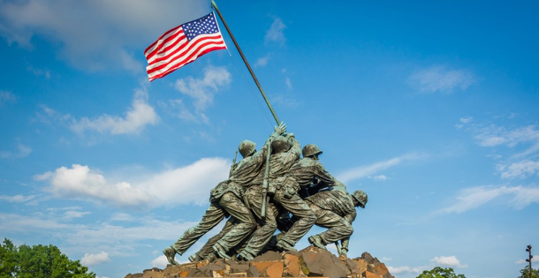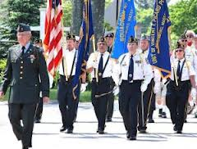

The newsletter veteran story this month is about our honorary military services comrade Ron Smith, who previously participated in rehabilitation recovery at the VA Hospital in Menlo Park. He served with honorary military services in the U.S. Navy as an Aviator Engineer fixing airplanes during the Vietnam War. He served in the military for 12 years during the Vietnam War era as active duty and 3 years in the reserve. He worked closely with his comrades to ensure war airplanes were ready “for action with efficiency hitting enemy targets.” He was assigned to the Naval Aviation Battalion during his active military duty assignments.

He is actively involved with other community organizations to help veterans with their families within local communities. He has been doing a lot of traveling with his wife and children during his retirement from military services and other civilian jobs. He tries to be actively involved with local services for veterans and families including human services when necessary.

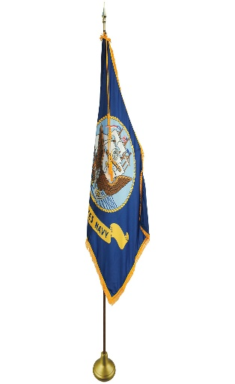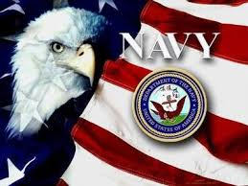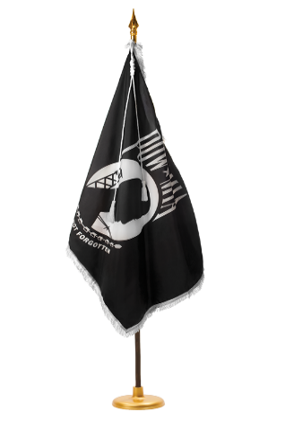

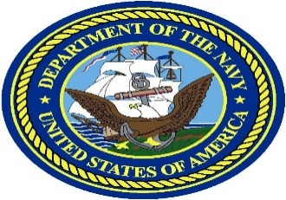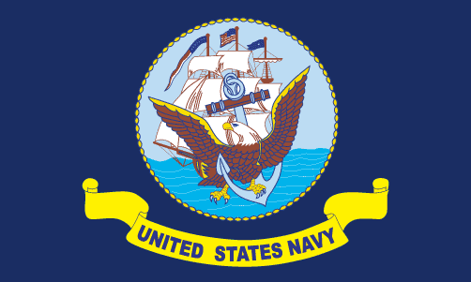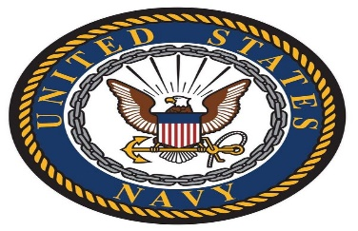

Page – 3
POST EVENTS PICTORIAL LAYOUT

The Post 105 participates in various local and state veteran events for supportive services for veterans and their families. The following pictures illustrating examples of Post 105 supportive services for veterans and their families during an event in local communities. It’s our post commitment for quality services supporting our veterans and their families – exemplifying by action throughout communities! (THANKS to all photographers for pics)

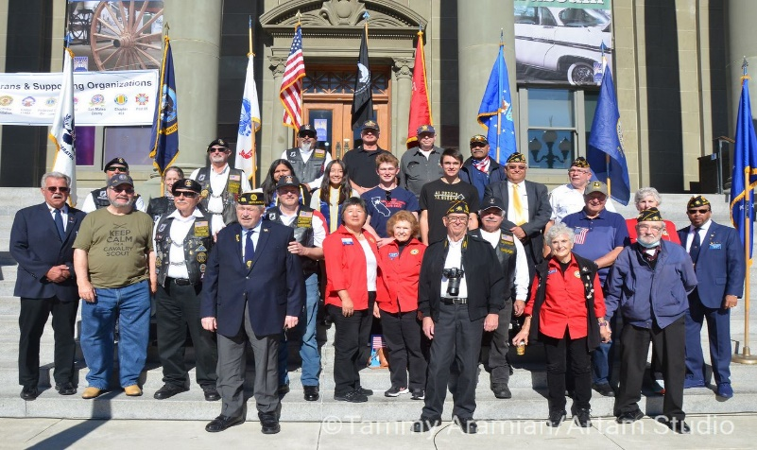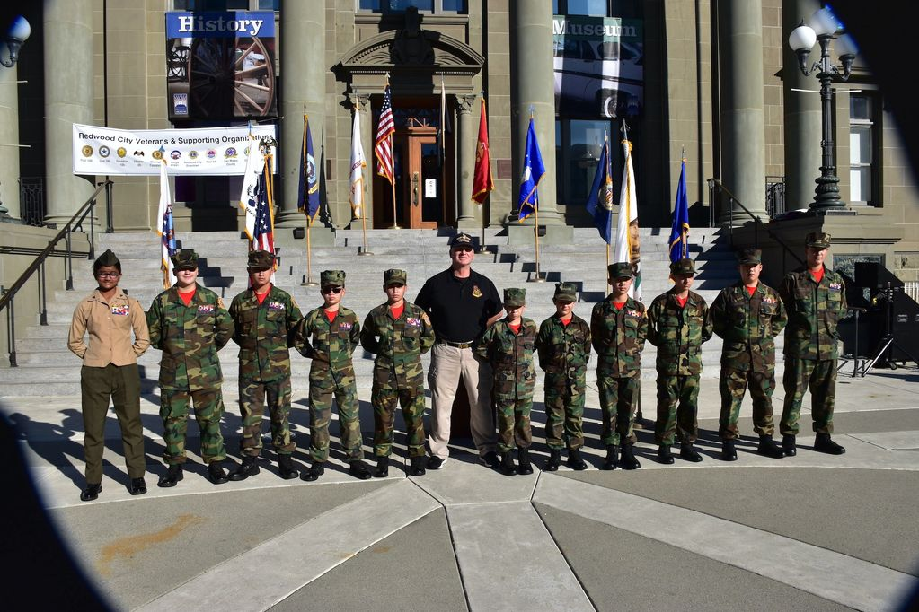
AL Post 105 photo display during the 2021 Veterans Day Golden Gate Young Marines membership participated
Celebration at the Courthouse Square. at therein 2021 Veterans Day Celebration event.

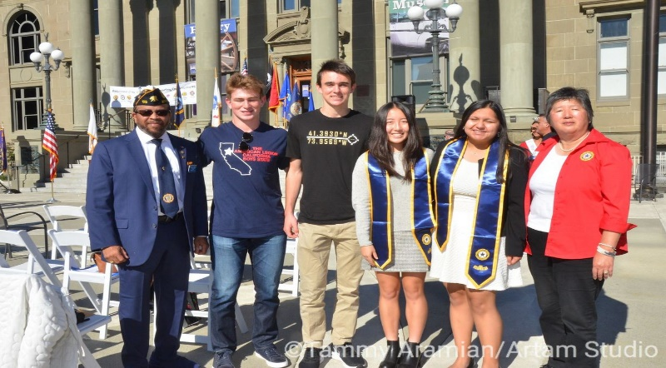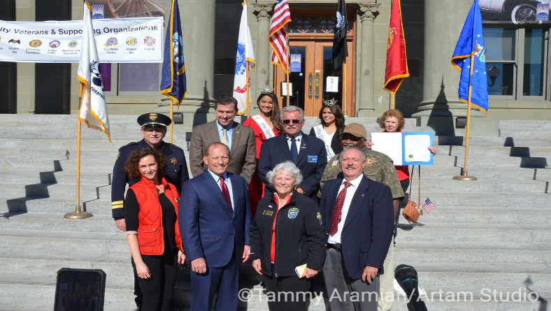
Bill with two Boys State gentlemen and Peggy with two AL Post 105 Commander, George Smith, and Redwood
Girls State ladies during therein 2021 Veterans Day City Mayor, Diane Howard with other dignitaries during
Celebration event. therein 2021 Veterans Day Celebration.

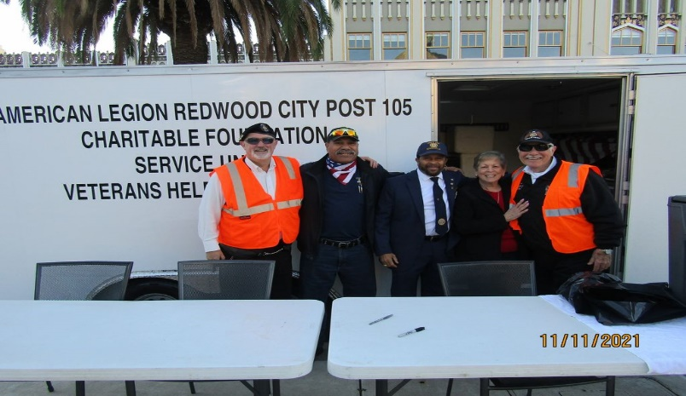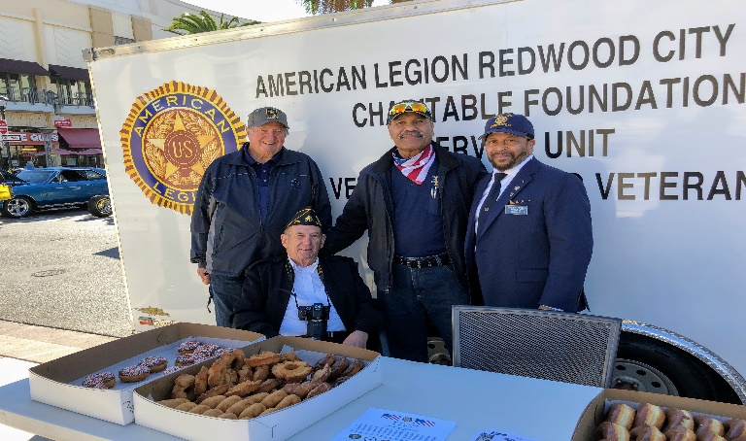
AL Post 105 members Andrew, Chester, Bill, and Gary Leo, Michael, Chester, and Bill preparing the donuts
with our veterans friend Linda preparing for therein and coffee for participants of therein 2021 Veterans Day
celebration event. Celebration.

Page – 4
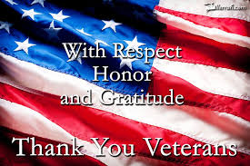

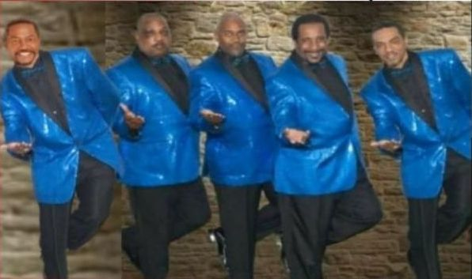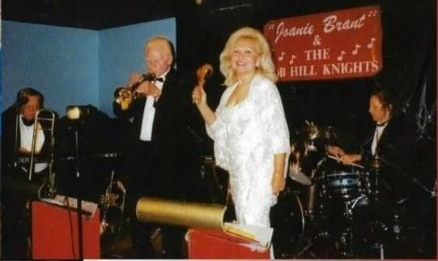
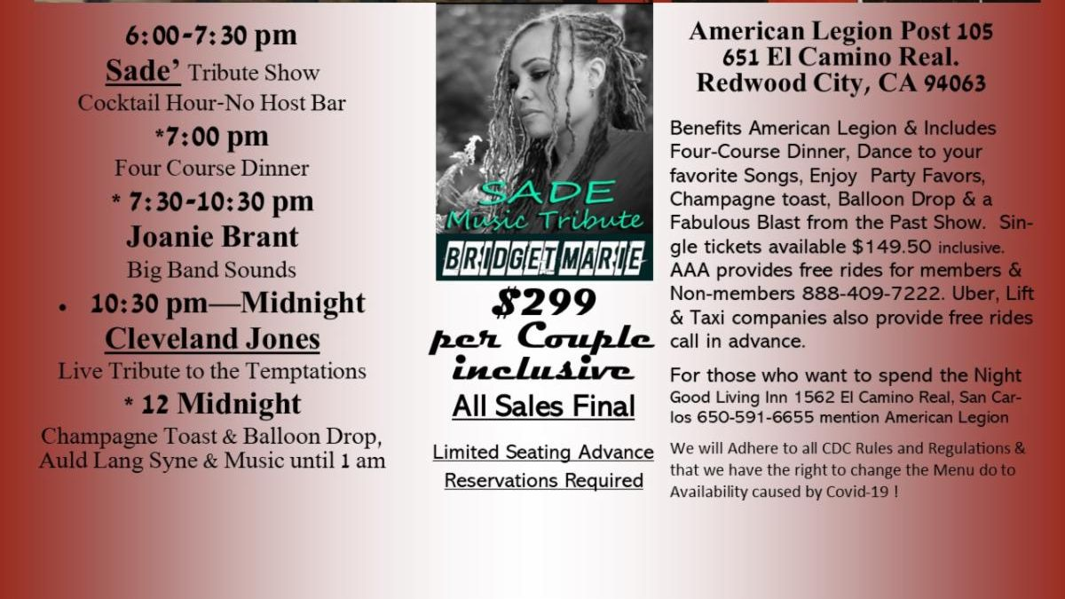
Call for Tickets @ Joan Brant 415–518–8434 or Kimberly @ 408–892–0974

Page – 5
- From the desk of the Commander

Wishing you and your families good health, a safe and Happy Holiday Season and may 2022 be the best year ever!
December is starting out with a Craft Faire at the Post on Saturday the 4th, hope to see you all there.
The hall is booked the first 3 Saturdays this month, the last two Saturdays it’s closed for the Holidays.
Friday, December 31st there is a New Years Eve Celebration at the Post, please see flyer in this newsletter.
Friday and Saturday, Christmas Eve and Christmas Day the Post will be closed.
Saturday, New Years Day, the Post will be closed.
The last Wednesday of the month (every month, except December) is Commander’s Coffee from 9:00 AM to 12:00 noon. Come down and join us for coffee and pastries, post officers will be there to answer any questions you might have. January 26, 2022, we will be highlighting MyLegion.org and how to use it. If you have anything you’d like to see on the list of things to do for the Commanders coffee, please let me know, CommanderPost105@gmail.com
Until next month, be safe and Happy New Year.
George
Commander Post 105

- Our EBoard continues to keep up with our post updates with therein post development status, and therein comprehensive DDA/Development Agreement (“Agreement”) has been signed appropriately by all involved parties and moving forward for next steps – development status letter was sent to our post membership. The next steps may take two years because of development permits and/or assessments for therein project. Our post development status is going through the permits process, and a Building Committee has been meeting to consider what is best for our post development situation – stay tuned!

- Our AL Post 105 Family units have been proactively participating with local activities to support veterans and their families last month. Including flag retirement ceremonies, Thanksgiving family activities for veterans, and successful 2021 Veterans Day Celebration at the Courthouse Square – mission accomplished!

- Our membership is coming along well with early bird membership renewals and 1 member is eligible for 60 years membership, and 4 eligible for 50 years membership certificates. Our AL Post 105 First Vice Commander recommends having a special recognition event for therein 5 legionnaire members of our post.

Department of California Reporting Data – 11/23/2021
Total Members | Membership Goal | New Members | PUFL Members | Paid To The Post | Current Percentage
137 | 233 | 1 | 45 | 91 | 59%

Many THANKS to renewal members who are already in place and your membership dues go directly to help veterans and their families. Please visit our website www.americanlegionpost105rwc.org for more membership information and updates.

Page – 6
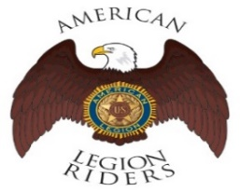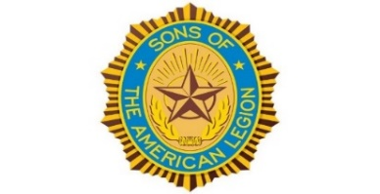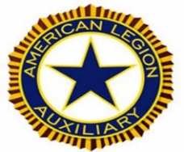

- The American Legion Riders Chapter 105 President, Ed Fifer and colleagues shared herein following progressive activities. American Legion Riders Chapter 105 has participated in many missions supporting veterans and their families, and participated in more than 6 missions and rifle firing details. The ALR105 rode more than 565 miles and donated more than 69 volunteer hours since last month. Including an escort ride scheduled for the National Commander in California on December 10 and 11. The new ALR105 President, Jim Bustos, will take over his new position role. If you own a freeway legal motorcycle, are a member of the American Legion, American Legion Auxiliary or Sons of the American Legion and would like to join us, please drop me an email at ALRChapt105@gmail.com or call me at 650-349-7146.
- The SAL Unit 105 Commander, Andrew Trapani reported previously another new member joined and elevated their membership numbers to 17. The AL California Department identifies SAL Unit 105 with 80% membership retention versus their membership goal. The SAL Unit 105 participated in 5 Final Hours Details during rifle-firing details to honor our veterans, and with 105 participants during the month of October 2021 – more details are scheduled for this month of December 2021. The SAL Unit 105 donated $100 for the Veterans Day Celebration and they contributed 28 hours of volunteering time with 239 miles. We are constantly looking for new qualified members, and not only can Patriots join but veterans can also join the Sons of The American Legion. The following are eligibility qualifications for SAL Unit 105: A male descendants adopted sons, and stepsons of members of The American Legion, and such male descendants of veterans who died in service during the period of April 6, 1917. Through November 11, 1918, or any time from December 7, 1941, to date, who served honorably, as set forth in Article IV, Section 1, of the National Constitution of The American Legion, or who died subsequent to their honorable discharge from such service shall be eligible for membership.

- The AL Auxiliary Unit 105 President, Carol Rael continues to meet with their unit in-person at the Post--second Wednesday @ 6pm. The Auxiliary procured a Proclamation from the City of Redwood City naming November “Veterans & Military Family Month.” The Auxiliary was pleased to have our Girls State Citizens Kasvi Singh (Design Tech High) and Adrienne Park (The Nueva School) acknowledged at Redwood City’s Veterans Day celebration. These accomplished students were honored with California Girls State stoles to wear at their graduation this coming spring. Our Unit is gearing up to host Aux District 26 for the annual veterans gift dropoff run by our very own Arlene Muller, VA&R Deputy. Units bought VA-Menlo Park Bldg. 331 patients gifts off their holiday wishlist. We’re set to wrap gifts at VA-MP on Dec. 16 for “Toys for Vets.” On Dec. 18, we’ll be joining San Mateo County Blue Star Moms in laying wreaths at Golden Gate National Cemetery for Wreaths Across America. We wish all our Post families a safe holiday season. (Pictures by Tammy Aramian, Artam Studios)

- Our Post 105 has a calendar identifying daily and/or monthly events as well as specified holidays, and other national calendar dates for your review, etc. Please visit herein following linkage below to review our https://americanlegionpost105rwc.org/calendar calendar of events and for more information.

- Please contact our post if anyone else of our Post 105 membership is aware of any other Everlasting Post members, and/or anyone in the hospital because of his/her illness. Please contact our Post Chaplain Dennis Lopez at 650-346-9825 for assistance when necessary regarding logistical matters.

Page – 7
- The Blue Star Moms will assist Golden Gate National Cemetery to honor and remember our veterans, just by laying wreaths on the graves of our fallen veteran heroes nationwide. The honorary effort is partnering with Wreaths Across America and people can volunteer to help and/or sponsoring a wreath for our veteran heroes. Please click onto herein linkage online https://wreathsacrossamerica.org/pages/30681/Overview for more information about Wreaths Across America. Local organizations can collaborate to support therein effort within San Mateo County, and contact American Legion Post 105 Family for assistance if necessary about volunteering and/or wreath sponsorship.

- The Blue Star Moms organization of San Mateo County has been a respectful agency with quality services to help veterans and their families. They are having a fundraising effort during the Holiday Season in partnership with See’s Candies by ordering candies online with discounts – sale ends on Friday, December 3, 2021. Please click onto herein linkage below online for more information and for quick services https://www.yumraising.com/secure/sanmcb_san_mateo_county_blue_star_moms_fall_70/candy?h=Amy_Wal4401 Because the time is near for your support during this holiday season – many THANKS to you in advance for your support and Happy Holidays!

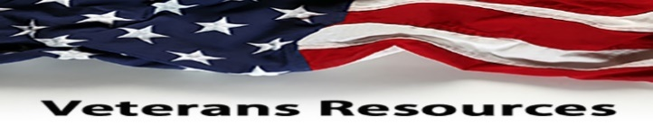

- The statewide Women Veterans Affairs is growing rapidly and advocating for effective services throughout California. The CalVet women organization is having online webinar sessions by clicking to the following link. https://www.calvet.ca.gov/WomenVets/Pages/Monthly-Statewide-Webinars.aspx

- We know how critically IMPORTANT to help our veteran comrades and families with many ongoing human service challenges in life. Because many veterans may not be able to find appropriate help for assistance with health, safety, suicide and human services including crisis matters. If a veteran is NOT sure where to start looking for help, please contact the Veterans Crisis Hotline at 1-800-273-8255. Copy and click online following linkage http://www.knowavet.org and/or text 838255 for more information.

- The U.S. Department of Veterans Affairs (VA) recently released their 2021 National Veterans Suicide Prevention Report for the public. The report provides critical information and click online to herein following linkage https://www.mentalhealth.va.gov/docs/data-sheets/2021/2021-National-Veteran-Suicide-Prevention-Annual-Report-FINAL-9-8-21.pdf for more information. Other resources that may help prevent suicide for veterans and their families is visiting herein online website www.godsnotdead.com for God’s Not Dead series film – enjoy the movie series!

- The U.S. Department of Veterans Affairs (VA) provides outreach information to help veterans with their families and children when necessary. The VA also tries to keep veterans updated with new regulations aligned with eligible veteran benefits. Go online with herein following linkage below to help you with VA claims when necessary, https://www.calvet.ca.gov/veteran-services-benefits/va-claims especially during these challenging times with the pandemic. Needless to say, therein pandemic is impacting many local communities affecting our veterans and their families, and appropriate health care services has to be in place to protect our veterans. Including appropriate suicide prevention elements in place to eradicate increasing suicide issues of concern for our veterans – protecting veterans and their family is an essential matter!

Page – 8
- All local families as well as our veteran families deserve the best health care systems in place, for protection especially with the pandemic virus impact. The UCSF Health Care system opens the new clinic within San Mateo County to help veterans and their families locally, and make it easier for them especially during the COVID-19 pandemic health crisis. We want the best health care providers to help our veterans and their families for appropriate protection, and UCSF is one of the best health care providers – local veterans don’t have to travel long distance for health care anymore. Please go online to the following linkage below for clinics https://www.ucsf.edu/news/2020/01/416536/ucsf-health-opens-new-clinics-peninsula and more accessible threshold contact. Our AL Post 105 Family advocated for local clinics – mission accomplished!

- The veterans and their families need appropriate transportation to mobilize within local communities when necessary. The SamTrans Transit District has a public traveling program called Veterans Mobility Corps Vet 2 Vet Program to help veterans with local transportation within San Mateo County. Please go online with the following website www.samtrans.com for more program information. The transit program staff can train veterans and share available traveling elements, as well as shuttling services for each coverage area within countywide jurisdictions to make it convenient for veterans.

- The local Holiday Season is here and veterans with their families need food for support, and community programs such as Second Harvest Food Bank can help. The Second Harvest Food Bank offers food pickup locations within San Mateo County on their website at https://www.shfb.org/get-food/ – contact phone number 800–984–3663 or text GETFOOD at 408–455–5181.

- The Daly City Partnership is a collaboration effort to help local veteran families and children with accessible healthy food to promote well-being communities. Please go online to the partnership following website https://www.dcpartnership.org/covid19/ for more information and free meals for students, and contact email at mike@dcpartnership.org and phone number 650–301–3300.

- The food programs in San Mateo County can help people with nutrition meals during these challenging times for veteran families and children. The CalFresh Program can help provide healthy nutritional food for local communities. Please go online with herein linkage https://www.cdss.ca.gov/food-nutrition/calfresh for more information and access – contact email at antorres@smcgov.org and phone number 650–802–6575.

- Our veteran families and children needs discount programs during these challenging times with therein pandemic. Please go online at www.legion.org/benefits for all essential discounting programs to help local veterans and their families. Especially with health and dental discounting programs as well as financial assistance with medical bills, and help with holiday gifts for veteran families and children.

NEWSLETTER EDITOR NOTICE

Our post newsletter is offering this opportunity to reach out and work closely with our membership legionnaires and all veterans! The post members can provide future newsletter articles and/or “appropriate” newsletter posting information, and posting information can be verbatim if necessary. Including stories and comments about post activities, veteran’s insight views and information sharing, pictures, etc. Please send information by email mfcpalesoo@gmail.com or phone call at 650-365-1337 for informational message.

American Historical Quote: “Efforts and courage are not enough without purpose and direction.”

President John F. Kennedy
Page – 9

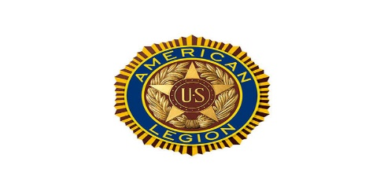

AMERICN LEGION

POST 105 FAMILY

WISHING YOU, FAMILIES, AND FRIENDS

A

JOYFUL HAPPY HOLIDAY SEASON!

MERRY CHRISTMAS & HAPPY NEW YEAR!

George Smith, Commander, American Legion Post 105 Family

Page – 10

