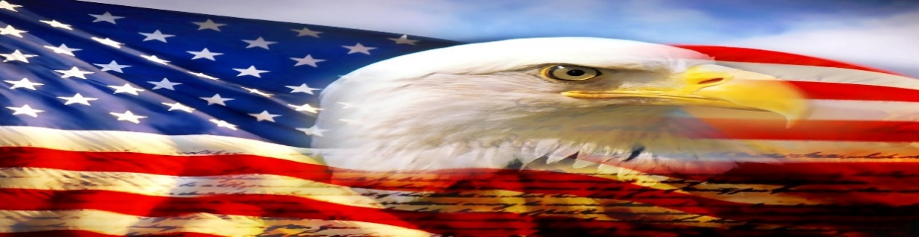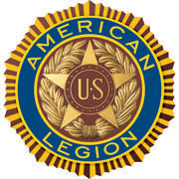

AMERICAN LEGION POST-105 SUNRISE NEWSLETTER
651 El Camino Real, Redwood City, CA 94063 www.americanlegionpost105rwc.org – Vol. 00041 March 2022

COMMANDER GREETINGS
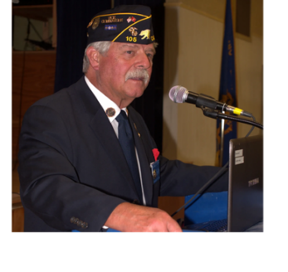

THANKS to God Almighty, the pandemic is strategically disappearing from our communities, and hoping all our AL Post 105 Family legionnaire members and their families are doing fine! It’s a pleasure to share my gratitude and appreciation to ALL female veterans of our post for their honorary military services, as well as ALL female veterans for their honorary contribution to help our diversified communities. To honor National Women’s History Month of March 2022! Our post is here to help veterans and their families when necessary – please let us know immediately! Many THANKS
to our proactive members for their ongoing support of our post mission in life, and
George Smith, Commander veterans services for God and Country to strengthen America!

Encouraging our Post 105 members to join our membership meetings on the second Wednesday of each month at 6 PM. The meeting veteran participants can enjoy a FREE dinner meal and possibly WIN a cash monetary prize! The winner MUST be present at therein general membership meetings requirement, to personally accept thereby cash monetary prize from the raffle tickets drawing.

Because our freedom in America is NOT free like it appears within our social environments, and many THANKS to our military veterans for their services! It is our post legionnaire mission in life with 100+ years of patriotic services for God and Country with the ability to strengthen America. Our Post 105 family team is always WELCOMING new veteran legionnaires for our post mission! STAY SAFE & HEALTHY!

Happy St. Patrick’s Day, Happy Birthdays, Happy Anniversaries, etc. to ALL legionnaire members in
March 2022 and many more! Enjoy and have fun at your celebrations – STAY SAFE & HEALTHY!
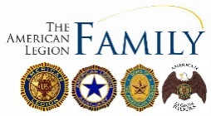

Page – 1
POST EVENTS & INFORMATION SHARING

Priority Hiring Veterans  Beltran Tires,  249 El Camino Real, Redwood City, CA 94062  Phone Number: 650–368–3762  Website: www.beltrantires.com | Hiring Local Veterans  Jiffy Lube,  2517 S. El Camino Real, San Mateo, CA 94403  Phone Number: 650–349–7222  Website: www.jiffylube.com
Police Academy Entry Level Test  Tuesday, March 8, 2022 @ 6 PM – 9 PM  San Jose Police Department Training Center,  6087 Great Oaks Parkway, San Jose, CA 95119  Phone Number: 408-277-5339  Website: www.sjpd.org | Post 105 General Meeting – NEED rsvp for dinner  Wednesday, March 9, 2022 @ 7 PM  American Legion Post 105,  651 El Camino Real, Redwood City, CA 94063  Phone Number: 650–365–1337 (FREE DINNER @ 6 PM)  Website: www.americanlegionpost105rwc.org
The Power Law of Venture Capital  Thursday, March 10, 2022 @ 7 PM – 8:15 PM  Computer History Museum,  1401 North Shoreline Blvd, Mountain View, CA 94043  Contact Phone: 650–810–1010  Website: www.computerhistory.org | AL Post 105 Community Service Project  Saturday, March 12, 2022 @ 9:30 AM – 11:30 AM  Skylawn Memorial Park (FREE breakfast & lunch provided)  Hwy. 92 and Skyline Blvd, San Mateo, CA 94062  Phone Number: (650) 227–3142  Website: www.skylawnmemorialpark.com
VA Farmers Market  Wednesday, March 16, 2022 @ 10 AM – 2 PM  San Francisco VA Medical Center,  4150 Clement Street, San Francisco, CA 94121  Phone Number: 415–221–4810  Website: www.sanfrancisco.va.gov | Grace Cathedral Sound Bath  Monday, March 21, 2022 @ 7 PM – 8:30 PM  Grace Cathedral San Francisco,  100 California Street, San Francisco, CA 94108  Phone Number: (415) 749–6300  Website: www.gracecathedral.org

IMPORTANT NOTICE: The veterans can contact American Legion Post 105 and/or American Legion District 26 with information below, for assistance with veteran’s resources regarding how to secure appropriate assistance when necessary. The American Legion Post-105 and/or District-26 will align veterans with available resources for supportive services.

American Legion Post 105  651 El Camino Real,  Redwood City, CA 94063  Contact Phone: 650-365-1337  Website: www.americanlegionpost105rwc.org | American Legion District 26  1159 Bush Street,  San Carlos, CA 94070  Contact Phone: 650-349-7146  Website: www.ALDistrict26.org

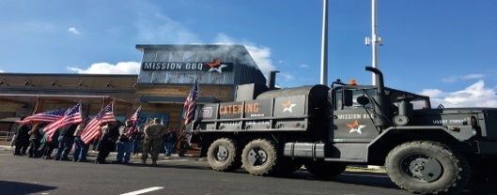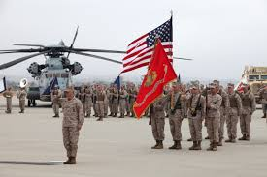

Page – 2
MEMBERSHIP VETERAN STORIES

Post membership and/or all military veterans can share stories about the war (all wartimes) during their veteran services, community services to help veteran families, etc. and many THANKS to veterans for sharing.

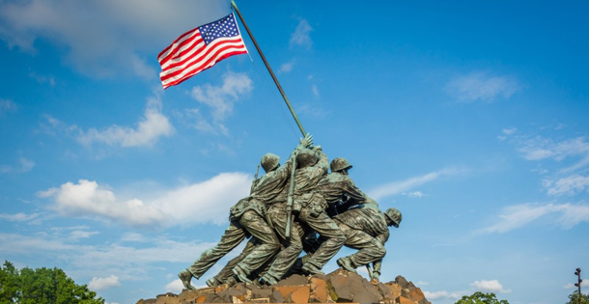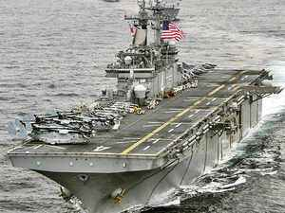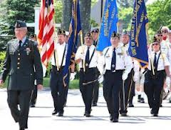

The newsletter veteran story this month is about our honorary military services veteran comrade David Miller who served in the U.S. Navy thereafter graduating from high school. He decided to join the military with available schools and decided to join the U.S. Navy military services. He likes to travel along with therein U.S. Navy military ships and participated in welding training, and became a successful structural welder in the Pacific Northwest. He worked onboard the USS Francis Hammond in San Diego and Yokosuka in Japan, and stationed in the Persian Gulf onboard the USS McKee.

His military services provided him with good decision-making skills and believes life is fragile, and he made good friends in the U.S. Navy. He believes our democracy is worth fighting for with protection, and military veterans should not be forgotten and/or neglected for their honorable military services. Needless to say, military veterans who retired with honorary services should be provided all appropriate human services for support when necessary.

THANKS to Kalidev Choudhury for sharing the veterans lost stories on his website www.theloststories.org

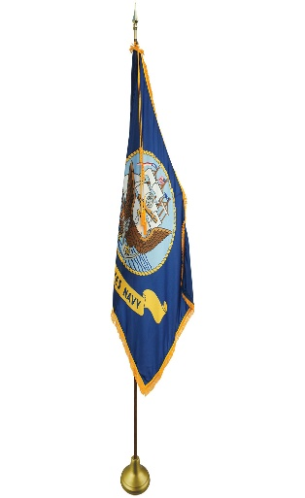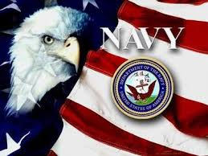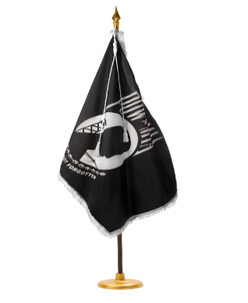

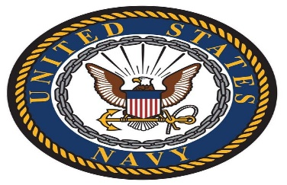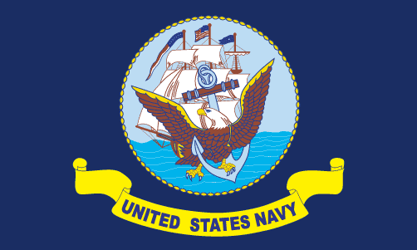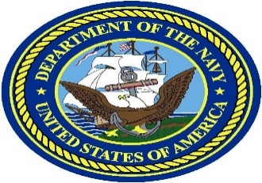

Page – 3
POST EVENTS PICTORIAL LAYOUT

The Post 105 participates in various local and state veteran events for supportive services for veterans and their families. The following pictures illustrating examples of Post 105 supportive services for veterans and their families during an event in local communities. It’s our post commitment for quality services supporting our veterans and their families – exemplifying by action throughout communities! (THANKS to all photographers for pics)

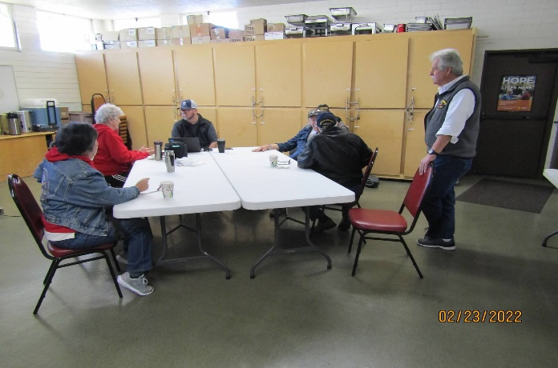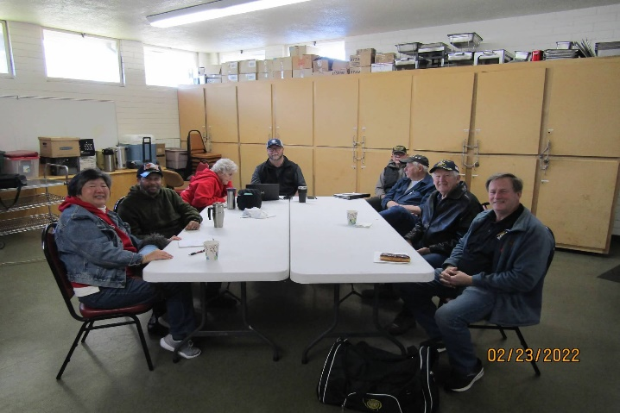
Post 105 Commander, George Smith with AL Post 105 AL Post 105 Family unit members at the Commanders
Family unit members at therein Commanders Coffee event. Coffee social event on Wednesday, February 23, 2022.

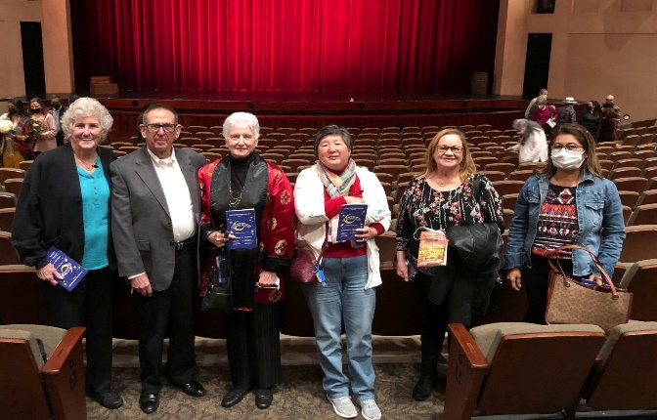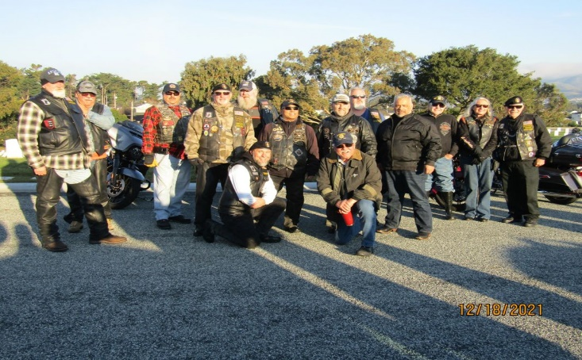
Auxiliary Unit 105 President, Carol Rael with members ALR Post 105 Family members with veteran friends
and friends enjoying the Gershwin tunes social event preparing for therein Wreaths Across America event at
at San Mateo High School Performance Arts Center. Golden Gate National Cemetery.

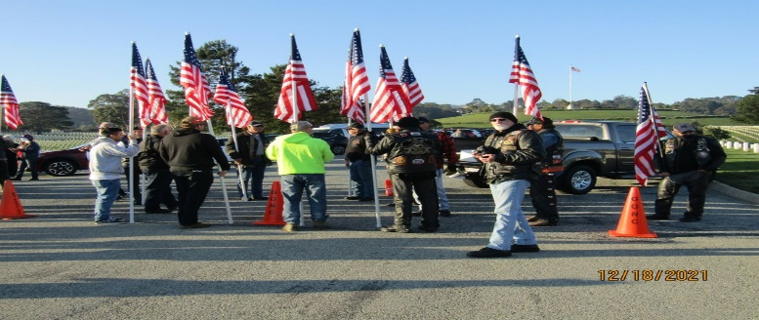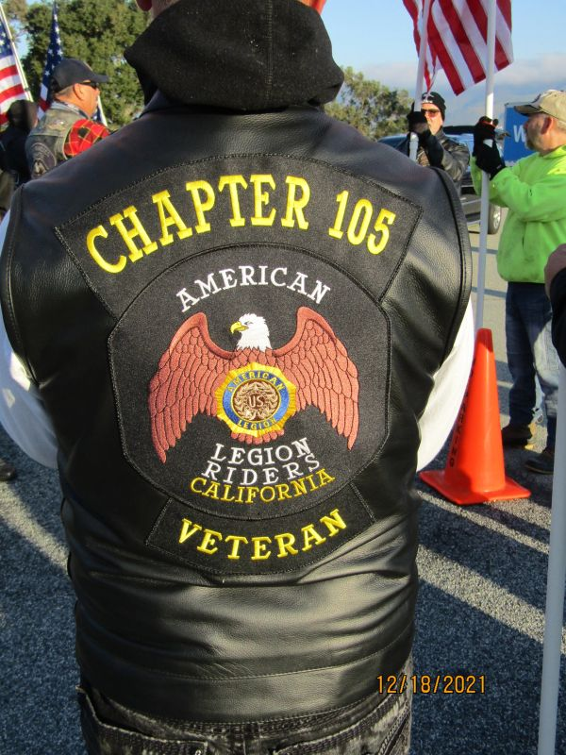
ALR Post 105 members with veteran friends preparing ALR Post 105 Family members during a flag ceremonial
for therein flag ceremony event. event.

Page – 4
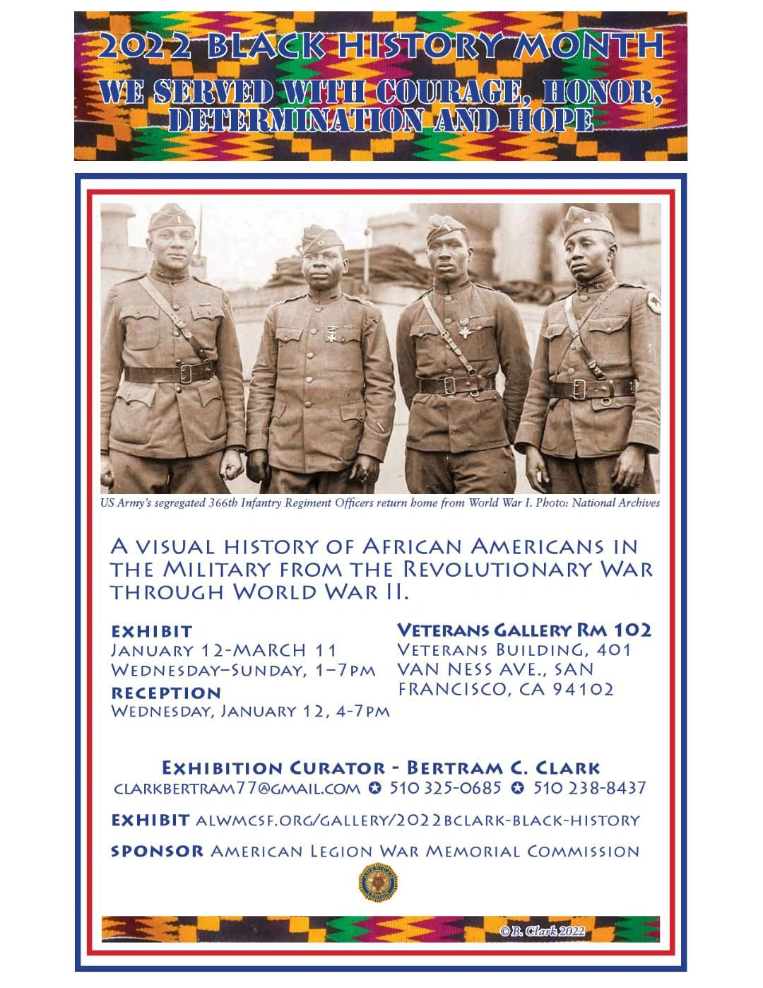
The honorary history of African Americans in the U.S. Military to visualize is still available until March 11, 2022 – honoring Black History Month in February 2022. The exhibition display is at thereby Veterans Building in San Francisco on Van Ness Avenue – Veterans Gallery Room 102.

Page – 5
- From the desk of the Commander
The ides of March are upon us, will it come in like a lamb and go out like a lion, visa versa or will it be all lamb or all lion? I know what I’m hoping for, ALL LION, we need the rain!
It seems like COVID-19 is getting under control, thanks to everyone that was vaccinated and/or wore a mask. Hopefully, we’ll get back to some sort of normalcy.
If you happen to know anyone that can patch our plastered ceiling in the hall, please have them contact me, we need to get that fixed now that we’ve had the roof repaired.
Rentals are slowly but surely picking up. We have 2 confirmed and 2 pending for March, hopefully, those pending will confirm.
I hope everyone is checking out our website, https://americanlegionpost105rwc.org/ a lot of good information with updates on everything that’s going on at the Post.
The last Wednesday of the month (every month, except December) is Commander’s Coffee from 9:00 AM to 12:00 noon. Come down and join us for coffee and pastries, post officers will be there to answer any questions you might have. March 30, 2022 is Vietnam Veterans Day, we will be giving out Pins along with a paper explaining the meaning of the Pin to all Vietnam Veterans that haven’t received theirs. So, please come down and be part of the festivities. If you have anything you’d like to see on the list of things to do for the Commanders coffee, please let me know, CommanderPost105@gmail.com
Until next month, be safe and ‘Thank You’ for supporting our Veterans, their Families and our Community!
George
Commander Post 105

- Our AL Post 105 Family welcomes our new Post Chaplain, Cobbey Sova and she has been a proactive member of our post with local missionary activities. Many THANKS to our former Chaplain, Dennis Lopez for his unrelenting support of our post mission to help veterans and their families – will keep everyone in our prayers! Please contact our post if anyone is aware of our Post 105 membership regarding Everlasting Post members, and/or anyone in the hospital because of his/her sickness and/or specific type of illness – will keep them in our prayers with quick recovery! Please contact our post administrative office at 650-365-1337 for assistance when necessary regarding logistical matters, and/or visit our website at www.americanlegionpost105rwc.org for more information.

- All our AL Post 105 Family units continue to proactively participate with local activities to support veterans and their families during last month in February 2022. Including partnership activities with Blue Star Moms in our diversified communities to support veterans and their families. As well as youth leadership activities to help and support veterans in the future with their family needs when necessary. Including flag retirement ceremonies, rifle-firing detail events to honor our everlasting comrades, etc. Needless to say, our AL Post 105 Family units have completed a greater number of volunteer hours with community services to help our veterans and their families. Including previous escorting details for the AL National Commander and ALA Department President will visit our Post 105 during a luncheon event session on April 2, 2022. Our Post 105 Family ALR unit members will coordinate and schedule an escorting detail for thereby Department of California honorary official. The table to honor our MIA/POW veteran comrades is in place at our family post because they will never be forgotten – love you fellow brothers and sisters!

Page – 6
- Our membership is coming along well with early bird membership renewals and 1 member is eligible for 60 years membership, and 4 members are eligible for 50 years membership certificates. The First Vice Commander, Mr. Tom Day of our AL Post 105 Family, is recommending to have a special recognition event for therein 5 exceptional legionnaire members of our Post 105.

Department of California Reporting Data – 2/11/2022

Total Members | Membership  Goal | New  Members | Transfer  Members | PUFL Members | Paid To The Post | Current Percentage
179 | 233 | 7 | 3 | 45 | 124 | 77%

Many THANKS to renewal members and your membership dues that will go directly to help veterans and their families. Please visit our website www.americanlegionpost105rwc.org for more membership access and informational forms. You can also contact the First Vice Commander Mr. Tom Day by email at thomas.day505@gmail.com and THANK YOU for your support!

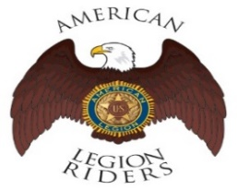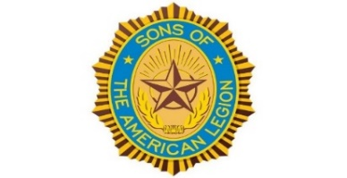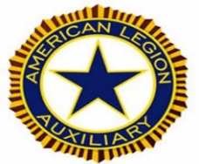

- The American Legion Riders Chapter 105 membership and colleagues shared herein following progressive activities. American Legion Riders Chapter 105 has participated in many missions supporting veterans and their families, and participated in more than 14 missions and rifle firing details during February 2022. The ALR105 rode more than 1826 DOC miles and donated more than 261 volunteer hours since last month. Including an escort ride scheduled for the National Commander in California on December 10 and 11. The new ALR105 President, Andrew Trapani is taking over his new position role with great leadership performance! The ALR105 chapter raised $3700 during therein Suicide Prevention ride with monetary contribution for the VA Palo Alto Hospital. Also, raised $410 and donated therein monetary contribution to Wreaths Across America. The Post 105 Riders participated in the Berkeley ½ marathon directing local traffic control. If you own a freeway legal motorcycle, are a member of the American Legion, American Legion Auxiliary or Sons of the American Legion and would like to join us, please email at ALRChapt105@gmail.com or call me at 650-349-7146.
- The SAL Unit 105 Commander, Andrew Trapani reported previously another new member joined and elevated their membership numbers to 17. The AL California Department identifies SAL Unit 105 with 80% membership retention versus their membership goal. The SAL Unit 105 participated in 7 Final Hours Detail missions during rifle-firing details to honor our veterans, and with 105 participants and more details are scheduled for March 2022. The SAL Unit 105 donated $100 for the Veterans Day Celebration and they contributed 46 hours of volunteering time with 650 miles. We are constantly looking for new qualified members, and veterans can also join the Sons of The American Legion. The following are eligibility qualifications for SAL Unit 105: A male descendants adopted sons, and stepsons of members of The American Legion, and such male descendants of veterans who died in service during the period of April 6, 1917. Through November 11, 1918, or any time from December 7, 1941, to date, who served honorably, as set forth in Article IV, Section 1, of the National Constitution of The American Legion, or who died subsequent to their honorable discharge from such service shall be eligible.

Page – 7
- The AL Auxiliary Unit 105 President, Carol Rael continues to meet with their unit in-person at Post-105 on the second Wednesday @ 6pm. The Auxiliary is well over 116% of membership goal. Officers are serving double-duty as District officers as we prepare for the Auxiliary Department President’s brunch on April 2; Auxiliary members are encouraged to attend. By publication time, our four panelists (Julie, Pauline J, Stacy, Peggy) will have completed their Girls State selection for d.tech, Notre Dame Belmont, Nueva and Sequoia High Schools. Unit 474 Coastside lost their Girls State chairperson; as a courtesy, Unit 105's panelists will interview Coastside’s Capuchino and Half Moon Bay High Schools’ Girls State candidates in March. (We did so last year for Unit 585 San Carlos' Aragon High.) We’re revamping our website. Use this link for Blue Star Moms’ March 17 Panda Express fundraiser. The Auxiliary welcomed Legionnaires and other Units to attend San Mateo High's musical, "Crazy for You."

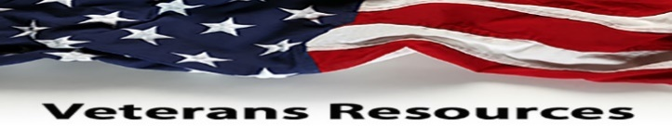

- The statewide Women Veterans Affairs is growing rapidly and advocating for effective services throughout California. The CalVet women organization is having online webinar sessions by clicking to the following link. https://www.calvet.ca.gov/WomenVets/Pages/Monthly-Statewide-Webinars.aspx

- The Redwood City Public Library is WELCOMING back participants from our local communities, as well as other public libraries in San Mateo County. They have great family events for parents and children, and storytelling times with other family activities – please visit www.redwoodcity.org for library information.

- We know how critically IMPORTANT to help our veteran comrades and families with many ongoing human service challenges in life. Because many veterans may not be able to find appropriate help for assistance with health, safety, suicide and human services including crisis matters. If a veteran is NOT sure where to start looking for help, please contact the Veterans Crisis Hotline at 1-800-273-8255. Copy and click online following linkage http://www.knowavet.org and/or text 838255 for more information.

- The Blue Star Moms have been an exceptional partnership agency with our AL Post 105 Family, and having their Panda Express fundraising on Thursday, March 17, 2022. Please copy and go online to herein linkage
https://www.community-fundraiser.com/virtual-fundraiser/events/promotions/b4143a68-f161-b46b-cd68-6e8d492abd4f/en/landing for help. You can contact Brenda Ternullo at email bsmavolunteer@gmail.com for more information – THANKS for your support!
NEWSLETTER EDITOR NOTICE

Our post newsletter is offering this opportunity to reach out and work closely with our membership legionnaires and all veterans! The post members can provide future newsletter articles and/or “appropriate” newsletter posting information, and posting information can be verbatim if necessary. Including stories and comments about post activities, veteran’s insight views and information sharing, pictures, etc. Please send information by email mfcpalesoo@gmail.com or phone call at 650-365-1337 for informational message.

American Historical Quote: “The life of a nation is secure only while the nation is honest, truthful,
and virtuous!”
Frederick Douglass, Abolitionist

Page – 8

