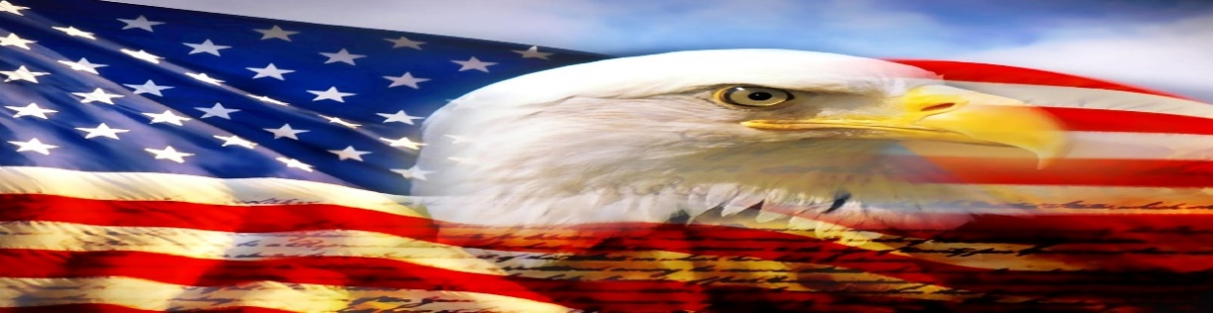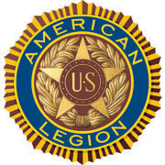

AMERICAN LEGION POST-105 SUNRISE NEWSLETTER
651 El Camino Real, Redwood City, CA 94063 www.americanlegionpost105rwc.org – Vol. 00042 April 2022

COMMANDER GREETINGS
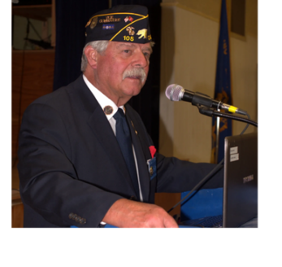

Greetings! Hoping all our AL Post 105 Family legionnaire members and their families are doing fine! It’s a pleasure to share my gratitude and appreciation to all Scottish-American veterans of our post for their honorary military services, as well as ALL veterans for their honorary contribution to help our diversified communities. To honor Scottish-American History Month of April 2022! Our post is here to help veterans and their families when necessary – please let us know immediately! Many THANKS to our proactive members for their ongoing support of our post mission in life, and veteran services for God and Country to empower America!
George Smith, Commander

Encouraging our Post 105 members to join our membership meetings on the second Wednesday of each month at 6 PM. The meeting veteran participants can enjoy a FREE dinner meal and possibly WIN a cash monetary prize! The winner MUST be present at therein general membership meetings requirement, to personally accept thereby cash monetary prize from the raffle tickets drawing.

Because our freedom in America is NOT free like it appears within our social environments, and many THANKS to our military veterans for their services! It is our post legionnaire mission in life with 100+ years of patriotic services for God and Country with the ability to strengthen America. Our Post 105 family team is always WELCOMING new veteran legionnaires for our post mission! STAY SAFE & HEALTHY!

Happy Birthdays, Happy Anniversaries, etc. to ALL our post legionnaire members in April 2022 and many more! Enjoy and have fun at your celebrations – STAY SAFE & HEALTHY!
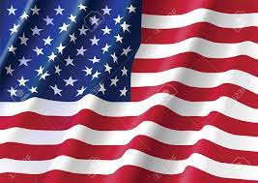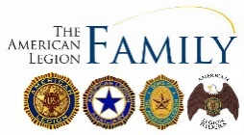

Page – 1
POST EVENTS & INFORMATION SHARING

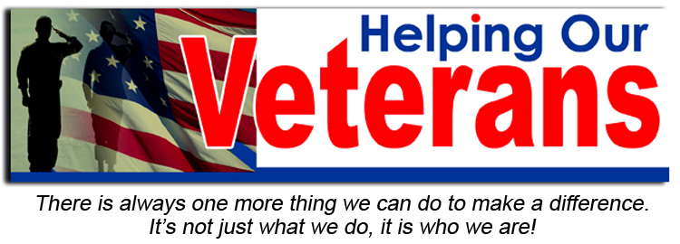

Hiring Local Veterans  BART (Bay Area Rapid Transit),  P.O. Box 12688, Oakland, CA 94604  Phone Number: 510–464–7134  Website: www.bart.gov | Hiring Local Veterans  Caltrain,  1250 San Carlos Avenue, San Carlos, CA 94070  Phone Number: 650–508–6200  Website: www.caltrain.com
Veterans Piedmont Hoopster Tots – Ages 3 to 5  Tuesday, April 5, 2022 @ 1:15 PM – 2 PM  Piedmont Veterans Memorial Building,  401 Highland Avenue, Piedmont, CA 94611  Phone Number: 510-420-3081  Website: www.ci.piedmont.ca.us | San Francisco Bay Area Veterans Job Fair  Thursday, April 7, 2022 @ 11 AM – 3 PM  Levi’s Stadium,  4900 Marie P. DeBartolo Way, Santa Clara, CA 95054  Phone Number: 415-464-9377  Website: www.levisstadium.com
IGNITE! Play Party for Community Veterans  Saturday, April 9, 2022 @ 7 PM – 1 AM  Transform 1060,  1060 Folsom Street, San Francisco, CA 94103  Email: info@transform1060.org  Website: www.transform1060.org | Post 105 General Meeting – NEED rsvp for dinner  Wednesday, April 13, 2022 @ 7 PM  American Legion Post 105,  651 El Camino Real, Redwood City, CA 94063  Phone Number: 650–365–1337 (FREE DINNER @ 6 PM)  Website: www.americanlegionpost105rwc.org
Crissy Field Community Beach Clean Up  Saturday, April 23, 2022 @ 9:30 AM – 11:30 AM  Crissy Field,  1199 E. Beach, San Francisco, CA 94129  Phone Number: 415–561–4323  Website: www.parksconservancy.org | VA Farmers Market  Wednesday, April 27, 2022 @ 10 AM – 2 PM  San Francisco VA Medical Center,  4150 Clement Street, San Francisco, CA 94121  Phone Number: 415–221–4810  Website: www.sanfrancisco.va.gov

IMPORTANT NOTICE: The veterans can contact American Legion Post 105 and/or American Legion District 26 with information below, for assistance with veteran’s resources regarding how to secure appropriate assistance when necessary. The American Legion Post-105 and/or District-26 will align veterans with available resources for supportive services.

American Legion Post 105  651 El Camino Real,  Redwood City, CA 94063  Contact Phone: 650-365-1337  Website: www.americanlegionpost105rwc.org | American Legion District 26  1159 Bush Street,  San Carlos, CA 94070  Contact Phone: 650-349-7146  Website: www.ALDistrict26.org

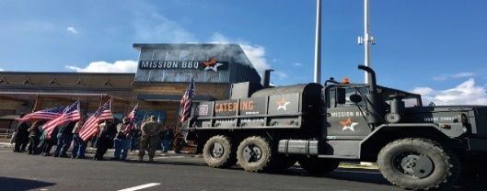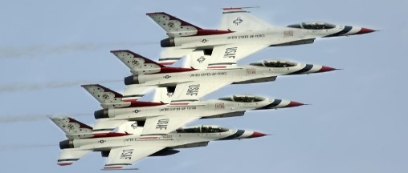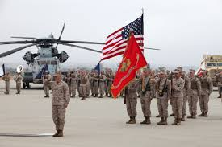

Page – 2
MEMBERSHIP VETERAN STORIES

Post membership and/or all military veterans can share stories about the war (all wartimes) during their veteran services, community services to help veteran families, etc. and many THANKS to veterans for sharing.

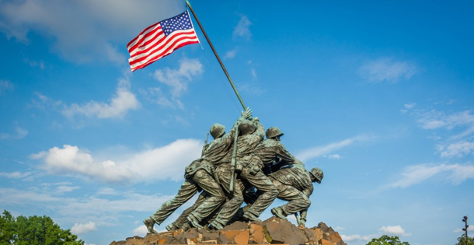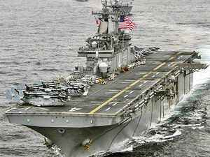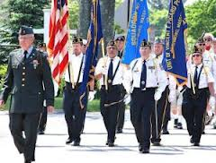

The newsletter veteran story this month is about our honorary military services veteran comrade Marshal Rosenthal who served in the U.S. Marines. He decided to join the U.S. Marines for his mother and thought it was a tough branch of the military services. He wanted to be somebody and trained at Camp Pendleton in San Diego, California for boot camp. He was onboard the ship with his military comrades to Okinawa for therein ground battlefield to combat targeting enemies. He was part of the 2nd Marine Division and joined the 6th Division Pioneer Battalion. He was discharged from military services and went home to his family, and started to work during his civilian life.

He is very happy to become a Marine soldier and would do it again with no problem. He still stay in contact with his community military friends, and will help veterans and their families in local communities.

THANKS to Kalidev Choudhury for sharing the veterans lost stories on his website www.theloststories.org

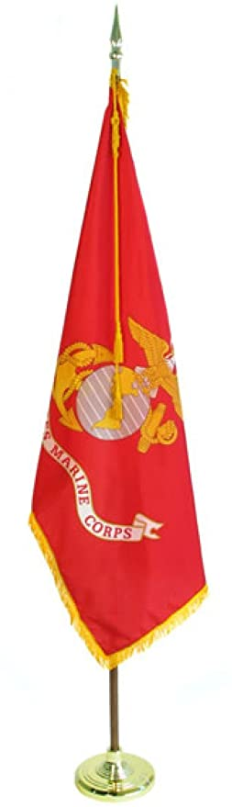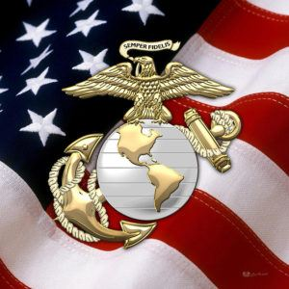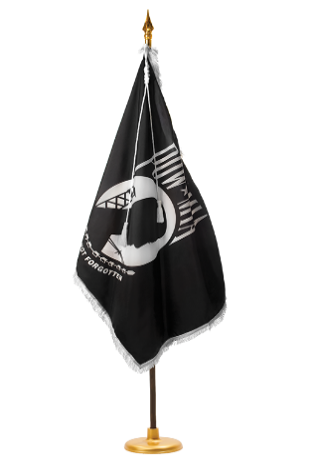

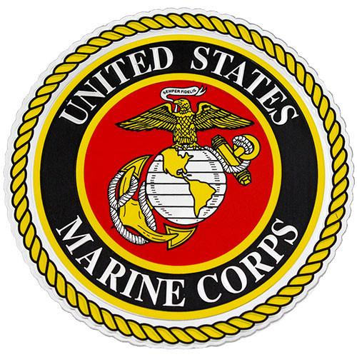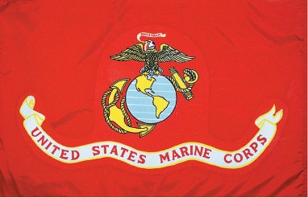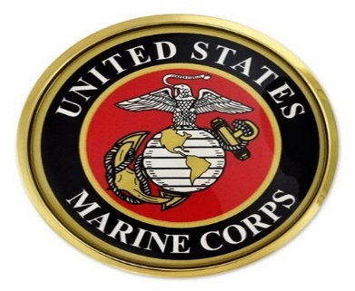

Page – 3
POST EVENTS PICTORIAL LAYOUT

The Post 105 participates in various local and state veteran events for supportive services for veterans and their families. The following pictures illustrating examples of Post 105 supportive services for veterans and their families during an event in local communities. It’s our post commitment for quality services supporting our veterans and their families – exemplifying by action throughout communities! (THANKS to all photographers for pics)

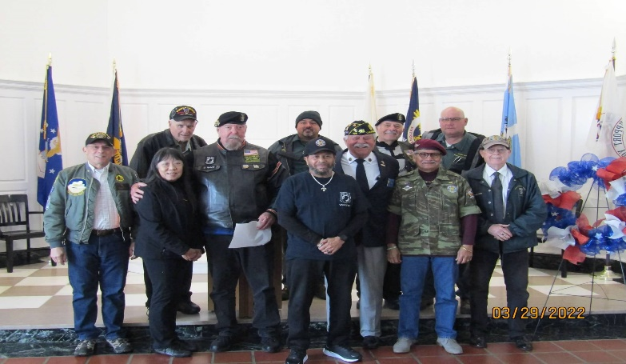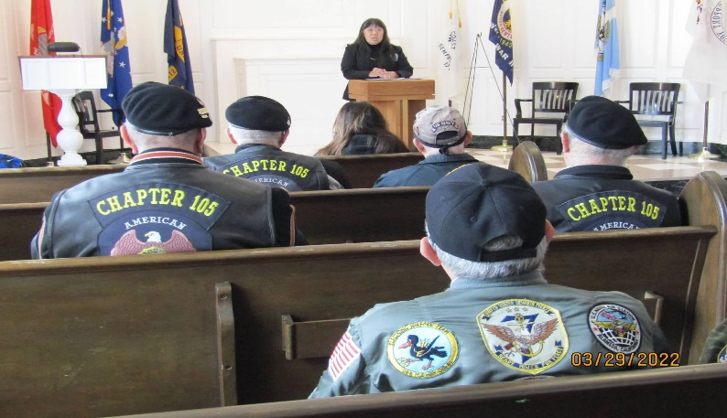
AL Post 105 Commander, George Smith with post family Cathay Post 384 Commander, Helen Wong is sharing with
unit members at GGNC on Vietnam Veterans Day 2022. participants at GGNC on Vietnam Veterans Day 2022.

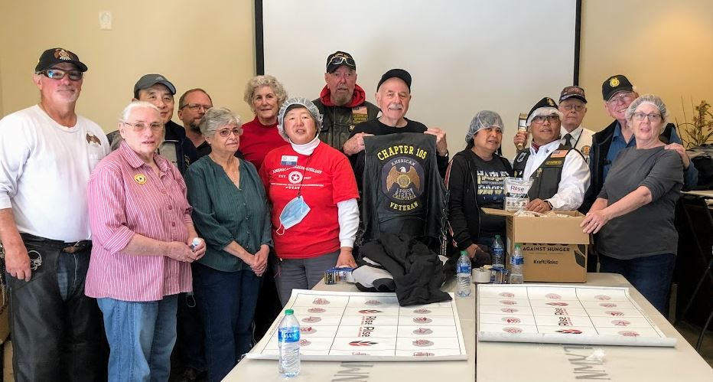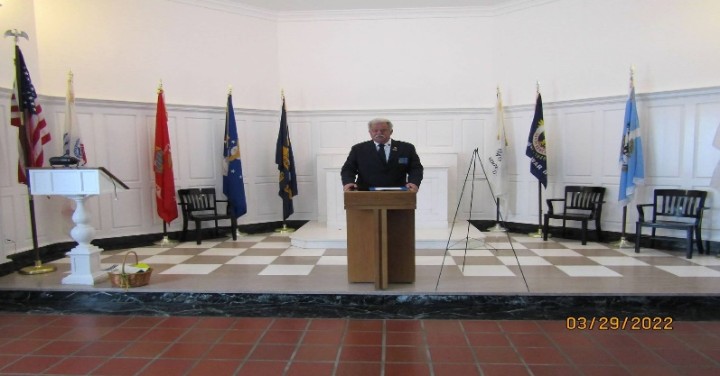
Auxiliary Unit 105 President, Carol Rael with Post 105 AL Post 105 Commander, George Smith is sharing with
family and friends at Skylawn Memorial Park for participants at GGNC on Vietnam Veterans Day 2022.
community services “Got Rice” project.

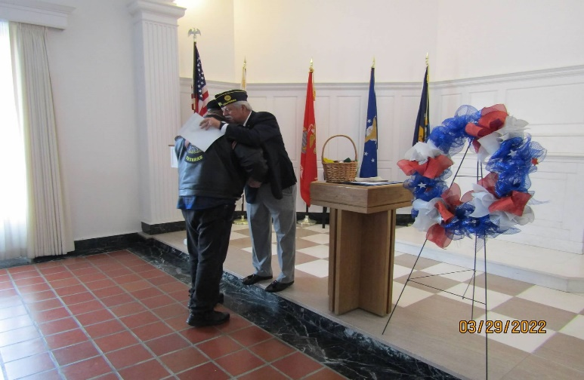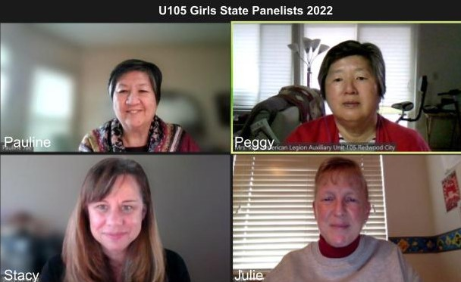
AL Post 105 Commander, George Smith is hugging Auxiliary Unit 105 California Girls State Panel members.
ALR105 family member Ken at therein GGNC event,
and thanking him for his service.
Page – 4
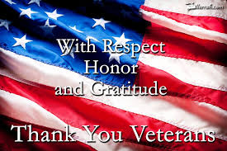

GIRLS STATE CITIZEN INITIATES THE VA COFFEE DRIVE

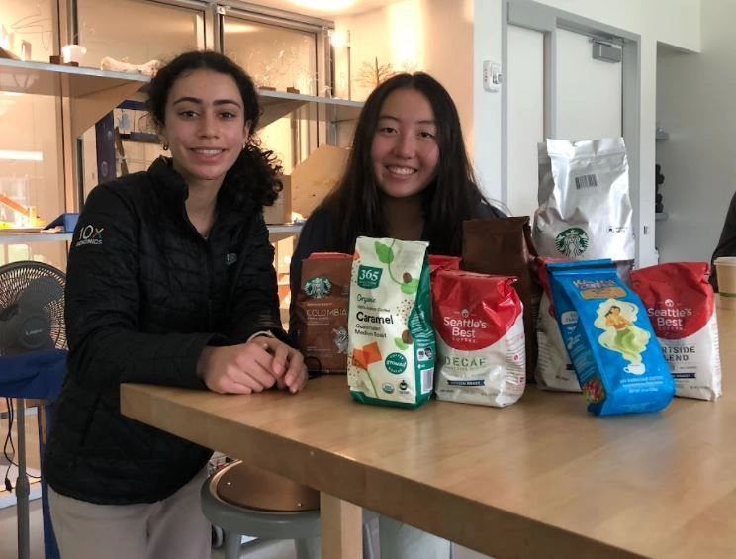

Nueva High's Community Service Club's Adrienne (right) organized coffee donations for VA-Menlo Park.
In September, Unit 105 heard about the experiences of their three 2021 California GIRLS STATE (CAGS) Citizens. Immediately following the brunch, Nueva High senior Adrienne approached CAGS Chairperson Peggy--wanting to contribute to the veterans community. Hence, Adrienne and Nueva's Community Service Club collected 15 bags (approx. 25 lbs.) for the VA-Menlo Park patients. Adrienne awaits word from two vendors before delivering the coffee to Unit 105 for delivery.

This is a wonderful example of continued engagement with our Girls State and Boys State citizens – great civic leadership program. Last year, Design Tech High's CAGS alternate contributed by reciting a portion of "In Flanders Field" poem for Post 105's Memorial Day video.

Page – 5
- From the desk of the Commander
The ides of April are upon us, will it come in like a lamb and go out like a lion, visa versa or will it be all lamb or all lion? I know what I’m hoping for, ALL LION, we need the rain!
It seems like COVID-19 is getting under control, thanks to everyone that was vaccinated and/or wore a mask. Hopefully, we’ll get back to some sort of normalcy.
If you happen to know anyone that can patch our plastered ceiling in the hall, please have them contact me, we need to get that fixed now that we’ve had the roof repaired.
Rentals are slowly but surely picking up and hopefully those pending will confirm.
I hope everyone is checking out our website, https://americanlegionpost105rwc.org/ a lot of good information with updates on everything that’s going on at the Post.
The last Wednesday of the month (every month, except December) is Commander’s Coffee from 9:00 AM to 12:00 noon. Come down and join us for coffee and pastries, post officers will be there to answer any questions you might have. So, please come down and be part of the festivities. If you have anything you’d like to see on the list of things to do for the Commanders coffee, please let me know, CommanderPost105@gmail.com
Until next month, be safe and ‘Thank You’ for supporting our Veterans, their Families and our Community!
George
Commander Post 105

- Our AL Post 105 Family welcomes our new Post Chaplain, Cobbey Sova and she has been a proactive member of our post with local missionary activities. Please contact our post if anyone is aware of our Post 105 membership regarding Everlasting Post members, and/or anyone in the hospital because of his/her sickness and/or specific type of illness – will keep them in our prayers for quick recovery! Please contact our post administrative office at 650-365-1337 for assistance when necessary regarding logistical matters, and/or visit our website at www.americanlegionpost105rwc.org for more information.

- All our AL Post 105 Family units continue to proactively participate with local activities to support veterans and their families during last month in March 2022. Including partnership activities with Blue Star Moms in our diversified communities to support veterans and their families. As well as youth leadership activities to help and support veterans in the future with their family needs when necessary. Including flag retirement ceremonies, rifle-firing detail events to honor our everlasting comrades, etc. Needless to say, our AL Post 105 Family units have completed a greater number of volunteer hours with community services to help our veterans and their families. Including previous escorting details for the AL National Commander and ALA Department President will visit our Post 105 during a luncheon event session on April 2, 2022. Our Post 105 Family ALR unit members will coordinate and schedule an escorting detail for thereby Department of California honorary official. The table to honor our MIA/POW veteran comrades is in place at our family post because they will never be forgotten – love you fellow brothers and sisters!

- Our AL Family Post 105 Commander, George Smith, handed out commemorative pins for Vietnam Veterans during therein Commanders Coffee event on Wednesday, March 30, 2022 to honor their services!

Page – 6
- Our membership is coming along well with early bird membership renewals and 1 member is eligible for 60 years membership, and 4 members are eligible for 50 years membership certificates. The First Vice Commander, Mr. Tom Day of our AL Post 105 Family, is recommending to have a special recognition event for therein 5 exceptional legionnaire members of our Post 105.

Department of California Reporting Data – 3/25/2022

Total Members | Membership  Goal | New  Members | Transfer  Members | PUFL Members | Paid To The Post | Current Percentage
183 | 233 | 7 | 4 | 45 | 127 | 79%

Many THANKS to renewal members and your membership dues that will go directly to help veterans and their families. Please visit our website www.americanlegionpost105rwc.org for more membership access and informational forms. You can also contact the First Vice Commander Mr. Tom Day by email at thomas.day505@gmail.com and THANK YOU for your support!

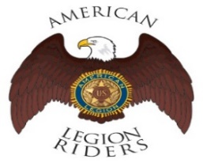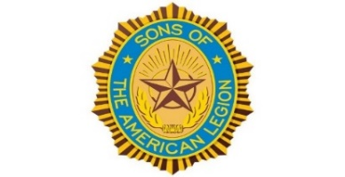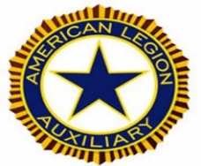

- The American Legion Riders Chapter 105 membership and colleagues shared herein following progressive activities. American Legion Riders Chapter 105 has participated in many missions supporting veterans and their families, and participated in more than 14 missions and rifle firing details during February 2022. The ALR105 rode more than 1826 DOC miles and donated more than 261 volunteer hours since last month. Including an escort ride scheduled for the National Commander in California on December 10 and 11. The new ALR105 President, Andrew Trapani is taking over his new position role with great leadership performance! The ALR105 chapter raised $3700 during therein Suicide Prevention ride with monetary contribution for the VA Palo Alto Hospital. Also, raised $410 and donated therein monetary contribution to Wreaths Across America. The Post 105 Riders participated in the Berkeley ½ marathon directing local traffic control. If you own a freeway legal motorcycle, are a member of the American Legion, American Legion Auxiliary or Sons of the American Legion and would like to join us, please email at ALRChapt105@gmail.com or call me at 650-349-7146.
- The SAL Unit 105 Commander, Andrew Trapani reported previously another new member joined and elevated their membership numbers to 17. The AL California Department identifies SAL Unit 105 with 80% membership retention versus their membership goal. The SAL Unit 105 participated in 7 Final Hours Detail missions during rifle-firing details to honor our veterans, and with 105 participants and more details are scheduled for April 2022. The SAL Unit 105 donated $100 for the Veterans Day Celebration and they contributed 46 hours of volunteering time with 650 miles. We are constantly looking for new qualified members, and veterans can also join the Sons of The American Legion. The following are eligibility qualifications for SAL Unit 105: A male descendants adopted sons, and stepsons of members of The American Legion, and such male descendants of veterans who died in service during the period of April 6, 1917. Through November 11, 1918, or any time from December 7, 1941, to date, who served honorably, as set forth in Article IV, Section 1, of the National Constitution of The American Legion, or who died subsequent to their honorable discharge from such service shall be eligible.

Page – 7
- The AL Auxiliary Unit 105 President, Carol Rael continues to meet with their unit in-person at Post-105 on the second Wednesday @ 6pm. Our month started with California Girls State (CAGS) panelists completing nine interviews for the four Delegates we’ll send to CAGS and six interviews for Unit 474 Coastside to send their one Delegate. Thanks go to panelists Stacy, Pauline J and Julie for their time and pensive questions. The Tonga Relief effort culminated with the Post Family meeting the Consul General. Pauline R, Peggy and Carol joined the Post Family in the “Rise Against Hunger” gig to package 15,000 bags of rice/soy. Rice was donated by the Bay Area Global Outreach Lions Club and Skylawn Memorial Park. The Lions kindly provided breakfast & lunch for volunteers.

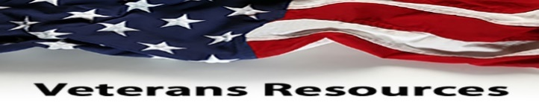

- The statewide Women Veterans Affairs is growing rapidly and advocating for effective services throughout California. The CalVet women organization is having online webinar sessions by clicking to the following link. https://www.calvet.ca.gov/WomenVets/Pages/Monthly-Statewide-Webinars.aspx

- The Nation’s Finest program helps provide services for veterans looking for transitional and/or permanent housing, mental health assistance, employment, etc. Their local office is located at therein VA Menlo Park, Building 334 (second floor), Phone Number 650-566-0240, website www.nationsfinest.org for more information and they have a computer lab center.

- We know how critically IMPORTANT to help our veteran comrades and families with many ongoing human service challenges in life. Because many veterans may not be able to find appropriate help for assistance with health, safety, suicide and human services including crisis matters. If a veteran is NOT sure where to start looking for help, please contact the Veterans Crisis Hotline at 1-800-273-8255. Copy and click online following linkage http://www.knowavet.org and/or text 838255 for more information.

- The Camp Southern Ground program provides summer camp activities for veterans children and/or community children for human development elements. The programmatic services for veterans are free including transitional assistance to civilian life and their motto is “Where Goodness Grows.” Their program website is www.campsouthernground.org and visit therein site for more information, and available services for veterans families and children.

NEWSLETTER EDITOR NOTICE

Our post newsletter is offering this opportunity to reach out and work closely with our membership legionnaires and all veterans! The post members can provide future newsletter articles and/or “appropriate” newsletter posting information, and posting information can be verbatim if necessary. Including stories and comments about post activities, veteran’s insight views and information sharing, pictures, etc. Please send information by email mfcpalesoo@gmail.com or phone call at 650-365-1337 for informational message.

American Historical Quote: “Let us never negotiate out of fear. But let us never fear to negotiate.”

President John F. Kennedy

Page – 8

