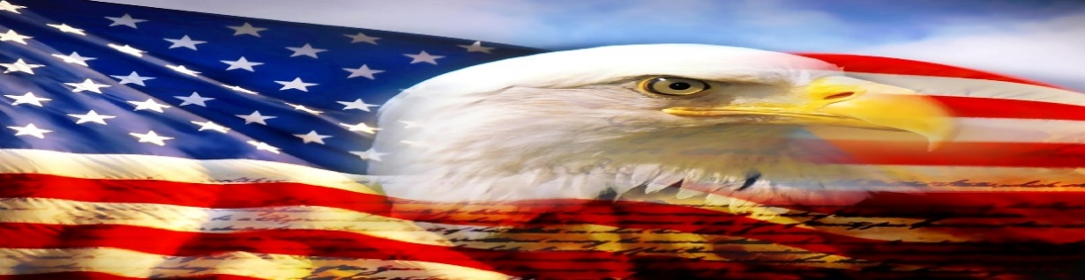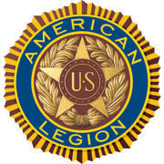

AMERICAN LEGION POST-105 SUNRISE NEWSLETTER
651 El Camino Real, Redwood City, CA 94063 www.americanlegionpost105rwc.org – Vol. 00043 May 2022

COMMANDER GREETINGS
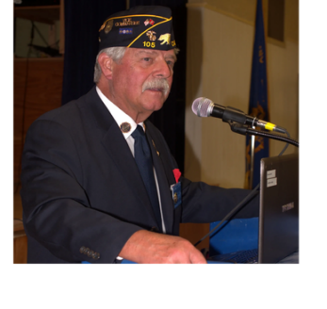

My great hopes all our AL Post 105 Family legionnaire members and their families are doing fine while things are reopening! Sharing my gratitude and appreciation to all Asian Pacific American veterans, as well as Jewish American veterans of our post for their honorary military services. Honoring Asian Pacific Islander American heritage month and Jewish American month of May 2022. Including ALL veterans for their honorary contribution to help our diversified communities. Our post family continues to help veterans and their families when necessary – please let us know quickly! Many THANKS to our proactive members and our American Legion
George Smith, Commander Post 105 Family for their ongoing support for God and Country empowering America!

Encouraging our Post 105 members to join our membership meetings on the second Wednesday of each month at 6 PM. The meeting veteran participants can enjoy a FREE dinner meal and possibly WIN a cash monetary prize! The winner MUST be present at therein general membership meetings requirement, to personally accept thereby cash monetary prize from the raffle tickets drawing.

Because our freedom in America is NOT free like it appears within our social environments, and many THANKS to our military veterans for their honorable services! It is our post legionnaire mission in life with 100+ years of patriotic services, and wishing Happy Mother’s Day to all veteran mothers of our AL Post 105 Family! Our post family is always WELCOMING new veteran legionnaires for our community mission!

Happy Mother’s Day, Happy Birthdays, Happy Anniversaries, etc. to ALL our post legionnaire members in May 2022 and many more! Enjoy and have fun at your celebrations – STAY SAFE & HEALTHY!
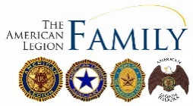

Page – 1
POST EVENTS & INFORMATION SHARING

Hiring Veterans  Kennedy Auto Body & Paint,  1026 El Camino Real, Redwood City, CA 94063  Phone Number: 650–365–1565  Website: www.kennedyautobody.com | Hiring Local Veterans  Roundtable Pizza,  1225 El Camino Real, Menlo Park, CA 94025  Phone Number: 650–321–6861  Website: www.roundtablepizza.com
City Skyline Challenge 2022  Thursday, May 5, 2022 @ 8 AM – 6 PM  OBCA (Skyline event at the Hilton Union Square Hotel)  1539 Pershing Drive, San Francisco, CA 94129  Phone Number: 415–933–6222  Website: www.outwardboundcalifornia.org | Veterans Virtual Antioch Job Fair  Monday, May 9, 2022 @ 11 AM – 2 PM  Hirex Local Job Fair – Antioch, California  670 South Green Valley Parkway, Henderson, NV 89052  Phone Number: 702-269-1414  Website: www.hirex.us
Post 105 General Meeting – NEED rsvp for dinner  Wednesday, May 11, 2022 @ 7 PM  American Legion Post 105,  651 El Camino Real, Redwood City, CA 94063  Phone Number: 650–365–1337 (FREE DINNER @ 6 PM)  Website: www.americanlegionpost105rwc.org | Marin Symphony – Spring POPS Concert  Saturday, May 14, 2022 @ 7 PM – 9 PM  Marin Veterans Memorial Auditorium  10 Avenue of the Flags, San Rafael, CA 94903  Phone Number: 415–479–8100  Website: www.marinsymphony.org
Veterans Piedmont Hoopster Tots – Ages 3 to 5  Tuesday, May 17, 2022 @ 1:15 PM – 2 PM  Piedmont Veterans Memorial Building,  401 Highland Avenue, Piedmont, CA 94611  Phone Number: 510-420-3081  Website: www.ci.piedmont.ca.us | VA Farmers Market  Wednesday, May 25, 2022 @ 10 AM – 2 PM  San Francisco VA Medical Center,  4150 Clement Street, San Francisco, CA 94121  Phone Number: 415–221–4810  Website: www.sanfrancisco.va.gov

IMPORTANT NOTICE: The veterans can contact American Legion Post 105 and/or American Legion District 26 with information below, for assistance with veteran’s resources regarding how to secure appropriate assistance when necessary. The American Legion Post-105 and/or District-26 will align veterans with available resources for supportive services.

American Legion Post 105  651 El Camino Real,  Redwood City, CA 94063  Contact Phone: 650-365-1337  Website: www.americanlegionpost105rwc.org | American Legion District 26  1159 Bush Street,  San Carlos, CA 94070  Contact Phone: 650-349-7146  Website: www.ALDistrict26.org

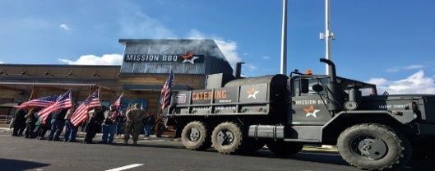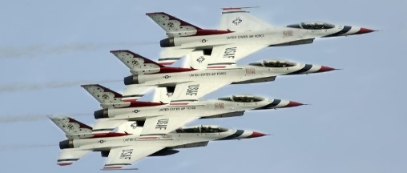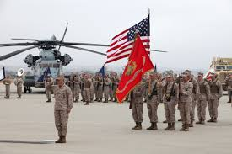

Page – 2
MEMBERSHIP VETERAN STORIES

Post membership and/or all military veterans can share stories about the war (all wartimes) during their veteran services, community services to help veteran families, etc. and many THANKS to veterans for sharing.

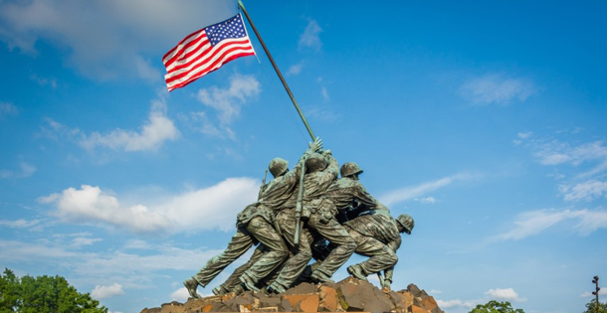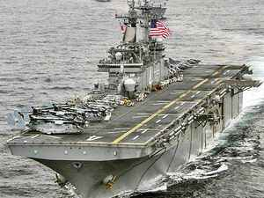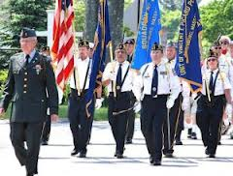

The newsletter veteran story this month is about our honorary military services veteran comrade Captain Robert Safreno who served in the U.S. Air Force. He was inspired by a helmet at his home and declared himself to become a pilot, and attended Air Force ROTC and earned his license in college. He served as a 2nd Lieutenant and graduated in his Air Force uniform, and didn’t have any problems adjusting to military life. He was in navigation training in Texas and became a B-52 bomber navigator. He worked closely with his comrades to control and launch missiles targeting enemies, and was deployed to Vietnam within a gunship in the AC119-G gunship mission. He spent 8 years in the National Guard and retired as a Captain, and his honorable military services didn’t affect him at all.

He is glad to serve in the military and learned many things about life, and advocates for troops to have a guidance friend for assistance. Because when soldiers make mistakes it jeopardizes your opportunity for promotions, and continues to help veterans and their families in local communities.

THANKS to Kalidev Choudhury for sharing the veterans lost stories on his website www.theloststories.org
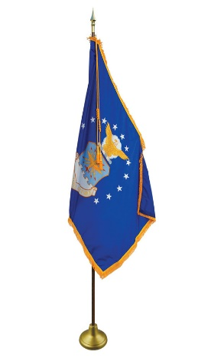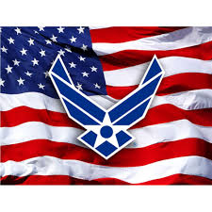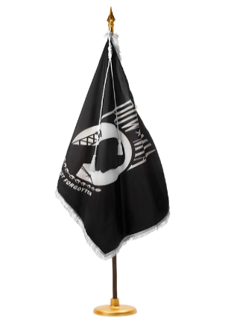
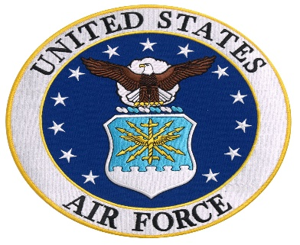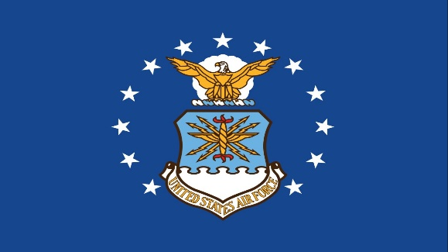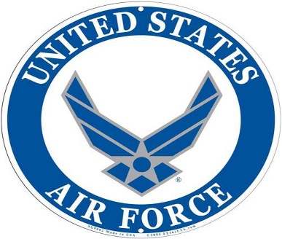

Page – 3
POST EVENTS PICTORIAL LAYOUT

The Post 105 participates in various local and state veteran events for supportive services for veterans and their families. The following pictures illustrating examples of Post 105 supportive services for veterans and their families during an event in local communities. It’s our post commitment for quality services supporting our veterans and their families – exemplifying by action throughout communities! (THANKS to all photographers for pics)

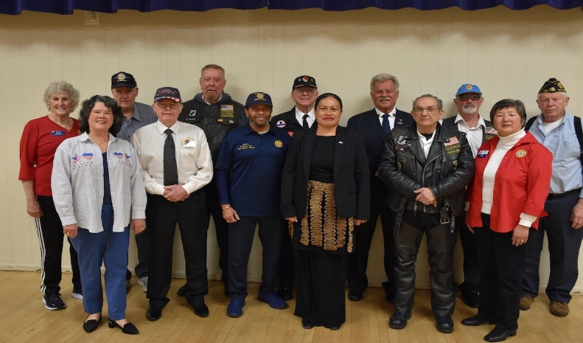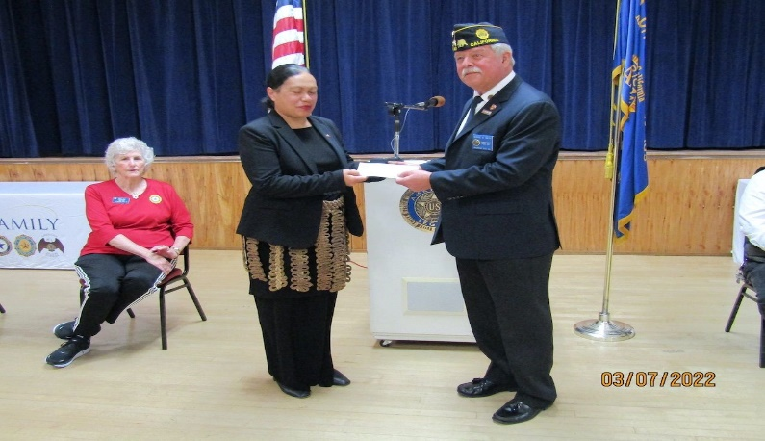
AL Post 105 Commander, George Smith with post family AL Post 105 Commander, George Smith presenting an $800
unit members and Tonga Consul General Sela Tukia. relief donation check to Tonga Consul General at the event.

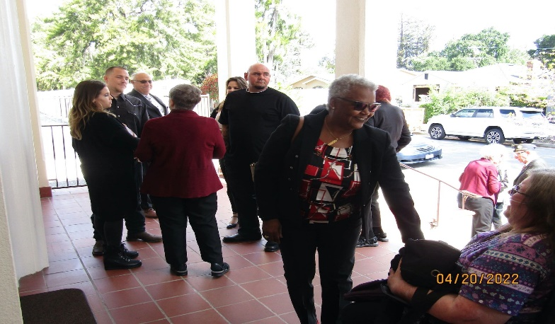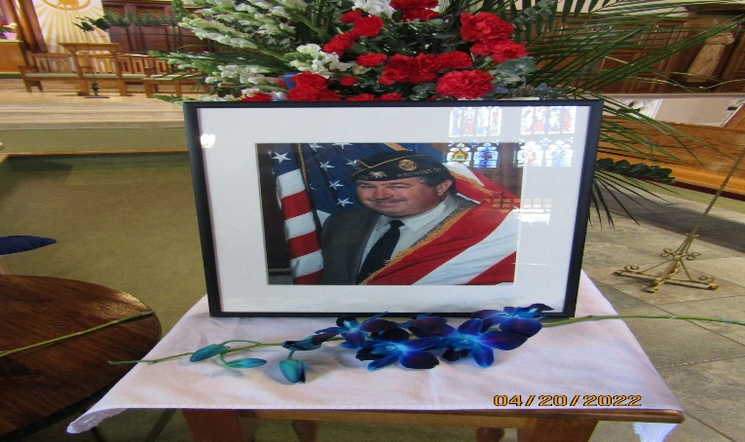
Family and friends of Romie Bassetto are arriving at the The picture of American Legion Post 105 Past
church for his funeral everlasting services, and celebration Commander, Romie Bassetto at therein church funeral
of his life at American Legion Post 105. everlasting event for his family and friends.

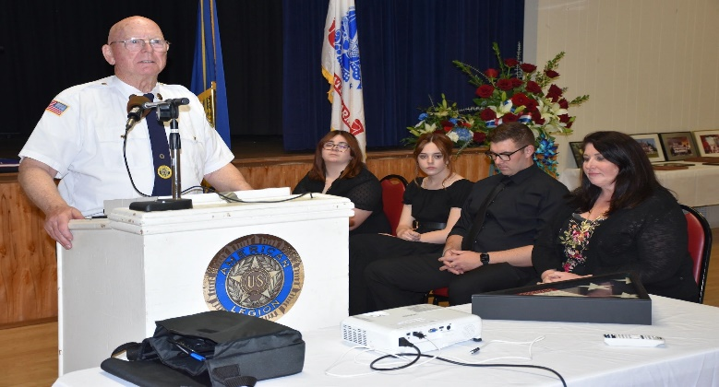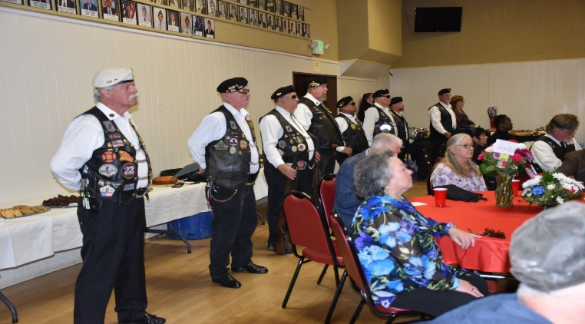
AL Post 105 2nd Vice Commander, Col. Leo McArdle AL Post 105 Riders presented military honorable rifle
sharing his remarks at the celebration of Romie Bassetto firing salute, and with the American flag presentation
during his lifetime. Romie’s daughter Shana and kids to honor Romie Bassetto and his military services.
are attentive with gratitude and appreciation!
Page – 4

American Legion Auxiliary Department President Visits Bay Area Districts

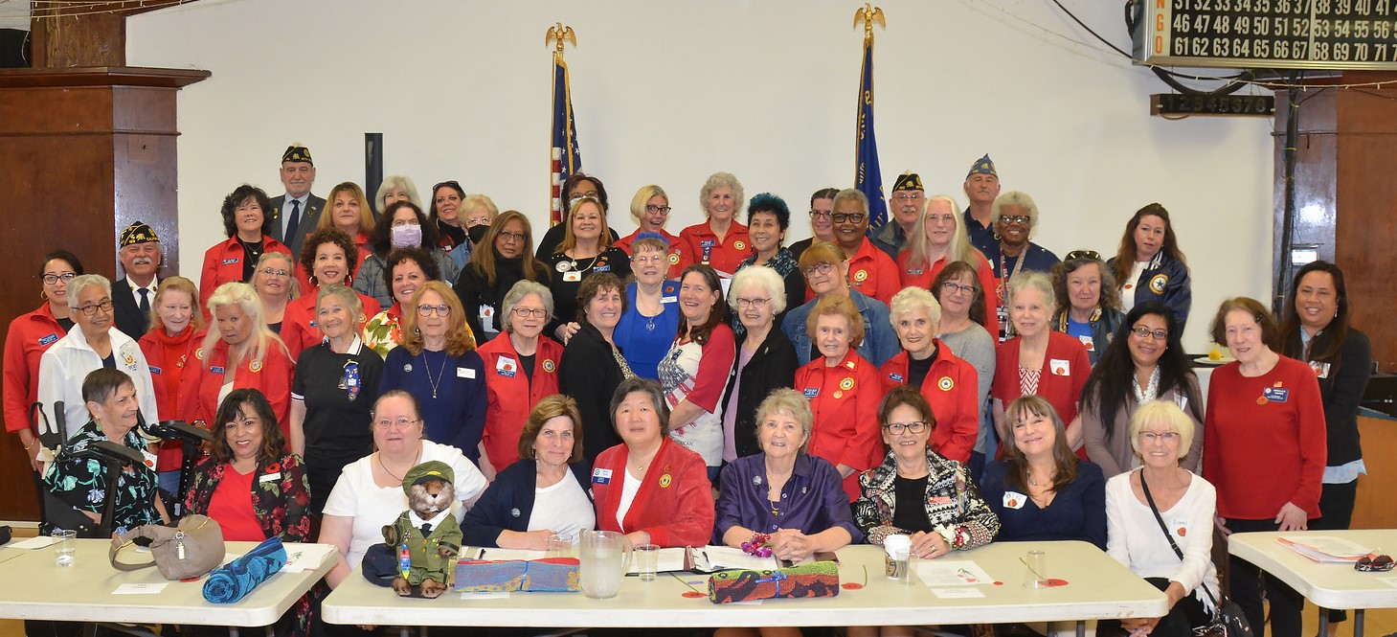

Bay Area Five-District Visitation by Department President Dee Ann Graham. Madam President Dee Ann Graham seated (4th from right) next to Visitation host District 26 President Peggy Toye (in red). Can you identify the eight Unit 105 members in the picture?

American Legion Post 105 Family – European Relief Fundraising

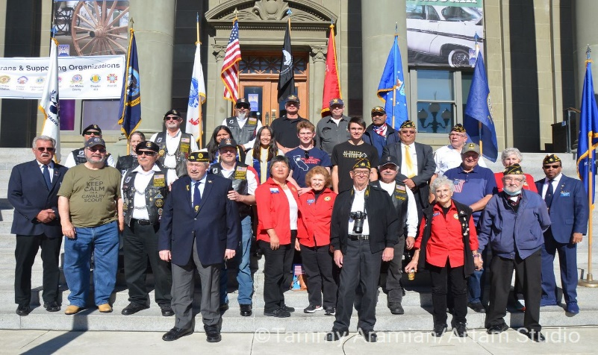

Our veterans community post is raising funds for humanitarian assistance in Eastern Europe, and helping families with children affected by therein wars currently happening and helping Ukrainian refugees. Please visit our website at www.americanlegionpost105rwc.org for more information.
Page – 5
- From the desk of the Commander
The ides of May are upon us, will it come in like a lamb and go out like a lion, visa versa or will it be all lamb or all lion? I know what I’m hoping for, ALL LION, we need the rain!
It seems like COVID-19 is getting under control, thanks to everyone that was vaccinated and/or wore a mask. Hopefully, we’ll get back to some sort of normalcy.
If you happen to know anyone that can patch our plastered ceiling in the hall, please have them contact me, we need to get that fixed now that we’ve had the roof repaired.
I hope everyone is checking out our website, https://americanlegionpost105rwc.org/ a lot of good information with updates on everything that’s going on at the Post.
The last Wednesday of the month (every month, except December) is Commander’s Coffee from 9:00 AM to 12:00 noon. Come down and join us for coffee and pastries, post officers will be there to answer any questions you might have. So, please come down and be part of the festivities. If you have anything you’d like to see on the list of things to do for the Commanders coffee, please let me know, CommanderPost105@gmail.com
Until next month, be safe and ‘Thank You’ for supporting our Veterans, their Families and our Community!
George
Commander Post 105

- Please contact our post if anyone is aware of our Post 105 membership regarding Everlasting post members, and/or anyone in the hospital because of his/her sickness or specific type of illness – will keep them in our prayers for quick recovery! Please contact our post administrative office at 650-365-1337 for assistance and/or our Post Chaplain, Cobbey Sova when necessary regarding logistical matters, You can visit our website at www.americanlegionpost105rwc.org for more information.

- All our AL Post 105 Family units continue to proactively participate with local activities to support veterans and their families during last month in April 2022. Including partnership activities with Blue Star Moms in our diversified communities to support veterans and their families. As well as youth leadership activities to help and support veterans in the future with their family needs when necessary. Our post family continues to increase more volunteer hours helping veterans and families. The table to honor our MIA/POW veteran comrades is in place at our family post because they will never be forgotten – love you comrades!

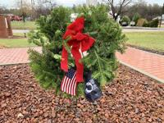 | American Legion Post 105 Family lost one of our effective and efficient leader in our veterans community – Romie Bassetto, Past Commander. His leadership effectiveness performance helps our post elevate to the optimal level, and with many community activities to support veterans and their families. His ethical leadership skills continue to move our community post forward with development. Our friendly comrade will be missed and will keep his family in our prayers. | 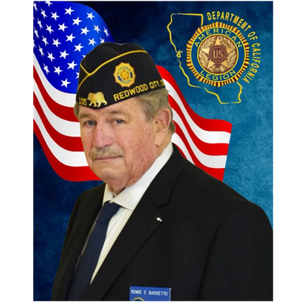

Page – 6
- Our membership is coming along well with early bird membership renewals and 1 member is eligible for 60 years membership, and 4 members are eligible for 50 years membership certificates. The First Vice Commander, Mr. Tom Day of our AL Post 105 Family, is recommending to have a special recognition event for therein 5 exceptional legionnaire members of our Post 105.

Department of California Reporting Data – 4/29/2022

Total Members | Membership  Goal | New  Members | Transfer  Members | PUFL Members | Paid To The Post | Current Percentage
192 | 233 | 9 | 5 | 45 | 133 | 82%

Many THANKS to renewal members and your membership dues that will go directly to help veterans and their families. Please visit our website www.americanlegionpost105rwc.org for more membership access and informational forms. You can also contact the First Vice Commander Mr. Tom Day by email at thomas.day505@gmail.com and THANK YOU for your support!

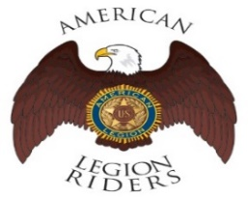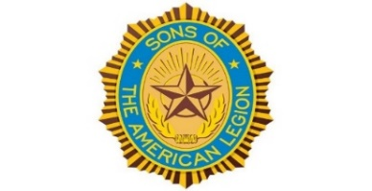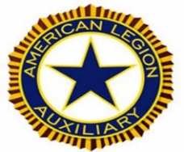

- The American Legion Riders Chapter 105 membership and colleagues shared herein following progressive activities. American Legion Riders Chapter 105 has participated in many missions supporting veterans and their families, and participated in more than 14 missions and rifle firing details during February 2022. The ALR105 rode more than 1826 DOC miles and donated more than 261 volunteer hours since last month. Including an escort ride scheduled for the National Commander in California on December 10 and 11. The new ALR105 President, Andrew Trapani is taking over his new position role with great leadership performance! The ALR105 chapter raised $3700 during therein Suicide Prevention ride with monetary contribution for the VA Palo Alto Hospital. Also, raised $410 and donated therein monetary contribution to Wreaths Across America. The Post 105 Riders participated in the Berkeley ½ marathon directing local traffic control. If you own a freeway legal motorcycle, are a member of the American Legion, American Legion Auxiliary or Sons of the American Legion and would like to join us, please email at ALRChapt105@gmail.com or call me at 650-349-7146.
- The SAL Unit 105 Commander, Andrew Trapani reported previously another new member joined and elevated their membership numbers to 17. The AL California Department identifies SAL Unit 105 with 80% membership retention versus their membership goal. The SAL Unit 105 participated in 7 Final Hours Detail missions during rifle-firing details to honor our veterans, and with 105 participants and more details are scheduled for May 2022. The SAL Unit 105 donated $100 for the Veterans Day Celebration and they contributed 46 hours of volunteering time with 650 miles. We are constantly looking for new qualified members, and veterans can also join the Sons of The American Legion. The following are eligibility qualifications for SAL Unit 105: A male descendants adopted sons, and stepsons of members of The American Legion, and such male descendants of veterans who died in service during the period of April 6, 1917. Through November 11, 1918, or any time from December 7, 1941, to date, who served honorably, as set forth in Article IV, Section 1, of the National Constitution of The American Legion, or who died subsequent to their honorable discharge from such service shall be eligible.

Page – 7
- The AL Auxiliary Unit 105 President, Carol Rael continues to meet with their unit in-person at Post-105 on the second Wednesday @ 6pm. Unit 105 continues as a team to fulfill the mission of the Auxiliary and thereby the Legion’s mission. In April, our Unit represented well at the Department’s Visitation which was hosted by District 26; Unit 105 officers hold dual roles as District 26 officers. Department President Dee Ann Graham was especially touched by Chapter 105 Riders escorting her to the all-Bay Area Districts Visitation meeting (representing San Francisco, Alameda, Contra Costa, Santa Clara and San Mateo Counties). More than 60 Legion family members attended the Visitation; the first since 2019 and COVID. Our Unit will assist San Mateo County Blue Star Moms with their Packing Day on May 14. The next day on May 15, our Unit will participate in the annual Girls State Tea to recognize the Delegates selected to represent their high schools at the June Girls State to be held at Sacramento State.
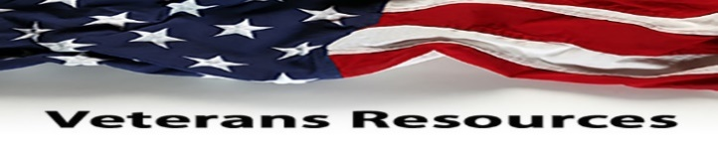

- The statewide Women Veterans Affairs is growing rapidly and advocating for effective services throughout California. The CalVet women organization is having online webinar sessions by clicking to the following link. https://www.calvet.ca.gov/WomenVets/Pages/Monthly-Statewide-Webinars.aspx

- We know how critically IMPORTANT to help our veteran comrades and families with many ongoing human service challenges in life. Because many veterans may not be able to find appropriate help for assistance with health, safety, suicide and human services including crisis matters. If a veteran is NOT sure where to start looking for help, please contact the Veterans Crisis Hotline at 1-800-273-8255. Copy and click online following linkage http://www.knowavet.org and/or text 838255 for more information.

- The U.S. Department of Veterans Affairs (VA) Administration is extending disability benefits available for veterans who served in Southwest Asia and Middle Eastern country wars. Because of the exposure of military soldiers to toxic substances and presumption to have been exposed to particulate matter. These exposures can lead into health and illness conditions affecting our veterans during and/or thereafter military services. Please visit herein linkage https://www.legion.org/veteranshealthcare/253707/new-presumptive-conditions-gulf-war-and-post-911-veterans-exposed for more information.

- The ALA Unit 105 National Poppy Day is on Friday, May 27, 2022 before Memorial Day, and honoring all military veterans who sacrificed their lives for our freedom in the United States of America. The ALA Unit 105 and local districts are having fundraising activities on therein National Poppy Day, and please visit their website at www.alaunit105rwc.com for more information.

NEWSLETTER EDITOR NOTICE

Our post newsletter is offering this opportunity to reach out and work closely with our membership legionnaires and all veterans! The post members can provide future newsletter articles and/or “appropriate” newsletter posting information, and posting information can be verbatim if necessary. Please send information by email mfcpalesoo@gmail.com or phone call at 650-365-1337 for informational message.

American Historical Quote: “Out of the mountain of despair is a stone of hope!”

Dr. Martin Luther King Jr., Civil Rights Activist
Page – 8

