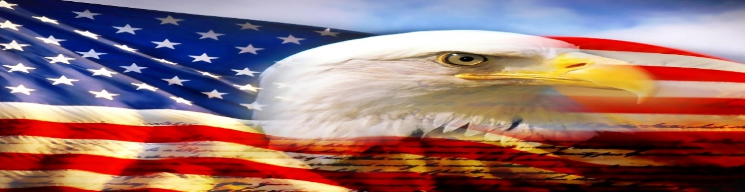 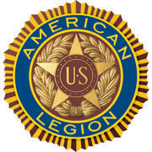

**AMERICAN LEGION POST-105 SUNRISE NEWSLETTER**

651 El Camino Real, Redwood City, CA 94063 [www.americanlegionpost105rwc.org](http://www.americanlegionpost105rwc.org) – Vol. 00044 June 2022

**COMMANDER GREETINGS**

|  |
| --- |
| https://img1.wsimg.com/isteam/ip/eb7373fb-b40d-4133-b880-404188854286/blob-0088.png/:/cr=t:11.29%25,l:0%25,w:100%25,h:71.8%25/rs=w:388,h:388,cg:true |

Hoping all our AL Post 105 Family **legionnaire members and their families** are doing fine! Sharing my gratitude and appreciation to our post veterans and all U.S. Military veterans, aligned with remembrance activities on **Memorial Day** last month. Honoring their sacrifice for our freedom and protection in The United States of America – **we don’t know them all, but we owe them all with respect!** Our post has been proactive with local community activities to honor our military heroes, and remembering our fallen comrades. Our post family continues to help veterans and

their families when necessary – please let us know immediately! Many THANKS to

***George Smith, Commander*** our **proactive members** and our American Legion Post 105 Family for their ongoing

support for God and Country encouraging America!

Encouraging our Post 105 members to join our membership meetings on the second Wednesday of each month at 6 PM. The meeting veteran participants can enjoy a FREE dinner meal and possibly WIN a cash monetary prize! The winner MUST be present at therein general membership meetings requirement, to personally accept thereby cash monetary prize from the raffle tickets drawing.

Because our freedom in America is NOT free like it appears within our social environments, and many THANKS to our military veterans for their honorable services! It is our post legionnaire mission in life with more than **100 years** of patriotic services, and wishing **Happy Father’s Day** to all veteran fathers of our AL Post 105 Family! Our post family is always WELCOMING new legionnaires for our community mission!

   

Happy Father’s Day, Happy Birthdays, Happy Anniversaries, etc. to ALL our post legionnaire members in **June 2022** and many more! Enjoy and have fun at your celebrations – STAY SAFE & HEALTHY!

 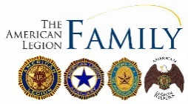 

Page – 1

**POST EVENTS & INFORMATION SHARING**



|  |  |
| --- | --- |
| **Hiring Local Veterans**  U.S. Postal Service Office,  3875 Bohannon Drive, Menlo Park, CA 94025  Phone Number: 800–275–8777  Website: [www.usps.com/careers](http://www.usps.com/careers) | **Hiring Local Veterans**  U.S. Postal Service Office,  2085 E. Bayshore Road, Palo Alto, CA 94303  Phone Number: 800–275–8777  Website: [www.usps.com/careers](http://www.usps.com/careers) |
| **2022 D-Day Defending the Bay Sail**  Sunday, June 5, 2022 @ 9:45 AM – 1 PM  Bay Model Visitors Center/US Army Corps of Engineers,  2100 Bridgeway, Sausalito, CA 94965  Phone Number: 415–289–3007  Website: [www.callofthesea.org](http://www.callofthesea.org) | **Post 105 General Meeting – NEED rsvp for dinner**  Wednesday, June 8, 2022 @ 7 PM  American Legion Post 105,  651 El Camino Real, Redwood City, CA 94063  Phone Number: 650–365–1337 (**FREE DINNER @ 6 PM**)  Website: [www.americanlegionpost105rwc.org](http://www.americanlegionpost105rwc.org) |
| **6th Annual Flag Retirement Ceremony**  Sunday, June 12, 2022 @ 11:30 AM  Cypress Lawn Memorial Park – Nobel Chapel,  1363 El Camino Real, Colma, CA 94014  Phone Number: 650–755–0580  Website: [www.cypresslawn.com](http://www.cypresslawn.com) | **VA Farmers Market**  Wednesday, June 15, 2022 @ 10 AM – 2 PM  San Francisco VA Medical Center,  4150 Clement Street, San Francisco, CA 94121  Phone Number: 415–221–4810  Website: [www.sanfrancisco.va.gov](http://www.sanfrancisco.va.gov) |
| **Bridge To Adults Ceremony**  Saturday, June 25, 2022 @ 2 PM – 3:30 PM  Girls Scouts of Northern California – Alameda Office,  1650 Harbor Bay Parkway #100, Alameda, CA 94502  Phone Number: 510-562–8470  Website: [www.gsnorcal.org](http://www.gsnorcal.org) | **San Francisco Veterans Virtual Job Fair**  Wednesday, June 29, 2022 @ 11 AM – 2 PM  Hirex Local Job Faire – San Francisco,  670 South Green Valley Parkway, Henderson, NV 89052  Phone Number: 702–269–1414  Website: [www.hirex.us](http://www.hirex.us) |

**IMPORTANT NOTICE:** The veterans can contact American Legion Post 105 and/or American Legion District 26 with information below, for assistance with veteran’s resources regarding how to secure appropriate assistance when necessary. The American Legion Post-105 and/or District-26 will align veterans with available resources for supportive services.

|  |  |
| --- | --- |
| **American Legion Post 105**  651 El Camino Real,  Redwood City, CA 94063  Contact Phone: 650-365-1337  Website: [www.americanlegionpost105rwc.org](http://www.americanlegionpost105rwc.org) | **American Legion District 26**  1159 Bush Street,  San Carlos, CA 94070  Contact Phone: 650-349-7146  Website: [www.ALDistrict26.org](http://www.ALDistrict26.org) |

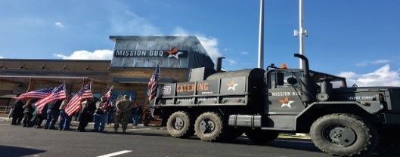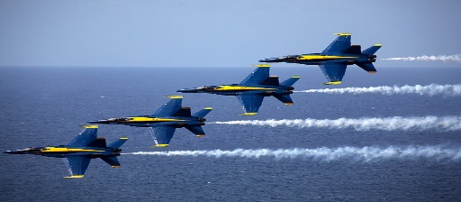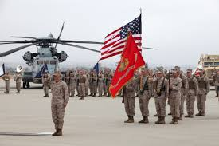

Page – 2

**MEMBERSHIP VETERAN STORIES**

Post membership and/or all military veterans can share stories about the war (***all wartimes***) during their veteran services, community services to help veteran families, etc. and many THANKS to veterans for sharing.

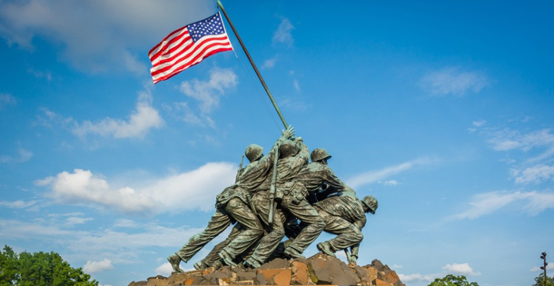 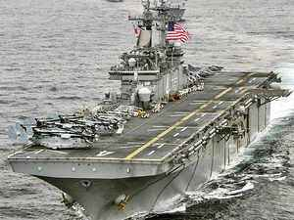 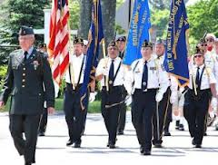

The newsletter veteran story this month is about our honorary military services veteran comrade Lieutenant Colonel Nathan Reiney who served in the U.S. Army. He joined the U.S. Army thereafter graduating from the military academy at West Point in New York. He enjoyed his military services for 21 years and served in Iraq with two tours of duty, and he was an Engineer Officer to make improvements to support combat operations. He was initially part of the Operation Iraqi Freedom and became a Senior Advisor to assist the Iraqi Security Forces in the region. He worked closely with his comrades team along with Iraqi forces and learning how to value leadership. He developed his leadership skills and learned how to develop an effective teamwork unit, and supporting combat troops on the battlefield.

He really appreciate the opportunity to serve his country and would do it again, and with his knowledgeable skills of team building. He enjoyed working with different people and helping each other for support on the battlefield. He is retired and gladly served in the military to enforce policy decisions to help our veterans in the frontline. He made a lot of military friends and will continue to help veterans and families in communities.

*THANKS to Kalidev Choudhury for sharing the veterans lost stories on his website* [*www.theloststories.org*](http://www.theloststories.org)

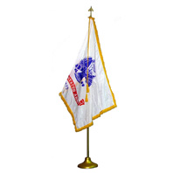 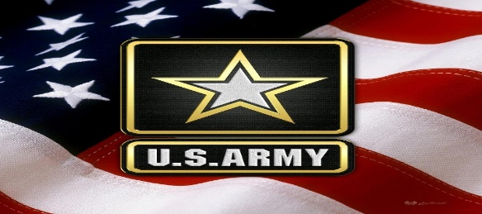 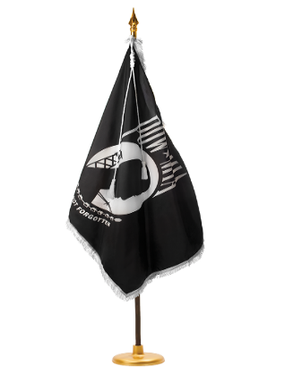

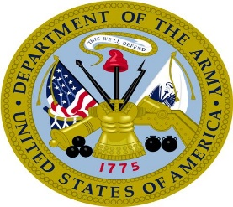 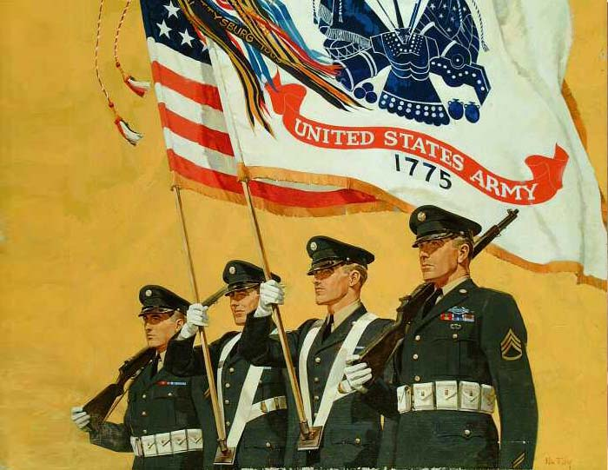 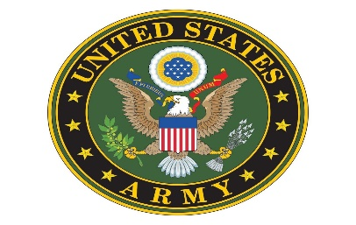

Page – 3

**POST EVENTS PICTORIAL LAYOUT**

The Post 105 participates in various local and state veteran events for supportive services for veterans and their families. The following pictures illustrating examples of Post 105 supportive services for veterans and their families during an event in local communities. It’s our post commitment for quality services supporting our veterans and their families – exemplifying by action throughout communities! (*THANKS to all photographers for pics)*

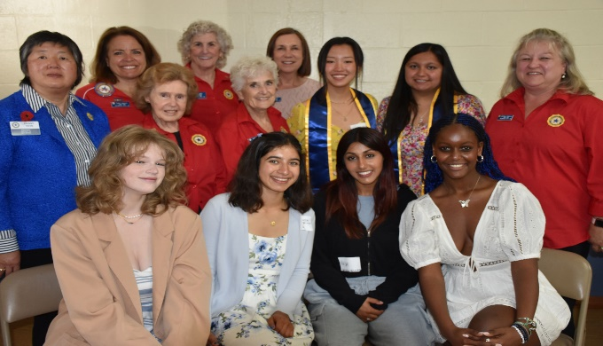 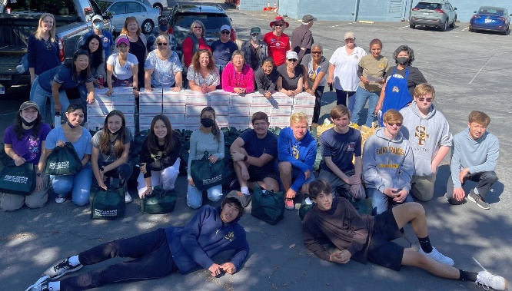

School Delegate Members of the Annual Girls State Tea ALA Unit 105 team and San Mateo County Blue Star

event with District 26 President Peggy Toye and ALA Unit Moms joined National Charity League, Young Mens

105 President Carol Rael with unit team members to host Service League, and Forrester Financial volunteers for

thereby annual event. therein Packing Day on May 14, 2022 at Post 105.

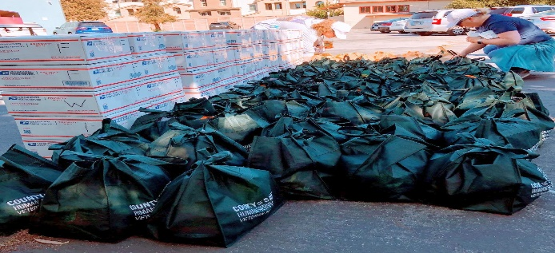 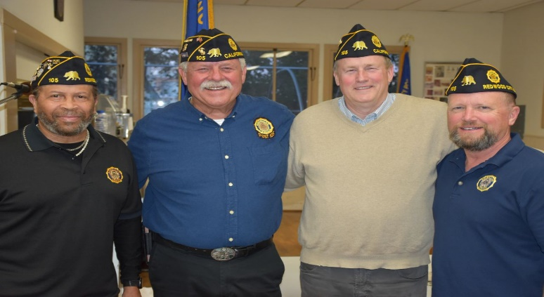

The San Mateo County Blue Star Moms Packing Day Department Fiscal Year 7/1/22 – 6/30/23 election

was successful with all herein boxes and care bags for winners for Post 105 is Commander, George Smith, 1st

veteran troops at Post 105. Vice Commander, Tom Day, and Members at Large

William Jackson Jr. and Stan Maupin for three year terms.

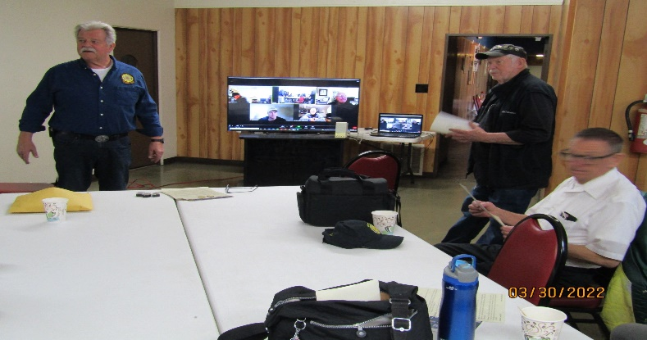 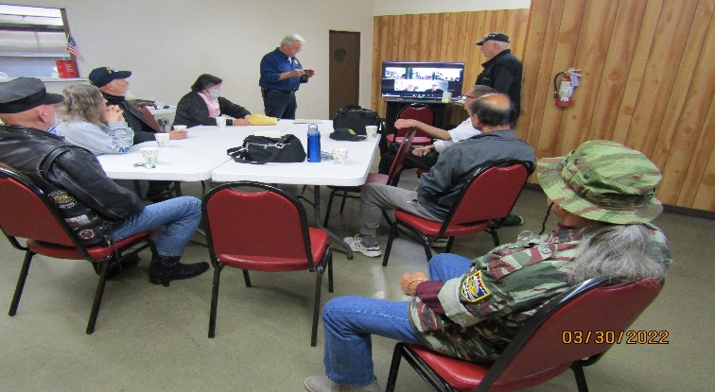

AL Post 105 Commander, George Smith shares his The commander is presenting Vietnam Veteran Lapel Pins

remarks with participants at therein Commanders Coffee to veterans who served in the Vietnam War.

event with John and Michael listening.

Page – 4

  

**American Legion Post 105 Family & San Mateo County Veterans Office Partnership**

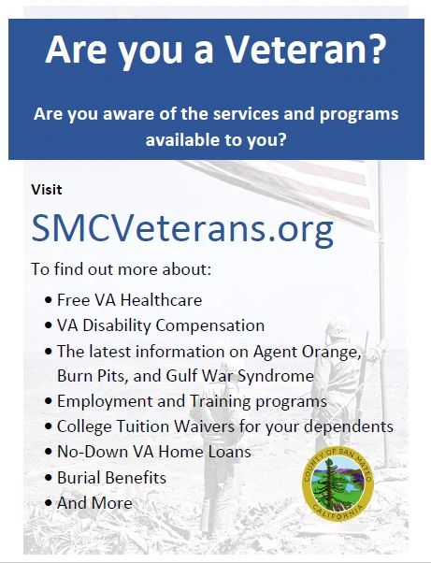

Our community AL Post 105 Family services agency continues to work closely with community agencies, and helping veterans and their families when necessary. Including partnership services with San Mateo County Veterans Office to support local veterans and their families. Please visit our website at [www.americanlegionpost105rwc.org](http://www.americanlegionpost105rwc.org) for more information and/or veterans partnership services.

Page – 5

**2022-2023**

**State of the American Legion Post 105**

American Legion Post 105 Family is growing with members becoming more involved across the Peninsula. Our family includes the Post, Auxiliary,

Riders and Blue Star Moms, all working together to assist our Redwood City Veterans and Community.

Membership led by our 1st Vice Commander Thomas Day is about the same

as last year, holding steady at around 200 members. We have added many

new members from the Gulf War and the War on Terror. We have also had a few members report to Post Everlasting, including past Commander Romie Bassetto. Commander Bassetto was a huge influence on Post 105 for several decades and his leadership will be missed.

Due to the pandemic, we are still dealing with slow hall rentals. For the past several years our Post rentals have been managed by Adjutant John Robinson. He’s been the glue that has kept the post up and running through this pandemic. On behalf of Officers and members of Post 105, ‘Thank You John’.

A Building Development Committee led by Past Commander Romie Bassetto and now led by Members at Large, Al Rosenmiller and Stan Maupin, they continue to make progress with our builder making sure nothing slows this project. The project involves a new structure, including a new Post, meeting rooms, kitchen, bar and 68 below market housing for veterans. Groundbreaking for this project should be some time in 2024.

We are very close to bringing Bingo back to the Post, Bingo should be back sometime in June or July of 2022. Vanguard will be running the Bingo and renting our facility on Tuesday and Thursday nights.

The American Legion Auxiliary led by Carol Rael continues to do great work supporting veterans at the Post and Peninsula, holding several fundraisers, supporting the Menlo Park VA Hospital, packing packages for deployed veterans and packages for at risk veterans. Besides supporting Veterans, the Auxiliary sponsored four girls to Girls State.

Chapter 105 Riders led by Andrew Trapani continues to do amazing work throughout the year. This last year the Riders provided Final Honors for veterans reporting to Post Everlasting, including TAPS and a Firing Detail. As of last count the Riders did 150 final honors.

Our American Legion Post 105 has had a website for several years [https://americanlegionpost105rwc.org](https://americanlegionpost105rwc.org/) and has kept the post up to date on the happenings of the Post, Family and other American Legion Posts by adding a BLOG to the site. As of now we have 50 subscribers to the BLOG. Thanks to Michael Toschak, our webmaster.

Information pertaining to what’s happening at the Post and connections to all the Family’s websites, Facebook Pages and contact information for all our Officers can be found on our website.

We’re looking forward to a very prosperous 2022-2023 annual year filled with many events supporting our Veterans and Community, come on down and be part of it, it’ll make you feel good and bring joy to others.

Page – 6

Hope to see you soon. Until then, be safe.

George W. Smith

Commander

American Legion

Post 105 Redwood City

|  |  |
| --- | --- |
| **POST 105 COLLABORATIVE TASK FORCE**  Legion Family logo Logo.png | |
| StickerTalk USA Flag Vinyl Sticker, 5 inches by 3 inches | Flag of the National League of POW/MIA Families |

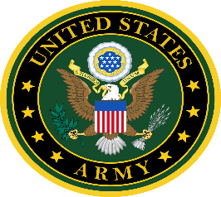 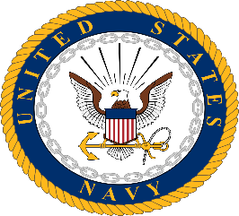 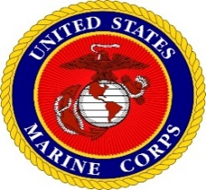 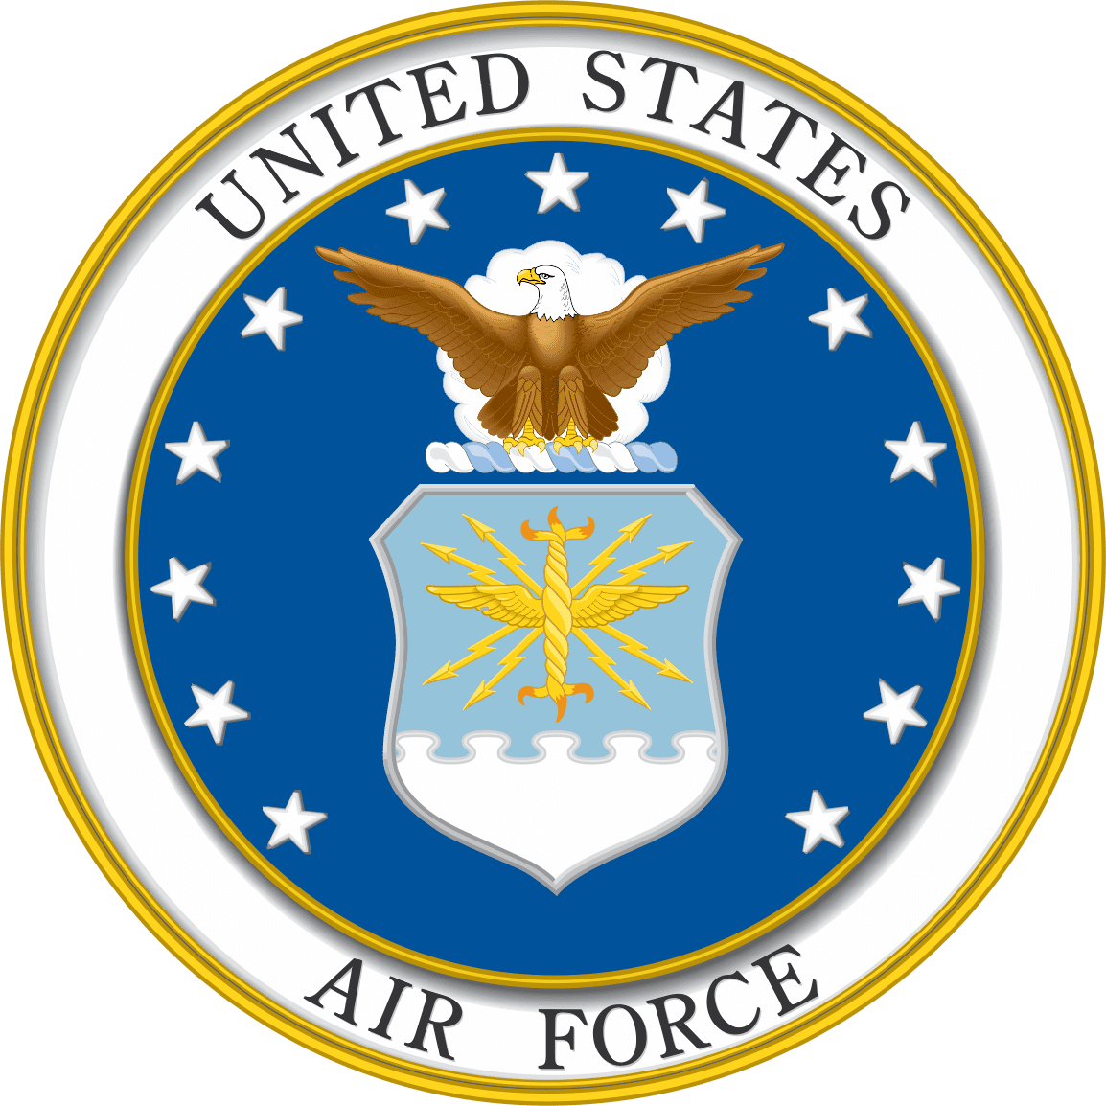 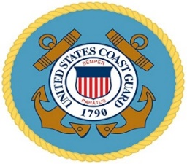 

Page – 7

* **From the desk of the Commander**

The last Wednesday of the month (every month, except December) is Commander’s Coffee from 9:00 AM to 12:00 noon. Come down and join us for coffee and pastries, post officers will be there to answer any questions you might have. If you have anything you’d like to see on the list of things to do for the Commanders coffee, please let me know, [CommanderPost105@gmail.com](mailto:CommanderPost105@gmail.com)

Until next month, be safe and ‘Thank You’ for supporting our Veterans, their Families and our Community!

George

**Commander Post 105**

* Please contact our post if anyone is aware of our Post 105 membership regarding Everlasting post members, and/or anyone in the hospital because of his/her sickness or specific type of illness – will keep them in our prayers for quick recovery! Please contact our post administrative office at 650-365-1337 for assistance and/or our Post Chaplain, Cobbey Sova when necessary regarding logistical matters, You can visit our website at [www.americanlegionpost105rwc.org](http://www.americanlegionpost105rwc.org) for more information.
* All our AL Post 105 Family units continue to proactively participate with local activities to support veterans and their families during last month in May 2022. Including partnership activities with Blue Star Moms in our diversified communities to support veterans and their families, and Memorial Day local activities in the Bay Area. In fact, our Post 105 Family received a Certificate of Appreciation from Avenue of Flags Committee. It’s for participating with local activities at Golden Gate National Cemetery to honor, and remember our veterans for their sacrifice. As well as youth leadership activities to help and support veterans in the future with their family needs, and continues to increase volunteer hours.
* Our Post 105 Family is having a Dinner & Dance Party on Saturday, June 11, 2022 at 6 PM to 10 PM with therein No Host Bar. Including a raffle drawing to win outstanding prizes and proceeds to support our local veterans and their families, as well as veteran troops overseas for their on-duty assignments. Please go online to herein linkage <https://americanlegionpost105rwc.org/post-news/f/dinner-dance-post-105-get-your-tickets> for more information and/or purchasing tickets for therein event. The Dinner & Dance Party will be at our post and get tickets at following linkage <http://www.dinnerdancejune11.eventbrite.com/> to attend thereby great eventful cause to help our veterans.
* Our membership is coming along well with early bird membership renewals, and the First Vice Commander, Mr. Tom Day of our AL Post 105 Family, is recommending to have a special recognition event for therein 5 exceptional legionnaire members of our post.

|  |  |  |  |  |  |  |
| --- | --- | --- | --- | --- | --- | --- |
| **Department of California Reporting Data – 5/20/2022** | | | | | | |
| Total Members | Membership  Goal | New  Members | Transfer  Members | PUFL Members | Paid To The Post | Current Percentage |
| 195 | 233 | 9 | 5 | 45 | 136 | 84% |

Many THANKS to renewal members and your membership dues that will go directly to help veterans and their families. Please visit our website [www.americanlegionpost105rwc.org](http://www.americanlegionpost105rwc.org) for more membership access and informational forms. You can also contact the First Vice Commander Mr. Tom Day by email at [thomas.day505@gmail.com](mailto:thomas.day505@gmail.com) and THANK YOU for your support!

Page – 8

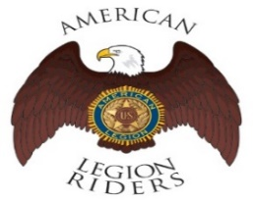 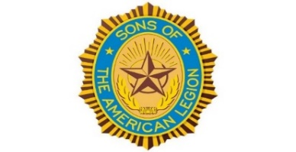 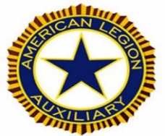

* The **American Legion Riders Chapter 105** membership and colleagues shared herein following progressive activities. American Legion Riders Chapter 105 has participated in many missions supporting veterans and their families, and participated in more than 117 missions and rifle firing details during May 2022. The ALR105 rode more than 34,753 miles and donated more than 2,482 volunteer hours since last month. Including escort rides for the National Commander in California on December 10 and 11, and many other escorts for state and/or national officials. The ALR105 chapter raised $3700 during therein Suicide Prevention ride with monetary contribution for the VA Palo Alto Hospital. Also, raised $410 and donated therein monetary contribution to Wreaths Across America. Including Tongan Relief Fund check presentation and Rise Against Hunger and Ukrainian Relief Fund. The Post 105 Riders participated in the Berkeley ½ marathon directing local traffic control. If you own a freeway legal motorcycle, are a member of the American Legion, American Legion Auxiliary or Sons of the American Legion and would like to join us, please email at [ALRChapt105@gmail.com](mailto:ALRChapt105@gmail.com) or call me at 650-349-7146.
* The **SAL Unit 105** Commander, Andrew Trapani reported previously another new member joined and elevated their membership numbers to 17. The AL California Department identifies SAL Unit 105 with 80% membership retention versus their membership goal. The SAL Unit 105 participated in **69** Final Hours Detail missions during rifle-firing details to honor our veterans, and with 105 participants and more details are scheduled for June 2022. The SAL Unit 105 donated $100 for the Veterans Day Celebration and they contributed 527 hours of volunteering time with 5975 miles. We are constantly looking for new qualified members, and veterans can also join the Sons of The American Legion. The following are eligibility qualifications for SAL Unit 105: A male descendants adopted sons, and stepsons of members of The American Legion, and such male descendants of veterans who died in service during the period of April 6, 1917. Through November 11, 1918, or any time from December 7, 1941, to date, who served honorably, as set forth in Article IV, Section 1, of the National Constitution of The American Legion, or who died subsequent to their honorable discharge from such service shall be eligible.
* The AL **Auxiliary Unit 105** President, Carol Rael continues to meet with their unit in-person at Post-105 on the second Wednesday @ 6pm. Unit 105 continues as a team to fulfill the mission of the Auxiliary and thereby the Legion’s mission. Elections were held in May: President Carol Rael, 1st Vice President Pauline Robinson, 2nd Vice President Peggy Toye, Secretary Diane Day, and Treasurer Brenda Ternullo. Blue Star Moms (BSM) Packing Day was a usual success; members Pauline, Pat, Carol, Diane, Brenda (BSM), Amy (BSM), and Peggy joined National Charity League, Young Mens Service League, and Forresters Financial. District 26 hosted the annual Girls State Tea with Unit 105 attending. Don’t forget to buy your tickets for the June Dinner/Dance using this link: [June 11 Dinner/Dance](http://tinyurl.com/endlesssummer2022)**.**
* Our AL Post 105 Family elections for next Fiscal Year 7/1/2022 – 6/30/2023 has been completed with the following winners during our general membership meeting in May 2022. The Post 105 Commander is George Smith, 1st Vice Commander is Tom Day, 2nd Vice Commander is Col. Leo McArdle, 3rd Vice Commander William Jackson Jr. and Stan Maupin won three years term, and Alan Rosenmiller was appointed with approval to continue thereby incomplete term for Romie Bassetto. Other members of therein post Executive Board will remain until their terms are up for election and/or re-election.

Page – 9

  

* The statewide **Women Veterans Affairs** is growing rapidly and advocating for effective services throughout California. The CalVet women organization is having online webinar sessions by clicking to the following link. [https://www.calvet.ca.gov/WomenVets/Pages/Monthly-Statewide-Webinars.aspx](http://r20.rs6.net/tn.jsp?f=0015STogUg_VIxOBYVssmtPypmC2GvcnD9ZgGhmrtottoNinTHGb5RUvwCXFQgU9szwmaTdBBfxw04XWYtXyp0R7nRfvI9BVGff0h5Barz4dgT-rmd80BwkwIiI1ouWLQoeMDxG0Qsna0Xxk0N4eUa8EGHFXYJq6uHCUFyF9Q4k4v1p64MFvoLqGkDPmShCjpyj0fveFv7oQ4cVAKjiNJKNvQ==&c=WT-cH0OnWIOLoTKqhacONB6VGdI75SwNSjVrcG9q2QYNAuPfRNJJ_g==&ch=KzA0Ptk4eQmVURV8W5NUxxCcQuQswDjMdsCySzTQWpW1oN7QuhPbKg==)
* We know how critically IMPORTANT to help our veteran comrades and families with many ongoing human service challenges in life. Because many veterans may not be able to find appropriate help for assistance with **health, safety, suicide and human services** including crisis matters. If a veteran is NOT sure where to start looking for help, please contact the Veterans Crisis Hotline at 1-800-273-8255. Copy and click online following linkage <http://www.knowavet.org> and/or text 838255 for more information.
* The U.S. Department of Veterans Affairs (VA) Administration is launching $20 million challenge to help minimize and/or eliminate veteran suicides nationwide. The VA effort is also inviting the public for assistance to help veterans reduce suicide rates, and provide innovative prevention programs to support veterans and their families. The Veterans Crisis Hotline answers 2,000 calls every day, and National Suicide Prevention Lifeline will get the three-digit code number 988 effective during July 2022. Please

go online to herein linkage <https://www.legion.org/veteranshealthcare/255864/va-launches-20m-challenge-help-reduce-veteran-suicides> for more information.

* The Sierra Club is having free training for veterans using three types of Pole training methods for walking, hiking, physical balancing, and maintaining body mobility with physical exercise using Poles. The free training for veterans and their families will be provided Poles for each training session, and/or people can bring their own Poles to use. The Pole training requires registration and please go online to herein linkage

<https://www.sierraclub.org/loma-prieta/military-outdoors> for more information and registration.

* The free veterans Pole training **may have many benefits** for your life and your family, and improving your power with confidence and control. Please go online to herein linkage below for more better information <https://adventurebuddiesblog.com/2010/12/save-your-knees-benefits-of-using-poles-for-hiking-and-walking/> and how Poles can make a positive change in your life. Including improvement with your posture and building core strength for your human system. As well as creating abilities for yourself to reduce the risk of falling, and/or potential injury and enjoying the outdoor life with fun activities.

**NEWSLETTER EDITOR NOTICE**

Our post newsletter is offering this opportunity to reach out and work closely with our membership legionnaires and all veterans! The post members can provide future newsletter articles and/or “appropriate” newsletter posting information, and posting information can be verbatim if necessary. Please send information by email [mfcpalesoo@gmail.com](mailto:mfcpalesoo@gmail.com) or phone call at 650-365-1337 for informational message.

**American Historical Quote: “***Every man’s happiness is his own responsibility!”*

***President Abraham Lincoln***

Page – 10