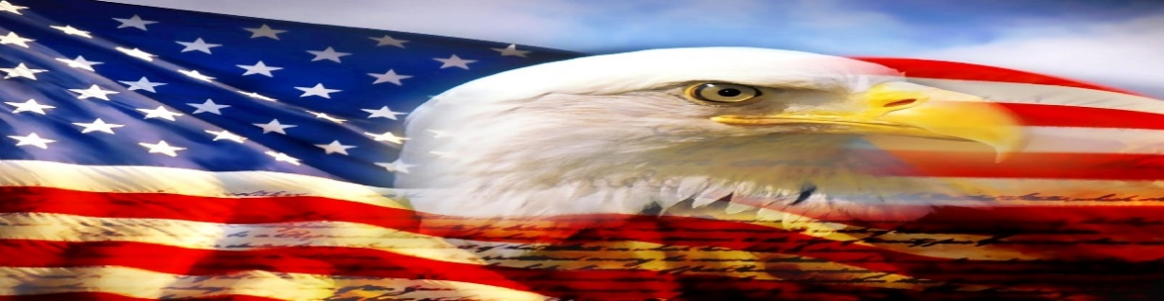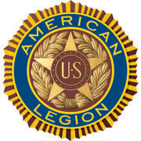

AMERICAN LEGION POST-105 SUNRISE NEWSLETTER
651 El Camino Real, Redwood City, CA 94063 www.americanlegionpost105rwc.org – Vol. 00046 August 2022

COMMANDER GREETINGS
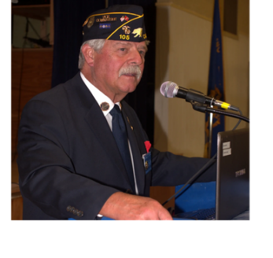

Greetings with hopeful feelings that all our AL Post 105 Family legionnaire members and their families are doing fine! Wishing Happy Purple Heart Day on Sunday, August 7, 2022 to all our post recipient legionnaires! CONGRATULATIONS and many thanks for your honorary military services. I would like to also share my gratitude and appreciation, to ALL our post veterans for their honorable military services and their sacrifice. Remembering our fallen comrades as well because they will never be forgotten! Our post family continues to help veterans and their families when necessary – please let us know immediately. We are approaching our new
George Smith, Commander fiscal year with accomplishments from last year, and carrying forward our post mission
to help veterans and their families. Many THANKS to our proactive members and our American Legion Post 105 Family, for their ongoing support for God and Country to enable America!

It’s an honor to recognize and acknowledge all our AL Post 105 Family Purple Heart recipients, for their courage and merit of services during their U.S. Military endeavor. Including all Purple Heart veteran recipients and their families! The Purple Heart commemorative medal is to honor our veterans for their heroic and honorary patriotic military services – THANKS for your service!

Because our freedom in America is NOT free like it appears within our social environments, and many THANKS to our military veterans for their honorable services! It is our post legionnaire mission in life with more than 100 years of patriotic services for veteran families and their children. Our post family is always WELCOMING new veteran legionnaires for our community mission!

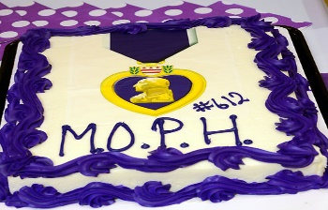

Happy Purple Heart Day, Happy Birthdays, Happy Anniversaries, etc. to ALL our post legionnaire members in August 2022 and many more! Enjoy and have fun at your celebrations – STAY SAFE & HEALTHY!
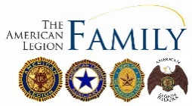

Page – 1
POST EVENTS & INFORMATION SHARING

Hiring Veteran Bus Drivers & Plus Hiring Bonus  SamTrans Bus Transportation,  1250 San Carlos Avenue, San Carlos, CA 94070  Phone Number: 650–508–6200  Website: www.samtrans.com | Hiring Veteran Bus Drivers & Plus Hiring Bonus  VTA Bus Transportation,  3331 N. First Street, San Jose, CA 95134  Phone Number: 408–321–5680  Website: www.vta.org
Veterans Pets Wellness Clinic  Wednesday, August 3, 2022 @ 8 AM – 4 PM  Tony LaRusa Animal Rescue Foundation,  2890 Mitchell Drive, Walnut Creek, CA 94598  Phone Number: 925–256–1273  Website: www.arflife.org | Mindful Eating Film and Food Festival  Sunday, August 7, 2022 10 AM – 8 PM  Marin Veterans Memorial Auditorium,  10 Avenue of the Flags, San Rafael, CA 94903  Phone Number: 415–473–6400  Website: www.marincounty.org
Oakland Veterans Job Fair  Monday, August 8, 2022 @ 11 AM – 2 PM  West Oakland Job Resource Center,  1801 Adeline Street, Second Floor, Oakland, CA 94607  Phone Number: 510–419–0509  Website: www.wojrc.org | Benicia Historical Museum & Military Presence  Saturday, August 13, 2022 @ 11:30 AM – 12:30 PM  Benicia Historical Museum at the Camel Barns  2060 Camel Road, Benicia, CA 94510  Phone Number: 707–745–5435  Website: www.beniciahistoricalmuseum.org
VA Farmers Market  Wednesday, August 24, 2022 @ 10 AM – 2 PM  San Francisco VA Medical Center,  4150 Clement Street, San Francisco, CA 94121  Phone Number: 415–221–4810  Website: www.sanfrancisco.va.gov | 6th Annual Fisher House Fundraiser  Saturday, August 27, 2022 @ 11 AM – 3:30 PM  Veterans Memorial Senior Center,  1455 Madison Avenue, Redwood City, CA 94061  Phone Number: 650–780–7306  Website: www.redwoodcity.org

IMPORTANT NOTICE: The veterans can contact American Legion Post 105 and/or American Legion District 26 with information below, for assistance with veteran’s resources regarding how to secure appropriate assistance when necessary. The American Legion Post-105 and/or District-26 will align veterans with available resources for supportive services.

American Legion Post 105  651 El Camino Real,  Redwood City, CA 94063  Contact Phone: 650-365-1337  Website: www.americanlegionpost105rwc.org | American Legion District 26  1159 Bush Street,  San Carlos, CA 94070  Contact Phone: 650-349-7146  Website: www.ALDistrict26.org

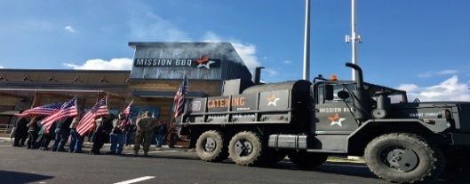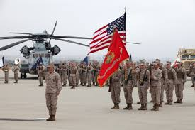

Page – 2
MEMBERSHIP VETERAN STORIES

Post membership and/or all military veterans can share stories about the war (all wartimes) during their veteran services, community services to help veteran families, etc. and many THANKS to veterans for sharing.

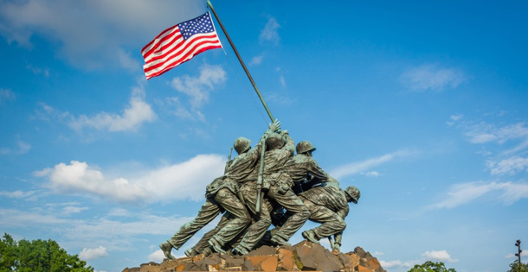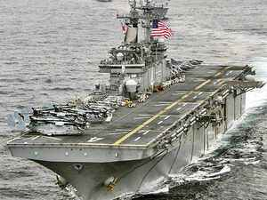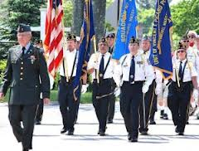

The newsletter veteran story this month is about our honorary military services veteran comrade Steve Lancer who served in the U.S. Marines. His father and brothers served in the U.S. Military as well, and just following their military careers. His military trainings and service as a Lance Corporal started at ROTC in school and decided to join the U.S. Marine Corps. He attended training at Camp Pendleton and stationed in Okinawa, and served as the Radio Operator. He worked closely with his friendship comrades for Marine Detachment on the ground unit. He worked along an advisory team and returned back onboard the USS Valley Forge, and Lance Corporal Steve Lancer was discharged with honors for his military services!

He continues to work with local veterans and their families for assistance, and likes outdoor environments as well as hunting. He is retired and feels good about serving his country, and believes every citizen should serve in the military to help protect our people. He has many military friends and will continue to stay in contact with them when necessary, and especially during the holiday season.

THANKS to Kalidev Choudhury for sharing the veterans lost stories on his website www.theloststories.org

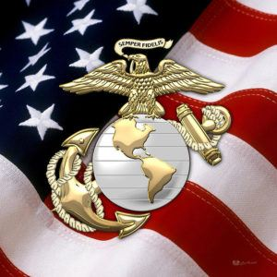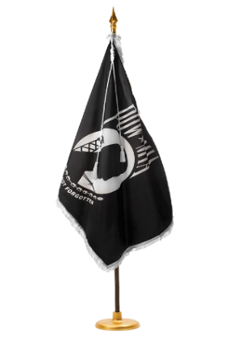

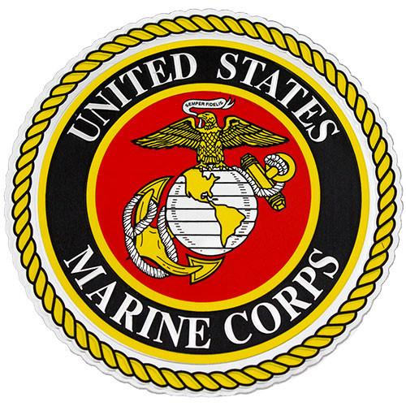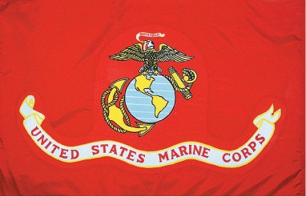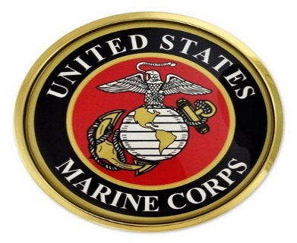

Page – 3
POST EVENTS PICTORIAL LAYOUT

The Post 105 participates in various local and state veteran events for supportive services for veterans and their families. The following pictures illustrating examples of Post 105 supportive services for veterans and their families during an event in local communities. It’s our post commitment for quality services supporting our veterans and their families – exemplifying by action throughout communities! (THANKS to all photographers for pics)

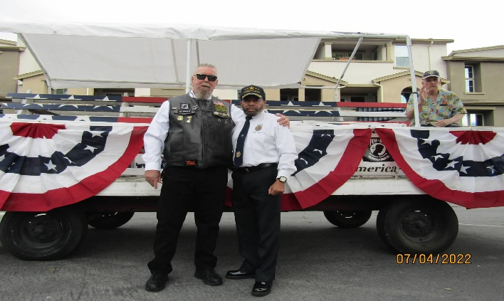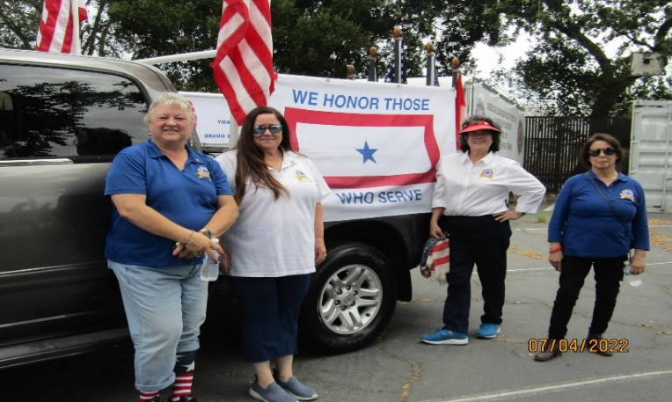
Ken and Bill with Gary sitting down on the float getting Blue Star Moms, President, Amy Walsh and Brenda
ready for the July 4th parade in Redwood City. with friends preparing for the July 4th parade.

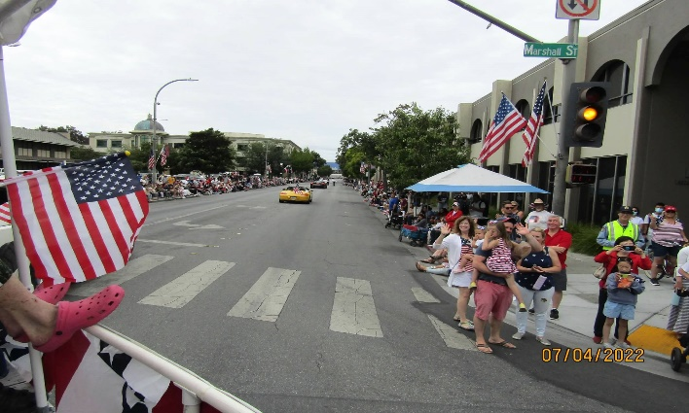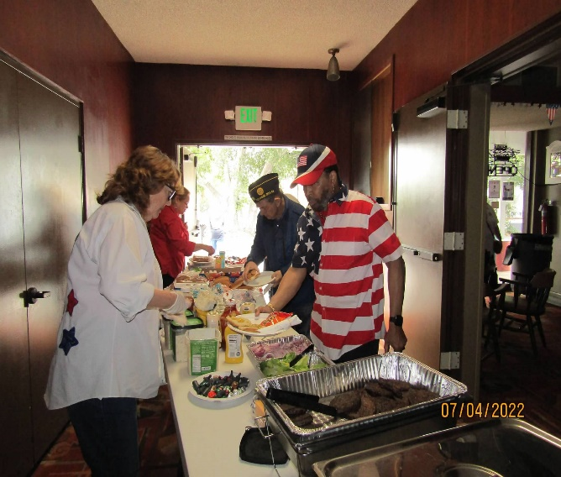
Post 105 float going down the parade street with people Wendy is serving food for participants, and Bill thereafter
watching at downtown Redwood City. the parade during a BBQ to celebrate at Post 105.

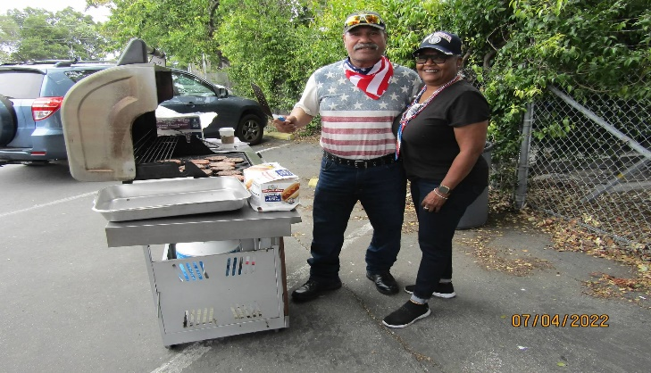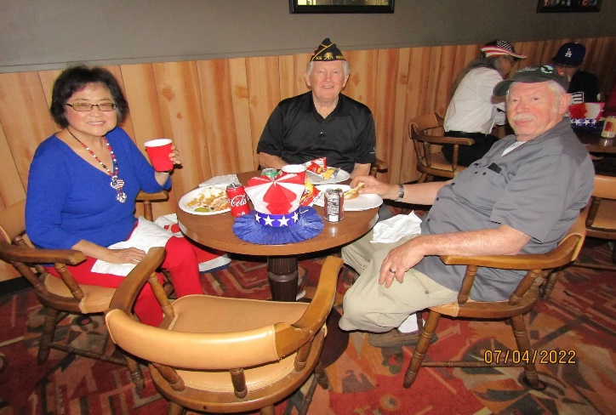
Pat is helping Chester during the BBQ celebration at Vern and his wife with John enjoying their BBQ meal
Post 105 thereafter the parade. at Post 105 during the July 4th celebration.

Page – 4

American Legion Post 105 Family & Blue Star Moms Partnership

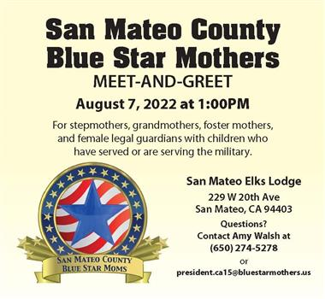

Our community AL Post 105 Family veterans service agency continues to support veterans and their families. The Blue Star Moms of San Mateo County has always been serving veterans, and their families countywide and beyond. The agency has always been a critical partner of our Post 105 Family to help veterans with different partnership activities. The Blue Star Moms MEET & GREET event is happening, to share with communities some of local and/or international activities they provide to help veterans and their families.

Page – 5
POST 105 COLLABORATIVE TASK FORCE
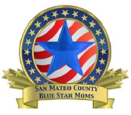

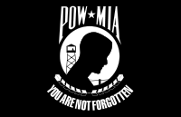

AL Post 105 Riders 2022 Annual Suicide Prevention Ride

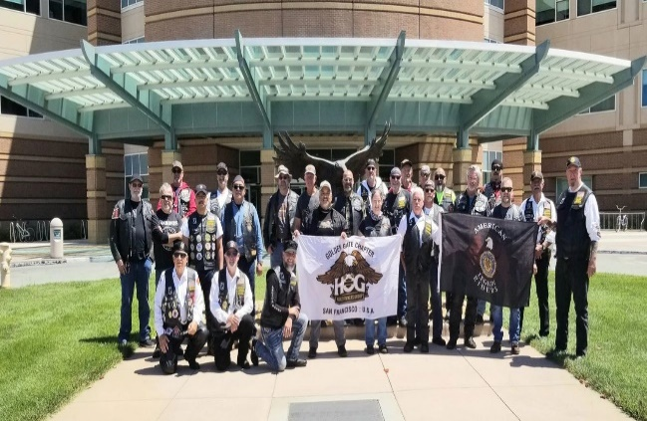

The AL Post 105 Riders were able to partner with HOG (Harley Owners Group) riding team members for thereby Annual Suicide Prevention Ride. The annual event is to raise funds to help veterans prevent suicide at therein Palo Alto VA Medical Center. It’s a 22 mile ride for a great healthy cause to help veterans and their families, and they raised $4,347 to assist veterans.
Page – 6
- From the desk of the Commander
The last Wednesday of the month (every month, except December) is Commander’s Coffee from 9:00 AM to 12:00 noon. Come down and join us for coffee and pastries, post officers will be there to answer any questions you might have. If you have anything you’d like to see on the list of things to do for the Commanders coffee, please let me know, CommanderPost105@gmail.com
Until next month, be safe and ‘Thank You’ for supporting our Veterans, their Families and our Community!
George
Commander Post 105

- Please contact our post if anyone is aware of our Post 105 membership regarding Everlasting post members, and/or anyone in the hospital because of his/her sickness or specific type of illness – will keep them in our prayers for quick recovery! Please contact our post administrative office at 650-365-1337 for assistance and/or our Post Chaplain, Cobbey Sova when necessary regarding logistical matters, You can visit our website at www.americanlegionpost105rwc.org for more information.

- All our AL Post 105 Family units continue to proactively participate with local activities to support veterans and their families during last month. Including partnership activities with Blue Star Moms in our diversified communities to support veterans and their families. Our post family continues to assist each unit when necessary with projects to help veterans. The Post 105 Riders Annual Suicide Prevention Ride was very successful, and raised $4,347 for Palo Alto VA Medical Center to help veterans. The ALA unit 105 team were always able to help with labor work aligned with local veteran projects. Including youth leadership activities to help and support veterans with their family needs, and continues to increase their volunteer hours. Our Post 105 Family participated in the local annual parade in Redwood City to celebrate July 4th Independence Day. Including a BBQ at the post thereafter, a successful parade event and many veterans with their families participated. Our Post 105 Family were able contribute supportive funds for the Tongan Relief Fund and Ukrainian Relief Fund. The Post 105 ALR and SAL teams continue to honor our fallen veteran comrades with rifle firing details every month. Including more honorary details during this month and keeping our veteran families in our prayers.

- Our membership is coming along well with early bird membership renewals, and the First Vice Commander, Mr. Tom Day of our AL Post 105 Family, is recommending to have a special recognition event for therein 5 exceptional legionnaire members of our post.

Department of California Reporting Data – 7/22/2022

Total Members | Membership  Goal | New  Members | Transfer  Members | PUFL Members | Paid To The Post | Current Percentage
197 | 233 | 9 | 5 | 44 | 139 | 85%

Many THANKS to renewal members and your membership dues that will go directly to help veterans and their families. Please visit our website www.americanlegionpost105rwc.org for more membership access and informational forms. You can also contact the First Vice Commander Mr. Tom Day by email at thomas.day505@gmail.com and THANK YOU for your support!

Page – 7
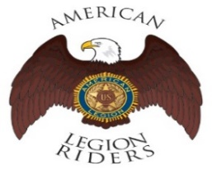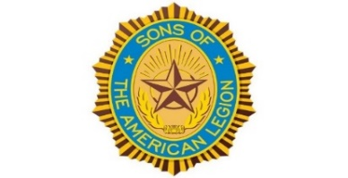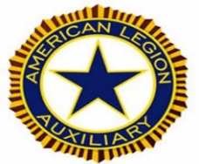

- The American Legion Riders Chapter 105 membership and colleagues shared herein following progressive activities. American Legion Riders Chapter 105 has participated in many missions supporting veterans and their families. Including more than 140 missions and rifle firing details during July with more scheduled this month in August 2022. The ALR105 rode more than 39,657 miles and donated more than 3,016 volunteer hours since last month. Including escort rides for the National Commander in California on December 10 and 11, and many other escorts for state and/or national officials. The ALR105 chapter raised $4347 during thereby annual Suicide Prevention Ride with monetary contribution for the VA Palo Alto Hospital. Also, raised $410 and donated therein monetary contribution to Wreaths Across America. Including $100 for Tongan Relief Fund, $720 for Berkeley Half Marathon, $1080 for Oakland Marathon, and $100 for Ukrainian Relief Fund. As well as community resources to support 2022 Seamans Memorial Cruise, and escorting services for ALA President and Operation Surf. The Post 105 Riders participated in the Berkeley ½ marathon directing local traffic control. If you own a freeway legal motorcycle, are a member of the American Legion, American Legion Auxiliary or Sons of the American Legion and would like to join us, please email at ALRChapt105@gmail.com or call me at 650-349-7146.
- The SAL Unit 105 Commander, Andrew Trapani reported previously another new member joined and elevated their membership numbers to 17. The AL California Department identifies SAL Unit 105 with 80% membership retention versus their membership goal. The SAL Unit 105 participated in 76 Final Hours Detail missions during rifle-firing details to honor our veterans, and with 105 participants and more details are scheduled for July 2022. The SAL Unit 105 donated $100 for the Veterans Day Celebration and they contributed 546 hours of volunteering time with 6099 miles. Including funding support for Tongan Relief Fund with $100 and Ukrainian Relief Fund with $100, and community supportive resources for Rise Against Hunger Lions Club. We are constantly looking for new qualified members, and veterans can also join the Sons of The American Legion. The following are eligibility qualifications for SAL Unit 105: A male descendants adopted sons, and stepsons of members of The American Legion, and such male descendants of veterans who died in service during the period of April 6, 1917. Through November 11, 1918, or any time from December 7, 1941, to date, who served honorably, as set forth in Article IV, Section 1, of the National Constitution of The American Legion, or who died subsequent to their honorable discharge from such service shall be eligible.

- The AL Auxiliary Unit 105 President, Carol Rael continues to meet with their unit in-person at Post-105 on the second Wednesday @ 6pm. Unit 105 continues as a team to fulfill the mission of the Auxiliary and thereby the Legion’s mission. Elections were held in May: President Carol Rael, 1st Vice President Pauline Robinson, 2nd Vice President Peggy Toye, Secretary Diane Day, and Treasurer Brenda Ternullo. Blue Star Moms (BSM) Packing Day was a usual success; members Pauline, Pat, Carol, Diane, Brenda (BSM), Amy (BSM), and Peggy joined National Charity League, Young Mens Service League, and Forresters Financial. District 26 hosted the annual Girls State Tea with Unit 105 attending.

- Our AL Post 105 Family Commander, George Smith and new administrative team is moving forward accordingly, and will work closely with the Executive Board to help veterans. The post Development Committee has been meeting regularly, and reports to thereby Executive Board regarding development matters procedurally in place.

Page – 8
U.S. MILITARY HISTORICAL CONFIRMATION

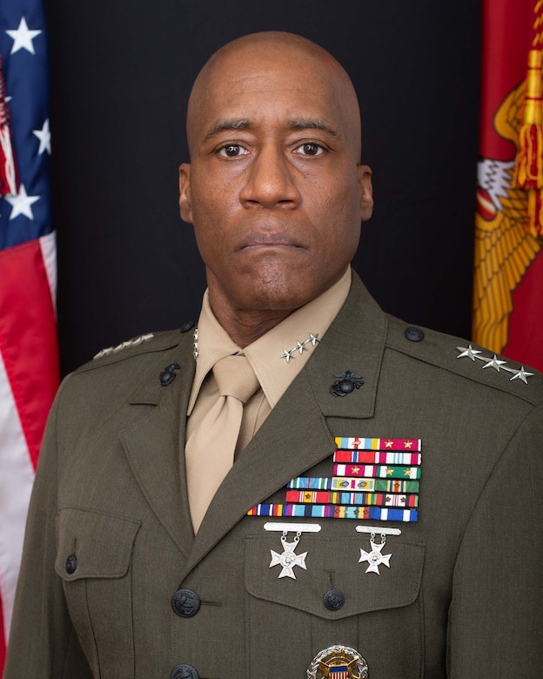

The U.S. Senate successfully confirms a first Black 4-Star General in U.S. Military history, within the U.S. Marine Corps since 246 years of operation. CONGRATS to General Michael Langley because he is the first Black veteran to attain therein rank in the U.S. Marine Corps.

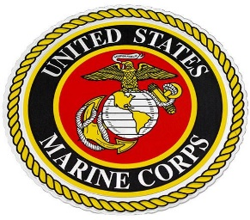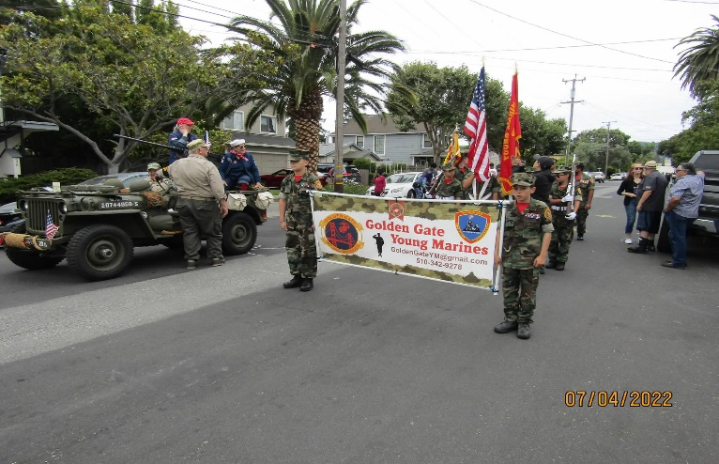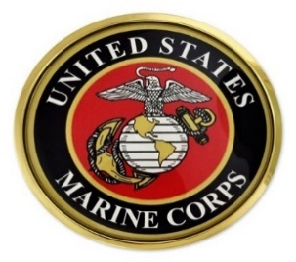

The Golden Gate Young Marines are preparing for the July 4th Independence Day parade in Redwood City. They have always been a critical part of our AL Post 105 Family, and participated in many partnership activities to help veterans.
Page – 9

- The U.S. Senate ratified therein PACT (Promise to Address Comprehensive Toxics) Act legislation to expand medical benefits for U.S. Military veterans exposed to toxic burning pits. The passage of thereby legislation will have expansion health care services for veterans along with disability benefits. Please visit online herein following linkage for more information https://www.nbcnews.com/politics/congress/senate-oks-enhanced-benefits-vets-exposed-burn-pits-rcna33961 and procedures.

- We know how critically IMPORTANT to help our veteran comrades and families with many ongoing human service challenges in life. Because many veterans may not be able to find appropriate help for assistance with health, safety, suicide and human services including crisis matters. If a veteran is NOT sure where to start looking for help, please contact the Veterans Crisis Hotline at 1-800-273-8255. Copy and click online following linkage http://www.knowavet.org and/or text 838255 for more information.

- The Veterans Crisis Hotline answers 2,000 calls every day, and National Suicide Prevention Lifeline will get the three-digit code number 988 is now operating. Please go online to herein linkage for more information https://www.legion.org/veteranshealthcare/255864/va-launches-20m-challenge-help-reduce-veteran-suicides and/or referrals.

- The San Mateo County Health Department is offering Spirituality Initiative monthly meetings through Behavioral Health and Recovery Services. The program monthly meetings is on the second Tuesday of each month, and therein meetings can provide resources veterans. It can help explore your awareness and relationship aligned with the human health, and increasing well-being. Please go online on website at www.smchealth.org/spirituality for more information. It may provide veterans with ways and means of preventing suicidal thoughts and behavioral mindset.

- The Menlo Park Community Shuttles offers free transportation for veterans and their families, and opens to everyone with wheelchairs and bicycles. The shuttle services can help veterans with local hospital appointments, shopping, etc. Please visit website www.menlopark.org/shuttles for more information.

NEWSLETTER EDITOR NOTICE

Our post newsletter is offering this opportunity to reach out and work closely with our membership legionnaires and all veterans! The post members can provide future newsletter articles and/or “appropriate” newsletter posting information, and posting information can be verbatim if necessary. Please send information by email mfcpalesoo@gmail.com or phone call at 650-365-1337 for informational message.

American Historical Quote: “The true measure of a man is not where he stands in times of comfort, but where he stands in times of challenge and controversy.”

Dr. Martin Luther King Jr.
Civil Rights Leader & Activist
Page – 10

