 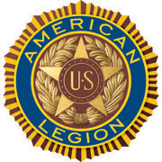

**AMERICAN LEGION POST-105 SUNRISE NEWSLETTER**

651 El Camino Real, Redwood City, CA 94063 [www.americanlegionpost105rwc.org](http://www.americanlegionpost105rwc.org) – Vol. 00056 June 2023

**COMMANDER GREETINGS**

|  |
| --- |
| https://img1.wsimg.com/isteam/ip/eb7373fb-b40d-4133-b880-404188854286/blob-0088.png/:/cr=t:11.29%25,l:0%25,w:100%25,h:71.8%25/rs=w:388,h:388,cg:true |

Greetings! Hoping all our AL Post 105 Family **legionnaire members and their families** are doing fine! Sharing my gratitude and appreciation to ALL our post veterans, and Caribbean American veterans for their U.S. Military services. Honoring the Caribbean American month of **June 2023** for their heritage and military services. It was an honor to remember all our veterans on **Memorial Day** last month, and for their sacrifice for our freedom in The United States of America – **we don’t know them all, but we owe them ALL with respect!** Our family continues to help veterans and their families when necessary – please let us know immediately! Many THANKS

***George Smith, Commander*** to our **proactive members** and our American Legion Post 105 Family, for their

ongoing support for God and Country to strongly empower America!

Encouraging our Post 105 members to join our membership meetings on the second Wednesday of each month at 6 PM. The meeting veteran participants can enjoy a FREE dinner meal and possibly WIN a cash monetary prize! The winner MUST be present at therein general membership meetings requirement, to personally accept thereby cash monetary prize from the raffle tickets drawing.

Because our freedom in America is NOT free like it appears within our social environments, and many THANKS to our military veterans for their honorable services! It is our post legionnaire mission in life with more than **100 years** of patriotic services, and wishing **Happy Father’s Day** to all veteran fathers of our AL Post 105 Family! Our post family is always WELCOMING new legionnaires for our community mission!

   

Happy Father’s Day, Happy Birthdays, Happy Anniversaries, etc. to ALL our post legionnaire members in **June 2023** and many more! Enjoy and have fun at your celebrations – STAY SAFE & HEALTHY!

  

Page – 1

AL Post 105 Family partnership with presenters

Retired Marine Corps Sergeant Major

Michael Childs and Casey Gracey!



Page – 2

**POST EVENTS & INFORMATION SHARING**



|  |  |
| --- | --- |
| **Hiring Local Veterans – $4,000 Hiring Bonus**  Bus Driver/Operator  1250 San Carlos Avenue, San Carlos, CA 94070  Phone Number: 650–508–6200  Website: [www.samtrans.com](http://www.samtrans.com) | **Hiring Local Veterans – $2,000 Hiring Bonus**  Bus Driver/Operator  1600 Franklin Street, Oakland, CA 94612  Phone Number: 510–891–4777  Website: [www.actransit.org](http://www.actransit.org) |
| **23rd Regiment Marine Corps Car Wash**  Saturday, June 3, 2023 @ 9 AM – 2 PM (Bring Your Car)  American Legion Post 105,  651 El Camino Real, Redwood City, CA 94063  Phone Number: 650–365–1337  Website: [www.americanlegionpost105rwc.org](http://www.americanlegionpost105rwc.org) | **Veterans Lindamar Rocks Surf**  Tuesday, June 6, 2023 @ 7 AM  Veteran Surf Alliance/Pacific State Beach,  5000 California Highway 1, Pacifica, CA 94044  Contact Email: [veteransurfalliance@gmail.com](mailto:veteransurfalliance@gmail.com)  Website: [www.veteransurfalliance.com](http://www.veteransurfalliance.com) |
| **2023 Bay Area Military Classic**  Monday, June 12, 2023 @ 10 AM  The Course at Wente Vineyards,  5040 Arroyo Road, Livermore, CA 94550  Phone Number: 925–456–2475  Website: [www.bayareamilitaryclassic.com](http://www.bayareamilitaryclassic.com) | **Post 105 General Meeting – NEED rsvp for dinner**  Wednesday, June 14, 2023 @ 7 PM (Officers Installation)  American Legion Post 105,  651 El Camino Real, Redwood City, CA 94063  Phone Number: 650–365–1337 (**FREE DINNER @ 6 PM**)  Website: [www.americanlegionpost105rwc.org](http://www.americanlegionpost105rwc.org) |
| **Veterans Tribute To The Buffalo Soldiers**  Saturday, June 17, 2023 @ 2 PM – 3 PM  Brava Theater Center,  2781 24th Street, San Francisco, CA 94110  Phone Number: 415–641–7657  Website: [www.brava.org](http://www.brava.org) | **Travis AFB Hiring Job Fair Event**  Thursday, June 22, 2023 @ 1 PM – 3 PM  Delta Breeze Club,  400 Scott Street, Travis, CA 94535  Phone Number: 855–383–3332  Website: [www.travisfss.com](http://www.travisfss.com) |

**IMPORTANT NOTICE:** The veterans can contact American Legion Post 105 and/or American Legion District 26 with information below, for assistance with veteran’s resources regarding how to secure appropriate assistance when necessary. The American Legion Post-105 and/or District-26 will align veterans with available resources for supportive services.

|  |  |
| --- | --- |
| **American Legion Post 105**  651 El Camino Real,  Redwood City, CA 94063  Contact Phone: 650-365-1337  Website: [www.americanlegionpost105rwc.org](http://www.americanlegionpost105rwc.org) | **American Legion District 26**  1159 Bush Street,  San Carlos, CA 94070  Contact Phone: 650-349-7146  Website: [www.ALDistrict26.org](http://www.ALDistrict26.org) |

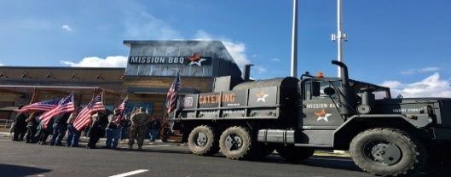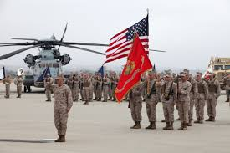

Page – 3

**MEMBERSHIP VETERAN STORIES**

Post membership and/or all military veterans can share stories about the war (***all wartimes***) during their veteran services, community services to help veteran families, etc. and many THANKS to veterans for sharing.

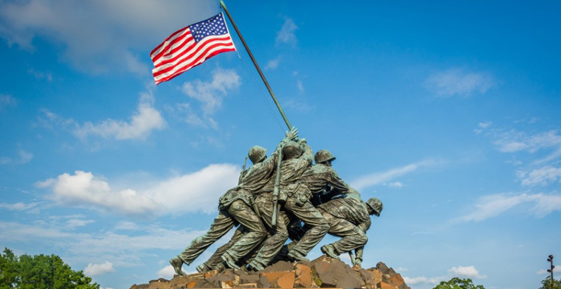 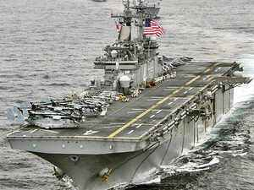 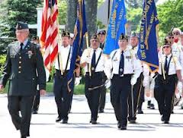

The newsletter veteran story this month is about our honorary military services veteran comrade Staff Sergeant Ron Garcia who served in the U.S. Marine Corps. He joined the U.S. Marines thereafter graduating from High School, and was trained for basic military readiness at Camp Pendleton. He successfully completed his MOS (Military Occupational Specialty) training in Metal Worker/Welding specialties field. He worked closely with his military friends with Special Marines Air-Ground Task Force unit. To repair heavy equipment for special missions and engineering projects, and repairing damaged equipment for combat readiness. He worked closely with his team to ensure heavy equipment is operating well and providing ongoing maintenance.

He is really glad of serving his country and protecting our freedom in America. He said, “yes the government should do more for veterans.” He liked his military career because it really helped him with his future, and his family. He is retired and feels great about serving in the U.S. Marine Corps, and would do it again and sharing his stories with family children. He made a lot of veteran friends and will be happy to help veterans with their families in the East Coast – moved to New Jersey with his family thereafter retirement.

 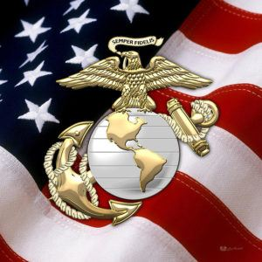 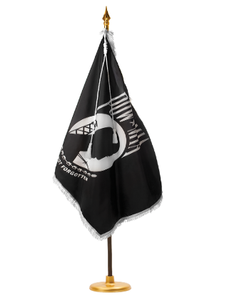

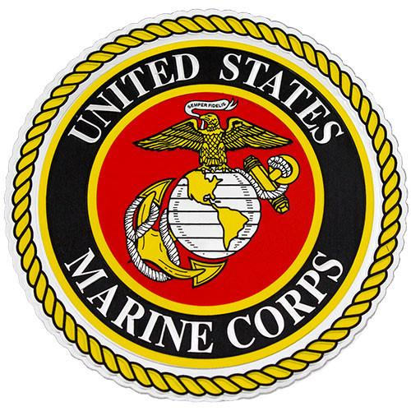 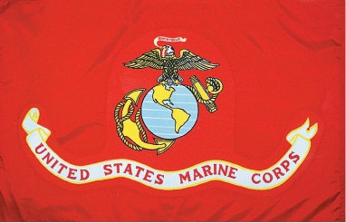  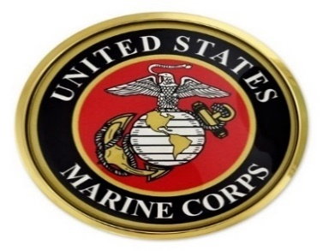

Page – 4

**POST EVENTS PICTORIAL LAYOUT**

The Post 105 participates in various local and state veteran events for supportive services for veterans and their families. The following pictures illustrating examples of Post 105 supportive services for veterans and their families during an event in local communities. It’s our post commitment for quality services supporting our veterans and their families – exemplifying by action throughout communities! (*THANKS to all photographers for pics)*

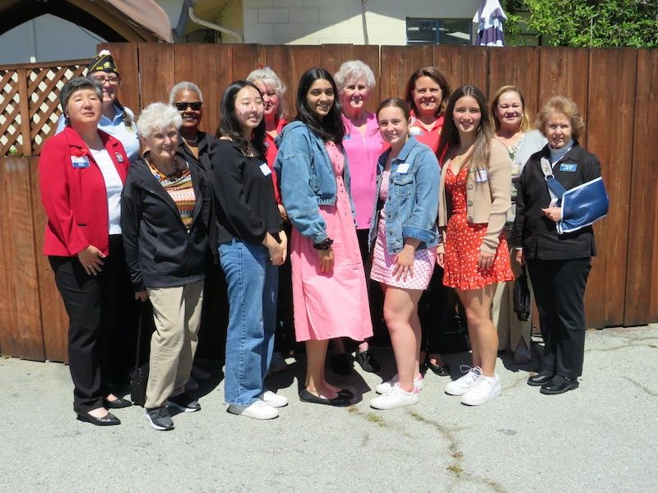 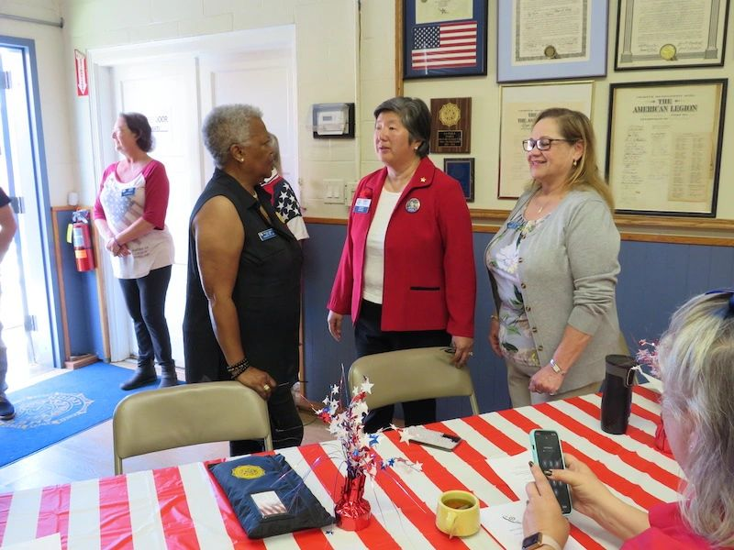

All Girls State candidates participated at therein District 26 ALA Unit 105 team members Pat, Peggy, and Cindy

Girls State Tea event sponsored by ALA Unit 105, and the socially interacting with Brenda sitting down looking at

successful event was hosted at American Legion Post 585. her phone during the Girls State Tea event.

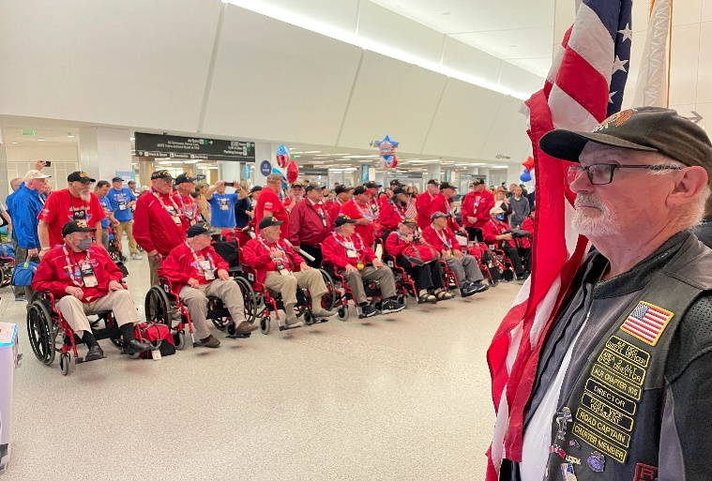 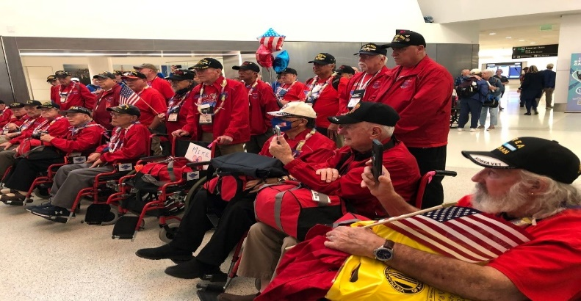

ALR Charter 105 is honoring a flight back for veterans The Honor Flight veterans are cleared to get back to their

returning from Washington DC. The veterans flight is local homes from a long flight. Many veterans really

sponsored by Honor Flight Bay Area Foundation to help appreciate therein flight, and other veterans will never

veterans – picture above is Andrew, Director of ALR105. forget their experience during thereby Honor Flight.

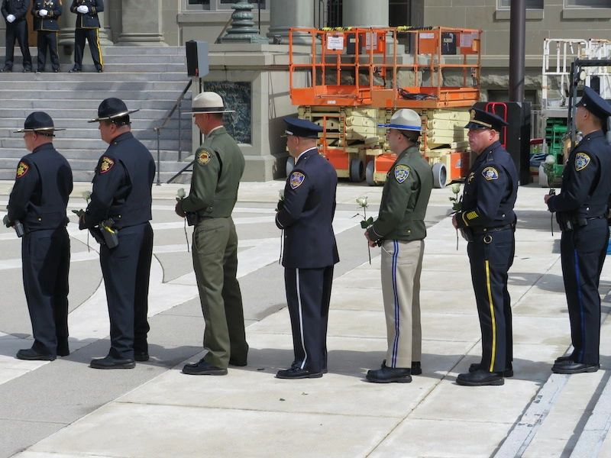 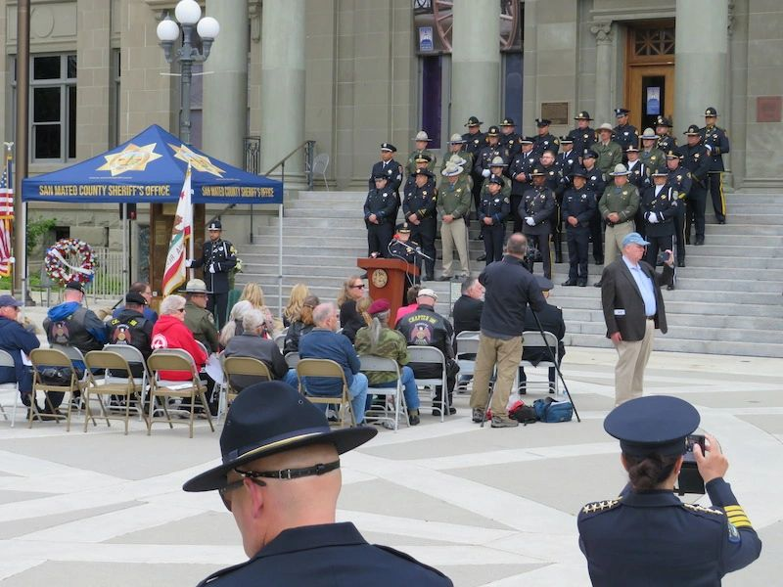

Police officers within San Mateo County are preparing to The participating audience is listening to more speakers

honor their friendship partners, during the 2023 Fallen during thereby memorial event, to honor fallen peace

Peace Officers Memorial Ceremony. officers for their sacrifice.

Page – 5

**AL Post 105 Family & Redwood City Public Library Partnership**

sharing herein local service events to help veterans and their families!

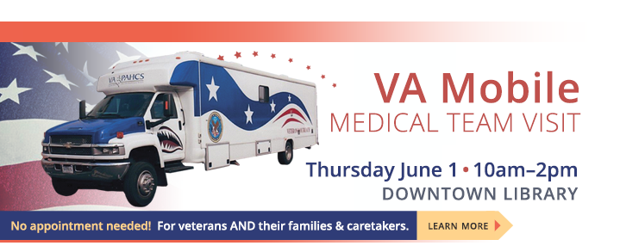

LOCATION: Downtown Library, 1044 Middlefield Road, Redwood City, CA 94063

WEBSITE: [www.redwoodcity.org](http://www.redwoodcity.org)

PHONE NUMBER: 650–780–7056

CONTACT NAME: Fiona Potter

IMPORTANT: Veterans need to bring a copy of their DD214 with them and VA Mobile Medical Team staff will answer any questions with resources.



LOCATION: Courthouse Square, 2200 Broadway Street, Redwood City, CA 94063

CONTACT PHONE NUMBER: 650–780–7035

CONTACT NAME: Sarah La Torra

WEBSITE: [www.redwoodcity.org](http://www.redwoodcity.org)

Page – 6

|  |
| --- |
| **POST 105 COLLABORATIVE TASK FORCE**  Legion Family logo Logo.png    StickerTalk USA Flag Vinyl Sticker, 5 inches by 3 inches Flag of the National League of POW/MIA Families |

AL Post 105 Family Collaborative Task Force collaborates with San Mateo County Police Chiefs & Sheriff Association as well as The 100 Club of San Mateo County. To honor and memorialize our fallen police officers for their sacrifice and serving our communities. By presenting therein 2023 Fallen Peace Officers Memorial Ceremony.

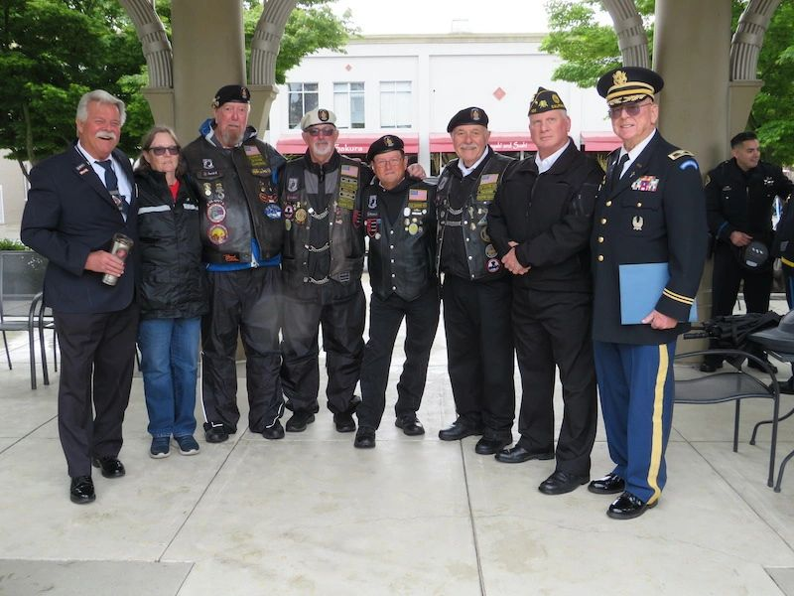 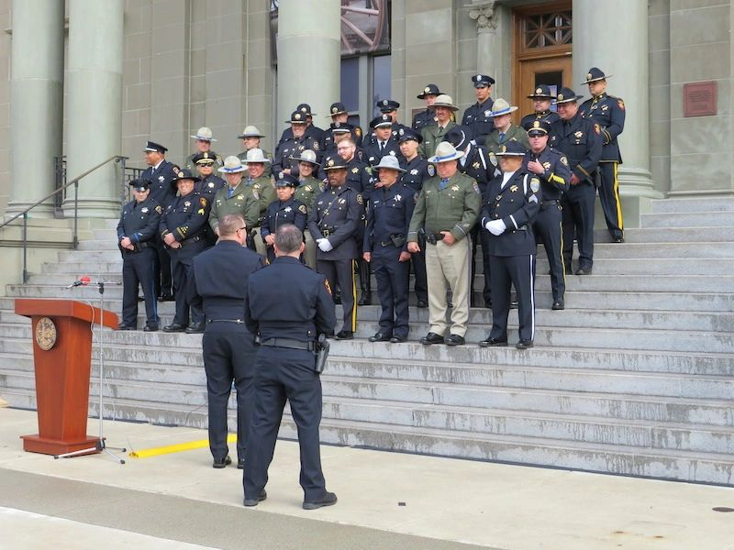

The AL Post 105 Family Commander, George Smith, and team members picture (left side) above participated at thereby event in Redwood City, California. Many police officers within San Mateo County participated as well at the event showing with therein picture (right side) above. The reporting sources identifies therein memorial event was awesome, and great to honor our fallen peace officers for their sacrifice. We will keep them and their families in our prayers. Needless to say, many of community police officers are veterans, and serving local communities to support veterans and their families.

Page – 7



* Please contact our post if anyone is aware of our Post 105 membership regarding Everlasting post members, and/or anyone in the hospital because of his/her sickness or specific type of illness – will keep them in our prayers for quick recovery! Please contact our post administrative office at 650-365-1337 for assistance and/or our Post Chaplain, Cobbey Sova when necessary regarding logistical matters, You can visit our website at [www.americanlegionpost105rwc.org](http://www.americanlegionpost105rwc.org) for more information.

* All our AL Post 105 Family units have been proactively participating with local activities to support veterans and their families last month during May 2023. Our post units continue to partner with Blue Star Moms on projects to help veterans and their families. Including displays and ongoing rifle detailing at ceremonies, to honor and remember veteran comrades entering the everlasting stage. Many THANKS to ALR and SAL units for their ongoing support with many successful hours of thereby local honorary missions. Including flag retirement partnership activities when necessary, and keeping our everlasting veterans and families in our prayers. As well as youth leadership activities to help and support veterans with their families, and aligned with Boys and Girls state leadership performance.
* Our AL Post 105 Family has donated many financial support for international relief funding, and helping families and children at impacted communities. Including Girls Scout cookies contribution to help veterans and their families in local communities when necessary.
* The AL Post 105 Family participation at thereby 2023 Memorial Day ceremony at the GGNC in San Bruno, California was outstanding with great success! Our post family ALR Charter 105 unit performed the gun salute with a Firing Detail, and along with the American Flag Line. Some audience participants shared their appreciation with the professional gun salute activity. One widow lady with her veteran husband passed away said, “My veteran husband would have loved you guys professional gun salute.” The annual event at GGNC (Golden Gate National Cemetery) is sponsored by therein Avenue of Flags Committee. The San Bruno Police Department presented the colors for therein Memorial Day event. Please visit herein following linkage <https://abc7news.com/memorial-day-2023-golden-gate-national-cemetery-in-san-bruno-cemeteries-open-bay-area/13316250> for more information.
* The ALR and SAL members continue to honor our fallen veteran comrades with rifle firing details every month. Every team mission accomplished with success during last month in May 2023, and every prior months before last month,

|  |  |  |  |  |  |  |
| --- | --- | --- | --- | --- | --- | --- |
| **Department of California Reporting Data – 5/26/2023** | | | | | | |
| Total Members | Membership  Goal | New  Members | Transfer  Members | PUFL Members | Paid To The Post | Current Percentage |
| 186 | 196 | 6 | 1 | 46 | 133 | 95% |

Many THANKS to renewal members and your membership dues that will go directly to help veterans and their families. Please visit our website [www.americanlegionpost105rwc.org](http://www.americanlegionpost105rwc.org) for more membership access and informational forms. You can also contact the First Vice Commander Mr. Alan Rosenmiller and THANK YOU for your support!

Page – 8

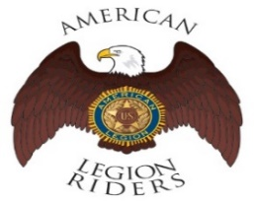 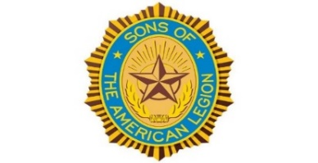 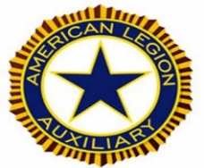

* The **American Legion Riders Chapter 105** membership and colleagues shared herein following progressive activities. American Legion Riders Chapter 105 has participated in many missions supporting veterans and their families, and participated in more than 188 missions and rifle firing details. The ALR105 rode more than 44,077 miles and donated more than 4,111 volunteer hours since last month in May 2023. Including an escort ride scheduled for the National Commander in California on December 10 and 11, 2022. The new ALR105 President, Andrew Trapani, will take over his new position role. The ALR105 chapter raised $6347 during therein Suicide Prevention ride with monetary contribution for the VA Palo Alto Hospital. Also, raised $410 and donated therein monetary contribution to Wreaths Across America. Including $100 for Tongan Relief Fund, $720 for Berkeley Half Marathon, $1080 for Oakland Marathon, $100 for Ukrainian Relief Fund, and $289.56 for Post 105 Dinner Dance. As well as a successful escort for therein 2022 National Wreaths Across America to Golden Gate National Cemetery. Including community resources to support 2022 Seamans Memorial Cruise, and escorting services for ALA President and Operation Surf. The Post 105 Riders participated in the Berkeley ½ marathon directing local traffic control. If you own a freeway legal motorcycle, are a member of the American Legion, American Legion Auxiliary or Sons of the American Legion and would like to join us, please email at [ALRChapt105@gmail.com](mailto:ALRChapt105@gmail.com) or call me at 650-349-7146.
* The **SAL Unit 105** Commander, Andrew Trapani reported previously another new member joined and elevated their membership numbers to 17. The AL California Department identifies SAL Unit 105 with 80% membership retention versus their membership goal. The SAL Unit 105 participated in **137** Final Hours Detail missions during rifle-firing details to honor our veterans, and with 105 participants and more details are scheduled for next month. The SAL Unit 105 donated $100 for the Veterans Day Celebration and they contributed 577 hours of volunteering time with 6508 miles. They continue to partner with ALR for missions when necessary. We are constantly looking for new qualified members, and not only can Patriots join but veterans can also join the Sons of The American Legion. The following are eligibility qualifications for SAL Unit 105: A male descendants adopted sons, and stepsons of members of The American Legion, and such male descendants of veterans who died in service during the period of April 6, 1917. Through November 11, 1918, or any time from December 7, 1941, to date, who served honorably, as set forth in Article IV, Section 1, of the National Constitution of The American Legion, or who died subsequent to their honorable discharge from such service shall be eligible.
* The AL **Auxiliary Unit 105** President, Carol Rael continues to meet with their unit in-person at Post-105 on the second Wednesday @ 6pm. Unit 105 continues as a team to fulfill the mission of the Auxiliary and thereby the Legion’s mission. ALA participated in Blue Star Moms, Wreaths Across America on December 17th, as well as Toys for Vets wrapping gifts that had been donated for the children and grandchildren of VA patients.  ALA also fulfilled a VA patient wishlist and delivered the presents of December 6th. On December 23rd ALA attended the Veterans Christmas Luncheon at San Mateo Elks, hosting a table which gave out information on Unit 105.  Unit 105/District 26 raised over $2,100. of toys/donations for Toys for Vets to avoid a toy shortfall.  RED (Remember Everyone Deployed) T-shirt sales are available for $30. each.  Contact ALA Carol Rael, President for more information or to order – visit their website [www.alaunit105rwc.com](http://www.alaunit105rwc.com) for more purchasing events.

Page – 9

  

* The statewide **Women Veterans Affairs** is growing rapidly and advocating for effective services throughout California. The CalVet women organization is having online webinar sessions by clicking to the following link. [https://www.calvet.ca.gov/WomenVets/Pages/Monthly-Statewide-Webinars.aspx](http://r20.rs6.net/tn.jsp?f=0015STogUg_VIxOBYVssmtPypmC2GvcnD9ZgGhmrtottoNinTHGb5RUvwCXFQgU9szwmaTdBBfxw04XWYtXyp0R7nRfvI9BVGff0h5Barz4dgT-rmd80BwkwIiI1ouWLQoeMDxG0Qsna0Xxk0N4eUa8EGHFXYJq6uHCUFyF9Q4k4v1p64MFvoLqGkDPmShCjpyj0fveFv7oQ4cVAKjiNJKNvQ==&c=WT-cH0OnWIOLoTKqhacONB6VGdI75SwNSjVrcG9q2QYNAuPfRNJJ_g==&ch=KzA0Ptk4eQmVURV8W5NUxxCcQuQswDjMdsCySzTQWpW1oN7QuhPbKg==)
* We know how critically IMPORTANT to help our veteran comrades and families with many ongoing human service challenges in life. Because many veterans may not be able to find appropriate help for assistance with **health, safety, suicide and human services** including crisis matters. If a veteran is NOT sure where to start looking for help, please contact the Veterans Crisis Hotline at 1-800-273-8255. Copy and click online following linkage <http://www.knowavet.org> and/or text 838255 for more information. The National Suicide Prevention Lifeline three-digit code number **988** is NOW working! Dial **988** and press 1 for assistance, and/or more mental supportive information.
* The VA suicide prevention hotline spiked over the 2022 holidays with increasing calls at almost 19% and veterans can have FREE access for emergency mental health care at any medical clinic. Please visit herein linkage for more information <https://calegion.org/va-to-pay-for-all-emergency-mental-health-care/> and access. The latest suicidal data identifies around 17 veterans die of suicide every day in our communities.
* The American Flag Day is **Wednesday, June 14, 2023** this month and American Legion raises funding from buying American Flags at American Legion, and proudly Made In America with high quality. The funding resources really helps with veterans and their families with supportive programs. The American Flags purchased at American Legion certainly helps veterans and their families locally and nationwide. Including trainings and support for active duty veterans on local and/or international assignments. Please visit therein national website [www.legion.org](http://www.legion.org) for more information for an American Flag at American Legion – flags are Made In America with high quality.
* The veterans and their families can have preventative health screenings with less money, and preventing major illness and avoiding a stroke. Please visit herein following linkage for more information and identifying <https://www.lifelinescreening.com/home-pack-test?sourcecd=WABF001> local screening clinics.

**NEWSLETTER EDITOR NOTICE**

Our post newsletter is offering this opportunity to reach out and work closely with our membership legionnaires and all veterans! The post members can provide future newsletter articles and/or “appropriate” newsletter posting information, and posting information can be verbatim if necessary. Please send information by email [mfcpalesoo@gmail.com](mailto:mfcpalesoo@gmail.com) or phone call at 650-365-1337 for informational message.

**American Historical Quote: “***Every man’s happiness is his own responsibility!”*

***President Abraham Lincoln***

Page – 10