
🐾 Meet Our 2026 Kittens! 🐾
Welcome to our catalog of the sweetest, cuddliest, and most playful kittens looking for their forever homes. We are happy to offer delivery for our kittens to families in the Sacramento and Bay Area areas.

Contact Stacy: (650)678-5714 stacy@kittyhavenrescue.com www.kittyhavenrescue.com

🩷 Kenzie
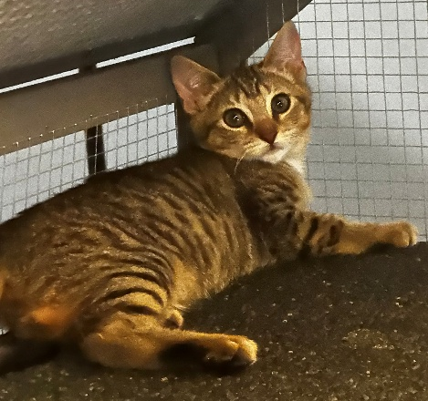
Meet Kenzie! Kenzie is a sweet little girl with the cutest round eyes and tiniest paws. She absolutely loves curling up beside her favorite people, purring away, and soaking up all the cuddles she can get. If you're looking for a gentle, affectionate companion, Kenzie would love to steal your heart!
Age: 15 Weeks
Sex: F - Spayed and Vaccinated
Gotcha Date: 6/20/2026
Ja

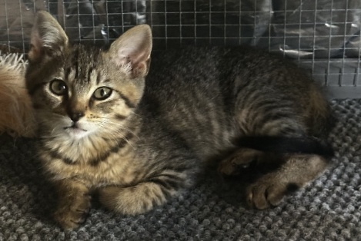
💜 Melanie
Say hello to Melanie! Melanie is an adventurous little explorer who is always curious about what everyone is doing. Whether she's chasing toys, investigating every corner of the room, or making you laugh with her playful personality, she's guaranteed to brighten your day.
Age: 15 Weeks
Sex: F - Spayed and Vaccinated
Gotcha Date: 6/15/2026

💙 Sincere

This is Sincere! This handsome gray fluffball is as cuddly as they come. He loves being close to people and will happily curl up for a nap after a fun play session. His soft fur and loving personality make him impossible to resist.
Age: 15 Weeks
Sex: M - Neutered and Vaccinated
Gotcha Date: 6/15/2026

💚 Bryce
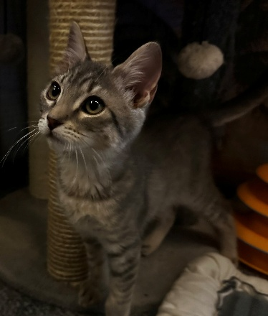
Meet Bryce! Bryce is a confident little guy who is always ready for his next adventure. He loves to play, explore, and keep everyone entertained with his silly kitten antics. Once he's tired out, he's more than happy to settle in for some pets.
Age: 15 Weeks
Sex: M - Neutered and Vaccinated
Gotcha Date: 6/16/2026

☀️ Sol

Say hi to Sol! Don't let her tiny size fool you—this little sunshine is full of personality! Sol is playful, curious, and loves discovering new things. She's sure to fill your home with happiness.
Age: 12 Weeks
Sex: F - Spayed and Vaccinated
Gotcha Date: 6/19/2026

🧡 Corbin - ADOPTED
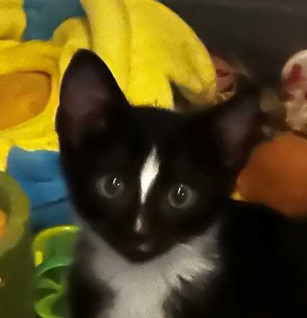
Meet Corbin! Corbin is an energetic little boy who loves chasing toys and showing off his playful side. He’s truly a diamond – check out his cute markings!
Age: 12 Weeks
Sex: M – Neutered and Vaccinated
Gotcha Date: 6/20/2026

🌸 Bea
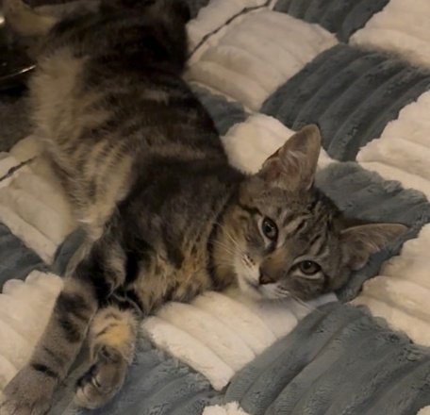
This is Bea! Bea is a gentle, loving kitten with a sweet personality that will melt your heart. She enjoys affection, cozy naps, and spending time with people. She's the perfect combination of playful and snuggly.
Age: 12 Weeks
Sex: F - Spayed and Vaccinated
Gotcha Date: 6/20/2026

⭐ Caleb
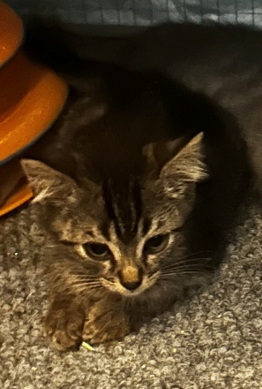
Meet Caleb! Caleb is a brave little explorer who approaches every day with curiosity and excitement. He's always ready to investigate something new before settling in for some well-deserved cuddles.
Age: 10 Weeks
Sex: M – Not neutered/vaccinated yet
Gotcha Date: 7/08/2026

💖 Parmida - ADOPTED
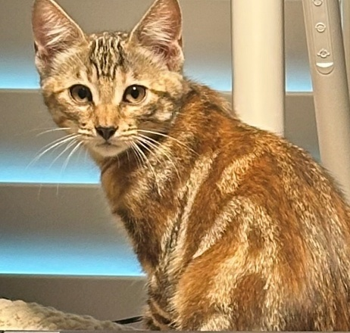
Say hello to Parmida! Parmida is a graceful young lady with a loving heart. She enjoys attention, affection, and spending time with her people. She's as sweet as she is beautiful.
Age: 18 Weeks
Sex: F - Spayed and Vaccinated
Gotcha Date: 6/14/2026

💛 Ronnie - ADOPTED

Meet Ronnie! Ronnie is the social butterfly of the group! He's friendly, outgoing, and always one of the first kittens to come say hello. He loves making new friends and is sure to become part of the family in no time.
Age: 18 Weeks
Sex: M - Neutered and Vaccinated
Gotcha Date: 6/14/2026

💙 Carl
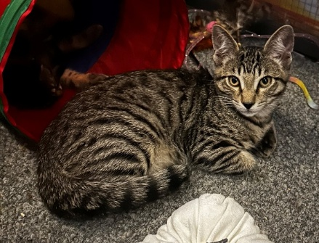
This is Carl! Carl has a calm, easygoing personality that makes everyone fall in love with him. He enjoys relaxing with his people, getting plenty of pets, and taking life one cuddle at a time.
Age: 18 Weeks
Sex: M - Neutered and Vaccinated
Gotcha Date: 6/14/2026

💚 Dylan - ADOPTED
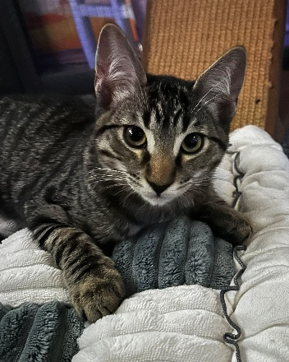
Meet Dylan! Dylan is full of playful kitten energy and loves turning everyday moments into an adventure. Whether he's zooming around with toys or climbing to the best nap spot, he'll keep you smiling every day.
Age: 18 Weeks
Sex: M - Neutered and Vaccinated
Gotcha Date: 6/14/2026

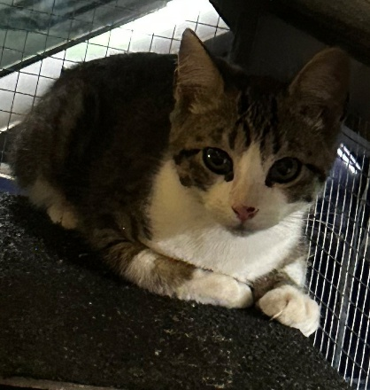
🧡 Jasper
Say hello to Jasper, one of the newest additions to the litter! Jasper is a sweet and curious little kitten with an affectionate purr that never stops. They love pouncing on feather toys, chasing paper balls, and finding the sunniest spot in the room to curl up for a long afternoon nap.
Age: 12 Weeks
Sex: M - Neutered and Vaccinated
Gotcha Date: 7/26/2026

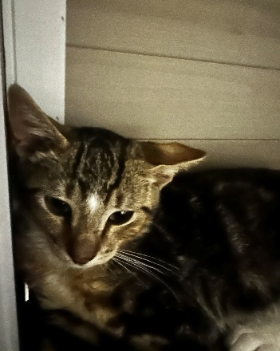
💖 Daisy
Meet Daisy, another one of the newest additions to the litter! Daisy is a darling little kitten who loves affection and human company. With their soft fur, gentle demeanor, and sweet chirps, they're guaranteed to make you fall in love the moment you meet them!
Age: 12 Weeks
Sex: Unknown - Not Fixed or vaccinated yet
Gotcha Date: 7/26/2026

