Lockport Area Centered on the Chestnut Ridge Cemetery
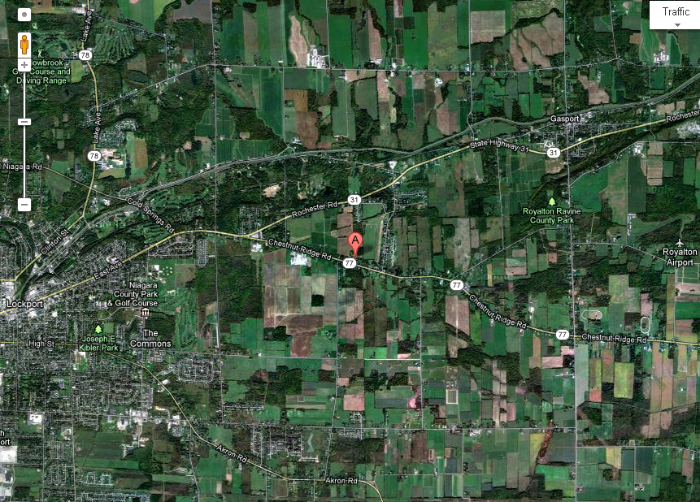

The “Little Stone Church” at the Intersection of Chestnut Ridge Road and Keck Road
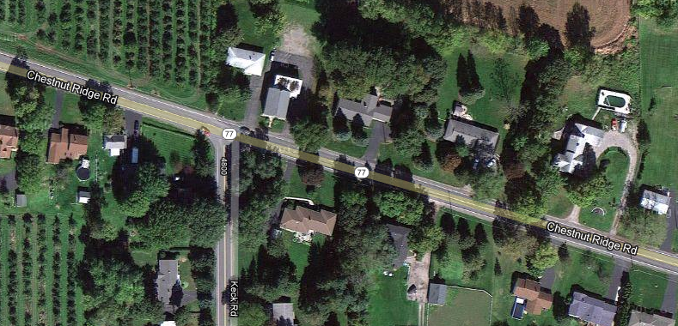

Chestnut Ridge Cemetery in the Town of Royalton
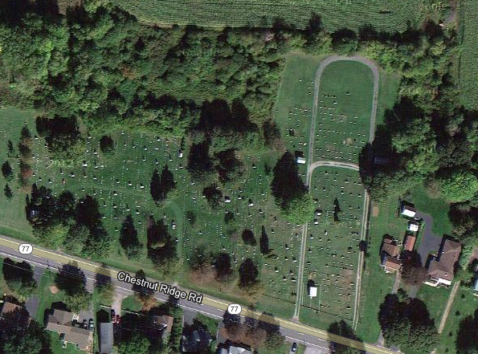

The Henry Barnett home (note) and the Jeffery & Elizabeth Barnett Homestead in Royalton
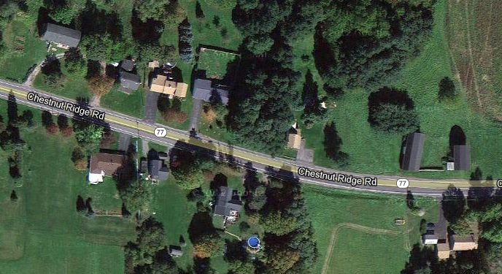
The Jeffery Barnett home is in the lower right of the picture. The Henry Barnett property and barn with a loop driveway is in the upper right of this photo. This property was later transferred to Wallace.

