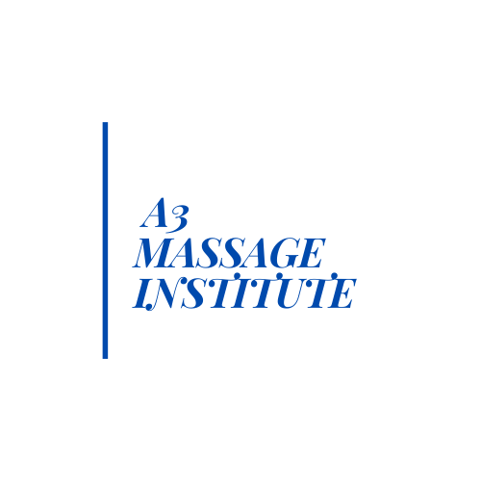
Massage Program Tuition Payment Plan & Discounts

Monthly Payment Options:

Option 1: 12,260
-500
11,760 / 7 months = 1680.00 monthly

Option 2: 11,760 + 5%= 12,348
12,348 /12 months= 1030.00 monthly

Option 3: 11,760 + 15%= $13,524
13,524 / 18 months = 755.00 monthly

Discounts:

Option A:
PAID IN FULL: 12,260- 5% (613.00) = $11,647 Total

PAID IN FULL w/Deposit : 11,760- 5% (588.00) = $11,172 Total

Option B:
MILITARY: Active Duty, Veteran, & Military Spouse
(Please provide Military ID or DD 214**)

12,260-5% (613.00) = $11,647 Total
Option C:
BETTER TOGETHER:
Enrollment with friend, colleague, family member.
(Must be enrolled the same class start date)**

12,260 - 5% (613.00) each = $11,647 Total
Option D:
ALUMNI DISCOUNT: For students who have graduated from Aesthetics Program.
12,260- 10% (1226.00) = $11,034 Total

**Discount offers cannot be combined.

