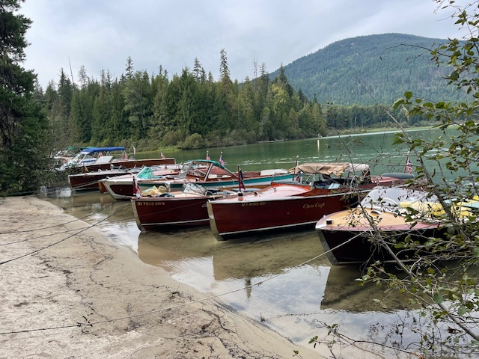

Starting August 29th, 4 days of celebrating in your boat on beautiful Priest Lake. Priest Lake Dry Rot Wooden Boat Show is held on the last major holiday of the summer boating season (Labor Day weekend).

You can find more information at the Priest Lake Dry Rot website: www.priestlakedryrot.com. 2025 show dates are Friday, August 29th^{th} thru Monday, September 1st.

Registration:
Complete the events & number of people in your party and join us for a fun filled weekend of boating on beautiful Priest Lake. Rain or shine, it promises to be a fun boat show using your boat around Priest Lake. Complete your registration and get signed up now.

Registration Per Boat FOR LABOR DAY WEEKEND - $10 $ ________
OR
Registration for JUST SUNDAY - $25 $ ________

Friday, August 29th - Pulled Pork Sandwiches at Nordman Restaurant:
$30 per person x _______ $ ________
T-shirts/Hats/Posters Sold Friday Night

Saturday Morning, August 30th - Poker Run – Starting Out Front Our Cabin
(will provide a map)
$30 per boat - Includes 1 Hat $ ________

Saturday Evening, August 30th - Longhorn BBQ Dinner at Fair’s Cabin
$55.00 per person x______ $ ________
Includes Boat Shuttle to/from Elkins in Kaniksu Tour Boat
AWARDS FOR POKER RUN HANDED OUT – MUST BE PRESENT TO WIN

Sunday, Aug 31st - Dry Rot Public Show & Breakfast (Pay at Elkins for Brunch)

Sunday, Aug 31st – 11:00am Boat Parade to Hill’s - Gin Fizz (Pay at Hill’s for Lunch)
Awards Handed Out at Hill’s

Monday, Sept 1st - Hot Dog Roast at Upper Lake – Cruise on up from Fair’s Cabin
$10 per person x _______ $ ________

TOTAL REMITTANCE $_________

Registrations Would Be Appreciated by August 15, 2025

Register & Pay Online at www.priestlakedryrot.com
OR
Mail your Completed Registration w/your Check Payable to:
Inland Empire Chapter/ACBS
Priest Lake Dry Rot
c/o Brian Fair
7213 E. 44th Ave; Spokane, WA 99223

For more information, contact:

Kathy Fair - 509-993-6122 Email: kathy@priestlakedryrot.com
Brian Fair - 509-990-6796 Website: www. priestlakedryrot.com

Participant Information:

Captain: ______________________________ 1st Mate: _______________________________

Cell Phone: ______________________________ 1st Mate’s Cell Phone: __________________

Email Address: ________________________________________________________________

Boat Information: [if the same as last year, just state “same as 2024”]

Boat Name: _________________________________________________________________

Manufacturer: _________________________ Model: ________________________________

Year: ________ Length: _________ Engine Make: _______________________________

Cylinders: ___________ Horse Power: __________

Release of Liability:

Please read and sign the following agreement, which is required of all participants:

I hereby release, discharge, protect, indemnify & hold harmless the Inland Empire Chapter of the Antique & Classic Boat Society, the organizers, volunteers and/or hosts of the Priest Lake Dry Rot, committee chairpersons and/or directors, officers, administrators, successors & all other sponsors & assigns from & against any and all claims, liability demands & causes of action of all kinds, including without limitations property damage, injury, illness or death, including costs & attorney fees incurred in connection with the undersigned’s use of all facilities during this event. Further, I certify that I currently have effective insurance to cover any damage to my boat, and to cover my liability from any damages to others & their property arising from the use of my boat during this event.

Signed ______________________________________________ Date __________________

PRIEST LAKE DRY ROT WEBSITE www.priestlakedryrot.com

