How to Unlock a Geozone

Go to DJI.com

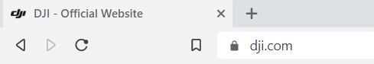

Log In with user name and password
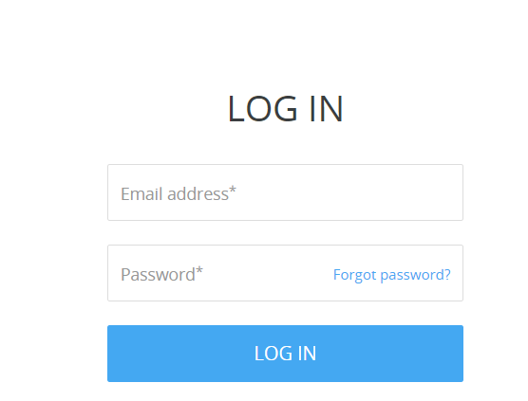

Go to support tab at top of page

Go to Fly Safe Tab
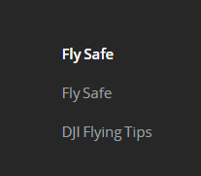

Select Region in World and Nation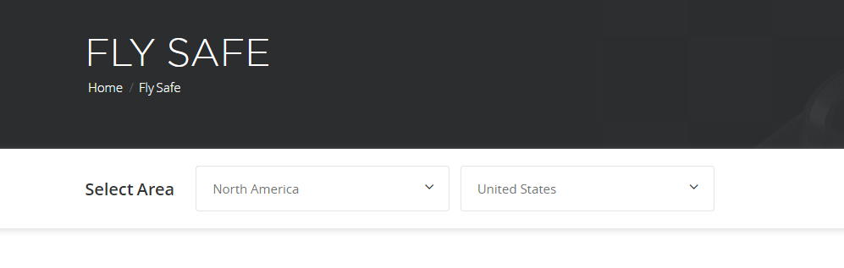

Scroll down to Unlocking Request

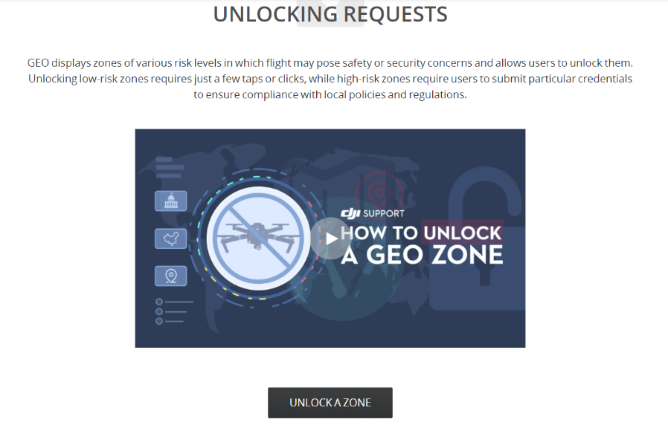

When you unlock a zone you may have to log in again.
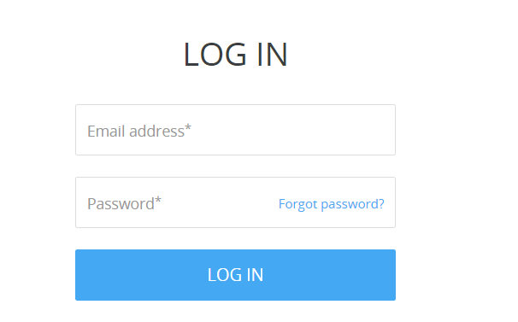

This screen may be empty if you have never done this before.
Click on blue box at the top “New Unlock Request”

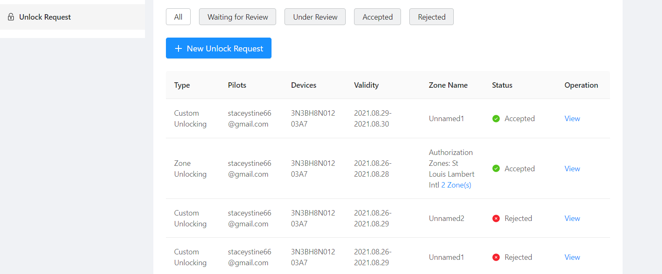

Please note that you must have Laanc or ATC authorization

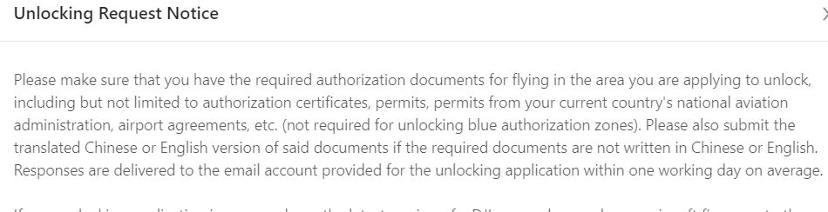

Reminder to update your app on phone or tablet and your firmware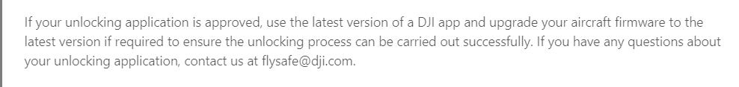

You agree to the following

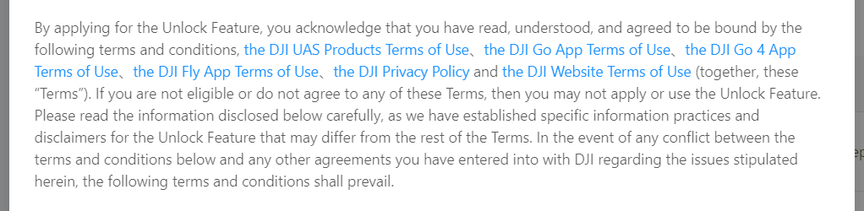
You may be required to upload a photo of your authorization from Laanc or ATC or your waiver.
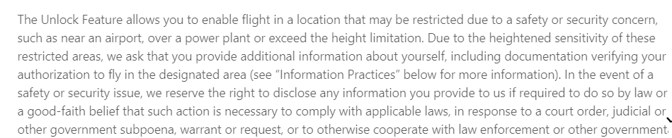

You must have a profile set up with necessary information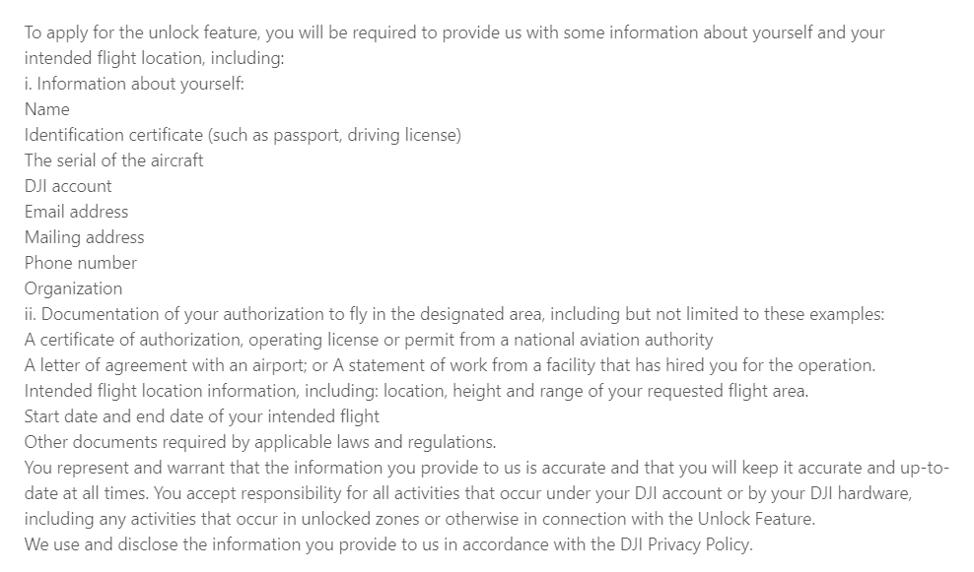

Typical Disclaimer, but good to read again-It’s on you to be legal

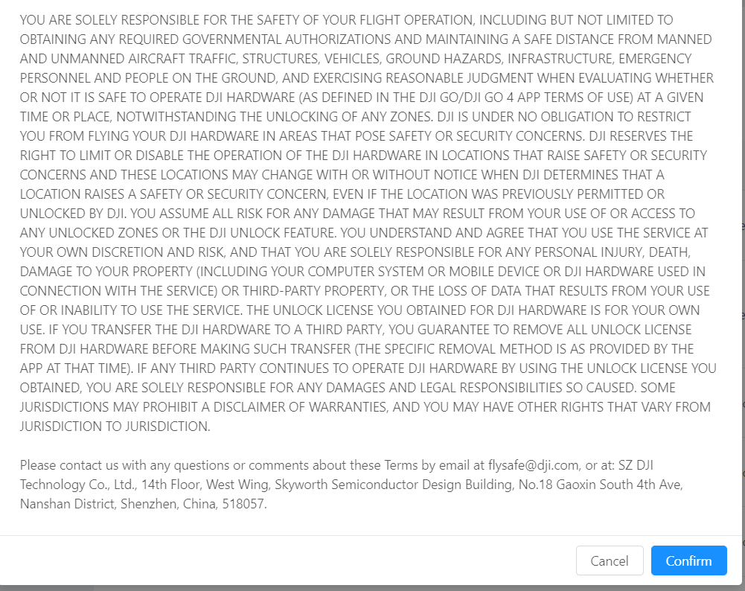

You can choose one of two types for unlocking. You can draw an area on the map or you can unlock a specific zone.
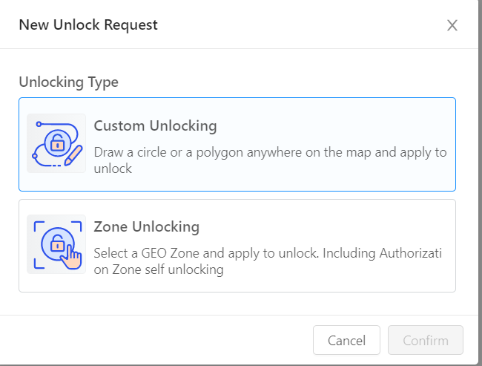

Enter Basic Information

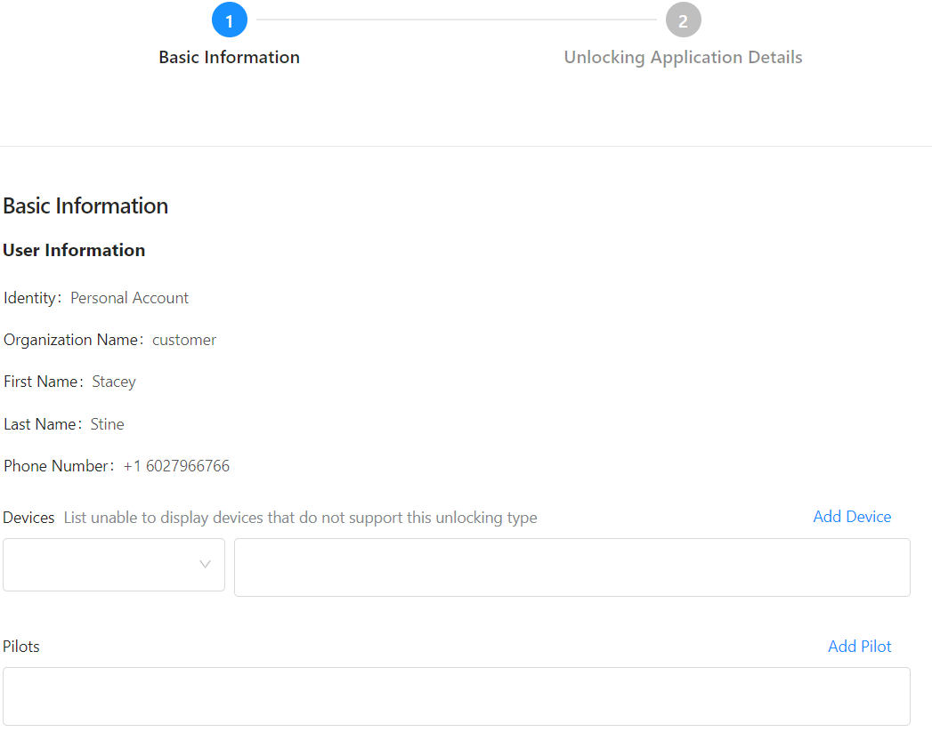

Add Device- You will need the SN number but you can find that under the battery compartment or in your DJI app

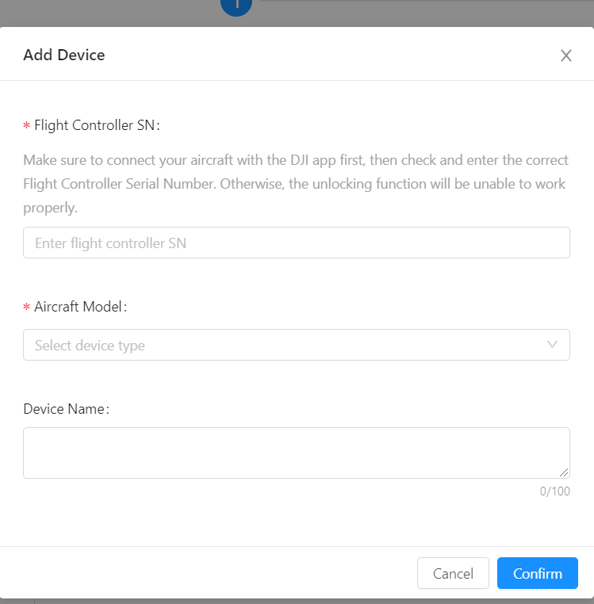

Add Pilot Information-They want your email and name

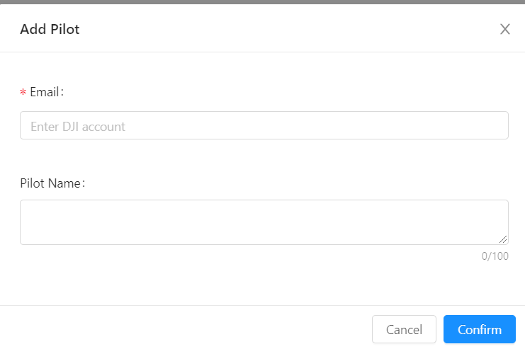
It should look like this,
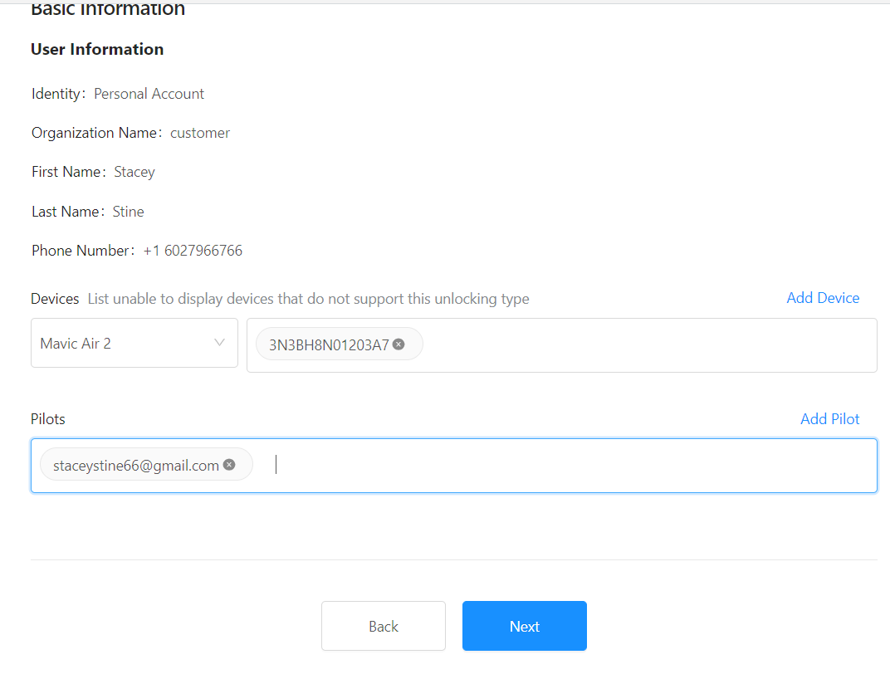
You will be see a map-Use the search to input the address of your mission, its faster.
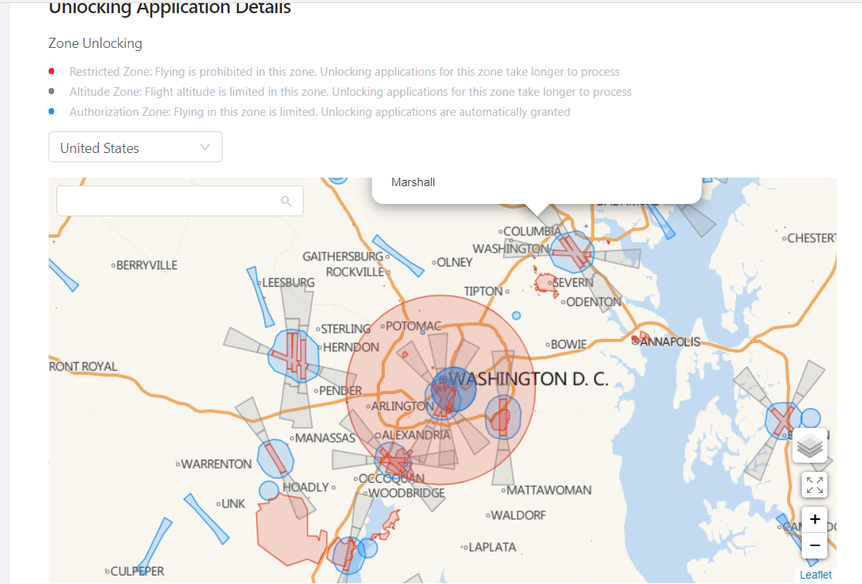

Enter your time range-Reason should be your laanc authorization or waiver. Have a picture so you can upload it quickly from your photos.

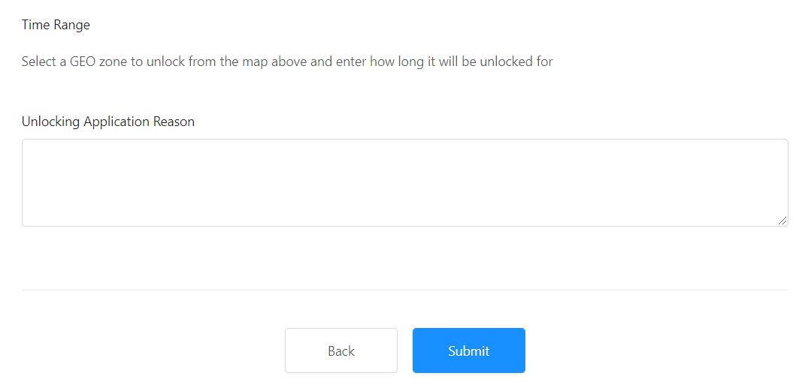

Remember it starts at Midnight (00:00) on the day you choose to start and ends at 23:59.

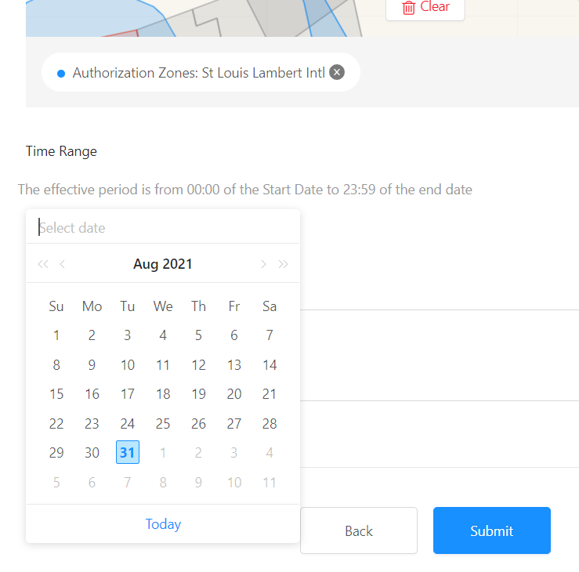

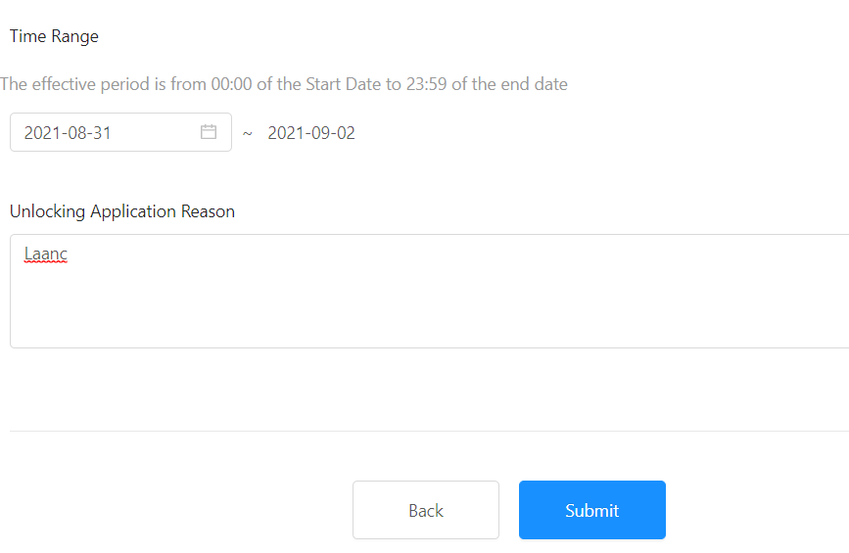

If you did it correctly you will see this message
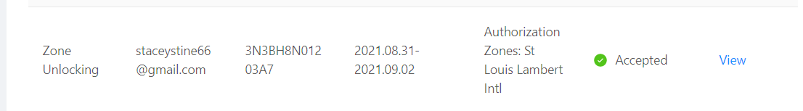

You will then get an email that gives you the tracking number

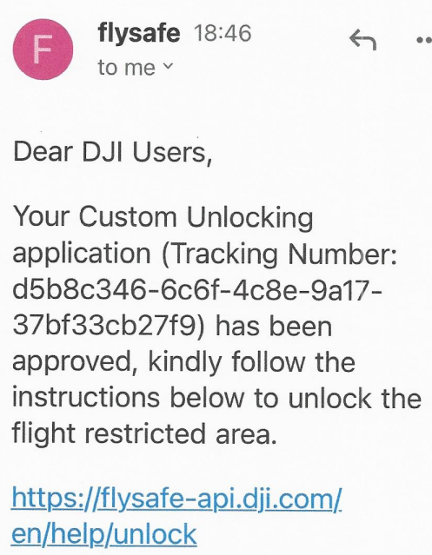

Follow the link-

