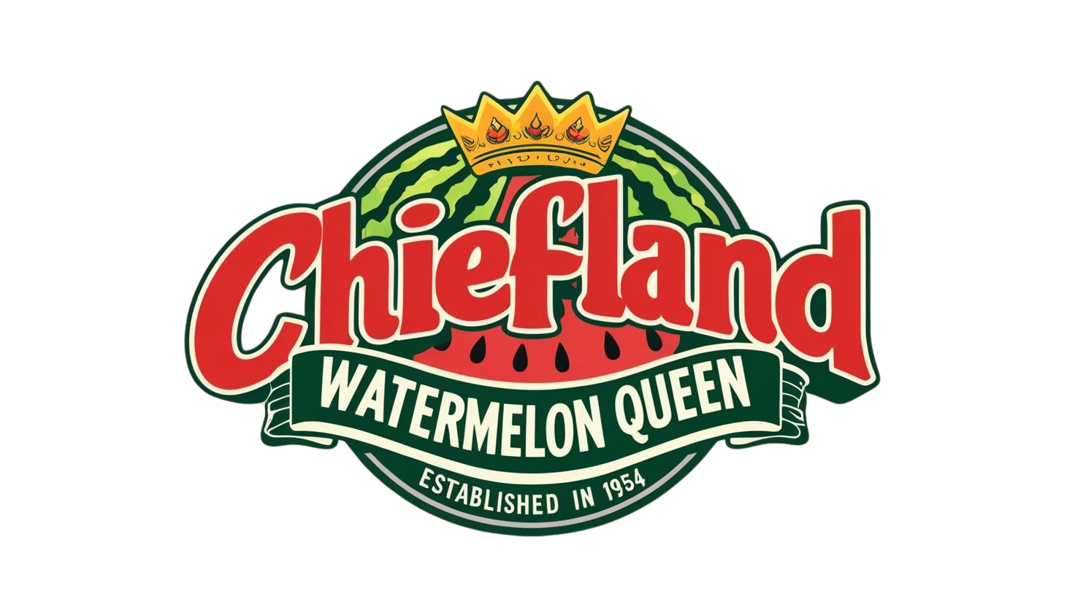
Chiefland Watermelon Festival Pageant
All contestants must live in one of the following counties:
Alachua, Bradford, Columbia, Dixie, Gilchrist, Levy, Lafayette, Marion, Suwannee, Taylor, or Union.
When: May 23rd, 2026
Where: Chiefland Woman’s Club & Chiefland Middle-High School Auditorium
Times: Luncheon & Interview 12:30pm-3:00pm; Stage Competition 5:00pm
Entry/Sponsor Fee is $100.00 to be paid by yourself/family member or friend/business. Entry Fee is nonrefundable. Cash or Check/Money Order.
Submit applications via email (PDF ONLY) to cwc2013pageant@gmail.com Or in-person at Jim King Realty or AgPro in Chiefland during business hours.
Sponsorship Fees ONLY can be dropped off at Jim King Realty or AgPro in Chiefland, or mailed to the listed address & MUST have contestant’s name noted.
Please make checks/money order payable to: Chiefland Woman’s Club
Event organized by The Chiefland Woman’s Club www.ChieflandWomansClub.org
Attire for contestants: More details provided at rehearsals/meetings. All attire must be age-appropriate and fit well-no midriffs, deep plunging necklines, or higher than mid-thigh slits. All attire must be approved prior to pageant by Director.
- Interview: Business attire to include suits, dresses, slacks/blazers
- Opening Number: black pants, black shoes, shirt will be provided (Will do watermelon promo/speech in this attire)
- Promotional Wear: choose an outfit that represents the Chiefland Watermelon Queen! May choose from farm tour, festival, speaking event/on-stage.
- Evening Gown: must be formal, floor length gown and adhere to all aforementioned guidelines.
___ 14-16 Year Olds (Teen Queen) ___17-18 Year Olds (Princess) ___18-22 Year Olds (Queen)
Eligible Teen, Princess, and Miss contestants are single/never married, have no children, are between the ages of 14-22 (Queen contestant must be 19 by October 1st) and reside in one of the following counties listed above.
A photograph must accompany this entry form, must be at least 3x5, head shot preferred. Photos will not be returned and will be used for Miss Photogenic and local newspapers. Please print contestant’s name and age legibly on the back of the photograph. Photos may be emailed in .jpeg format clearly labeled with the contestant’s full name. One photo per email, any blurry images will be rejected.
Teen, Princess, and Miss contestants will participate in an opening dance number (simple dance style with contestant introduction). Teen, Princess, and Miss contestants will answer one on-stage question. Teen, Princess and Miss will pull at random from bowl (personality based). Full description of Teen, Princess and Miss competition divisions and requirements can be found on the competition contract which must be completed and signed in order to compete.
I, we, the legal parent(s)/guardian(s) of _____________________________________________, hereby give full consent for photographs to be used in newspapers, magazines, television, or any legitimate advertising medium for the benefit of the Chiefland Watermelon Festival Contest and/or Chiefland Woman’s Club and/or state and national Watermelon Associations. I, we, understand ANY unsportsmanlike/harassment inappropriate behavior by parent/contestant/ accompanying party will not be tolerated and is at the director's sole discretion to revoke permission to compete, entry fee WILL NOT be returned. I, we, understand that Chiefland Woman’s Club and/or director will not assume responsibility or liability for any injury sustained or loss incurred for any contestant in this contest. This serves as a release for any liability. I, we, understand the application is not valid and complete until I submit both forms (Part 1 & 2), Entry Fee, and Photo by May 11th, 2026 and/or when age category is full. I agree to signing of Queen’s Contract if I am chosen winner that will be explained to me at length upon crowning. I agree to have a valid form of contact to be notified at on or before May 11th, 2026, so the director can confirm all parts have been received and until doing so my application is invalid. I have read and agreed to all of the information above in order to participate in this years pageant. I, we, further understand and consent in order to participate in this years pageant.
Any questions please contact director Maddie Chewning @ 352-356-3037 (please no calls after 8pm) or email cwc2013pageant@gmail.com

________________________________________________ _____________________________________________
Applicant Print Applicant Signature

________________________________________________ ______________________________________________
Guardian (if under 18) Print Guardian Signature

________________________
Date

Mailing Address:____________________________________________________________________________________

Chiefland Watermelon Pageant Queen Contestant Information
*Please print/type legibly-this form is used to introduce contestant on stage.
Name:_____________________________________________________________________________________
First Middle Last
Hometown:_______________________________ Parent(s):_____________________________________________
Sponsor(s):______________________________________________________________________________________
Date of Birth:__________________ Age:__________ Hair Color:__________________ Eye Color:_______________
School Attending:_____________________ Current Grade Level:______ Major/Minor (if applicable):_________________
School/Community Activities:__________________________________________________________________________________________________________________________________________________________________________________________________________________________________________________________________________________________________________

Hobbies:________________________________________________________________________________________________________________________________________________________________________________________________________________________________________________________________________________________________________
Future Career Goals:__________________________________________________________________________________________________________________________________________________________________________________________________________________________________________________________________________________________________________
Why do you want to be selected as Teen Queen/Princess/Queen?:___________________________________________________________________________________________________________________________________________________________________________________________________________________________________________________________________________________________
Describe your favorite watermelon memory:________________________________________________________________________________________________________________________________________________________________________________________________________________________________________________________________________________________________________

