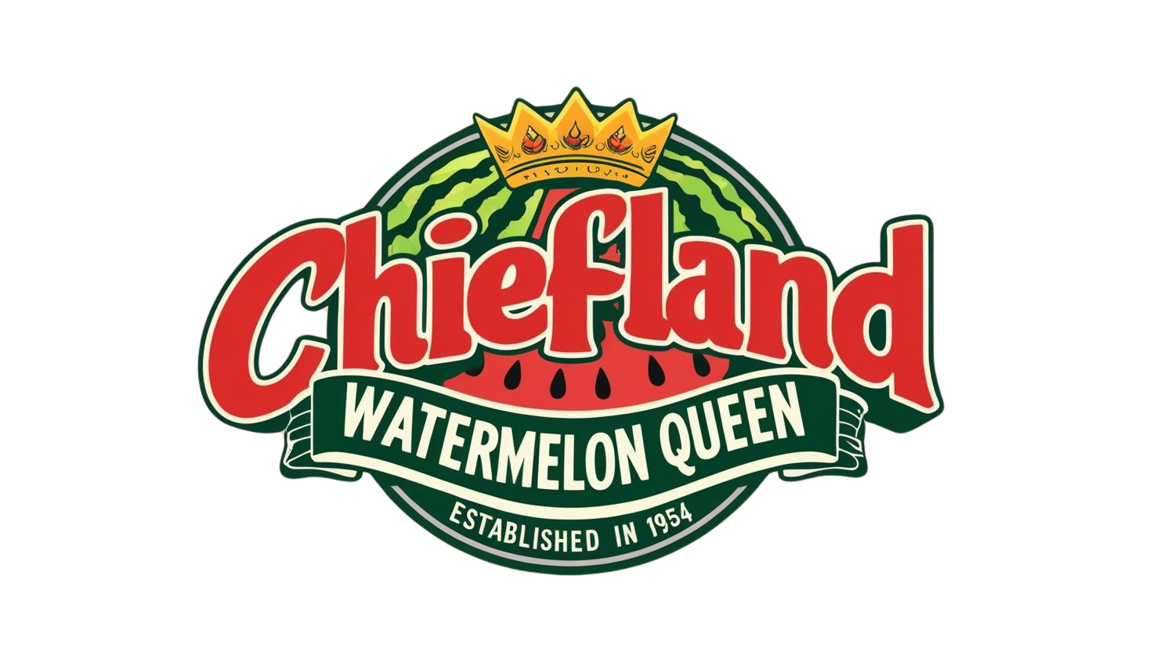
Chiefland Watermelon Festival Pageant
All contestants must live in one of the following counties:
Alachua, Bradford, Columbia, Dixie, Gilchrist, Levy, Lafayette, Marion, Suwannee, Taylor, or Union.
Entry/Sponsor Fee is $50.00 to be paid by you or sponsor received with your application. Entry Fee is nonrefundable. Cash, Check/Money Order, via Venmo.
When: May 23rd, 2026 Where: Chiefland Middle-High School Auditorium
Times: Ages 0-13 years old will begin at 9:00am, specific age group times will be announced!
To submit applications: emailed (PDF FORMAT ONY) to cwc2013pageant@gmail.com OR in-person at Jim King Realty or AgPro in Chiefland during business hours.
Sponsorship Fees ONLY can be dropped off at Jim King Realty or AgPro in Chiefland during business hours. NO OTHER METHOD OF PAYMENT WILL BE ACCEPTED!
Please make checks/money order payable to: Chiefland Woman’s Club
Event Organized by The Chiefland Woman’s Club www.ChieflandWomansClub.org
Watermelon Attire is required for girls 0-9 (represents watermelon, no bare midriffs), formal attire 10 & up (floor length; age appropriate). Ages 5 & up will be required to walk alone on stage and answer an on-stage question (from application).
___0-11 MO Girls  ___1-2 Year Old Girls  ___3-4 Year Old Girls  ___5-6 Year Old Girls | ___7-9 Year Old Girls  ___10-13 Year Old Girls | ___ 0-2 Year Old Boys (SUNDAY BEST ATTIRE)  ___ 3-5 Year Old Boys (SUNDAY BEST ATTIRE) ___ 6-9 Year Old Boys (SUNDAY BEST ATTIRE)
I, we, the legal parent(s)/guardian(s) of _____________________________________________, hereby give full consent for photographs to be used in newspapers, magazines, television, or any legitimate advertising medium for the benefit of the Chiefland Watermelon Festival Contest. I, we, understand ANY unsportsmanlike/harassment inappropriate behavior by parent/ contestant/accompanying party will not be tolerated and is at the directors sole discretion to revoke permission to compete, entry fee WILL NOT be returned. I, we, understand that Chiefland Woman’s Club will not assume responsibility or liability for any injury sustained or loss incurred for any contestant in this contest. This serves as a release for any liability. I, we, understand the application is not valid and complete until I submit both forms (Part 1 & 2), Entry Fee, and Photo. I agree to have a valid form of contact to be notified at on or before May 11th 2026 and/or when categories are full, so the director can confirm all parts have been received. I have read and agreed to all of the information above in order to participate in this years pageant. I, we, further understand and consent in order to participate in this years pageant.
Questions? Contact director Maddie Chewning @352-356-3037 (please no calls after 8pm) or email cwc2013pageant@gmail.com

Parent/Legal Guardian's Name (printed) Date

Parent/Legal Guardian’s Signature

 Chiefland Watermelon Festival
Like us on Facebook for announcements and updates.
Event Organized by The Chiefland Woman’s Club
Chiefland Watermelon Pageant Applicant Information
*Please print/type legibly- this form is used to introduce contestants on stage
Name:______________________________________________________
Address:_____________________________ City/State/Zip:__________________
Telephone:___________________________
Date of Birth:_________________________ Age:___________________________
Parents’ Names:________________________________________________________________________
Hair Color/ Eye Color:___________________________________________________________________

Favorite Toy/Activity:___________________________________________________________________
Favorite TV/ Book Character:___________________________________________________________
Favorite Color:_________________________________________________________________________
Hobbies:______________________________________________________________________________
Career Goals:___________________________________________________________________________
Sponsor(s):____________________________________________________________________________
Sponsor’s Address:_____________________________________________________________________
FOR OFFICIAL USE ONLY:
AGE CATEGORY:_________________________________
CONTESTANT NUMBER:__________________________

