Case Study of LSU Undergraduate Salaries

Version 1. 2/28/2025

Written by Christian Whitson

Based on public data from LSU

Dedicated to the current and future undergraduates at LSU.

Background and purpose:

In the Spring of 2025, which is the time this case study was done, Louisiana State University (LSU), Baton Rouge Campus, had 26,697 undergraduate students enrolled.

8536 are not in a senior college due to freshman status, GPA/credit minimums, or class requirements.

4402 were in the College of Humanities and Social Science

3991 were in the College of Engineering

2338 were in the College of Business

2251 in the College of Human Sciences and Education

1636 in the College of Science

1150 in the College of Art and Design

1031 in the College of Agriculture

780 in Mass Communications

422 in the College of Music and Dramatic Arts

160 in College of the Coast and Environment

Based on the salary data LSU provides, over half of these Undergraduate students will graduate with a degree that pays an inadequate amount to live comfortably.

The hope of this case study is to inform current and future students about the financial implications certain majors implicate.

“This dream is quickly becoming what’s known as a nightmare.” – Dave Ramsey

DATA

Data that is available:

LSU provides data from the last 5 years on the salaries of recent graduates. If there are less than 5 responses to the career outcome survey, then LSU will not post the average salary.

For example, if there were only 4 people that responded in 2023-2024 cycle, then LSU will not report the salary for 2023-2024. But, if there was 1 person that responded in the 2022-2023 cycle, and a user clicks on to the salary data for 2022 to 2024, a combination of cycles, then the average salary will be posted.

This is relevant for the outlier in the Music BA major.

Criticism of Data:

There’s a lot of issues.

LSU students that are nearing graduation to 6 months after are given a survey through “Handshake”, an online job listing and applying portal linked to a student’s academic credentials.

Below is a picture from the Handshake website of the Working and Salary section of the survey.

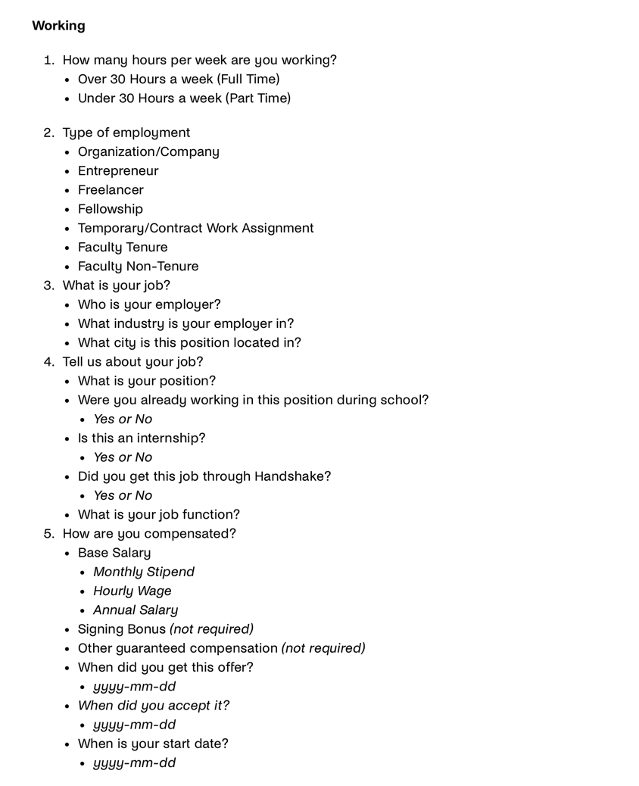

While there are many personal biases that may affect the validity of the salary numbers, such as a desire to portray LSU better with more income, a major issue of this survey is the “other guaranteed compensation” and the “(not required)” part that goes along with the data point.

This is a major issue since large companies offer many benefits, but one of them, healthcare, is also a top expense. Employer provided healthcare should be considered income, especially when comparing to other job offers that possibly do not. The part “(not required)” only discourages thought into “how else am I compensated?”

A better version would be to ask in the survey, “are you provided healthcare?”

From that, a rough estimated number could be generated.

While unlikely that people actually factored in healthcare, due to the wording of the survey and time intensity required by someone to value their noncore salary compensation package, in light of conservative estimates and the impossibility of knowing which jobs do and do not offer healthcare, this case study will add the cost of a common healthcare plan into the cost of “living comfortably” and will not add the possible compensation of healthcare into salary.

In addition, the response rate would preferably be much higher. Below is a chart provided by LSU of the response rate per senior college.

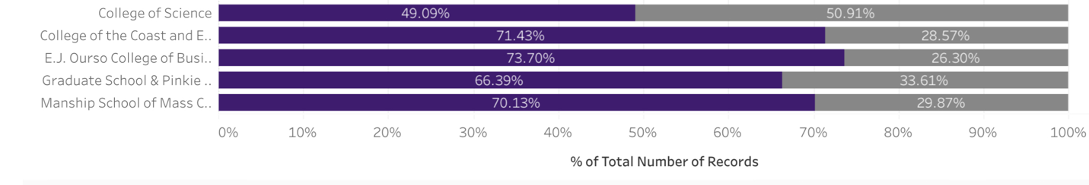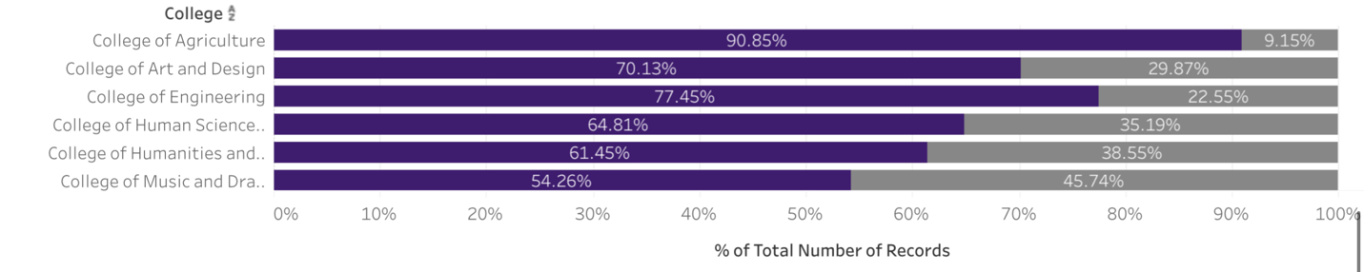

Under the idea that a larger percent response rate of the graduating group will yield more accurate information, data from engineering and agriculture should be the most accurate values, while the most inaccurate coming from the College of Science and the College of Music and Drama.

SALARY NUMBERS:

Listed below are the salary numbers from LSU(1.B). When data limitations do not apply, the 2019-2024 average salary numbers and the 2021-2024 average salary numbers are posted.

The two averages were done to see the impact covid had on pay.

Upon further analysis, Petroleum Engineering seemed to be the only major effected by covid, a time when oil prices went negative, with the average pay in the 2020-2021 graduating class dropping to $54,051 per year.

While covid may not have affected graduate salaries noticeably, inflation is an important factor to note, as the cumulative inflation from 2019-2024 was 22.63%(1.A). Salaries would ideally keep up with inflation. If a certain major group’s salary from 2021-2024 is not higher than from 2019-2024, that could be a sign of the labor market devaluing that major. This would also have to be corroborated with other salary data outside of LSU, as stating the job market is devaluing a certain major is quite bold. This study sticks only to the salary data LSU has provided and will not be making the mentioned claim, but the inflation dynamic is something to note.

This study sticks to undergraduate majors and only those that are offered at the Baton Rouge campus. Some majors do not have salary data for unknown reasons.

The Nursing School is not included and data on the nursing school pay is not readily available.

Accounting 2019-2024.    57,387

                      2021-2024.   57,972

Agriculture &

Extension Education

                   2021-2024    52,839

Agriculture Business

                   2019-2024.   58,657

                  2021-2024.  58,053

Animal Sciences

                  2019-2024. 35,885

                  2021-2024.  37,411

Anthropology

                   2019-2024.    36,960

                    2021-2024.    41,474

Architecture BARCH

                    2019-2024  50,824

                     2021-2024.  52,941

Art.

        2021-2024.    35,970

Athletic Training

                2019-2022.     35,467

Biochemistry

                  2019-2024.      34,846

                  2021-2024.        34,460

Biological Engineering

                2019-2024.          53,017

                  2021-2024.         56,113

Biological Sciences.

                 2019-2024.         32,411

                  2021-2024.         33,775

Business Analytics.    2022-2023   46,407

Chemical Engineering.

                                  2019-2024. 81,169

                                    2021-2024.     87,842

Chemistry

2019-2021.    42,711

                         2021-2024.  52,867

Child and family studies

                           2019-2024.    32,835

                            2021-2024.   34,931

Civil Engineering. 2019-2024.   62,523

                                2021-2024.   64,443

Coastal Environmental Science

                                 2019-2024.    38,697

                                    2021-2024.   35,665

Communication Disorders.

2019-2024.   32,092

2021-2024.   33,600

Communication Studies.

   2019-2024.      38,018

2021-2024.       35,957

Computer Engineering.

     2019-2024.    85,504

      2021-2024.   89,818

Computer Science.

         2019-2024.      73,666

         2021-2024.      78,161

Construction Management

2019-2024.  63,231

2021-2024.   65,577

Dual Cert Gen/ Spec Edu 1-5 BS

  2019-2024.    47,751

2021- 2024.   46,512

Early childhood education, no data

Economics BA

  2019-2024.    46,750

2021-2024.    46,750

Economics BS

2019-2024.     65,214

2021-2024.       66,818

Electrical Engineering

2019-2024.       79,414

2021-2024.        84,606

Elem Grades Education

2019-2024.      44,059

2021-2024.  44,594

English

2019-2024.   31,447

2021-2024 31,446

Entrepreneurship

2020-2024.   40,600

Environmental management Systems

2019- 2024.   49,300

2021-2024.  52,160

Environmental engineering

2019-2024.     72,353

2021-2024.   79,667

Film and Television BFA

2021- 2024.    29,640

Finance

2019-2024.   63,963

2021-2024.    66,911

French BA

No data

General Business

2019-2024.  48,199

2021-2024.    53,717

Geography. BA

2020-2024.   48,333

2021-2024.      45,000

Geography BS

2020-2024. 48,330

Geology - Professional BS.

2019-2024.  39,931

2021-2024. 55,00.

History

2019-2024.  42,904

2021-2024.    51,232

Industrial Engineering

2019-2024.  65,989

2021-2024.    67,394

Info systems and decision sci.

2019-2024.  64,271

2021-2024.    65,244

Interdisciplinary studies.

2019-2024.  54,217

2021-2024.   62,629

Interior Design.

2019-2024     39,729

2021-2024    41,745

Internet trade and finance.

2019-2024.  53,293

2021-2024.   57, 364

International studies.

2019-2024.    15,352

2021-2024.     12,000

Kinesiology.

2019-2024 31,621

2021-2024.    32,164

Landscape architecture.

2019-2024.    53,080

2021-2024.    54,654

Leadership and Human Resources

2020-2024 61,712

2021-2024 64,419

Liberal arts.

2019-2024.    34,543

Management BS.

2019-2024.  55,773

2021-2024.          58,677

Marketing Bs.

2019-2024.   44,897

2012-2024.       47,401

Mass communication.

2019-2024 39,637

2021 2024.   41,966

Math.

2019-2024. 56,311

2021-2024.    57,341

Mechanical engineering.

2019-2024. 81, 346

2021-2024.  80, 166

Microbiology.

2021-2024.   35,204

Music education BME.

2019 2024.  51,136.

2021-2024.   52,670

Music BA.

2019 -2024.    71,000

2021-2024   86,667

Music BM

2019-2024.  35,504

2021-2024.          19,560

Natural Resources Ecl & Mgt BS

2019-2024.       34,757

2021-2024.      35,612

Nutrition and Food science

2019-2024   34,489

2021-2024   37,052

Petroleum engineering

2019-2024.   85,495

2021-2024. 93,592

No data on philosophy

Physics

2019-2024      47,365

2021- 2024.    62,000

PreK teacher certification BS

2019-2024. 40, 704

2021-2024.  35, 744

Plant and soil systems

2019-2024.  35,150

2021-2024.   35,029

Political science

2019-2024 42,444

2021-2024.  46,160.

Psychology

2019-2024.   34,957

2021-2024.    34,283

Screen arts.  BA

2020-2024.  33,800

Social Work BSW

2020-2024.   32,690

Sociology BA

2019-2024.  40,352

2021-2024.   40,411

Spanish BA

2020–2024 61,760

2021-2024 73,333

Sports administration

2019-2024 39,657

2021-2024.   45,223

Studio art

2019-2024.   36, 781

2021-2024. 43,242

Textiles/ apparel/ merchandise

2019-2024 37,305

Theatre BA

2019-2024.  30,166

2021-2024. 34, 624

The “living comfortably” cost:

Apartments.com estimates that the “living comfortably” cost in Baton Rouge needs an income of $51,504 before taxes. The method of calculation would not be the most appropriate for a 22 year old recently graduated student, but does give a good reference for the calculations this study conducts.

While dependent person to person, below is the tally. This tally would be for an ideal case. (no debt of any kind and car prior to graduating)

Per year:

2 Bedroom Apartment $18,000

Health Insurance (1.E) $5,508

Car Insurance (1.D) $2,701

Food $7,200

Social $7,200

Charity $2,500

Miscellaneous $2,400

Gas $1,800

Total $47,809

Pre tax Income needed:

47,309 is after tax.

Here is the calculation for the salary needed before tax.

**Gross Income**: $59,174

**FICA Tax**: $4526.81 × 7.65% = $4526.811

**State Tax**: $1775.22 × 3% = $1775.22

**Taxable Income for Federal Tax**: $59,174 - $15,000(federal deduction) = $44,174

**Federal Tax Calculation**:

* 10% on first $11,925: $1,192.50​[legis.la.gov+4bipartisanpolicy.org+4nerdwallet.com+4](https://bipartisanpolicy.org/explainer/paying-the-2025-tax-bill-income-tax-rates-and-thresholds/)
* 12% on income between $11,926 and $48,475: $4385.88​[irs.gov+2nerdwallet.com+2bipartisanpolicy.org+2](https://www.nerdwallet.com/article/taxes/federal-income-tax-brackets)
* **Total Federal Tax**: $1,192.50 + $4,385.88= $5578.38​
* **FICA** $59,174 x .0765 = $4526.811

**Total Taxes**: $4526.811(FICA) + $1775.22 (State) + $5578.38(Federal) = $11,880.41

**Net Income**: $59,174 - $11,880.41 = $ 47,293.59

A person would need around $59,200 gross income to live comfortably in Baton Rouge.

Keep in mind this estimate is $7,696 over the apartments.com estimate and does include the cost of healthcare.

Majors that meet this requirement using either average:

Chemical Engineering.

                                  2019-2024. 81,169

                                    2021-2024.     87,842

Civil Engineering.

2019-2024.   62,523

                                2021-2024.   64,443

Computer Engineering.

     2019-2024.    85,504

      2021-2024.   89,818

Computer Science.

         2019-2024.      73,666

         2021-2024.      78,161

Construction Management.

2019-2024.  63,231

2021-2024.   65,577

Economics BS

2019-2024.     65,214

2021-2024.       66,818

Electrical Engineering

2019-2024.       79,414

2021-2024.        84,606

Environmental engineering

2019-2024.     72,353

2021-2024.   79,667

Finance

2019-2024.   63,963

2021-2024.    66,911

Industrial Engineering.

2019-2024.  65,989

2021-2024.    67,394

Info systems and decision sci.

2019-2024.  64,271

2021-2024.    65,244

Interdisciplinary studies.

2019-2024.  54,217

2021-2024.   62,629

Leadership and Human Resources

2020-2024 61,712

2021-2024 64,419

Mechanical engineering.

2019-2024. 81, 346

2021-2024.  80, 166

Music BA.

2019 -2024.    71,000

2021-2024   86,667

Petroleum engineering

2019-2024.   85,495

2021-2024. 93,592

Physics

2019-2024      47,365

2021- 2024.    62,000

Spanish BA

2020–2024 61,760

2021-2024 73,333

MUSIC BA:

Music BA’s averages are:

2019 -2024.    71,000

2021-2024.   86,667

Upon removing the 2023-2024 salary data, the average drastically drops to 24,000, indicating an outlier in the data that greatly skews the average in 2023-2024

Analysis of List Excluding MUSIC BA:

10 from the College of Engineering meets the “living comfortably” cost.

3 from the College of Business

3 from the College of Humanities and Social Sciences

1 from the College of Human Sciences and Education

1 from the College of Science

Conclusion: There are very few majors at LSU that enable a student to live comfortably after graduation.

They are:

Chemical Engineering.

Civil Engineering

Computer Engineering.

Computer Science.

Construction Management.

Economics BS

Electrical Engineering

Environmental engineering

Finance

Industrial Engineering.

Info systems and decision sci.

Interdisciplinary studies.

Leadership and Human Resources

Mechanical engineering.

Petroleum engineering

Physics

Spanish BA

“This dream is quickly becoming what’s known as a nightmare.” – Dave Ramsey

1.A [2019 dollars in 2024 | Inflation Calculator](https://www.officialdata.org/2019-dollars-in-2024..)

1.B [Graduated Student Outcomes | LSU Career Center](https://www.lsu.edu/career/outcomes/index.php)

1.C [Cost of Living in Baton Rouge LA - Compare costs vs. national average](https://www.apartments.com/cost-of-living/baton-rouge-la/)

1.D [How Much Is Car Insurance in Louisiana? (January 2025)](https://www.moneygeek.com/insurance/auto/average-cost-car-insurance-louisiana/)

1.E [Best Cheap Health Insurance in Louisiana (2025) - ValuePenguin](https://www.valuepenguin.com/best-cheap-health-insurance-louisiana)