Please complete this application form and return it to tj@dakalove.com. You will be notified by email of your acceptance for the 2018 class. Your place in Daka School will be reserved once your payment is received.

NAME: PHONE:

ADDRESS:

EMAIL:

Please check your previous Tantric Education with Source School of Tantra Yoga

_____ Certified Tantric Educator Level 1. _____ Certified Tantric Educator Level 2

_____ Certified Tantric Educator Level 3 Other Training:

To qualify for Daka School with Tj Barte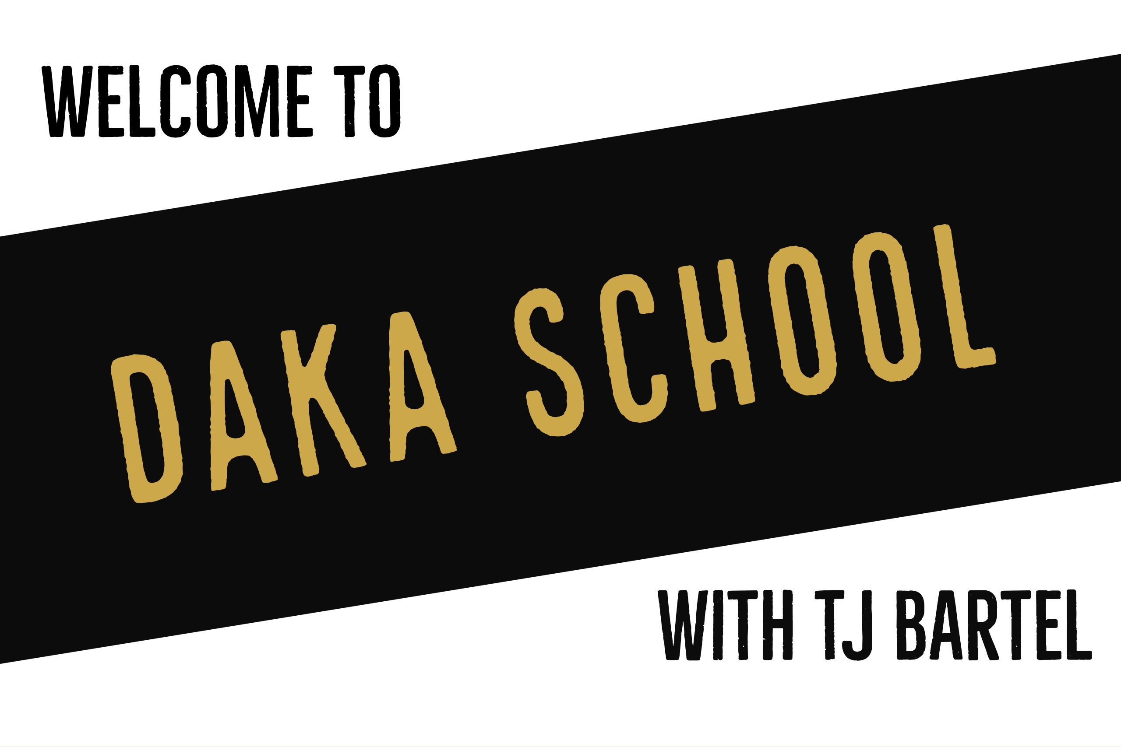l, you must have completed or be enrolled in at least CTE Level 1 with Source School of Tantra Yoga.

____ I am planning to take CTE Level 1 in December of 2017

How many sessions have you completed (please indicate how many are practice / professional)

What is your mission statement for your Daka business? If you do not have one, please create one and write it here:

What is your biggest strength and weakness as a Daka?

What do you hope to get from attending Daka School with Tj Bartel?

How did you hear about Daka School?