DECEMBER 2020 NEWSLETTER

Welcome to a new edition of the MPTTA monthly newsletter. We hope all members and their families are safe and well. Did you know the centre is now open most days and nights? If you want to dust the cobwebs off, come and have a hit. But you need to book as per COVID-19 regulations.
To Book, please call 0498 003 788. See our website www.mptta.org.au for details.

LES MISSES YOU. COME AND HAVE A HIT BEFORE WE BREAK ON THE 23RD.

2021 will see important changes to our club so that we can continue to grow and ensure inclusivity and sustainability for the future, as well as adapting to potential COVID-19 changes.

NEW NAME
We will be changing from MPTTA (Mornington Peninsula Table Tennis Association) to MFTTA (Mornington Peninsula and Frankston City Table Tennis Association), ensuring we become a regional hub, eventually with affiliated satellite centres on the Mornington Peninsula.

COMPETITION TIME CHANGES
- Reopen 11/1/2021.
- Effective start of 2021 season.
- All competition and grade nights (Mon, Tues, Wed, Thurs).
- Each night divided into EARLY session or LATE session.
EARLY session 6pm-7.30pm. LATE session 8pm – 9.30pm.
- The EARLY session allows families and younger players to finish at a reasonable time.
The LATE session allows those travelling from work that little bit of extra time to be ready to go at 8pm. This two session structure also better prepares us if there are any further COVID-19 changes.

ROUND ROBIN COMPETITION TO REPLACE SUMMER COMPETITION
Each year usually starts with summer competition. 2021 will be different as we have had such a large break due to COVID-19 and difficulties identifying who is coming back.
- Starts Monday, 1st February in place of usual summer competition, so get your name down early.
- The first week will be practice play followed by round robin competition for 8 weeks.
- Normal Autumn competition will follow with new time slots.

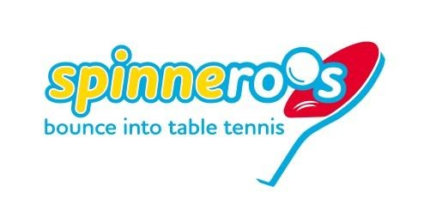
SPINNEROOS
MPTTA is proud to partner with TTA and TTV to become one of the first centres in Australia to offer the very successful Spinneroos program to our club. (see www.spinneroos.com.au Home - Spinneroos).

- What is Spinneroos?
8 -week program aimed at primary school age boys and girls (5-12 yo) to develop fundamental movement skills and social skills through fun activities while making new friends in a safe environment.

- Is this like table tennis coaching?
No. It is age- appropriate FUN activities to develop SKILLS and FRIENDSHIPS.

- When does it start? Early Feb 2021.
- Do you have girls only Spinneroos? Yes.

- What’s the cost?
$90 per child for Regular (mixed) Spinneroos or $50 for girls only
(subsidised).

- What does my child/grandchild get for $90/$50?
8 week program with Spinneroos coaches Sally, Sarah, Juan, Peter, David.
Player Kit containing Spinneroos T-Shirt with their name, bat, balls, bag.
Social membership to MPTTA for 12 months, plus accident insurance.

- Do I need to book? Yes, numbers are strictly limited.

For more information and to register visit the website www.spinneroos.com.au or contact
MPTTA for information at mptta88@gmail.com or david42harmony@hotmail.com.

Get the kids or grandkids and their friends involved.

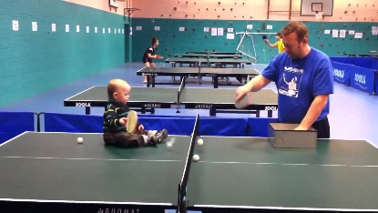
Maybe a bit young!!!

KEENAGERS
- Doubles is back.
- You still have a few weeks to get in and play doubles.
- Centre closes on 23/12/2020.
- Centre reopens on 11/1/2021.

All ABILITIES
Did you know that Thurs 3 Dec was The International Day of People with Disability (IDPWD).
Les has been instrumental in implementing and continuing the ALL ABILITIES program, leading to awards for the programs run and MPTTA along with its co-tenants are seen leaders in this area.

Check out the inspiring You Tube video specific to the Mornington Peninsula and features our hard working Les. https://youtu.be/3qpfbfx-SUg

Finally, the MPTTA board of Directors wish you and your families all the best over the festive season.

The centre will reopen on 11/1/2021.

