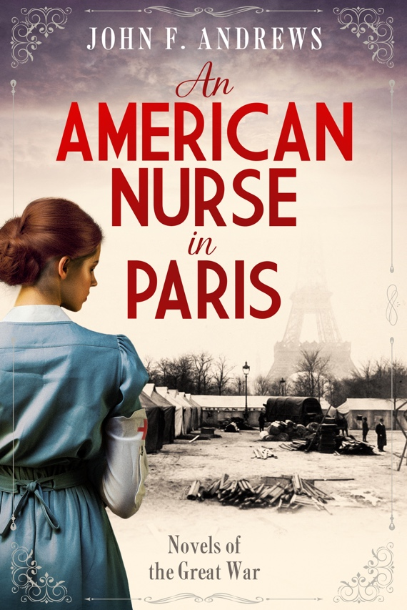

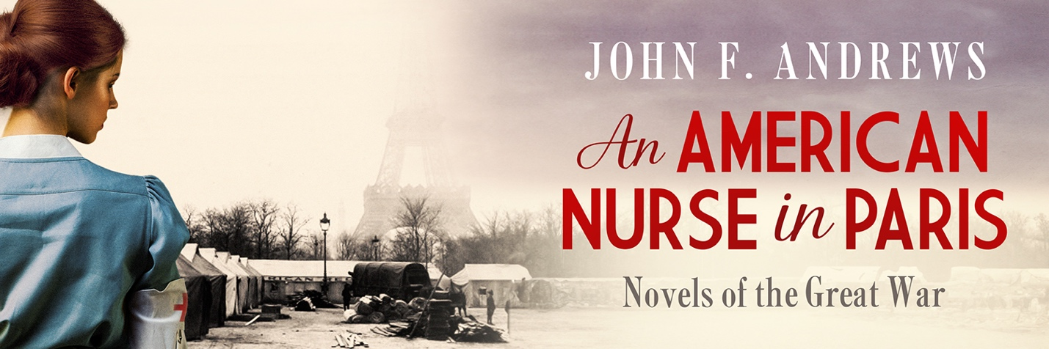

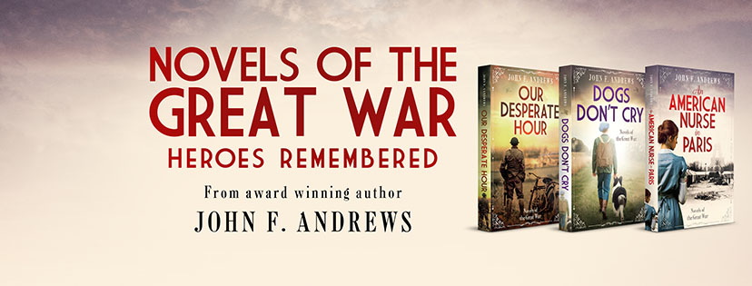

**Fans of inspiring war narratives will find much to love in this novel.**

**Rousing historical fiction with a feminist bent.**

**KIRKUS STAR AWARD. “Get It” recommendation.**

***Kirkus Reviews***

2023 Foreword Indies Awards: Bronze winner, War & Military

6/6/24

<https://www.forewordreviews.com/awards/winners/2023/war-and-military/>

Kirkus Reviews Star Award.

Finalist in the following awards:

2024 Eric Hoffer Award: Finalist

2024 International Book Awards: Best New Fiction

18th Annual (2024) National Indie Excellence Awards: Historical Fiction; Military Fiction

**Reviews of *An American Nurse in Paris***

As a historian of WW1, I found this wonderful book to be a well-written fictional account of the period. The Marine Corps references were accurate and brought some of the memorable characters of the war to life. Enjoyed it. Looking forward to the rest of the series.

Col. William T Anderson, USMC (Ret), author of numerous WWI historical works.

American Nurse in Paris is a great read. I learned a lot about WWI, especially medical care for wounded soldiers and Belleau Wood, the battle that was key in making the Marine Corps what it is today. John Andrews knows the power of story to educate and entertain, how to put readers on the edge of their seats and keep them there with great characters, crisp writing, and rich detail of the time and place. Andrews puts the reader in the sexism of the time side-by-side with a nurse who proves herself more than a match for her antagonists. Andrews did a fabulous job with his debut.

Scott Hibbard, author of *Beyond the River Gila*

John Andrews' extensive research and knowledge of World War I comes through clearly in this fascinating glimpse into a period of American history that Andrews shines a needed light on. He deftly develops his main characters, especially Alice whom I was rooting for throughout. John's medical background as an ER physician adds superb realism to the human costs of war. His secondary characters come alive throughout and the bad guys are very bad, which is very good. This is a sweeping saga of war, sexism, honor, regret, and finally retribution, that you will find hard to put down!

Mike Toreano, award winning author of *Fireflies at Dusk*, and others.

Set in France during World War I, this is an enthralling story of a young nurse’s quest to be a war reporter when women weren’t welcome at the front. The author—who’s a doctor with a son in the U.S. Marines—brings realism to both hospital and battle scenes. The main character Alice Simmons is engaging, stubborn, and ambitious, but we love her because her actions are tempered with a nurse’s sensibility and a young woman’s vulnerability. She’s beset with adversaries, but also allies, all of whom are fascinating characters in their own right. I thoroughly enjoyed every page! I’m looking forward to the promised sequels.

Margaret Rodenberg, award winning author of *Finding Napoleon.*

**Blurb:**

Medical journalist Alice Simmons has one last chance to stay alive in this story of courage, humility, determination, compassion, and hope during the last year of World War One.

Medical journalist Alice Simmons’s quest to become a war correspondent careens headlong into a wall of sexism and deceit after her arrival in Paris in 1918. The suave officer in charge of the American Army press office refuses to let Alice leave Paris while her male counterparts scramble to the Front during the German spring offensive. One evening, his misogyny escalates to a drunken assault. Alice manages to fight back, but then her attacker begins a campaign of false accusations to cover his crime.

A nursing position in an American Red Cross military hospital is Alice’s only hope to remain in France. It turns into the best scoop of her career. Wounded marines and soldiers from the Battle of Belleau Wood flood her ward. A tragic death amid the human wreckage of war unlocks Alice’s compassion and her capacity to love, both long-buried after a childhood tragedy. Her patients’ courage inspires Alice’s fight to restore her honor. Their plight and compassion open her heart.

**Short Description:**

Medical correspondent Alice Simmons turns defeat into the scoop of her career after an assault ends her journalistic ambitions and forces her work as a nurse at an American Red Cross hospital during in 1918.

**From the Author on Amazon:**

*An American Nurse in Paris* is written to honor the American women who went to France to serve during the First World War. It shows how poorly they were treated by the American press corps and the challenges nurses and nursing aids faced. It remembers the Marines and soldiers who fought in the epic Battle of Belleau Wood and shows the aftermath of battle on those wounded in action.

The novel explores the effects of PTSD, resilience, hope, and love—though it is not a romance novel. Themes include honor, courage, commitment, fortitude, compassion, and the bond among comrades, including the nursing and medical personnel.  
   
This award winning novel is ideal for book clubs.

Additional information from and about the author.



John F. Andrews was inspired to write fictional accounts about World War One by his sons, who both joined the United States Marine Corps in the early 2000s. He did a deep dive into Marine Corps history, lore, and current events and discussed USMC history with a number of Marines over the years. One thing that impressed him was how little any of them knew about the role of the USMC during WWI. The stories he read in histories and memoirs were incredible, courageous, heroic, and deserved to be told. While there are a number of history books to draw from, his Marine sons assured him that very few Marines sit around and read them. They want something more vital, active, gripping.

Nobody wants to fail a mission given to them by Marines! Through extensive years-long research and two trips to the USMC battlefields of WWI, the stories took shape. Andrews’ goal is enable readers to see and feel events through first-person fictional characters working shoulder to shoulder with the real people who fought the battles or were affected by them. To walk in the company of forgotten heroes, particularly the medical ones who are so-often ignored. *An American Nurse in Paris* is his debut novel, published on 11/7/23, just a few days before the 248th Birthday of the USMC. It is an inspiring novel in which Medical Journalist/Nurse Alice Simmons transforms journalistic defeat into the scoop of her career after signing up to nurse American Marines and soldiers wounded in the Battle of Belleau Wood.

Fiction writing is Andrews’ second or third career. He earned his MD degree from the University of Minnesota Medical School in 1975. He then trained and earned board certifications in Internal, Pulmonary, Sleep, and Critical Care Medicine, and then worked in Green Bay, Wisconsin, from 1985 to 2016. Retirement is little more than a change in job description with a dramatic drop in pay. Thus, he was swept up into a short career as a volunteer firefighter after he moved to Montana. That service included working at the medical officer for his fire department. He began his fiction writing career in 2012 but “got the rubber on the road” in 2023 with the publication of *An American Nurse in Paris*. The next two novels, *Dogs Don’t Cry* and *Our Desperate Hour* provide readers with a 180-degree experience of The Battle of Belleau Wood and were both published in 2024.

This novel crosses genres: it is accurate historical fiction, war & military fiction, and women’s fiction. It is ideal for book clubs but is equally loved by women and men readers alike.

**Novel details:**

*An American Nurse in Paris – Novels of the Great War* is available through the following:

Amazon:

<https://www.amazon.com/American-Nurse-Paris-Novels-Great-ebook/dp/B0CLL1T89T/>

Apple Books:

<https://books.apple.com/us/book/an-american-nurse-in-paris/id6738197201?ls=1>

Kobo:

<https://www.kobo.com/us/en/ebook/an-american-nurse-in-paris>

Ingram Spark paperback:

<https://shop.ingramspark.com/b/084?params=oTIv8xeAVF8MrsUmSjsKyjrsvuSjz4LmSWk4DXBG4am>

and for the hardcover through IS:

<https://shop.ingramspark.com/b/084?params=PaNWdqKcYWBGpAKkEbqHsZ6gdAPePWYzNtS8MoaE9yV>

Direct purchase links can be found at:

<https://johnfrederickandrews.com/where-to-buy>

*An American Nurse in Paris – Novels of the Great War*

Author: John F Andrews

Publisher: 46 North Publications.

Publication date 11/7/23

326 Pages (paperback and hardcover).

Digital: $6.99; paperback: $15.99; Hardcover: $23.99

Standard paperback and hardcover discounts to libraries and booksellers through Ingram Spark.

Author website: <https://johnfrederickandrews.com>

Facebook: <https://www.facebook.com/JohnAndrewsFiction>

Instagram: <https://www.instagram.com/johnandrews63/>

Amazon author page: <https://amazon.com/author/johnf.andrews>

Author newsletter sign up at: <https://46-north-publications-llc.kit.com/743a603dd0>

ISBN:

Digital: 979-8-9893835-0-4

Paperback: 979-8-9893835-1-1

Hardcover: 979-8-9893835-5-9

ASIN:

eBook: ASIN: B0CLL1T89T

Paperback: ASIN: B0CMXMW79F

Hardcover: ASIN: B0CN1VZD6L

Media Contact: For a review copy of *An American Nurse in Paris – Novels of the Great War* or to arrange an interview with John F Andrews, contact John F Andrews at 46 North Publications, llc by email at [jandrews@46north.net](mailto:jandrews@46north.net), or by phone: +1-920-621-5717.