**An Introduction to Phonics**

A Prospero Teaching CPD

Phonics is the teaching of Reading and Writing in the early years and KS1 stages of primary school. It serves as the introduction to letters and sounds and develops the learners phonemic awareness.

**Keywords:**

Phonics – The way we teach reading and writing.

Grapheme – The written letter used to represent a sound.

Phoneme – The sound of a single grapheme.

Digraph – To letters that make up one sound (sh)

Blending – Combining phonemes to sound out a word.

Segmenting – Breaking down a word into its phonemes and graphemes to sound it out.

Phases – There are 6 phases of phonics that progress and should be taught in order.

CVC Words – Consonant – Vowel – Consonant words such as ‘Cat’.

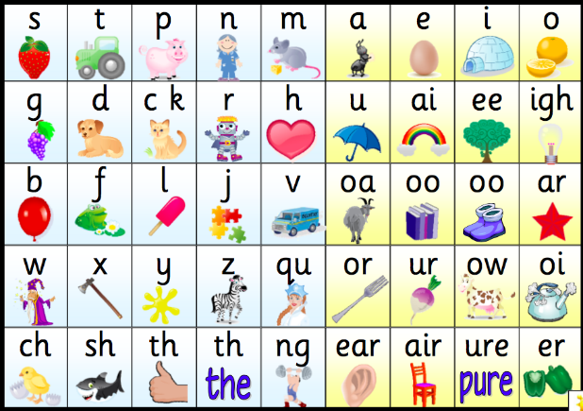Sets – Groups of graphemes to be taught in sequence.

* Learners need the ability to hear, identify and manipulate **phonemes**.
* Pupils use their phonemic knowledge to understand spelling plans.
* There are 44 **phonemes** in the English Language.

Different **graphemes** can represent the same **phoneme**:

* ‘A’ sound 🡪 ai ay eigh a-e

**Digraphs:**

Queen shoe chips

**Blending:**

B - e - d 🡪 Bed

**Segmenting:**

Bed 🡪 B - e - d

Tricky Words – These are taught to children as whole words because they are common but hard to sound out using basic phonics knowledge.

* The He She

Schemes of work:

The Government has produced a scheme of work called ‘Letters and Sounds’ (2007). There are other schemes of work however, such as ‘Read, Write, Inc’ and ‘Jolly Phonics’. The school may also have their own scheme of work based on Letters and Sounds.

Phonics Lesson Structure:

**Review** – Look back at graphemes and phonemes already learned.

**Teach** – Introduce a new grapheme/phoneme.

**Practice** – Practice writing words sing the grapheme.

**Apply** – Apply new knowledge to reading and writing sentences.

**REVIEW 🡪 TEACH 🡪 PRACTICE 🡪 APPLY**

Phonics Play

Mr Thorne

Alphablocks Online Resources

Sound Mats

Pinterest

The 6 Stages of Phonics:

**Phase 1:**

Teachers should introduce sounds using:

* Environmental Sounds
* Instrumental sounds
* Body Percussion
* Rhythm and Rhyme
* Alliteration
* Voice Sounds
* Oral blending and segmenting

**Phase 2:**

Children begin to use specific grapheme sets.

Set 1 - s a t p

Set 2 – I n m d

Set 3 – g o c k

Set 4 – ck e u r

Set 5 – h b f ff l ll ss

Some tricky words introduced such as – to the no go I into

Should last approximately 6 weeks.

**Phase 3:**

Should last approximately 10 weeks.

Introduce Sets 6 and 7.

Set 6 – j v w x

Set 7 – y z zz qu

Consonant Digraphs:

Ch sh th ng

Vowel Digraphs:

Ai ee igh oa oo oo ar or ur ow oi ear ure er

**Phase 4:**

Should last approximately 4 weeks.

* Revise all grapheme sets
* Introduce new tricky words:
  + Said have like so do some come were there little one when out what

**Phase 5:**

Usually begins in Year 1

New digraphs:

* Ay ou ie ea oy ir ue ue aw ew oe au ey wh ph

Introduce split digraphs:

* a—e e—e i—e o—e u—e

New tricky words:

* oh their people Mr Mrs looked called asked could

**Phase 6:**

* Introduce past tense
* Polysyballic words
* Contractions
* Common grapheme positions
* Suffixes

Ideas for Phonics Activities:

**Robotting –**

* Helps to hear all the sounds
* Children should complete an action for each sound so the teacher can see they know each sound is different.

**Sound Buttons:**

Helps to identify sounds and digraphs.

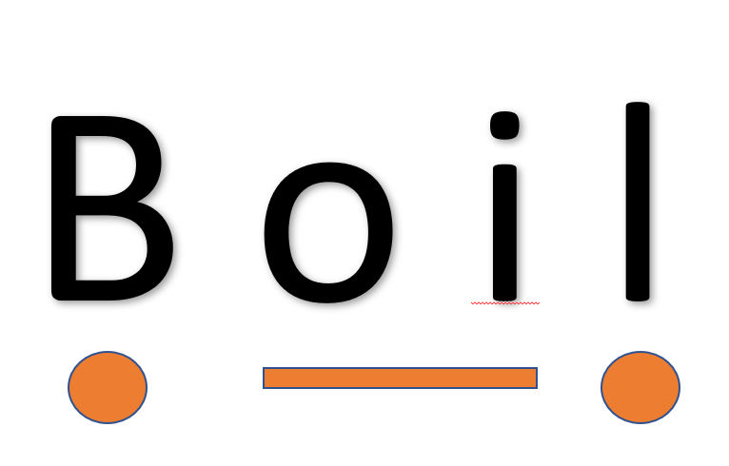

**Grapheme Bingo:**

* Create a 2x2, 2x4 or 3x3 grid and fill with graphemes.
* Teacher reads out graphemes or words and children cross of when they hear it.

**Countdown:**

* Give children a set of graphemes and they need to make as many words as possible using those grpahemes.

**Silly Sentences:**

* Read and write sentences using the grapheme words.
* Children must say if it is true of false and correct it.