Mr A Giles

Primary Science Education + QTS

Edge Hill University

DBS Number: 001624879962

23923237@edgehill.ac.uk

07889 438950

Dear Parents/Guardians,

I would like to introduce myself to you. My name is Mr Giles and am a student teacher starting in Miss XXXXX’s 2C class. I will be starting on the 23rd of November and will be at XXXX XXXX until the 12th March 2021. In that time I look forward to getting to know your child and I aim to provide an engaging learning experience.

This will be my third phase of professional practice and I am in my third year of a Primary Science Education degree at Edge Hill University in West Lancashire. I am a science specialist as well as minoring in History and I am very passionate about these two subjects. Although I specialise in science and history, I aim to provide a balanced learning experience that covers the entire curriculum in the hopes of allowing your child to develop new skills across a wide range of subjects.

I understand that we are in unprecedented times and that safety is of the upmost importance when in a school. Please know that I will be following XXXX XXXX’s health and safety policy in regards to the new COVID-19 restrictions and I will do all I can to create a safe environment for the class and the school.

I look forward to my time here at XXXX XXXX and I would like to thank Miss XXXXX and Mrs XXXXX for allowing me to teach in this wonderful school. If you would like to contact me about anything my contact information is above and I would happily answer any questions you may have.

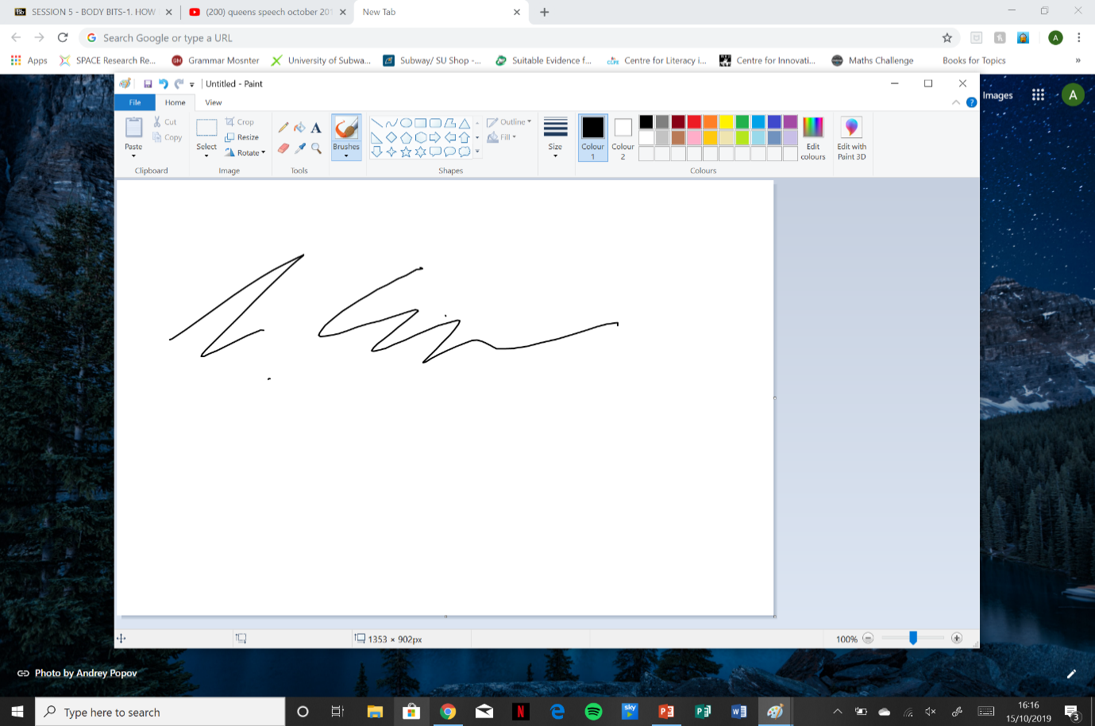Yours sincerely,

Mr A Giles