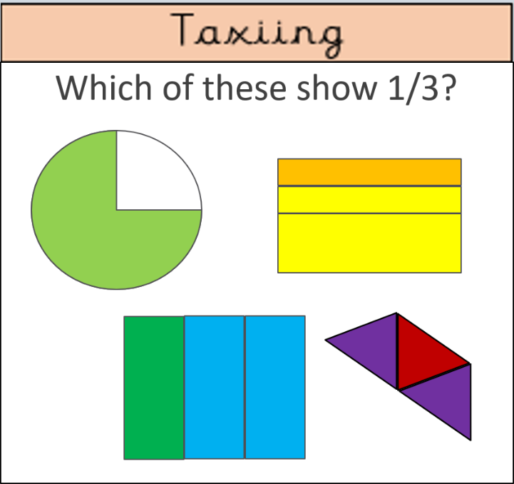

These are the typical difficulty levels of tasks. They range from Working Towards fluency, Age-Related fluency, Age-Related reasoning and a Greater Depth reasoning. The children are aware of the level of challenge of each task, Taxiing, Take-off, Soaring and In-Flight and they are able to choose where they want to start. This allows the child to show me how they think they are grasping the concepts as well as pushing themselves to do the more difficult challenges. I have found that because there are more difficult challenges to work towards, children are more motivated to push themselves towards the more challenging work. I scaffold learning by setting certain challenges to certain students in different topics, when either I know they don’t need to start on the easiest challenge and they are just doing that out of laziness, or if I know that a child needs more work in a certain topic so they should have a secure foundation in fluency before tackling reasoning problems. This differentiation strategy is effective as it removes the concept of ability-based learning, which often demotivates lower ability children and can hurt their self-confidence as they see that they are not ‘smart’ enough for the higher challenge work. This strategy has shown me that when children are low-ability in one area of mathematics, they might be confident in another and allowing them to choose their starting point allows me as the teacher to formatively assess their confidence and ability in each subject.

