Medical SME Written Assessment

Date | Provider | Medical Facts | Comments / Professional Opinion | Page #
07.25.2021 | Dr Matthew Bludom, DO  St Joseph Health Emergency Record | Patient Data  Complaint: ATV accident  Triage Time: Sun Jul 25, 2021 18:22  Urgency: 2 Emergent  Initial Vital Signs: 7/25/2021 18:21  BP: 156/107 [high but normal in setting of trauma]  MAP: [blank] R: 16 [normal]  T [temp] 98.9 P: 100  Pain: 10 O2 sat: 95% on room air  TRIAGE:  Complaint: ATV accident  Assessment: lower back and neck pain s/p ejected from vehicle  Triage Screening: patient denies suicidal ideation  Treatments in progress: C-Collar in place  Social History: patient drinks socially, every week, patient denies drug use, patient has no smoking history, lives at home with family  HISTORY OF PRESENT ILLNESS:  46 year old male presents to the ER with a complaint of neck pain, left shoulder pain, left shoulder numbness, left upper back pain, left lower back pain which began prior to arrival [required to document that symptoms occurred prior to arrival so no one can later claim that symptoms only started after coming to the hospital]. Patient reports that he was mowing his pastor [typo? pasture] when his gator tractor ran over a post and he was ejected from his Gator. The patient reports positive LOC [loss of consciousness] and states that the only thing he remembers is waking up standing in the field. The patient denies any chest pain, shortness of breath, abdominal pain, nausea, vomiting, diarrhea, or other symptoms at this time.  Chief Complaint: patient presents for evaluation of ATV accident  Historian: History provided by patient  Mechanism of Injury: Vehicle accident, all-terrain vehicle  Location: symptoms are localized, most severe to left neck, left upper back, left lower back  Quality [of pain]: pain is sharp in nature, described as stabbing  Severity [of pain]: Maximum severity of symptoms moderate, currently symptoms are moderate  Time Course: Sudden onset of symptoms, just prior to arrival, There has been no change in the patient’s symptoms over time.  Associated With: associated with neck pain… Associated with back pain…associated with shoulder pain…Associated with headache, associated with loss of consciousness, associated with numbness  Exacerbated by:…exacerbated by extension [bend backward].. exacerbated by flexion [lean forward toward toes]  Relieved by: … relieved by nothing  ROS [REVIEW OF SYSTEMS]  All findings were negative except for the following:  Musculoskeletal: Historian reports back pain, reports fall, reports injury, reports joint stiffness, reports neck pain, reports left shoulder pain.  Neurologic: reports headache, reports mental status changes, syncope [passing out]  PHYSICAL EXAM  All findings were negative except for the following:  Neck: tenderness, midline, lateral  Back: tenderness, midline to the lower back, paraspinal to the left lower back, left upper posterior back  RADIOLOGY INTERPRETATION:  Head: head CT negative, no bleed, no mass, no acute ischemic [clot blocking blood vessel] stroke, no acute changes  Neck: cervical spine CT negative, no fracture, no subluxation, no bony lesion, no cord compression  Abdomen: Abdomen/Pelvis CT scan, Impression: incidentally [found purely by chance] noted thyroid nodule for which non emergent follow up thyroid ultrasound is advised. No acute post traumatic abnormality is appreciated within the chest, abdomen, pelvis, thoracic spine or lumbar spine  DOCTORS NOTES:  Re-Evaluation: … Overall well appearing and fully alert and oriented. He had full active range of motion throughout. Multiple superficial contusions and abrasions.  Text: Patient has equal strength and full range of motion of bilateral upper and lower extremities [arms and legs]. No sign of fracture, dislocation, subluxation, compartment syndrome, or neurovascular injury. Patient symptoms improved after ER treatment. He is stable discharge home.  DIAGNOSIS:  Final: PRIMARY: closed head injury ADDITIONAL: back contusions, low back pain | R: respirations [times you take a breath in 1 minute]  P: pulse [how fast heart is beating in 1 minute]  BP: blood pressure  s/p [(status post) term to refer to a treatment (often surgical procedure) or event, that patient has experienced previously i.e. s/p dog bite]  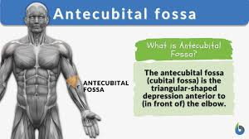  AC [antecubital]: on the front surface of the bend in the elbow  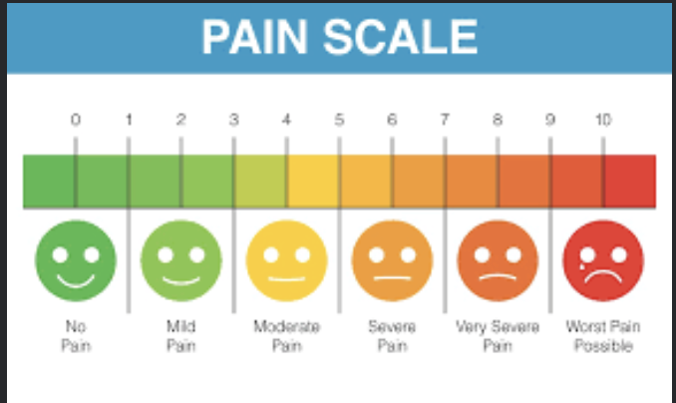  ** Patient’s name, SSN, DOB were not redacted on pg 9/19**  ATV: all-terrain vehicle  Lateral: toward the side of; away from the middle or center of the body  Acute conditions are severe and sudden in onset.  Subluxation: Subluxation is the medical term for a partial dislocation.  Cord Compression: when something is pinching on the spinal cord  Superficial: At the surface or just below skin  Abrasion: superficial scrape of skin  Active range of motion [AROM]: This is the space in which you move a part of your body by using your muscles. You make the effort without outside help.  Closed Head Injury S09.90XA | Copy of CHI St Joseph Health Medical Records.pdf pg 9-14/19
07.25.2021 |  | TRAUMA FLOW SHEET – ST JOSEPH HEALTH  Chief Compliant: ejection from ARV, LOC +, back and shoulder pain  Injury Date: 7/25/21  Injury Time: 17:00 [military time for 5:00pm]  Arrival Time: 1822 [military time for 6:22pm]  Mechanism of Injury: patient was driver of ATV  Primary Survey & Interventions  Airway: patent [normal, no obstructions to breathing]  Circulation: normal color, skin dry/warm, staff able to feel strong pulses in extremities  Breathing: spontaneous & regular [not requiring help to breathe]; both lungs sound clear  Neuro: patient is alert [normal finding]  Pupils: normal and responsive to light [normal finding]  Blood Pressure: 150/98 [high but normal in this setting]  Pulse: 87 beats per minute [normal]  Respirations: 21 breaths per minute [slight fast but normal in this setting]  Oxygen Saturations: 97% [normal finding]  Pain: 5/10  GCS [Glasgow Coma Scale]: total 15 [normal finding – no neurological deficits]  Secondary Assessment  All exam findings were negative [normal] except for the following: bilateral tenderness to back.  Patient had a C-collar on but was removed by Dr Bludom  Trauma Flow Sheet  Patient’s vital signs [blood pressure, heart rate, respiration rate, pain score, GCS] was checked every 30 minutes and no significant abnormalities noted. Patient remained stable.  ER Timeline  1840: …nursing greeted patient  1851: Pt [patient] transported via stretcher to CT  1903: returned to room  2010: IV removed; significant other assisted pt with dressing  2020: Pt ambulated [walked himself] with slow and steady gait to w/c [wheelchair]. Significant other drove pt [patient] home  Patient was given 1000 ml of IV fluid during ER visit  Patient was discharged from the ER at 2115 [military time for 9:15pm] | Assessing the color and temperature of distal extremities i.e. feet gives an indication of whether there is adequate circulation to that part of the body. Normal skin color is pink. Normal temperature is warm.  Assessing the pulses in the distal extremities i.e. feet will also allow the doctor to tell whether the blood flow to the feet are normal.  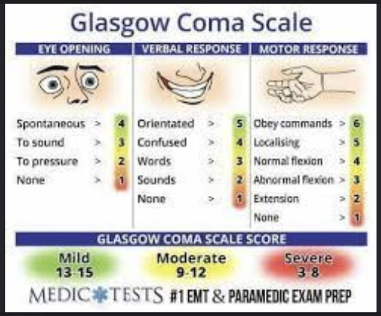 | Copy of CHI St Joseph Health Medical Records.pdf pg 1-5/19
07.25.2021 | St Joseph Health | DISCHARGE INSTRUCTIONS RECEIPT  Final Diagnosis: closed head injury  Additional Diagnosis: back contusions, low back pain  Follow up with primary care physician in 2-3 days  Return to the ER with any new or worsening symptoms.  FOLLOWING MEDICAL INSTRUCTIONS WERE GIVEN:  - Shoulder contusion  - Low back pain injury  - Closed head injury no wakeup adult  FOLLOWING [printed] PRESCRIPTIONS WERE GIVEN:  - Flexeril 10mg – take 1 tablet every 8 hours PRN [as needed] Dispense: 20 tablets  - Ibuprofen 800mg – take 1 tablet every 8 hours PRN [as needed] Dispense: 30 tablets | Closed brain injuries happen when there is a nonpenetrating injury to the brain with no break in the skull. A closed brain injury is caused by a rapid forward or backward movement and shaking of the brain inside the bony skull that results in bruising and tearing of brain tissue and blood vessels.  Contusion: medical term for a bruise | Copy of CHI St Joseph Health Medical Records.pdf pg 6-7/19
11.22.2021 | Pam Dobbs, NP | PRIMARY CARE VISIT  Chief Complaint: back pain, discuss referral  HPI: same as previous  No abnormal findings found on physical exam  ASSESSMENT:  - Lumbar pain – M54.50 (Primary)  - Lumbar paraspinal muscle spasm – M63.830  - Left inguinal hernia – K40.90  PLAN:  - Start Methylprednisolone [steroid] Therapy Pack [this is a titrated dose, starting high and slowly decreasing dose before stopping  - Start Zanaflex 2mg [muscle relaxer] – take 1-2 capsules as needed 3 times a day  - Referral to Sports Medicine and Orthopedics for evaluation of lumbar sacral [lumbosacral] narrow and increase pan | ATV: all terrain vehicle  PCP: primary care provider | Copy of City of College Station Employee Health Clinic (Medical Records).pdf pg 1-7/7
12/13/2021 | Dr Kory Gill, DO  Central Texas Sports Medicine and Orthopaedics | Reason for Appointment:  - Lower back  - L-spine 4V  History of Present Illness:  47 yo male presents for initial evaluation of low back pain. Pain description: sharp pain around low back belt line. Frequency of pain: constant. Duration DOI [date of injury] 7/25/2021. Accident caused pain. Pt [patient] was ejected from an ATV and had LOC [loss of consciousness] so does not remember how he landed. Pt was taken to the ER immediately after the accident and fractures were ruled out. Pt has recently started a muscle relaxer from his PCP 6 weeks ago. He has completed physician’s directed conservative rehab since October 2021 (6 weeks) without improvement. Pain Studies X-ray at CTSM 12/13/21.  What improves pain? Rest  What worsens pain? Back extension, standing, sitting  Symptoms associated with pain: patient describes sciatic pain into bilateral glutes [muscles of the buttocks]  Pain Scale: 6  EXAMINATION:  All findings negative [normal] except for the following:  Palpation: tenderness and spasms around paraspinal muscles  ROM [range of motion]: back ROM limited and hip ROM limited slightly; painful flexion/extension  ASSESSMENTS:  - M54.17 Lumbosacral radiculitis  TREATMENT:  - Lumbosacral radiculitis: Imaging MRI: Spine, Lumbar w/o contrast  - Setup MRI for persistent radicular symptoms despite rehab last 6 weeks and alleve [Aleve]/muscle relaxer | Numerical Pain Score on scale of 1 to 10 with 10 being worst pain imaginable  Palpation: a method of feeling with the fingers or hands during a physical assessment to assess various parts of the body  The paraspinal muscles are the "action" muscles of the back. When they work, the result is the obvious movement of your spine. These muscles course down your back and spine and help to move your spine into extension, rotation, and side bending.  Lumbosacral radiculitis = lumbosacral radiculopathy.  Lumbosacral radiculopathy, also known as sciatica, is a pain syndrome that occurs when nerve roots in the lower back are compressed or irritated.  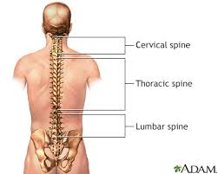 | Copy of Central Texas Sports Medicine_Orthopedics (Medical Records).pdf pg 1-2/2
12.21.2021 | Bryan Radiology Associates | MRI OF LUMBAR SPINE WITHOUT CONTRAST  Indications: Lumbar radiculitis  Impression: Disc bulge/protrusions at L4-5 and L5-S1 |  | Copy of Bryan Radiology Associates pg 1-2/2
01.13.2022 | BCS Pain Clinic | CURRENT PROBLEM LIST:  - M51.17 Intervertebral disc disorder with radiculopathy, lumbosacral region  CHIEF COMPLAINT: low back pain  HISTORY OF PRESENT ILLNESS: On 07.25.2021 patient was driving a UTV on his property and struck a pipe. He was ejected from the UTV causing injuries to his lumbar spine.  S1:Evaluation and management of low back pain  - Location: midline, lumbar region; bilateral (right worse than left) and midline sacral region, bilateral (right worse than left)  - Quality: aching, soreness, tightness  - Severity: pain rated as 8/10 [scale 1 to 10]. Qualitatively the pain is rated as moderate-to-severe. Functional impairment is moderate. When pain is present it will interfere with some of patient’s daily activities. Pain interferes with sleep regularly.  - Timing: patient experiencing low back pain at time of exam  - Referred/Radiating Symptoms: patient is experiencing the same quality of pain in both buttocks that he is experiencing in the lower back. Pain also present in posterior aspect of the right hip; and posterior aspect of the right thigh.  - Setting of Injury: Injury occurred as a result of trauma. Patient was driving a UTV on his property and struck a pipe. He was ejected from the UTV causing injuries to his lumbar spine. Injury occurred on 07.25.2021  - Aggravating Factors: Pain is worse when he is lying on the affected side and when he makes any movements involving his lower back  - Relieving Factors: Pain is relieved when patient changes position or adjusts the position of his back. Stopping the activity that aggravates it will also relieve the pain  - Previous tests and diagnostic procedures:  -MRI of lumbar spine  - Previous treatments and Responses:  -applying ice packs: pain unchanged  -applying heat: pain unchanged  -home exercise program: pain unchanged  -Over the counter medication: Aleve; effectiveness fair  -Prescription medication: Tizanidine HCL, effectiveness fair  REVIEW OF SYSTEMS: [these are descriptions given by patient]  Musculoskeletal: muscle pain, muscle tenderness, back pain  The following systems were reviewed and are negative: constitution [general terms including how patient is feeling], cardiovascular, Ears, Nose, Mouth, Throat, Endocrine, Eyes, Gastrointestinal, Genital/Urinary, Hematological [blood disorders, no abnormal bleeding] /Lymphatic [system in body that transfers fluid around – negative means no fluid retention], immunologic [immune system], Integumentary [skin], Nervous [nerves], psychiatric [mood, anxiety], respiratory [lungs/breathing]  PAST, FAMILY AND SOCIAL HISTORY:  Current Medications: not currently taking any medications  Medication Allergies: no known drug allergies  Non Medication Allergies: no information provided  Provider has reviewed current medications, medication allergies, and PFSH/ROS  OBJECTIVE:  Constitution: Height 6ft Weight 250lbs BMI 33.9 [considered obese]  General Appearance: well developed; well nourished; oriented x4; well groomed; cooperative; appears healthy  Ability to communicate: normal [no barriers noted such as language barrier, hard of hearing or medical literacy etc]  Musculoskeletal: Examination of gait and station is normal. (Patient is able to undergo exercise testing and/or participate in exercise program)  Lumbar Spine:  - straightening of the normal lordosis - moderate.  - Muscle tenderness bilaterally in a symmetrical distribution [same on both sides] in the paraspinous muscles – moderate.  - No muscle spasm.  - Active ROM [range of motion].  - Flexion restricted to 40 degrees; low back pain bilaterally – moderate.  - Extension – full to 25 degrees; low back pain bilaterally – moderate.  - Right lateral flexion – restricted to 5 degrees, low back pain bilaterally – moderate.  - No pain when rotating hips; no pain when abducting hips [moving leg outward from body]  - Muscle strength:  -Iliopsoas: 5/5 strength bilaterally  -Quadriceps femoris: 5/5 strength bilaterally  -Hamstring muscles: (semitendinous, semimembranous, and biceps) with 5/5 strength  -Gastrocnemius: 5/5 strength bilaterally  -Flexor digitorum longus flexor hallucis longus with 5/5 strength bilaterally  -Extensor hallucis longus with 5/5 strength bilaterally  Sacral Spine: Tenderness off midline bilaterally in a symmetrical distribution - moderate  Neurologic:  Higher integrative functions: no abnormal findings  Nerve and spinal cord tension-compression signs: Straight leg raising on the right at 60 degrees, supine [face up]; producing back and leg pain, buttock pain,  Lumbar provocative tests - Hyperextension test for pain – positive  Cerebellar examination: (including coordination) is normal  No abnormal findings noted during examination of patient’s head and face, eyes, ears, nose, mouth, throat, breathing, or heart sounds; no swelling is noted to arms or legs, no pain noted to arms or legs, able to feel pulses in patient’s legs and feet, no abnormal findings on skin.  ASSESSMENT:  M51.17 Intervertebral disc disorder with radiculopathy, lumbosacral region  PLAN: Impression:  - Patient was driving a UTV on his property and struck a pipe. He was ejected from the UTV causing injuries to his lumbar spine. He reports pain on both sides of his lower back and down into his right lower extremity. MRI of the lumbar spine shows a disc herniation at L5-S1 which results in compression of the right L5 nerve root [this is what causes pain down that leg]. I am going to schedule him for a lumbar epidural steroid injection with a right paramedian approach.  - Referral for 6 weeks of physical therapy sent today  - Continue Aleve and Tizanidine as needed  - Follow up after injection | Radiculopathy: Commonly referred to as a pinched nerve, radiculopathy is injury or damage to nerve roots in the area where they leave the spine.  Lumbosacral Region: area located in the lower back just above the tailbone  Bilateral: occuring on both sides of body  Numerical Pain Score on scale of 1 to 10 with 10 being worst pain imaginable  ADLs [activities of daily living]: basic activities necessary for survival such as eating/feeding, dressing, walking, toileting, transferring and bathing.  Posterior Aspect: referring to the back side of the body  Tizanidine: muscle relaxer  Review of systems is all subjective data. It will include information volunteered by the patient and will also include the answers a patient gives in response to questions asked by MD  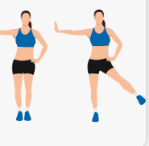  Abduction  PFSH: acronym for past, family and social history.  ROS: Review of systems  Oriented x4: oriented to self, place, time and situation  Lordosis: the forward curved spine in your neck or lower back  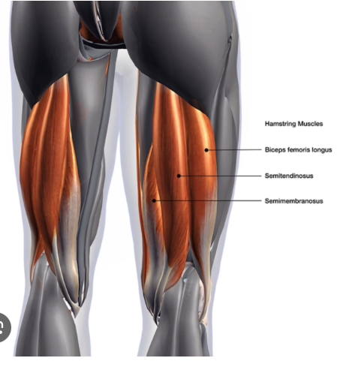  The hamstring muscles are a group of three muscles that run along the back of the thigh from the hip to just below the knee. These muscles make it possible to extend the leg back and to bend the knee.  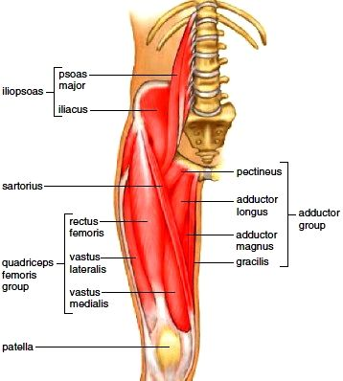  Iliopsoas & Quadriceps  Gastrocnemius: chief muscle of the calf of the leg, which flexes the knee and foot  Flexion/Extension of Spine:  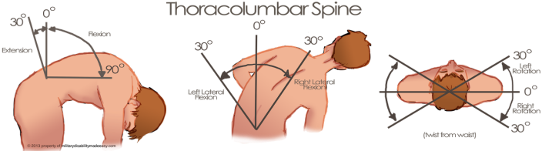  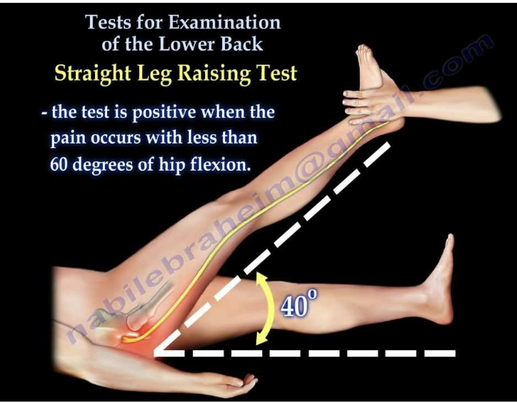  Positive straight leg test indicates possible disc problem or compressed nerve in the lumbar spine  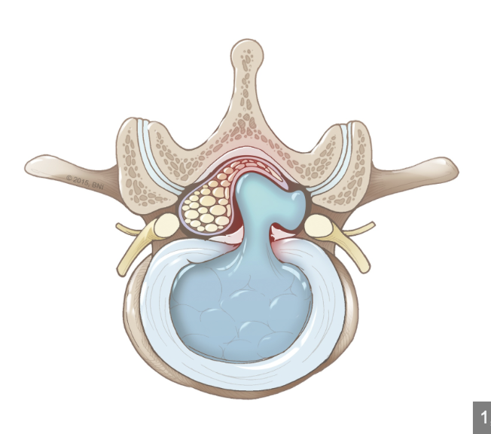  Disc Herniation L5-S1: occurs when jelly like substance in disc bulges out of weak part of spine  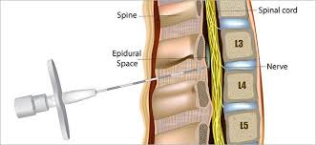  Lumbar Epidural Steroid Injection [LESI]  Paramedian approach: A skin wheal is raised 1 cm lateral [to the outside] and 1 cm caudal to the L4 spinous process. A longer needle is used to infiltrate deeper tissues. | Copy of BCS Pain Clinic (Medical Records) pg 1-8/8
01.26.2022 | BCS Pain Clinic | CURRENT PROBLEM LIST:  - M51.17 Intervertebral disc disorder with radiculopathy, lumbosacral region  CHIEF COMPLAINT: low back pain  REVIEW OF SYSTEMS:  Musculoskeletal: muscle pain, muscle tenderness, back pain  All other systems were reviewed and are negative: no other abnormal findings found on exam.  TESTS AND PROCEDURES PERFORMED THIS VISIT:  62323N Injections  Date performed: 26 Jan, 2022  OPERATIVE PROCEDURE:  Patient was placed on the exam table in a comfortable position lying face down. The skin over the procedure area was cleaned with betadine and covered with sterile drapes. Lidocaine, which is a local anesthesia was injected into the skin where procedure was to be performed. Using fluoroscopic guidance the surgeon injected a steroid medication mixed with lidocaine into his lower back between the vertebrae located at L5-S1[where disc was found to be herniated] and into the epidural space. The patient tolerated the procedure well and there were no complications. After being observed by medical staff for aa brief time the patient was ready for discharge. He was provided with instructions as to what to expect and contact information.  PLAN:  Follow up in 2 weeks  Impression:  Successful lumbar steroid injection done at (L5-S1) level with Dexamethasone 10mg/ml and 1% Lidocaine. Epidurogram demonstrating spread covering the L3-S1 levels on the right. | Radiculopathy: pain caused by a pinched nerve; can also cause pain to radiate down arm/leg. i.e. Sciatica  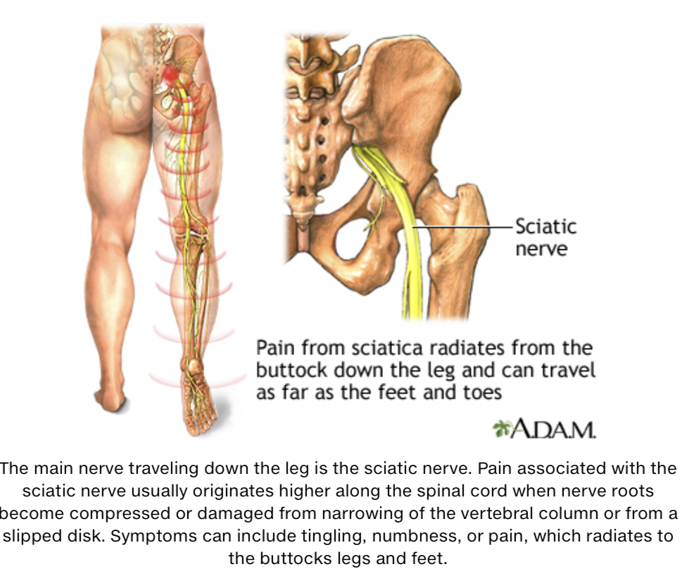  Lumbar radiculopathy: pain in lower back that radiates down legs  Fluoroscopy: type of medical imaging that shows a continuous X-ray image on a monitor. Typically used during a procedure in which the physician needs to know a specific location. To help ensure the injection is placed accurately and in the correct location  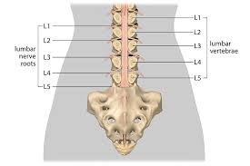
01.26.2022 | Dr Ben W Dudycha  BCS Pain Clinic | PROCEDURE TIME OUT:  Procedure: Lumbar ESI [epidural steroid injection]  Date: 17 Jun 2021 Time: 02:49 PM  No contraindications to procedure noted.  Pain score was a 6/10 prior to procedure. | The procedure report states that the procedure was done on 01/26/2022 but the time out procedure was dated in 2021. Not sure if this is a documentation error. Time out procedures are always done right before a procedure begins. | Copy of Bryan Radiology Associates (Medical Records).pdf pg 1-2/2

CURRENT ICD-10 CODES FOUND WITHIN PATIENT’S MEDICAL RECORDS

Injury/Diagnosis | ICD-10 Code | Relevance
Intervertebral disc disorder with radiculopathy, lumbosacral region | M51.17 | Related to injury in question
Lumbar/Low back pain | M54.50 | Related to injury in question
Disc Herniation – L5-S1 | M51.27 | Related to injury in question
Lumbosacral radiculitis | M54.17 | Related to injury in question
Sciatica | M54.30 | Related to injury in question
Closed Head Injury | S09.90XA | Related to injury in question
Superficial abrasions | T14.01 | Related to injury in question
Left shoulder contusion | S40.012 | Related to injury in question
Left shoulder pain | M25.512 | Related to injury in question
Back contusion | S20.229A | Related to injury in question
Lumbar paraspinal muscle spasm | M63.830 | Related to injury in question
Left inguinal hernia | K40.90 | Not likely related to injury in question
Thyroid nodule | E04.1 | Not related to injury in question

PROJECTED FUTURE TREATMENT

Future Treatment Projection | Reference Citations
Continued Physical Therapy | https://orthoinfo.aaos.org/en/diseases--conditions/herniated-disk-in-the-lower-back/  https://my.clevelandclinic.org/health/diseases/12768-herniated-disk  https://www.ncbi.nlm.nih.gov/books/NBK441822/
Use of OTC anti-inflammatory medications such as Ibuprofen; medications for neuropathic pain and opioids | https://www.mayoclinic.org/diseases-conditions/herniated-disk/diagnosis-treatment/drc-20354101  https://www.ncbi.nlm.nih.gov/books/NBK441822/
Massage therapy | https://www.sciatica.com/blog/11-treatment-options-for-herniated-discs/
Transcutaneous electrical nerve stimulation [TENS] | https://www.sciatica.com/blog/11-treatment-options-for-herniated-discs/
Nerve Conduction Study | https://www.mayoclinic.org/diseases-conditions/herniated-disk/diagnosis-treatment/drc-20354101
Electromyogram | https://www.mayoclinic.org/diseases-conditions/herniated-disk/diagnosis-treatment/drc-20354101
Further Lembar Epidural Steroid Injections | https://www.mayoclinic.org/diseases-conditions/herniated-disk/diagnosis-treatment/drc-20354101  https://my.clevelandclinic.org/health/diseases/12768-herniated-disk
Possible Spinal Fusion, diskectomy [surgical removal of disc]; laminotomy | https://orthoinfo.aaos.org/en/diseases--conditions/herniated-disk-in-the-lower-back/  https://www.aans.org/patients/conditions-treatments/herniated-disc/  https://my.clevelandclinic.org/health/diseases/12768-herniated-disk  https://www.ncbi.nlm.nih.gov/books/NBK441822/
Further imaging, particularly MRI | https://www.mayoclinic.org/diseases-conditions/herniated-disk/diagnosis-treatment/drc-20354101

