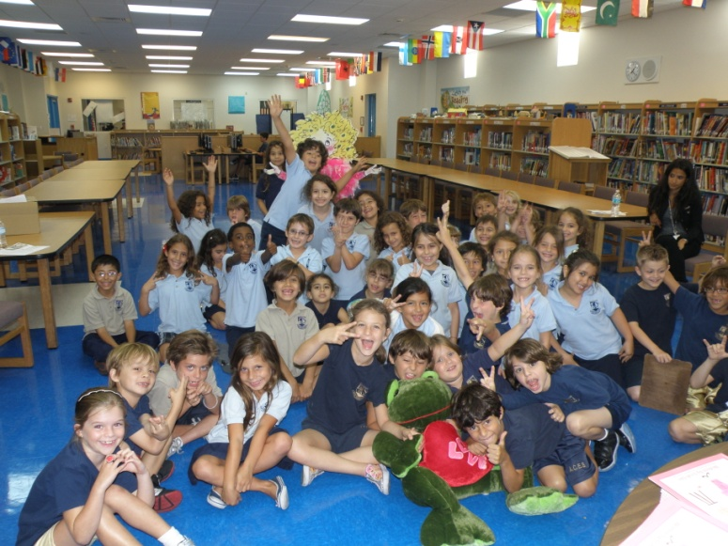

***Freddy The Love Frog***

Group 6 – 12:55 – 1:25 1st grade

Once Upon a time Freddy The Love Frog traveled to England, on the continent of Europe where he met 3 friends. Their names were love the kangaroo, jumbo the puppy, and gumbo the penguin.

At snack time they ate pizza, fish, sandwiches, spaghetti, soup, and meatballs.

They played hide and go seek, laser tag, leap frog, rock paper scissors, and hot potato.

Later that afternoon Freddy met Tracy the toad. He fell madly in love with her. He said she was so hot. He gave her presents like nuts, flowers, a purple dog, and iphone, a flat screen tv, a bulldog, a toad, earrings, a skunk, and a ginormous real life dinosaur.

He invited her to go to dinner at chucky cheese. she said yes. He came dressed in tuxedo, and she came dressed wearing a purple polka dot dress. .

He asked her to marry him and she said yes. They danced and danced at the ball. They dated for 30 months before they got married at 10am at chucky cheese. They went to Columbia for their honeymoon. They lived in a pool house. They had 10 children and lived happily ever after.

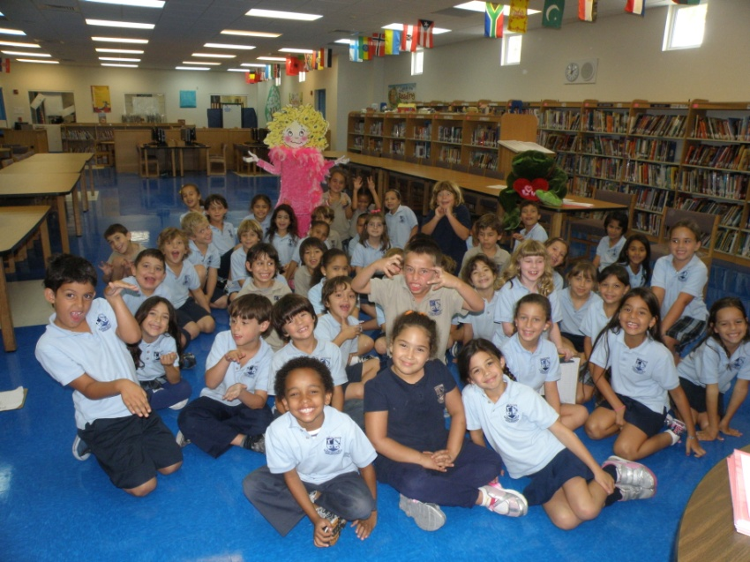

***Freddy The Love Frog***

Group 7 – 1:30 – 2:00 1st grade

Once Upon a time Freddy The Love Frog traveled to Venezuela, on the continent of South America where he met 3 friends. Their names were Hotima the horse, Fluffy the bunny, and Rainbow the chameleon.

At snack time they ate lizards, spiders, and bugs.

They played monopoly, sisters, life, and tag.

Later that afternoon Freddy met Poof the horse. He fell madly in love with her. He said she was so pretty. He gave her presents like a jump rope, a basketball, a snake, shocking gum, an iphone, and an ipad.

He invited her to go to dinner at burger king. she said yes. He came dressed in tuxedo, and she came dressed wearing a yellow and pink dress. .

He asked her to marry him and she said yes. They danced and danced at the ball. They dated for 14 months before they got married at the zoo. They went to the moon for their honeymoon. They lived in an igloo. They had 10 children and lived happily ever after.