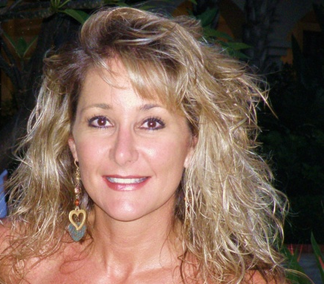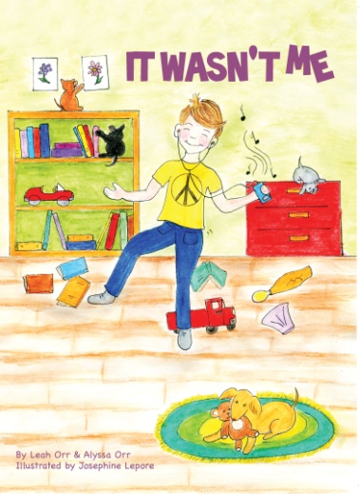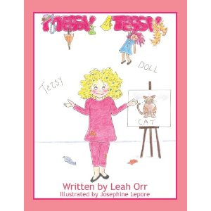

__________________ is pleased to announce:
an Author visit from Best Selling Author Leah Orr
for a book reading, creative writing lesson, and book signing.
____________________________, 2018

Leah will be reading her children’s picture books:
It Wasn’t Me & Messy Tessy.
If you would like to pre order books for $5.00 each please fill out the bottom portion of
this form and return back to your teacher.

Child’s Name____________________Teacher’s Name___________________
It Wasn’t Me _______copies
Messy Tessy _______copies
Would you like a special note written inside the book? Please write sentiment below

Please make checks payable to Leah Orr.
Profits from the sale of these books will be donated to the Cystic Fibrosis Foundation.
For more information please visit www.leahorr.com

