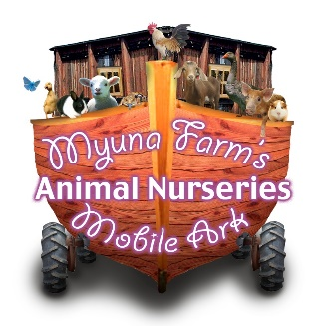
Myuna Farms Mobile Ark
Risk Assessment

Activity | Hazard Identification | Likelihood | Severity | Priority | Control Measures | Who
Feeding the animals | Bites from animals | 3 | 4 | 5 | Children instructed to feed the animals from the cups. Signage also instructing this. | Myuna Farm Ark Staff
 | Allergic reaction to food | 3 | 3 | 1 | Make allergies known to Myuna Farm Staff, food will not be distributed. | Event staff
Holding the animals | Scratches or bites from animals | 2 | 4 | 6 | Children instructed on how to hold the animals, parental supervision requested in some situations, visual signs | Myuna Farm Ark Staff  Guardians
 | Allergic reaction to animal | 3 | 3 | 1 | Children allergic to animals are discouraged from entering the pen. Allergies need to be made known to farmer. Eggs are removed from pen asap, if allergy is known. | Guardians Myuna Farm Staff
 | Germs from touching animals | 1 | 4 | 2 | Antibacterial hand gel provided | Myuna Farm Ark Staff
Set up Pack down of pen | Injury from moving equipment | 4 | 4 | 3 | Children to stay away from Myuna Farm Mobile Ark during set up and Pack down. If help requested farmers will give clear instructions on what is required | Myuna Farm Ark staff
Myuna Farm Mobile Ark General Visit | Exposure to outdoor weather conditions | 3 | 4 | 2 | Children encouraged to wear hats and sunscreen if pen is exposed to elements | Teachers Guardians
 | Potential exposure to Flies and insects | 4 | 4 | 6 | Pen is kept tidy as possible, animals confined. | Myuna Farm Staff
Entering exiting pen | Potential risk of animal escaping | 2 | 0 | 3 | Farmer is present to open close door and assist patrons, patron discouraged from using door themselves.  Farmer will catch escapee. | Myuna Farm Staff
 | Risk of child jamming finger | 4 | 4 | 5 | Farmer, present to open close door. | Myuna Farm Staff
Running children | Slipping, tripping, falling | 3 | 6 | 2 | Children must be adequately supervised and instructed not to run in the mobile farm area | Myuna Farm Staff  Guardians

RISK ASSESMENT MATRIX
Likelihood | Severity | Priority
1 = Very likely, could happen at any time | 1 = Death or cause permanent disability | 1,2,3 = Top Priority, take action immediately
2 = Likely to happen, could happen | 2 = Long term illness or serious injury | 4 = Moderate priority
3 = Unlikely, could happen, but very rarely | 3 = Medical attention and or time off work | 5,6 = Low , take action where possible
4 = Very unlikely, could happen but probably never will | 4 = First aid attention required

Our Responsibilities:
- Carefully transport animals following Industry Guidelines
- Arrive 30 Minutes Prior to booked time to setup for the event.
- Make sure area selected is suitable for mobile farm display (*see website for guidelines regarding site requirements)
- Provide animals with Fresh water. (*Please advise if water is not available onsite)
- Provide appropriate Shading/Cover for animals.
- Setup and Pack down enclosure
- Carry a basic first aid kit as part of the Mobile Farm
- Supervise and instruct patrons with regards to animal welfare in the pen to the best of our ability
- Any animals that shows signs of aggression will be immediately removed
*responsibility of event staff
