The Copyright, Designs and Patents Act 1988 (CDPA)

(CDPA) provides copyright owners with a range of exclusive rights.



The government carried out a Post Implementation Review (PIR), PDF 101KB of this legislation to assess whether the changes had achieved their original objectives and remained fit for purpose. The PIR recommended that the IPO publish updated guidance in this area to clarify licensing requirements.

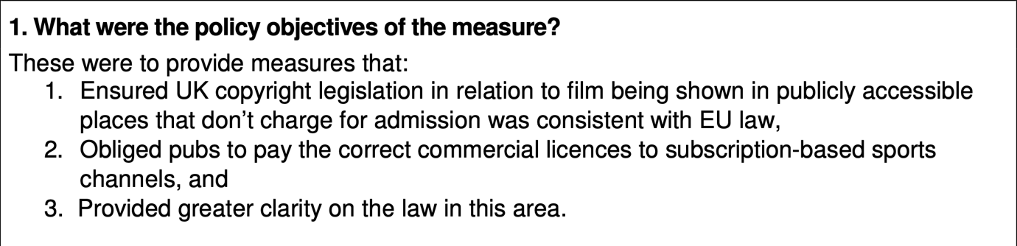
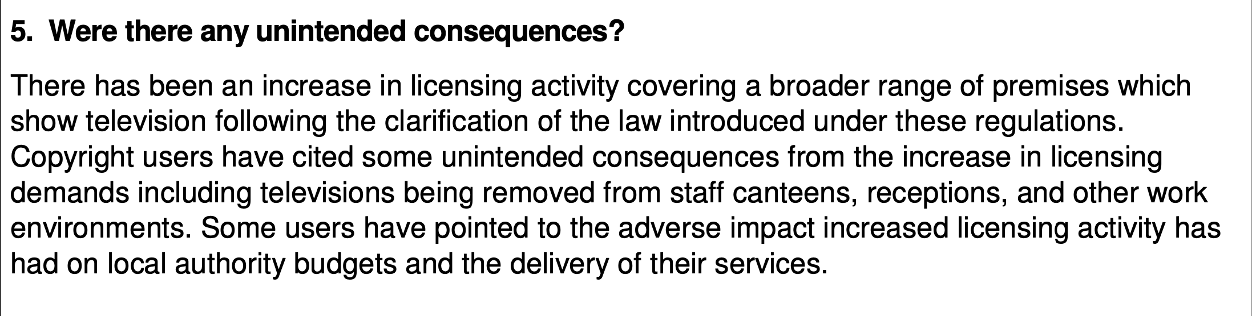
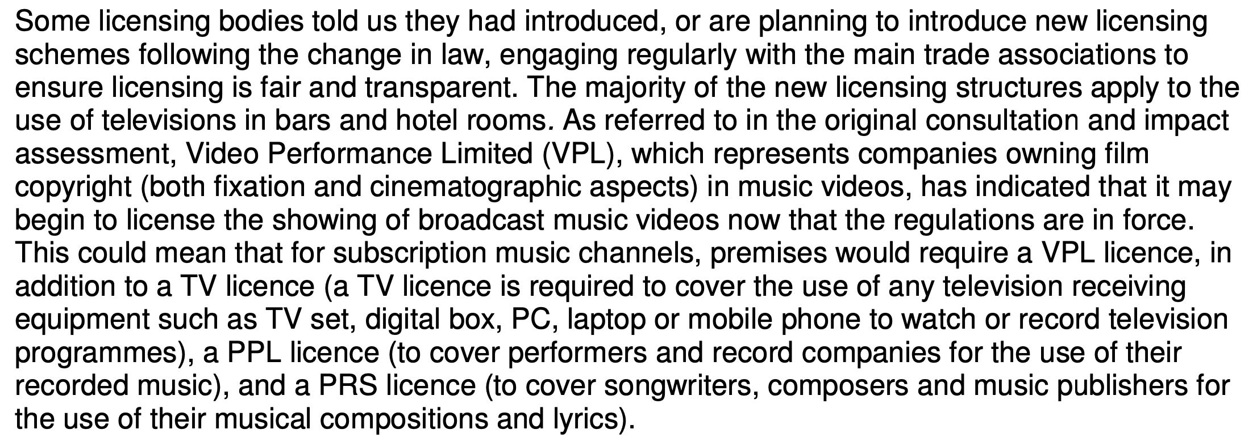

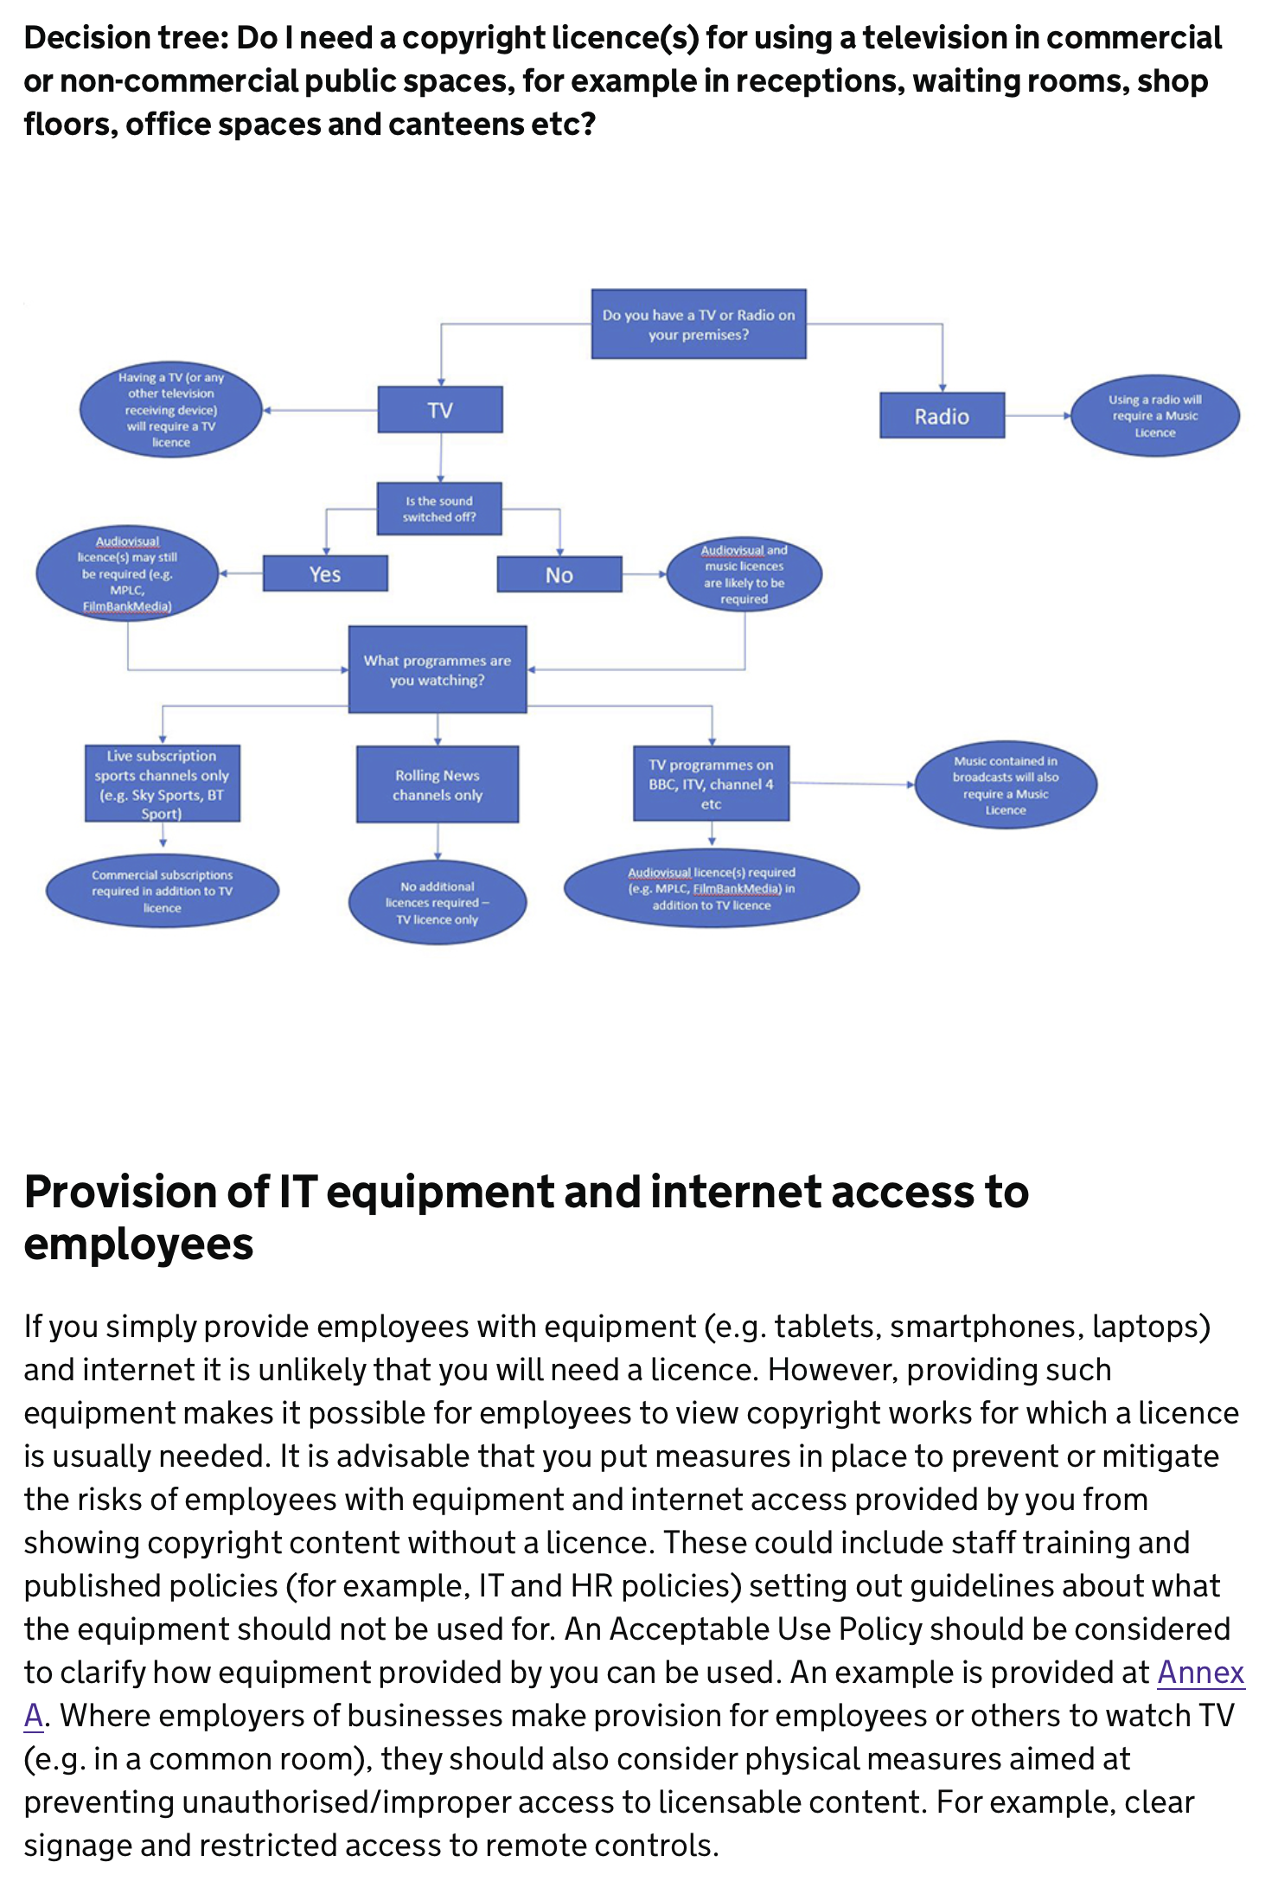
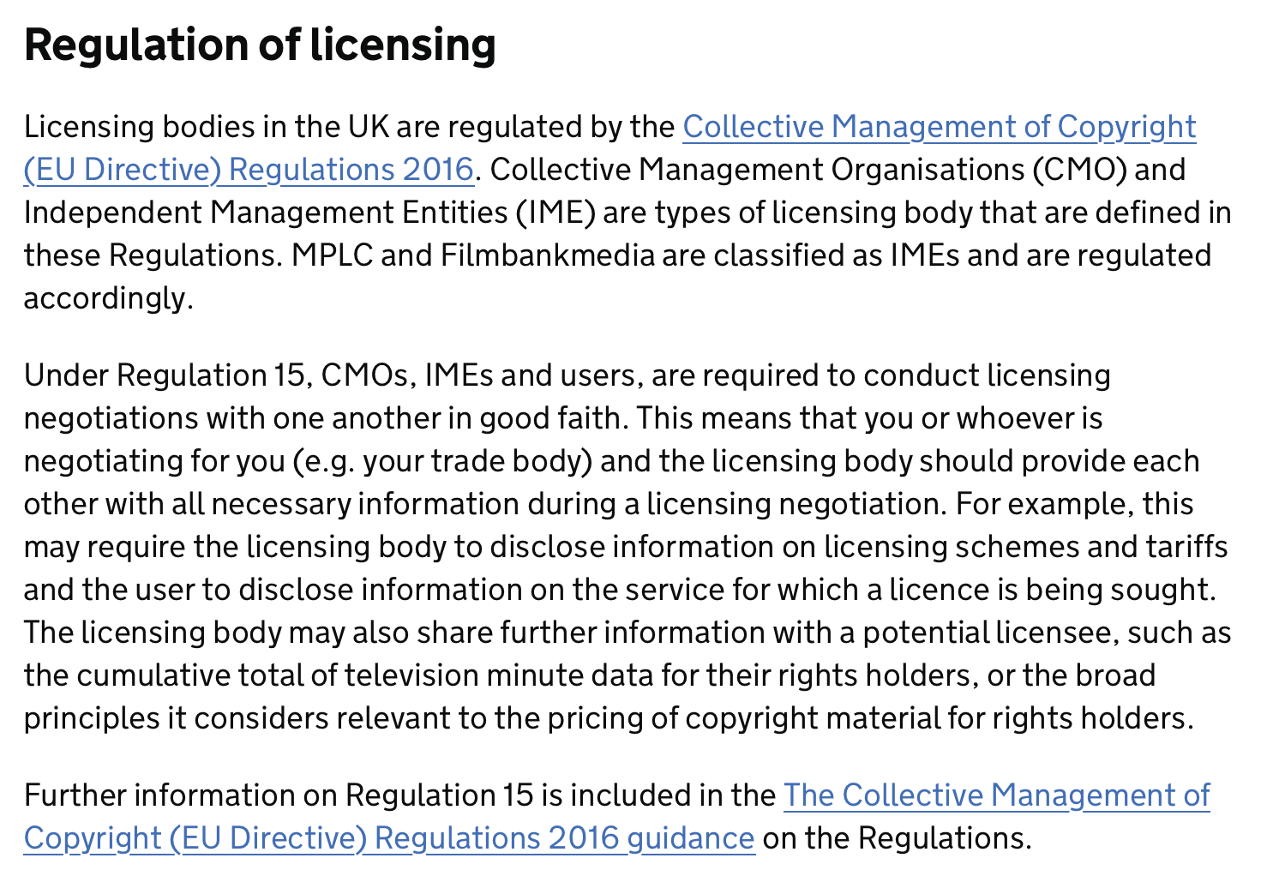

Showing films and TV shows in public

