**SUMTER, S.C. COMBAT**



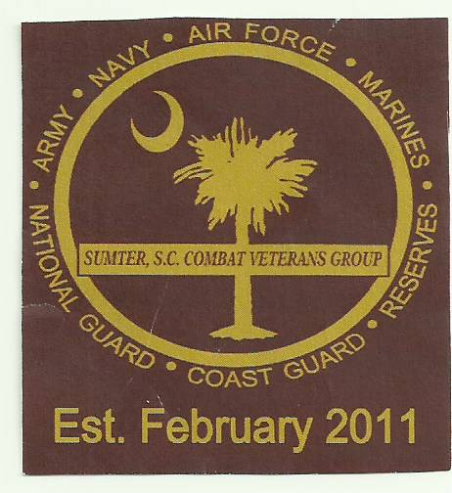

**VETERANS GROUP**

**SOME GAVE SOME - SOME GAVE ALL – SOME STILL DO**

**“HOLE” SPONSOR FORM**

**\*\*HELPING SUPPORT OUR SCHOLARSHIP PROGRAM AND MORE!\*\***

**Annual Golf Tournament (9TH) September 21, 2024**

Crystal Lakes Golf Course, 1305 Clara Louise Kellogg Drive, Sumter, SC 29153

**Sponsors are encouraged to participate as a HOLE Sponsor or make any monetary DONATION. * Or Sponsors can donate merchandise and Gift Cards to be used as prizes.**

**-All *PLATINUM* sponsors signs will be placed at the Club House for 3 days and receive a plaque.**

**-All *GOLD* Sponsors signs will be placed at the Club House for 3 days.**

**-All *SILVER* sponsors signs will be placed at hole NUMBER #1 tee hole.**

**-All other sponsors signs will be placed at a tee hole throughout the Golf Course.**

**HOLE SPONSOR**

NAME__________________________________

ADDRESS_______________________________

CITY__________________ST_____ZIP_______

EMAIL__________________________________

**\*Do you have your own sign? YES NO**

**\*HOLE SPONSOR LEVELS (please circle one)**

PLATINUM:----$500 - **GOLD:-----$300 - SILVER:-------$200 - MODEST:-----$100**

**\*In order to have a smoothly run tournament, it is extremely important that all sponsorships or donations are received by SEPTEMBER 13, 2024**

**MAKE CHECK PAYABLE TO: SSCCVG**

**MAIL TO: PO BOX 1776, SUMTER, SC 29151**

**ATTN: PHYLLIS ROBINSON**



**\*FOR MORE INFORMATION CONTACT:**

**Elbert Deas - 803-464-3858**

**Leroy Peeples – 803-509-2868**

**Robert Davis - 803-983--2563**

**James Ray – 803-406-6269**

**Phyllis Robinson – 803-983-9697**