**SUMTER, S.C. COMBAT**



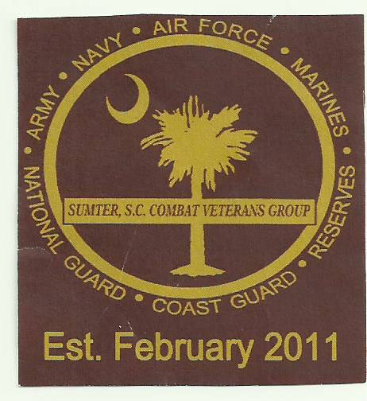

**VETERANS GROUP**

**“TEAM” Sponsor FORM**

**\*\*HELPING SUPPORT OUR SCHOLARSHIP PROGRAM AND MORE!\*\***

**Annual Golf Tournament (9TH) September 21, 2024**

Crystal Lakes Golf Course, 1305 Clara Louise Kellogg Drive, Sumter, SC 29153

**PRIZES: Men’s and Women’s 1st Place $200.00 - 2nd Place $100.00 - 3rd Place Men Only $40**

**Closest to Pin: MALE 65 & Over $10 MALE 64 & Under $10 *Women: $10**

**Longest Drive: MALE 65 & Over $10 MALE 64 & Under $10 *Women: $10**

**\*80 & Over $25 (Male & Female)**

**$50.00 PER PERSON 4 - PERSON TEAM **LIMIT TO THE 1ST  20 TEAMS**

**PLATINUM: $500 1 Teams – Men, Women or Mix 4 Mulligans and 3 hole advertising.**

**GOLD: $400 – 1 Teams – Men, Women or Mix – 2 Mulligans and 2 hole advertising.**

**SILVER: $300- 1 Teams – Men, Women or Mix -2 Mulligans and 1 hole advertising.**

1.__________________________________

2.__________________________________

3.__________________________________

4.__________________________________

Team Captain Email____________________________

**NEED TO BE PLACED ON A TEAM? YES NO**

**MULLIGANS AVAILABLE AT $5.00 EACH - LIMIT 2 PER PERSON**

**It is imperative that we follow the schedule on the morning of the Tournament:**

**Registration and Breakfast – 7:30am - Rules Meeting – 8:30m - Leave for Tee Box – 8:45am**

**Shotgun start – 9:00am - Lunch: *Will be served as teams come of the course.**

**We look forward to seeing you on Saturday morning September 21, 2024.**

**\***

**\*In order to have a smoothly run tournament, it’s extremely important that all fees are paid and received by September 13, 2024.**

**MAKE CHECK PAYABLE TO: SSCCVG**

**MAIL TO: PO BOX 1776, SUMTER, SC 29151**

**ATTN: Phyllis Robinson**



**\*FOR MORE INFORMATION CONTACT:**

**Elbert Deas -- 803-464-3858**

**Leroy Peeples - 803-509-2868**

**Robert Davis - 803-983-2563**

**James Ray - 803-406-6269**

**Phyllis Robinson – 803-983-9697**