**8 SUMTER, S.C. COMBAT**

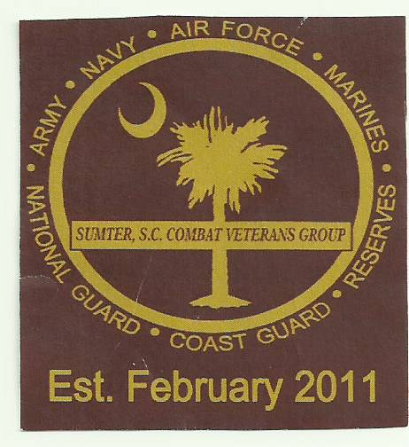



**VETERANS GROUP**

**529 NORTH WISE DRIVE, SUMTER, SC 29153**

**803-774-VETS (8387) ssccvgroup@gmail.com**

**SOME GAVE SOME * SOME GAVE ALL * SOME STILL DO**

**Business Name:**  07/16/2024

**ATTN: ___________________________**

**SUBJECT: 2024 Hole Sponsors for Our 9th Annual Golf Tournament**

**Dear Sponsors and Prospective Sponsors,**

We are ramping up our fundraising drive for 2024. This is our “ONLY” fundraiser so we really look forward to your supportfor our 9th Annual Golf Tournament.

We would like to see all of our Hole Sponsors from last year support us again this year. If you are a prospective sponsor receiving this letter for the first time, we really would appreciate your sponsorship as well. Please look at the flyers attached and respond **before** the deadline. Your sponsorship can be at any of the four levels, **but this year 2024, we would appreciate it very much if you would donate at the PLATIUM $500 or GOLD $300 level.** This will help us reach our goals and better fulfill the needs of our community. **But any level is greatly appreciated.**

***Again, this golf tournament is our only fundraiser for the year and we will not be successful if we don’t hear from you.*** It is businesses like you that allow the Sumter SC Combat Veterans Group to give back to the schools and communities we serve. The five counties we support are; Clarendon, Darlington, Kershaw, Lee, and Sumter. We would like to thank you in advance for your continued support.

If you have any questions regarding this letter, please contact me at 803-840-9900. The deadline for donations is September 13, 2024, but exceptions can be made.

**\*NOTE:** The main focus of this letter is on Hole Sponsors. But please contact us if you would also like to be a **“TEAM Sponsor”.** Four people to a team, $50 per person.

Sincerely,

Elbert Deas cc: Mary Glass, Commander SSCCVG

Chairperson for SSCCVG Golf Committee

SEE ATTACHMENT

.

**\*NOTE: We are a 501c-3 organization and all donations are tax deductible.**