SUMTER, S.C. COMBAT


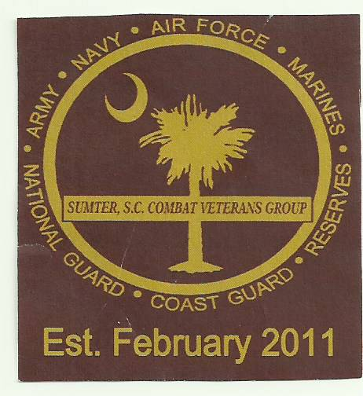
VETERANS GROUP

“TEAM” Sponsor FORM
**HELPING SUPPORT OUR SCHOLARSHIP AND BUILDING FUND!**
Annual Golf Tournament (10TH) September 19, 2026
Crystal Lakes Golf Course, 1305 Clara Louise Kellogg Drive, Sumter, SC 29153

PRIZES: Men’s and Women’s 1st Place $200.00 - 2nd Place $100.00 - 3rd Place Men Only $40
Closest to Pin: MALE 65 & Over $10 MALE 64 & Under $10 *Women: $10
Longest Drive: MALE 65 & Over $10 MALE 64 & Under $10 *Women: $10
*80 & Over $25 (Longest Drive - *one Male & one Female) $750 Total Prizes

$50.00 PER PERSON 4 - PERSON TEAM **LIMIT TO THE 1ST 20 TEAMS

$200 Per Team – Men, Women or Mixed – 1 Mulligan.

1.__________________________________

2.__________________________________

3.__________________________________

4.__________________________________
Team Captain Email____________________________

*NEED TO BE PLACED ON A TEAM? YES NO
MULLIGANS AVAILABLE AT $5.00 EACH - LIMIT 2 PER PERSON
It is imperative that we follow the schedule on the morning of the Tournament:
Registration and Breakfast – 7:30am - Rules Meeting – 8:30m - Leave for Tee Box – 8:45am
Shotgun start – 9:00am - Lunch: *Will be served as teams come off the course.
We look forward to seeing you on Saturday morning September 19, 2026.

*

*In order to have a smoothly run tournament, it’s extremely important that all fees are paid and received by September 11, 2026.

MAKE CHECK PAYABLE TO: SSCCVG
MAIL TO: PO BOX 1776, SUMTER, SC 29151
ATTN: Phyllis Robinson

*FOR MORE INFORMATION CONTACT:
Elbert Deas -- 803-464-3858
Leroy Peeples - 803-509-2868
Robert Davis - 803-983-2563
James Ray - 803-406-6269
Phyllis Robinson – 803-983-9697

