- SUMTER, S.C. COMBAT


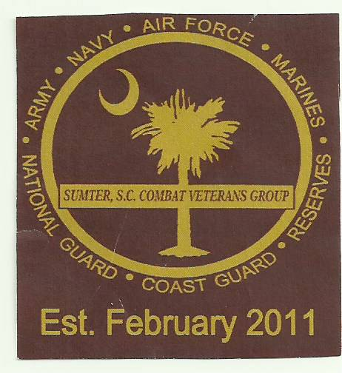
VETERANS GROUP
SOME GAVE SOME - SOME GAVE ALL – SOME STILL DO

“HOLE” SPONSORSHIP FORM
**HELPING SUPPORT OUR SCHOLARSHIP FUND!**
Annual Golf Tournament (10TH) September 19, 2026
Crystal Lakes Golf Course, 1305 Clara Louise Kellogg Drive, Sumter, SC 29153

Sponsors are encouraged to participate as a “HOLE SPONSOR” or make any monetary DONATION. *Sponsors can also donate Merchandise and Gift Cards to be used as prizes.
-All PLATINUM sponsors signs will be placed in front of Club House for 3 days of advertising.
-All GOLD Sponsors signs will be placed at the Club House for 3 days.
-All SILVER sponsors signs will be placed at hole NUMBER #1 tee hole.
-All other sponsors signs will be placed at a tee hole throughout the Golf Course.
HOLE SPONSOR

NAME__________________________________

ADDRESS_______________________________

CITY__________________ST_____ZIP_______

EMAIL__________________________________

*Do you have your own sign? YES NO

HOLE SPONSOR 4-LEVELS (please circle one)

PLATINUM: ----$500 - GOLD:-----$300 - SILVER:-------$200 - MODEST:-----$100

*In order to have a smoothly run tournament, it is extremely important that all sponsorships or donations are received by SEPTEMBER 11, 2026

MAKE CHECK PAYABLE TO: SSCCVG
MAIL TO: PO BOX 1776, SUMTER, SC 29151
ATTN: PHYLLIS ROBINSON

*FOR MORE INFORMATION CONTACT:
Elbert Deas - 803-464-3858
Leroy Peeples – 803-509-2868
Robert Davis - 803-983--2563
James Ray – 803-406-6269
Phyllis Robinson – 803-983-9697

