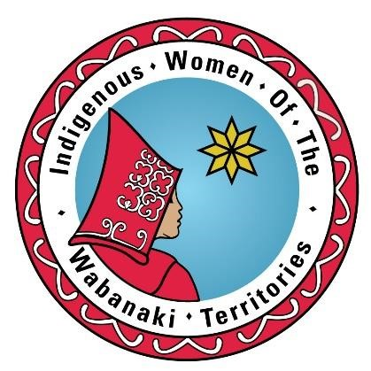

***Indigenous Women of the Wabanaki Territories (IWWT)***

***152 Main Street, Fredericton, NB***

***Phone #: 506-206-8220***

# MEMBERSHIP FORM

***NAME: _____***Click or tap here to enter text.***_________________________***

***ADDRESS: ______***Click or tap here to enter text.***__________________***

***PHONE #’s: __***Click or tap here to enter text.***_______________________***

## EMAIL: _____Click or tap here to enter text._____________________

Membership is open to all Indigenous Women in the Wabanaki Territories. Our mission is to provide healing and capacity building to Indigenous women in order to promote and recognize their traditional role. By submitting this membership application you agree that as a member you will always act with a good mind and recognize that all women deserve our respect, appreciation and support.

***Signed______***Click or tap here to enter text.***__ Date______***Click or tap here to enter text.***_***

*Please submit your membership forms to the following: IWWT Fax number: 1-506-206-6221 or drop off at the office

## The $5.00 membership fee for the year