AL BCA Pool League By-Laws
League Operator:
Sean Nicke
Phone# 760-987-1254
Email: sean_nicke@hotmail.com
Places: The Alabama BCA Pool League (AL BCAPL) currently plays BCA format games at the following Host Locations:
Chips n Salsa (Huntsville, AL)
Bumpers (Huntsville, AL)
Steve’s Cue & Grill (Huntsville, AL)
Tuck’s Bar (Minor Hill, TN)
Buck’s Lounge (Guntersville, AL)
Other places may be added as the demand for teams and divisions increase.
Session Dates:
Session 1- Runs December thru May
Session 2- Runs June thru October/November
Tournament play will begin November of each year.
8-Ball: 8-ball will be played in a 5x5x1 format (5 players per team will play each night, 1 game each match, round robin) Max *8 player roster per team.
9-Ball (if played at the site): 9-Ball will be played in a 3x3x2 format (3 players per team will play each night, 2 games each match, round robin) Max *5 player roster per team.
10-Ball: (if played at the site): 10-Ball will be played in a 3x3x2 format (3 players per team will play each night, 2 games each match, round robin) Max *5 player roster per team.
**As there are currently no divisions playing 10-Ball, this format may change.
Scoring: The BCAPL Scorer Application is the PRIMARY scoring method for both 8-ball and 9-ball. This app can be downloaded from both Android and iOS application sites. The instructions on how to use the app can be found on the CSI Website (playcsipool.com). Paper scoring is allowed, and if used, will be included in the envelope of the team using the paper method.
Annual Dues: All players are required to pay $20 Annual Dues (Membership Fee) before January 31 of the current year. Dues (Membership) lasts from Jan 1 thru Dec 31 of the current year. This sanction each member to play at the BCA Las Vegas World Championships.
Weekly Fees: Team weekly fees are $50 ($10 per player), $40 for BCA and $10 “green fees” paid to the Host Location for table usage. The team captain is responsible for the entire team's player fees each week, regardless of absent players. All fees are to be paid in cash/check and each week of play. Alabama BCA Pool League (Al BCAPL) cannot accept debit/credit payments. Fees must be placed in an envelope and then placed in the AL BCAPL drop box (2-drawer filing cabinet at each host location) by the end of the match the night of play. Envelopes are provided in the top drawer of the AL BCAPL drop box and will be CLEARLY MARKED WITH TEAM NAME and DATE OF PLAY (ANY OTHER MONEY ENCLOSED will be identified as well (i.e. Annual Dues with full name of player, make-up match dues with date, etc).
BCAPL World Championship Qualification: To qualify to play in the BCAPL World Championships each player MUST be a BCAPL Member by paying the $20 Annual Due AND play 8 weekly recorded 8-ball matches in one session. Once qualified, any player can go to the BCAPL World Championship held in Las Vegas, NV and register for any tournament play.
AL BCAPL Playoff Tournament (The Vegas Tournament): Tournament play will begin November of each year. Every year AL BCAPL will hold a tournament to send a certain number of teams to the BCAPL World Championships. To determine eligible players for tournament play, team rosters will be frozen 8 weeks from the end of the second session. Players can be added but will be ineligible for tournament play that year. The tournament will be held at a Host Location(s) identified by the League Operator. The tournament format will follow the BCAPL World Championships format as closely as possible. The winning teams will be provided a sum of money, to be divided up among players, for use on travel and hotel accommodations.
Contacting the League Operator: It is highly recommended that the captain or someone on your team utilize the Official Rules of CueSports International binder or these by-laws to answer any questions or determine rulings during league play. If this cannot be done, then the last resort is to contact the League Operator for a determination of the rules. Feel free to contact the League Operator via text or phone call whenever you need an answer to a question or an interpretation of the rules.
Captains are encouraged to have a copy of the official rulebook and bylaws on hand for reference.
All information can be found on our website: www.alabamabcapl.com
Starting Time of Match / Scoring / Venue Tables: Starting time of matches in a certain division will be determined by the teams within the division. All players should be respectful of their team and their opponents and should arrive at least 15 minutes prior to the agreed upon League start time. If you are running late, please notify your captain. “Shooting Out” policy is listed below. If a venue has made 2 tables available for league play, then teams WILL play their matches on 2 tables from the start of league play.
There is a printed copy of the Official Rules of CueSports International inside a binder provided at each Host Location. These are the official rules of play and cannot be overridden by any other rule book either hard copy or found online. Some rules are ambiguous and can be interpreted by the reader differently than another reader, therefore, some clarifications of certain rules are provided below. If a ruling is still ambiguous and the captains of the teams requiring a ruling cannot come to an agreed upon course of action, the League Operator will make the final decision on how the rules apply to a situation.
Cue ball &/or set of billiard balls
The Host Location will supply cue &/or set of billiard balls for use in match play, the substitution of personal cue &/or set of billiard balls for match play is not authorized.
Rescheduling of matches
Rescheduling of matches are allowed up to the last match of the session.
Rescheduling needs to be communicated to the league operator and opponent no less than 7 hours (24-hour notice would be appreciated) in advance unless extenuating circumstances apply. Matches will be played on 2 tables unless otherwise specified by the League Operator or Host Location.
If a complete match forfeit is deemed necessary, the winner will be determined by the league operator. The winning team will receive points based on an average of previous match points between the two teams during regular play.
If the two teams did not play during the regular session, the winner of the forfeit will receive an amount of points based on the season average of the winning team.
New Players
New players can be added at any time during the session, but players must have 8 matches played, in one session, with the team and be on the team roster during the second session to play with the team in the tournament. To determine eligible players for tournament play, team rosters will be frozen 8 weeks from the end of the second session. Players can be added but will be ineligible for tournament play that year.
New players must provide all contact information including legal name, city of residence, and any other pool league (APA, ARS, etc…) ratings. Any fees (Annual $20) are due on second night of play. New players must have a Fargo rating. If a player needs to be assigned a Starting Fargo Rate, the captain will advise the League Operator of the shooting skill of the player and the League Operator will decide on a starting Fargo Rating. Normally, a male starting Fargo rating is 450 and females are 350. If a player has an APA rating, the table below will be referenced for assigning a Fargo rating.

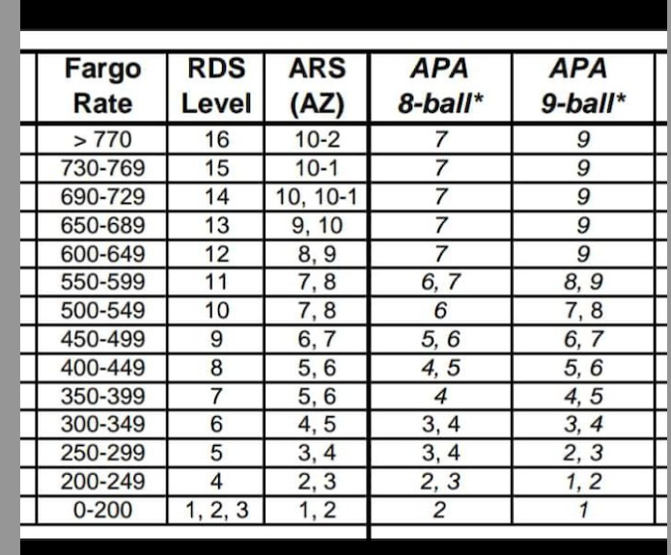
“Shooting Out” Policy
Occasionally and due to unexpected circumstances, with approval of the opposing team captain, a player on a team is allowed to "shoot out" or play all their games consecutively at the start or end of the match. Otherwise, if a team member is not ready for the 1st match, his/her match will be skipped. At the discretion of the opposing captain, if 1st match is not played by his/her 2nd match, the 1st match will be forfeited. If that player has not played his/her 2nd match at the scheduled 3rd match, the 2nd & 3rd match will be forfeited. Keep in mind that this is should only be used on occasion, and if a player has other commitments, then replacing the player with another on your roster may be necessary. Please keep sportsmanship in mind.
Breaking
In this division players will break according to the BCAPL Scorer app (paper score sheet) each round. The “Breaking” player will rack and break. Be aware that as stated in the CSI/BCAPL official rules and making the 8-ball on the break is NOT a win.
Coaching/Time Outs
Time Outs are not allowed in the AL BCA Pool League. Coaching of the player MAY ONLY occur when it is NOT the players turn at the table. The players turn at the table starts when the opponent misses, fouls, or pushes and ALL balls have stopped rolling. A distinction is made between coaching and communication when the player has a rule question during their turn at the table. Players may ask about rules during their turn at the table IF the rule would apply to the shot being decided upon. Players are to make their own decisions about all aspects of their individual match play.
Players Responsibility on the table
It is the players responsibility to know what your opponent is shooting or attempting to shoot. Stay near the table (but not in the shooting players way or shooting line) and if you have any concerns stop the game to ask your opponent. Please do not wait until the shooter is down on his/her shot to stop the game. The shooting player must acknowledge his opponent and answer their questions regarding the attempted shot. Once players have pocketed a legal ball, player can ask their opponents what balls they have (stripes or solids). It is always best to call each shot to avoid any confusion. It is expected ALL players to play with good sportsmanship, therefore it is imperative that you call your own fouls and listen to your opponent. ONLY THE 2 PLAYERS IN THE MATCH CAN CALL FOULS. Players must question the shot/foul prior the opponent going down on the next shot. If a question arises between the 2 players and it can't be resolved between the 2 players and another player was not called to watch the shot, the call will go to the shooting player. Remember you can call for any player, outside of the shooting teams, to watch a shot, and your opponent must wait until such person is at the table. Whomever is watching the shot, will call the ball first hit by the cue ball. The decision of the shot watcher is final and will be accepted by both shooting players. The shot may be videoed at the request of the opponent and replayed for verification keeping time restraints in mind.
Cue ball foul / other ball fouls
All fouls are ball-in-hand. Please review the Official Rules of CueSports International binder for more information.
Proof of Identity
If requested by the opposing team or League Operator, all players must be able to provide proof of their identity prior to the start of a match.
Unsportsmanlike Conduct
ALBCAPL will not tolerate any form of unsportsmanlike conduct. The guidelines for unsportsmanlike conduct are outlined in the Official Rules of CueSports International binder. Please make yourself aware of this rule.
Penalties for Unsportsmanlike Conduct
Exact penalties will be determined by the League Operators. These penalties may range from a warning to suspension / expulsion from the league, disqualification from a tournament or playoff, and forfeiture of all money paid &/or won during the regular or post session.
Late Players
Occasionally players are unavoidably detained or late. Please read the “Shooting Out” policy above.
Slow Play
We encourage people to have fun, play at a reasonable pace (approx. 45 seconds per shot) and enjoy league play.
Drop Out Teams and/or players
Teams that drop out during a session can create problems within the league. It can have an uneven or unfair effect on the division standings and reduce the prize money for the other teams.
All teams/players that drop out of the league will forfeit all prize money won in that session.
The League Operator will try to find a "replacement" team or players to fill the vacant spot, but if that is not possible, the League Operator will try to find the most equitable and fair way to adjust the league's team standings. This may include averaging points by a team for the session and applying that number of points to a forfeited match, or a similar method of points averaging.

