GQ Clothier Las Vegas / GY Custom Tailor
3314 Seminole Cir. Las Vegas, NV. 89169 (702) 732-9901
email: george@gqclothierlasvegas.com
ILLUSTRATED SUMMARY OF MEASUREMENTS
Name: /Co. Name
Phone #
Address:
Email:
Requested Completion Date:
Office Use: Date Promised: Ship Date:
Order # Price: Custom >͏͏

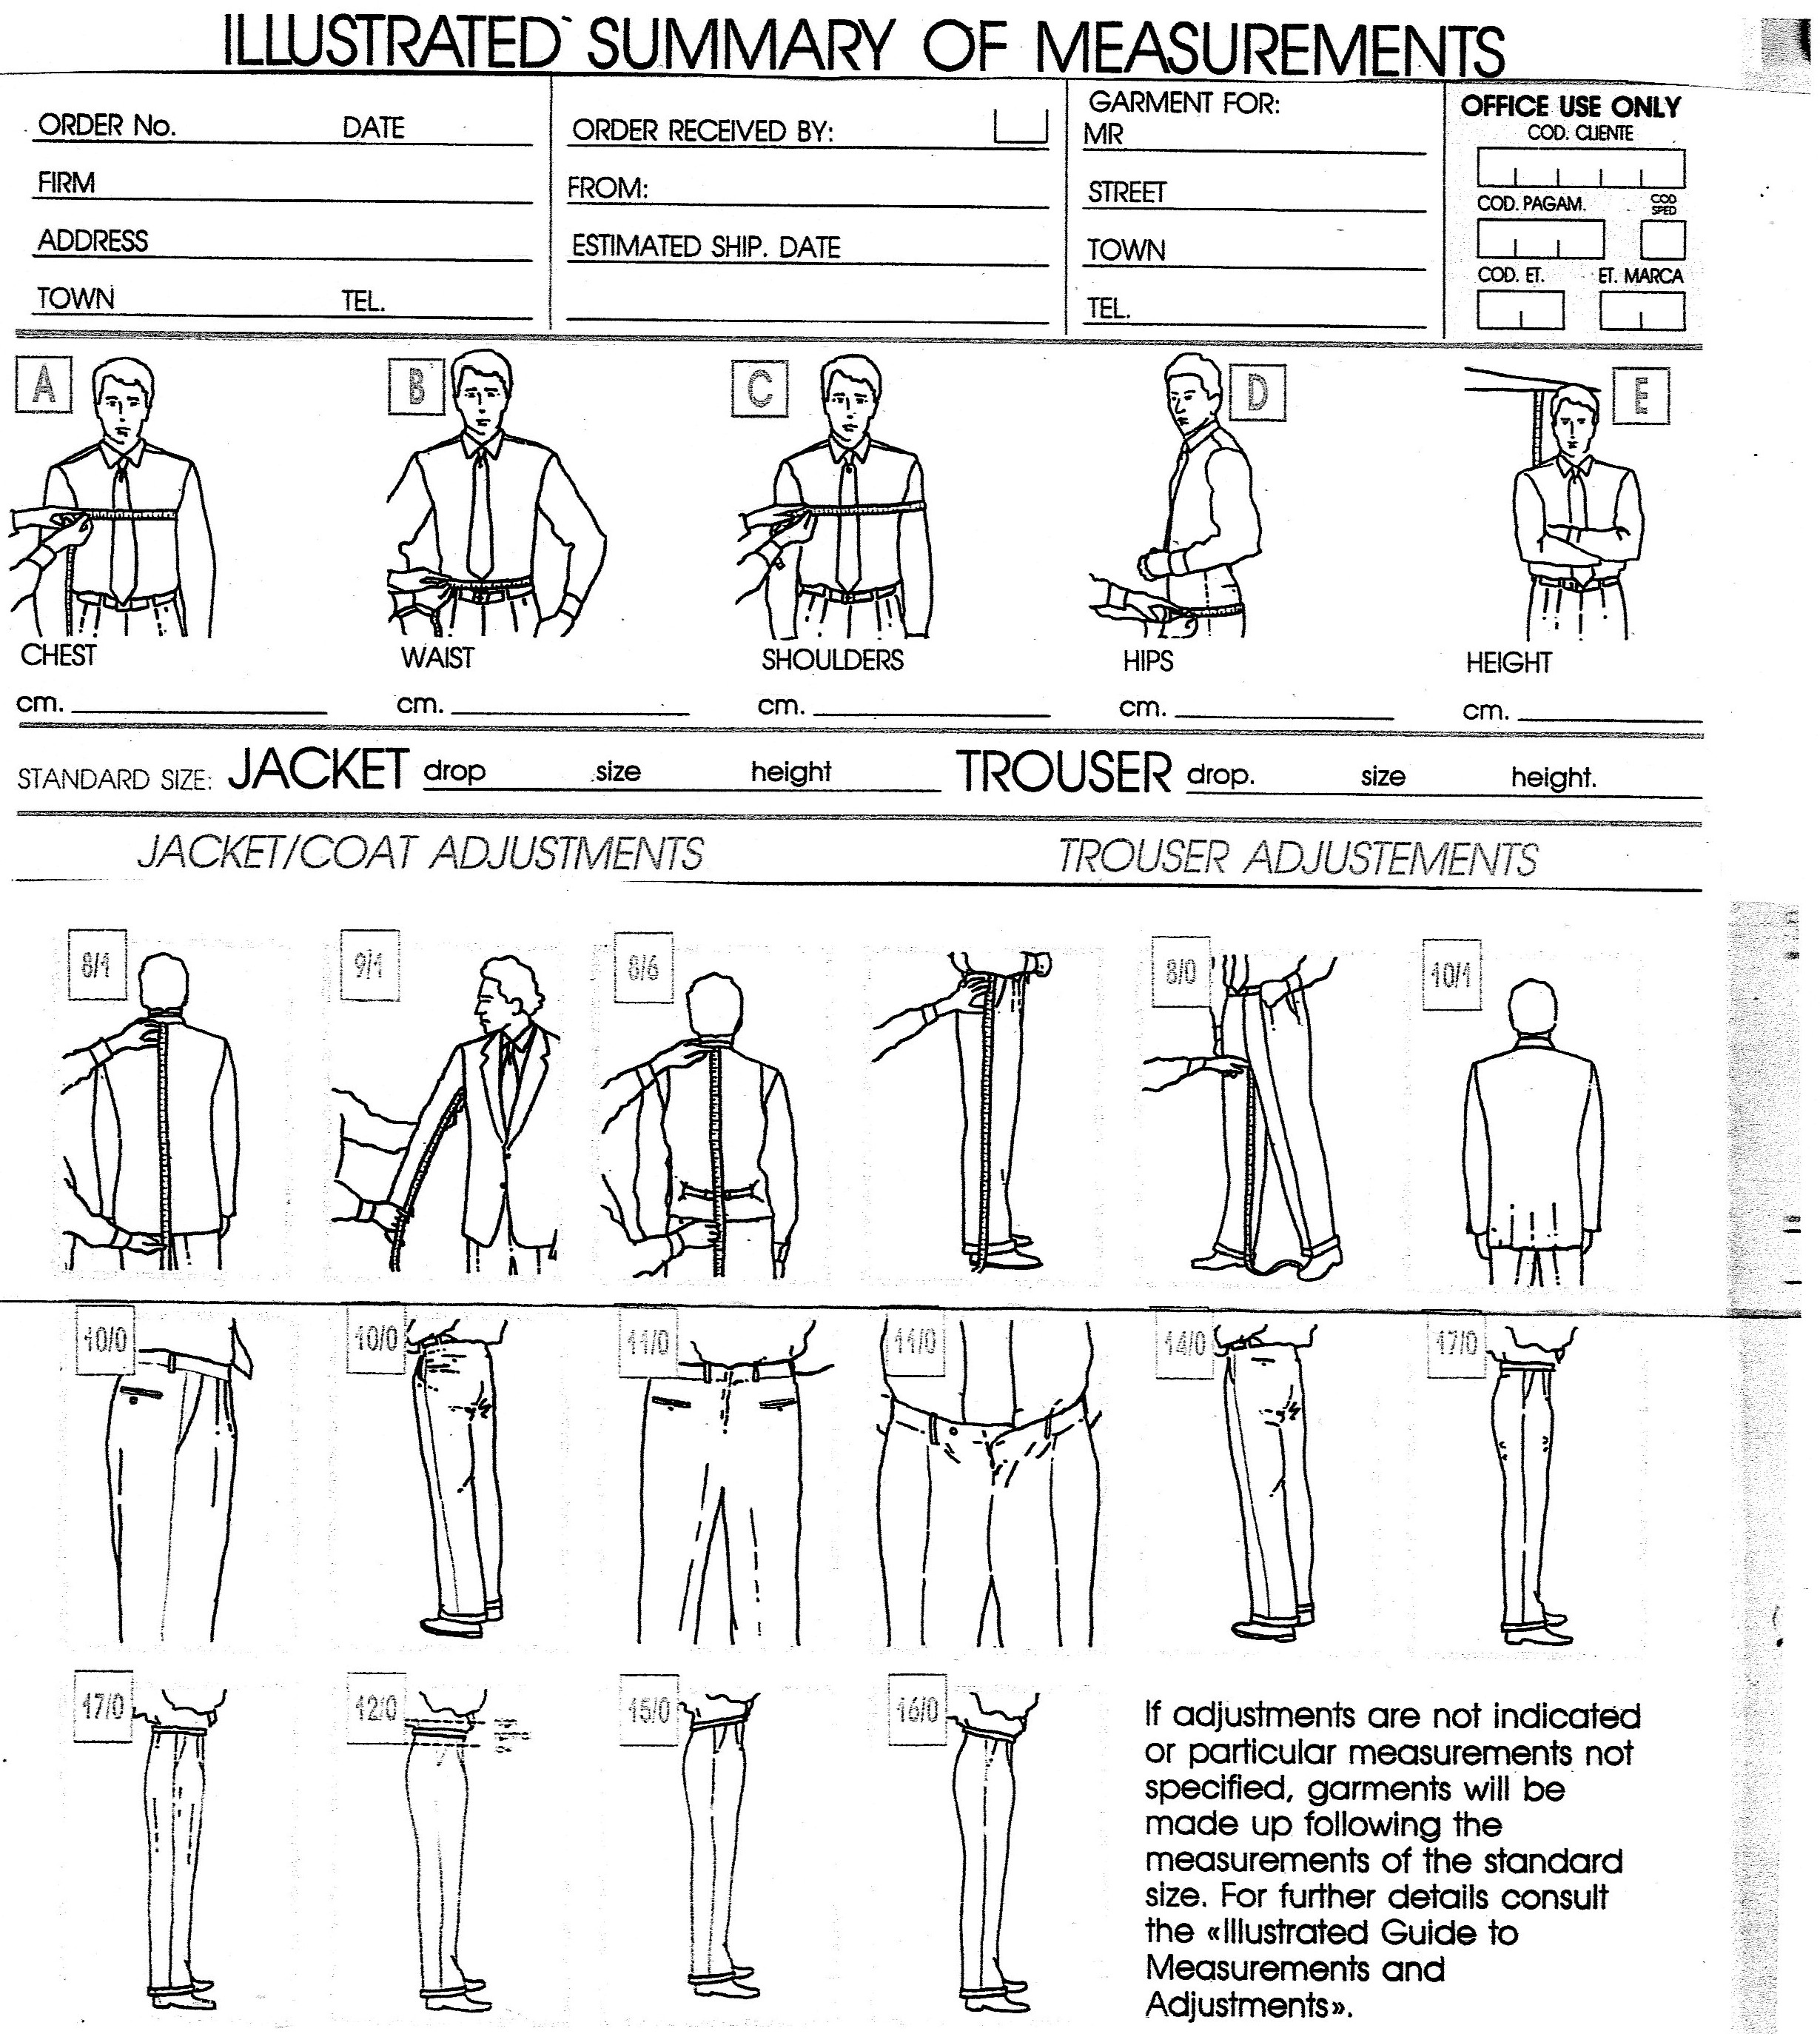

Type here →

JACKET: drop / size / height

TROUSER: drop / size / height

What is your size?
Short 38, 40, 42, 44, 46, / Reg. 38, 40, 42, 44, 46, 48, 50, 52/ Long 42, 44, 46, 48, 50, 52

Type here →
Type here →
Type here →
Type here →

