Strong core muscles improve our posture and reduce muscles aches. Our core muscles are the centre of our body and include our abdominals, inner thighs, outer thighs, gluteal, hips and lower back muscles.

**SINGLE LEG STRETCH–** *Strengthens the stomach muscles, abdominals & gluteal muscles.*

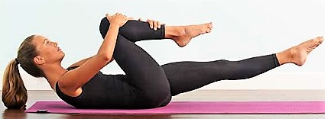

Lie flat on back and gently raise head and shoulders, keeping the neck long. Tighten core muscles. Hug right knee in and extend the left leg out to 45 degrees. (right hand holds right knee, left hand holds left ankle) Inhale to prepare.

1. **Exhale**- begin switching legs, inhaling for two hugs and exhaling for two hugs. **(Repeat 10 times, each leg)**

**THE HUNDRED–** *Strengthens the stomach muscles, abdominals & gluteal muscles.*

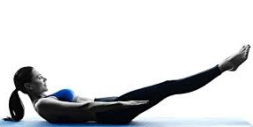

Lie flat on back, draw both knees in towards the chest, then straighten legs up towards the ceiling. Lengthen the back of the neck and slide shoulders down and back. Tighten the core musles. Initiating from the abdominals, raise your head and shoulders, drawing your chin towards your chest. Stretch arms long and raise to hip level. Lower your legs to 45 degree angle and tighten the glutes. Inhale to prepare.

1. **Exhale**- begin pumping your arms up and down vigorously. Inhale for 5 pumps, then exhale for 5 pumps. **(Pump your arms 50 times)**

**CORKSCREW–** *Strengthens the lower abdominal*s.

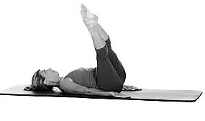

Lie flat on back, with both legs raised towards the ceiling. Arms long by sides. Pin shoulders back and press back of arms and palms flat into mat. Lengthen neck. Draw navel in and upwards, to engage the core musles. Inhale to prepare.

1. **Exhale**- squeeze your legs together and begin circling your legs to your right side (do not allow the left side of your body to lift off the mat) then down through the centre line of your body, then bring legs to the left side of your body.
2. **Inhale-** return legs to your starting position**. (5 repetions each direction, accentuating the upswing each time)**

**CRISS CROSS** – *Strengthens the abdominals and obliques.*

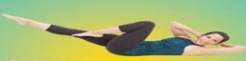 

Lie on your back, with hands behind the head and draw the knees into the body. Draw navel inwards and upward to engage the core muscles. Inhale to prepare.

1. **Exhale**- rise up, twist to the left side and extend the right leg out. Aim the right elbow to the left knee and open the left elbow behind you. Hold for three counts.
2. **Inhale-** switch sides. (**5 repetions, both sides)**

**SWIMMING-** Lengthens the stomach muscles and strengthens the back, gluteals & hamstrings.



Lie face down with arms and legs outstretched. Tighten core. Inhale to prepare.

1. **Exhale**- gently raise your head and then your right arm and left leg. Stretch out long , lengthening your lower back. Without shifting your body weight, flutter your ams and legs in a swimming motion. Breathe naturally throughout. **(10 repetitions)**

**DOUBLE STRAIGHT LEG STRETCH**– Strengthens the core and upper and lower stomach muscles.

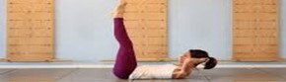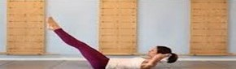

Lie on your back with hands behind your head. Elbows should be wide and torso anchored to the floor. Bend knees, then extend both legs up towards the ceiling. Tighten core muscles. Gently raise your head and shoulders off the mat, focusing your eyes on your midsection.

1. **Exhale** - slowly reach your legs away from you and hold for 3 counts.
2. **Inhale** -slowly return the legs to the ceiling and hold for 3 counts. (**8 repetitions**)

**PLANK ROCK-** Strengthens the core, upper back & shoulders.

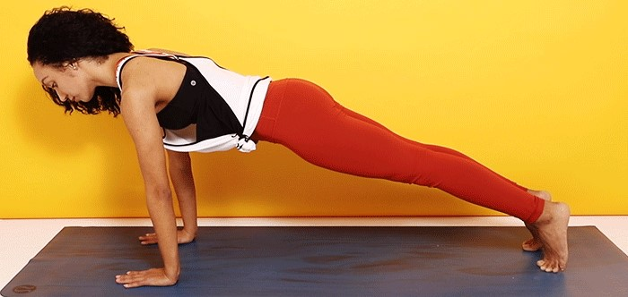

Start in a high plank with your hands directly under your shoulders. Tighten core, glutes and quads. Inhale to prepare.

1. **Exhale**- rock your whole body forward a couple inches toward your hands, then rock backwards toward your heels. **(10 repetitions)**