The Hamstrings are 3 muscles, **Biceps Femoris**, **Semi-Membranosis** and **Semi-Tendinosis**. These muscles begin at the base of the pelvis and run along the back of the thigh, to just below the knee. These muscles are responsible for hip extension (opening hip joint) and knee flexion.

**WALL ROLL DOWN***–* stretches the back and hamstrings.

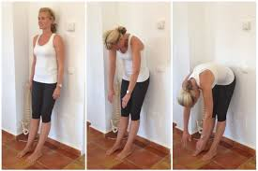

Stand with your back against a wall, feet hips width apart and in parallel position. Tighten core. Inhale to prepare.

1. **Exhale-** drop your chin towards the chest, allow the head to hang heavy, relax the shoulders, roll down and focus on moving vertebrae by vertebrae, until your hands touch the floor.
2. **Inhale** -relax for a few seconds.
3. **Exhale** – slowly return to start position, coming up one vertebra at a time – your head being the last part of the body that comes up. **(Five repetitions)**

**SPINE STRETCH***–* stretches the back and hamstrings.

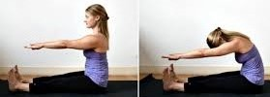

Sit tall, spread legs a little wider than hips and arms parallel in front. Engage core and flex your feet to engage your leg muscles.

1. **Exhale**– slowly begin to round your back into a “C” curve. Start by scooping out your lower belly, then pull the ribs in and finally round your neck and head forward.
2. **Inhale–** relax for a moment.
3. **Exhale**– slowly return to start position, moving vertebra by Vertebra. **(Five repetitions)**

**SAW**– stretches the back, hips and hamstrings.

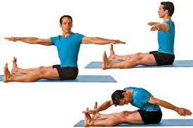

Sit tall, with legs extended in front and arms stretched out to the sides. Engage your core. Inhale to prepare.

1. **Inhale**– turn your waist to the left, carrying the arms with you, reach forward and touch your left toe.
2. **Exhale**– return to upright position,
3. **Inhale**- turn your waist to the right, reach forward and touch your left right toe. **(5 repetitions, both sides)**

**PELVIC CURL**–strengthens the glutes, lower back & hamstrings.

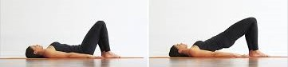

**Lie on your back with knees bent and feet flat on the floor, hip-distance apart. Place arms by your side, with palms down. Engage the core muscles. Inhale to prepare.**

1. **Exhale** - slowly curl the pelvis up, and lift the lower back, then the middle back, then the upper back off the mat.
2. **Inhale** -stay lifted, with your glutes engaged, abdominals pulled in to form a straight line on the top side of the body. Hold here for a few seconds.
3. **Exhale** -slowly lower the torso, starting with the upper back and return to the starting position. **(5 repetitions)**

**SEATED HAMSTRING STRETCH**-stretches & lengthens the hamstrings.

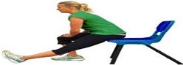

Sit tall at the edge of a chair. Straighten the left leg in front of the body, with heel on the floor and foot flexed. Place both hands over the right knee. Tighten core. Inhale to prepare.

1. **Exhale-** sit up straight and try pushing the navel towards the thigh without leaning the trunk of the body forwards. Hold this stretch for 30 seconds. **(3 Repetition, each leg)**

**LYING HAMSTRING STRETCH**- stretches & lengthens the hamstrings.

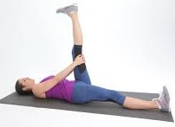

Lie on your back and raise the left leg towards the ceiling. Keep the knee bent and the hip flexed to 90 degrees. Tighten core. Inhale to prepare.

1. **Exhale**- grasp behind the knee of the left leg and attempt to straighten the knee. Keep toes pointed back toward you. Hold the stretch for a few seconds. (**5 repetitions, each leg)**

**SINGLE LEG CIRCLES**-stretches the hamstring, strengthens hip joints & flexors, encourages pelvic stabilisation.

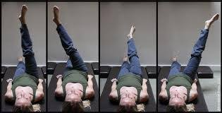

Lie on your back with arms by your side and parallel with shoulders. Palms flat. Draw one knee in towards the chest and then extend it straight toward the ceiling.

1. **Inhale** - cross the extended leg up and over the body, then towards the opposite shoulder, then over the outstretched leg.
2. **Exhale** - lower the leg down towards the centre line in a circling motion.