The hip muscles are the big and small muscles in our buttocks and at the sides of our hips - Glutus Medius, Minimus, Maximus, Piriformis and rotators. The following Pilates exercises help strengthen and improve the range of movement in the hip joints.

**SPINE TWIST–** helps release the sides of the body.

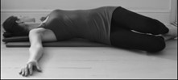

Lie on your back with knees bent. Arms should be stretched out and parallel with shoulders, with palms down. Tighten core. Inhale to prepare.

1. **Exhale** - allow your pelvis to tip to the right side and turn your head to the left, to stretch throughout your spine.
2. **Inhale** - hold for a few seconds.
3. **Exhale** - roll back slowly, moving your ribcage first, then your waist, hips, then knees. **(8 repetitions, both sides)**

**BENT KNEE OPENING**– helps release the hip sockets.

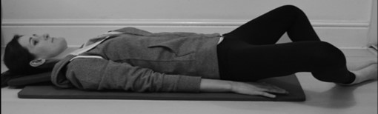

Lie on your back, knees bent and feet hip width apart. Tighten core. Inhale to prepare.

1. **Inhale** - gently allow the right knee to move towards the floor and hold for a few seconds.
2. **Exhale** -slowly return knee to start position. (**8 repetitions, both sides.** You can also vary by moving both knees out to the sides simultaneously)

**GLUTES STRETCH– helps release the 3 buttock muscles -Maximus, Medius and Minimus*.***

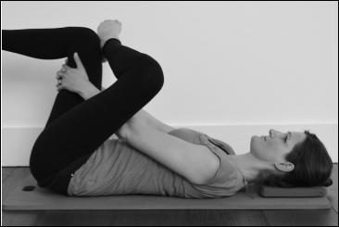

Lie on your back, raise your legs to a tabletop position and place your left foot on your right knee. Reach around your right leg and place your hands on your right thigh. Engage your core muscles. Inhale to prepare.

1. **Exhale-** gently pull your thigh forward, to stretch your buttock muscles.
2. **Inhale**– hold the stretch for a few seconds.
3. **Exhale**- slowly return to start position. (**5 repetitions, both legs)**

**GROIN STRETCH**– helps stabilise hips, knees & lower back.

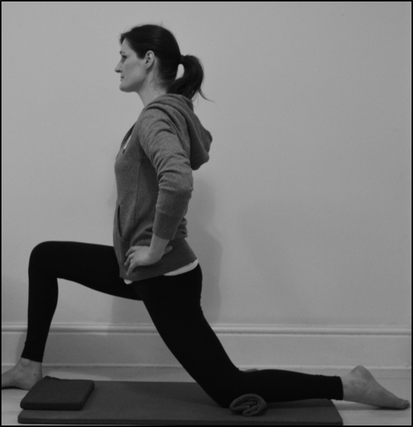

Place a rolled up towel under left knee, whilst the right knee should be bent in front, with foot on floor. Engage core. Inhale to prepare.

1. **Exhale**-tuck your tailbone under slightly and gently lean forwards, until you feel a stretch at the front of your hip.
2. **Inhale**- hold stretch for a few moments.
3. **Exhale**– gently return to start position. **(5 repetitions, both sides)**

**QUADRUPED ROCKING*–* strengthens spinal erectors, glutes, hips & hamstrings*.***

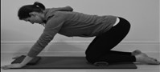

Place a rolled up towel under both knees and kneel on all fours. Lean back slightly and engage core. Inhale to prepare.

1. **Exhale**– slowly rock back into your hips, by pressing gently with your hands. Stop when you feel your tailbone tucking underneath.
2. **Inhale**– return to start position. **(8 repetitions)**

**Knee circles** –(*helps ease tightness in the lower back and hip joints)*

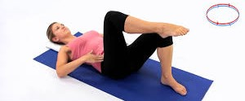

Lie on your back, knees bent, feet flat on the floor. Pelvis in neutral and engage your core. Inhale to prepare.

1. **Exhale**- lift one foot off the floor into a bent position and imagine drawing a circle on the ceiling with your knee, circling the thigh bone inside the hip joint. **(5 repetitions, both legs)**