Pilates exercises strengthen the core, increase muscle strength and flexibility and help improve our posture. Pilates exercises are excellent for improving lower back pain.

**PELVIC TILT***-*teaches you how to use the abdominals to lengthen and support the back*.*

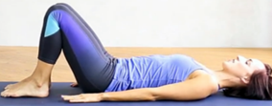

Lie on your back with knees bent and feet flat on the floor. Spine should be neutral and core tight. Inhale to prepare.

1. **Exhale** - gently tighten and lift the pelvic floor muscles (those that stop you from urinating), then pull the navel in towards the spine, so that the lower back is imprinted into the floor.
2. **Inhale** -relax the muscles and return to neutral spine. **(10 repetitions)**

**SINGLE LEG LIFTS**–a great exercise if you are lacking pelvic stability or core awareness*.*

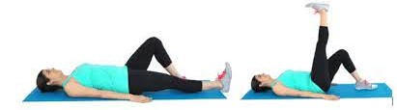

Lie on your back with bent knees, arms relaxed at the sides with the palms down. Tighten core. Inhale to prepare.

1. **Exhale**- raise one leg until the knee is above the hip joint and the thigh perpendicular to the mat.
2. **Inhale**– gently lower leg back to the floor and return to start position. **(5 repetitions, both legs)**

**SPINE TWIST–** promotes release along the sides of the body.

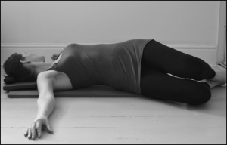

Lie on your back with knees bent and arms stretched to the side, in line with shoulders. Tighten core and inhale to prepare.

1. **Exhale**-allow your pelvis to gently tip to the right side and gently turn your head to the left, to stretch throughout your spine.
2. **Inhale**-hold for a few seconds,
3. **Exhale-**-gently return to start position. **(5 repetitions, each side)**

**CHEST RAISE**– strengthens the abdominal muscles and encourages pelvic stability*.*

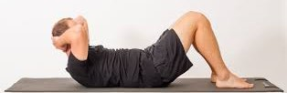

Lie on your back and bend your knees. Feet should be flat on the floor and hip width apart. Legs parallel. Place your hands behind your head and interlink your fingers. Tighten your core and inhale to prepare.

1. **Exhale-** gently raise your chest and head. (do not allow your legs to open)
2. **Inhale-** pause in the raised position for a few seconds.
3. **Exhale-** gently lower your upper body down to the start position.

**SUPINE SPINE TWIST-** stabilises the core muscles, strengthens the obliques and stretches the back muscles*.*



Lie on your back, bend your knees and bring your legs into tabletop position, with shins parallel to the floor. Bring your arms out to the side, parallel with the shoulders. Tighten core. Inhale to prepare.

1. **Exhale**- keeping your knees and feet together, slowly begin to lower your legs down to the right side. Avoid arching the lower back and keep it in contact with the mat throughout the movement.
2. **Inhale**- hold the stretch for a few seconds.
3. **Exhale-** bring your legs back to the starting position. **(8 repetitions, both legs)**

**SPINAL EXTENSION***–* strengthens back extensor muscles & helps develop control of the core muscles.

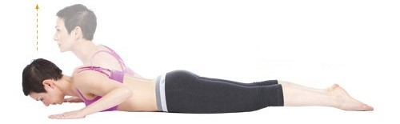

Lie face down with legs together. Palms should be flat, just wider than shoulder width and slightly forward of your armpits. Tighten core muscles. Inhale to prepare.

1. **Inhale-** press into your hands and raise your head, neck and upper back. Hold at the top for a couple of seconds.
2. **Exhale**- lower your upper back, neck and head **(8 repetitions)**

**STANDING SIDE BEND**–strengthens the shoulders, back and abdominals*.*



Stand tall with your feet shoulder-width apart, raise your arms up and above your head. Tighten your core. Inhale to prepare.

1. **Exhale**- bend your torso to the right, as far as it feels comfortable.
2. **Inhale**- hold the stretch for a few seconds.
3. **Exhale-** return to start position and bend your torso to the left side.