Shoulder pain and tightness is frequently a result of altered shoulder biomechanics. The following exercises address the most common muscle imbalances, that contribute to strain in the back, shoulders and neck.

**SPINE STRETCH FORWARD***–* stretches the back and hamstrings.

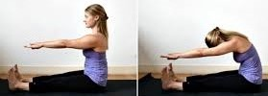

Sit tall, spread legs a little wider than hips and arms parallel in front. Engage core and flex your feet to engage your leg muscles.

1. **Exhale**– slowly begin to round your back into a “C” curve. Start by scooping out your lower belly, then pull the ribs in and finally round your neck and head forward.
2. **Inhale–** relax for a few seconds.
3. **Exhale**– slowly return to start position, moving vertebra by Vertebra. **(Five repetitions)**

**HEAD NOD**– extends and lengthens the spine.

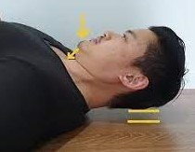

Lie on your back, knees bent and feet flat on the floor, hip-distance apart. Arms should be by your side, with palms inward. Tighten your core and inhale to prepare.

1. **Exhale**- lengthen the spine and tilt the chin down towards the chest (your head stays on the mat).
2. **Inhale**– gently lower your head back to the start position. (10 repetitions)
3. **Exhale**- gently tip the head back a little.
4. **Inhale**-.gently return to neutral position.

**SCAPULA ISOLATION**–.encourages scapula movement and stabilisation.

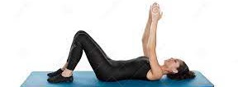

Lie on your back with knees bent and feet flat on the floor, hip-distance apart. Tighten your core. Reach your hands toward the ceiling, palms in. Inhale to prepare.

1. **Exhale**-.stretch up and reach your shoulders off the mat. Elevate the scapula by lifting shoulders towards the ears.
2. **Inhale**- slide shoulders down away from ears and return shoulders to neutral position. **(10 repetitions)**

**SWIMMING-** strong abs and back muscles are essential for relaxed shoulders. These exercises lengthen the stomach muscles and strengthen the back, gluteals & hamstrings.



Lie face down with arms and legs outstretched. Tighten core muscles. Inhale to prepare.

1. **Exhale**- gently raise your head and then your right arm and left leg. Stretch out long , lengthening your lower back. Without shifting your body weight, flutter your ams and legs in a swimming motion. Breathe naturally throughout. **(10 repetitions)**

**SCAPULA ISOLATIONS***–*encourages movement & stability in the shoulder blades.

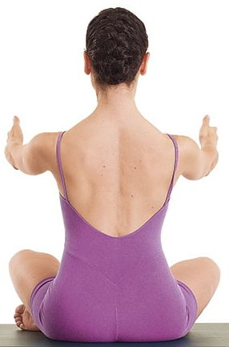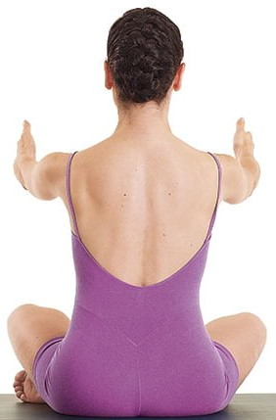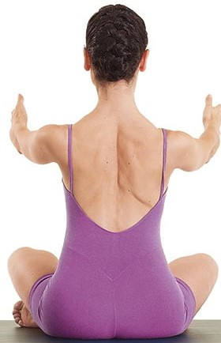

**Neutral Protraction Retraction**

1. **Exhale-**protract scapula (widen between the shoulder blades)
2. **Inhale** – bring scapula back to neutral (with feeling of opening the collarbone)
3. **Exhale**- retract scapula (bring shoulder blades closer together)
4. **Inhale-** return scapula to neutral position.

**ARM CIRCLES-** strengthens biceps, forearms, and triceps.

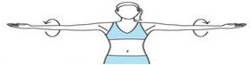

Stand with your feet shoulder width apart and extend your arms parallel to the floor. Tighten core. Inhale to prepare.

1. **Exhale**- circle your arms forward using small, controlled motions, gradually making the circles bigger, until you feel a stretch in your triceps.
2. **Inhale**- reverse the direction of the circles after 10 seconds. **(You can also add weights to increase resistance)**

**BOXING–** strengthens biceps, triceps, rotator cuff, deltoids. oblique’s & latissimus dorsi.

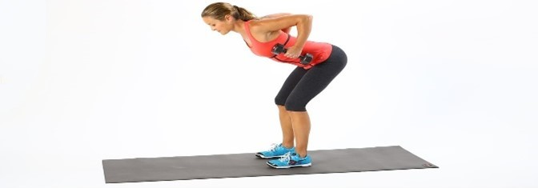 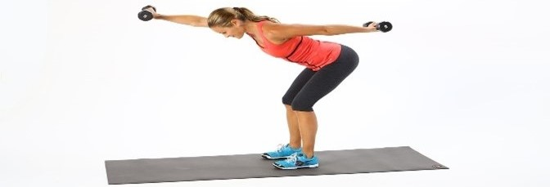

Bend your body forward, leaning your chest towards the ground so it is parallel to the floor. Slightly bend your knees and rest your weight on your heels. Knees should not go past your toes. Tighten core. Inhale to prepare.

1. **Exhale**- extend your right arm straight in front of you, palm facing down, and your left arm straight back, palm facing up. Both arms should be parallel to the ground. Switch sides in a swift, controlled motion and repeat. Breathe naturally. **(Add weights to increase resistance)**

**SHOULDER ROTATION (with resistance band)**- rebalances the muscles round the shoulders & prevents pain from occurring*.*

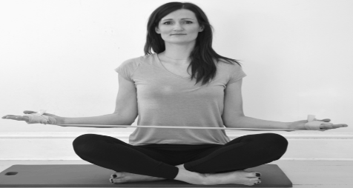

Sit on the ground in a prayer position. Your back should be tall and your core tight.Hold the band between both hands. Keep your elbows tucked into your waist throughout. Inhale to prepare.

1. **Exhale**- pulling on the band, slowly move your hands apart.
2. **Inhale**- hold the stretch for a few seconds.
3. **Exhale-** slowly return to start position. **(10 repetitions)**