The upper body controls our ability to perform everyday activities such as reaching, pulling, pushing and lifting. Upper body exercises help boost muscle strength and endurance in our arms, back, chest, and shoulders.

ARM CIRCLES- strengthens biceps, forearms, and triceps.
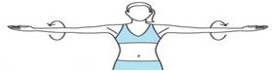
Stand with your feet shoulder width apart and extend your arms parallel to the floor. Tighten core. Inhale to prepare.

- Exhale- circle your arms forward using small, controlled motions, gradually making the circles bigger, until you feel a stretch in your triceps.
- Inhale- reverse the direction of the circles after 10 seconds. (You can also add weights to increase resistance)

BOXING– strengthens biceps, triceps, rotator cuff, deltoids. oblique’s & latissimus dorsi.
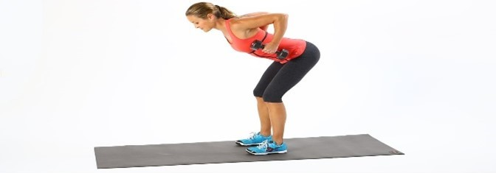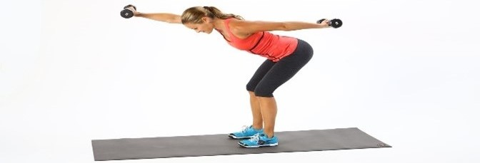
Bend your body forward, leaning your chest towards the ground so it is parallel to the floor. Slightly bend your knees and rest your weight on your heels. Knees should not go past your toes. Tighten core. Inhale to prepare.
- Exhale- extend your right arm straight in front of you, palm facing down, and your left arm straight back, palm facing up. Both arms should be parallel to the ground. Switch sides in a swift, controlled motion and repeat. Breathe naturally. (Add weights to increase resistance)

PUSH UP– strengthens shoulders, pecs, triceps & abdominals.
Begin in a plank position, with hands in line with shoulders. Keep your feet close together. Engage core. Inhale to prepare.
- Exhale- bend your elbows, keeping them as close to your core as possible and lower your body. (You should feel your triceps working if you are doing this move correctly.) Bend your elbows as far as you can, without rounding your back, or sticking your butt towards the ceiling.
- Inhale- bring your body back to starting position. (8 repetitions)

TRICEP DIPS- strengthens triceps, biceps, shoulders, chest and back.
Sit on the floor with your legs together and extended straight out in front of you. Place your hands about 10-12 inches behind you on the floor, with your fingers pointing forward. Engage your hamstrings and core and press your feet firmly into the floor.

- Inhale- lift yourself up into an incline plank position.
- Exhale - bend your elbows to lower down towards the floor, keeping your body as straight as you can. (10 repetitions)
PLANK- strengthens arms, legs, and especially the shoulder, back, and abdominal muscles.

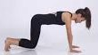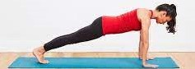
Kneel on all fours, with knees parallel with hips, and hands parallel with shoulders. Roll your shoulders back and down. Point your fingers forward and turn your inner elbows slightly forward as well. Engage core. Inhale to prepare.
- Exhale- lift up in your middle, as you step one foot straight back and then the other. (do not let the hips drop or elbows lock) Keep your legs engaged in supporting the plank position. (Hold for 30 seconds)
TRICEPS PRESS- strengthens triceps, rear deltoids, lats, waist & abdominals.

Stand tall, with legs pressed together and toes turned out. Place your hands behind your head, forming a triangle with elbows. Tighten core. Inhale to prepare. (You can use a weight to increase resistance)

- Exhale -raise your hands overhead, straightening out your elbows and pressing up and away from the body.
- Inhale -bring your hands back to their starting point behind your head. (10 repetitions)
WIDE LIFTED BICEPS CURL –strengthens the bicep muscles, traps and front deltoids.

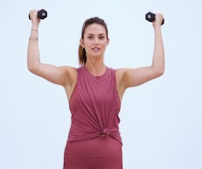
Stand tall with feet hip width apart. Open your arms wide. Tighten core. Inhale to prepare. (Add weights to increase resistance)

- Exhale-gently bend your arms to 90 degree angles.
- Inhale- gently bring your arms back to start position. (10 repetitions)

FRONT SCOOP– strengthens the rectus abdominus muscles.
Stand tall, with legs pressed together and toes turned out. Tighten core. Hold arms in front of hips, palms facing up and elbows bent behind body. Inhale to prepare. (Use weights to increase resistance)

- Exhale- extend arms in front of body, in line with shoulders (maintaining a slight bend in elbows)
- Inhale- slowly move arms back to start position. (10 repetitions)

