**Buying a Car, is More than Buying a Car**

So far, most of what we have discussed has involved unsecured loans. These are loans for which the only collateral is your word. However, most vehicle purchases are secured loans, meaning if you don’t make payments on time the company who gave you the loan (lien holder) can legally take your vehicle. Your vehicle is the collateral. Usually this involves a bigger loan amount than unsecured loans. However, there is less risk for the company. With an unsecured loan if you are unable to pay, the loaner can mess up your credit rating, which hurts you. However, they still lose their money. With a secured loan, if you are unable to make your payments they keep all of the money you have previously paid, mess up your credit, and take your collateral (car) which they resale. So, if you can’t pay they still get something of value in return. Therefore, secured loans usually carry a lower interest rate.

This is where APR (annual percentage rate) sometimes comes into play. Some lenders charge an interest rate, but also charge a percentage each year in the form of fees. Credit cards used to be notorious for advertising a very low interest rate but tacking on percentages as service fees, convenience fees, usage fees, summary fees, and countless other fees that were hidden in the fine print on page 27 of the form. It was determined that this was a predatory practice. So, now virtually every credit card advertises the APR only, which is all fees combined, which is what you actually have to pay. However, secured loans do not have the same rules.

A secured loan company is required to give you a final payment amount and break down the payments for you, but they may advertise the interest rate while also requiring that you pay a vehicle maintenance fee that is a percentage of the overall loan. When this is the case, don’t get caught up with the interest rate. Look at the APR. The APR is the total interest with all fees combined. It is what you will pay. So, it is what matters.

So, let’s look at buying a car. There are some very famous financial advisers who will say you should never buy a new car and instead should purchase a reliable used car, but who am I to tell you that. In truth, I don’t even agree with it. I will say this though. You should understand what you are actually getting when you buy a car.

When you buy a new car you should actually be paying for more than just a car. You should be paying for security. Cars come with varying levels of warranty, which is essentially a guarantee to ensure the car is in working order for a specified duration of time. Sometimes this includes major maintenance such as large belt changes and transmission flushes, but it can also include things like regular oil changes, tire repair, windshield repair, towing, roadside assistance, and even loaner vehicles during any maintenance or repairs. When you buy a used vehicle, you are unlikely to get most of these things unless you purchase a certified pre-owned vehicle in which case you are buying from a dealership who is going to ensure they get the same percentage of value when they sell you the pre-owned vehicle as they would on the new one. (We’ll look at that in greater detail later.)

So, what is a reliable vehicle?

It is a vehicle that you believe is in good condition, but that could have major issues very soon. I’ve owned plenty of “reliable used cars”, but most of them ended up costing me about the same as a new one would have when you average out the extra maintenance and repair work that this supposed “reliable” vehicle required. Some cost much more. Some cost much less, and you can’t be sure which will be which. So, it is a gamble. Financial advisers are actually telling us to gamble with our money, and we like hearing it. We like hearing it, because it sounds right, but I’m not sure such advice considers the whole picture.

Ultimately, you should ask yourself what you are actually buying:

* What do you get with this vehicle?
  + Does it help you with your job?
  + Does it make you feel happy?
  + Does it give you stress to make the payments?
* Does it give you the security of a warranty?
  + What does that warranty include?
  + What doesn’t it include?
  + How long will it last you?
* Are their benefits when you buy your specific vehicle?
  + Does it come with free maintenance?
  + Does it come with emergency help?
  + Does it come with loaner vehicles when needed?
* Perhaps most importantly, how well does this vehicle hold its value

Four vehicles available to purchase in March of 2020 along with their advertised interest rates and their projected annual repairs

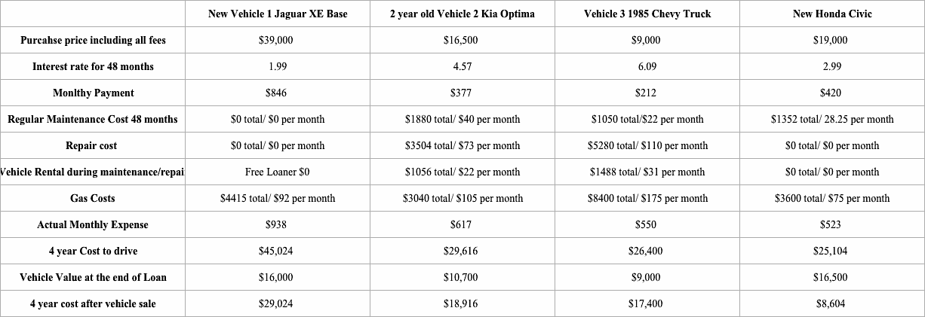

There are other considerations (such as inflation and personal insurance) that could go into actual vehicle cost as well. However, for the time being let’s just look at these simple considerations.