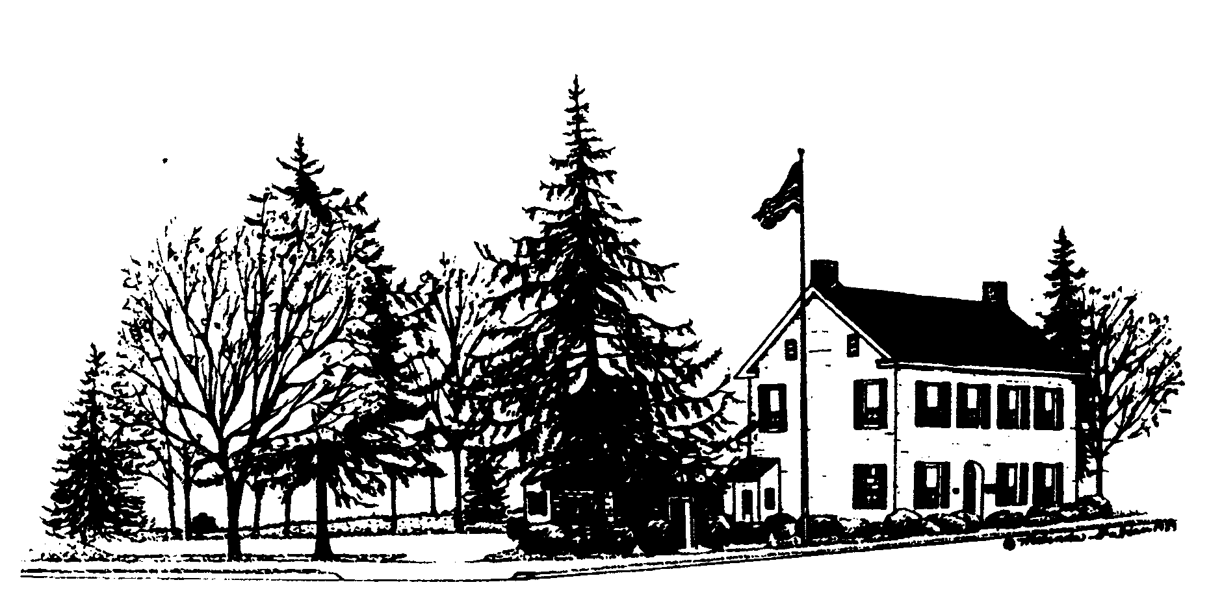 HELLERTOWN BOROUGH AUTHORITY
MEETING AGENDA
HELLERTOWN BOROUGH AUTHORITY
MEETING AGENDA
May 9, 2023
1. General Functions
a. Call to Order
b. Pledge of Allegiance
c. Roll Call
d. Action - Acceptance of Meeting Agenda
i. Additions/Deletions
ii. Motion to accept Meeting Agenda as presented
e. Action - Approval of Minutes of April 12, 2023
    - Changes/Additions/Deletions
    - Motion to approve the Minutes
f. Hearing of Citizens and Public Concerns
g. Board Member Concerns
h. Personnel Concerns
2. Operations
- Solicitor’s Report
- Engineer’s Report
- Field Report
- Administrator’s Report
3. Financial
- Action - Treasurer’s Report – April 2023
- Action – Payment of Bills
- P&L
4. Business
a. Action – Award Springhill Pump Station Contract of General Construction to
Blooming Glen Contractors in the Amount of $225,050.00
Action - Award Springhill Pump Station Contract of Electrical Construction to
Albarell Electric, Inc. in the Amount of $87,499.
b. Discussion – Caretaker Properties
5. Executive Session
6. Adjournment

