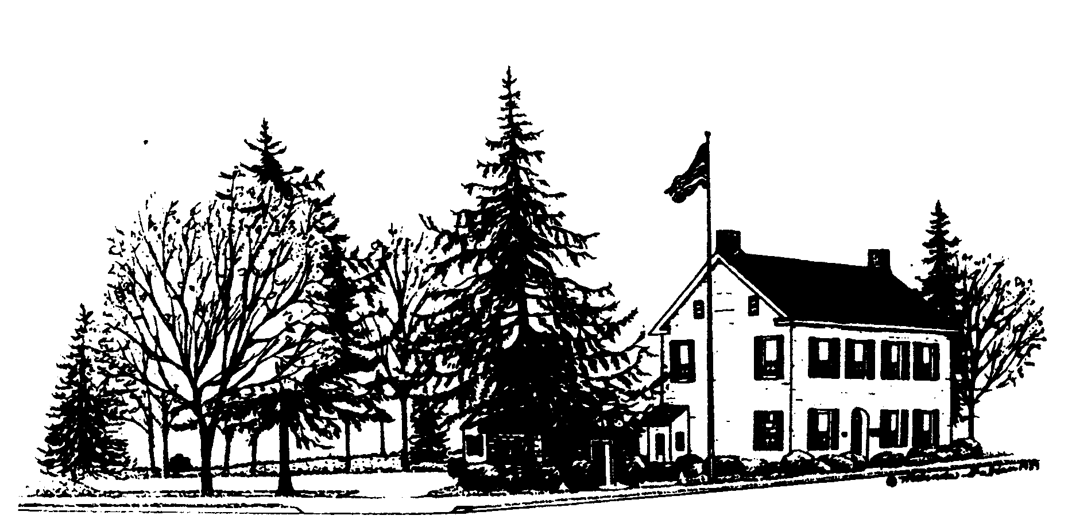 HELLERTOWN BOROUGH AUTHORITY
MEETING AGENDA
HELLERTOWN BOROUGH AUTHORITY
MEETING AGENDA
JULY 9, 2025
1. General Functions
a. Call to Order
b. Pledge of Allegiance
c. Roll Call
d. Action - Acceptance of Meeting Agenda
i. Additions/Deletions
ii. Motion to accept Meeting Agenda as presented
e. Action - Approval of Minutes of June 12, 2025
    - Changes/Additions/Deletions
    - Motion to approve Minutes of June 12, 2025
f. Public Comments
g. Board Member Concerns
h. Personnel Concerns
2. Operations
- Solicitor’s Report
- Engineer’s Report
- Field Report
- Administrator’s Report
3. Financial

- Action –Motion to Approve the June Treasurer’s Report

- Action – Motion to Approve the Payment of Reported Bills Since the June 12,
2025 Meeting and the Continuing Payment of Bills until the Next Board Meeting.

- P&L – Operational, Capital, and Forestry

4. Business
Action – Approval of Employee Manual Additions

5. Adjournment

