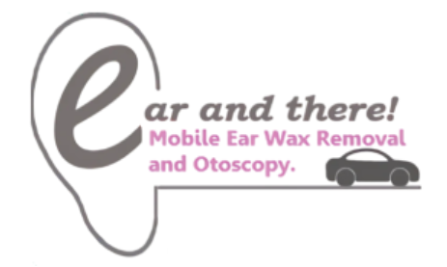
CLINICAL DISCLAIMER

Important Clinical Information
Ear and There York provides a private mobile earwax assessment and removal service for adults aged 18+.
This service is designed to assess for earwax build-up and, where appropriate and safe, remove earwax using suitable techniques.
This is not an emergency service, hearing test, or full medical diagnostic service.
Some ear symptoms can be caused by earwax, but they can also be caused by infection, inflammation, eardrum problems, hearing conditions, or other medical issues.
For this reason, earwax removal is not suitable for everyone, and treatment is always subject to assessment and clinical judgement.

Earwax removal may not be appropriate if you have:
Please do not book without seeking advice first, or contact us before booking, if you currently have or have recently had:
significant ear pain
active ear discharge
bleeding from the ear
sudden hearing loss or sudden one-sided hearing change
severe dizziness or vertigo
a suspected ear infection
a perforated eardrum (past or present)
recent ear surgery
grommets / ventilation tubes
a mastoid cavity or previous mastoid surgery
a foreign body in the ear
significant swelling, tenderness, or trauma around the ear
current ENT treatment for an ear condition
difficulty remaining still during treatment
any other ear condition you are unsure about
If you are unsure whether treatment may be suitable, please get in touch before booking.

Important: seek urgent medical advice if you have:
Please seek urgent medical advice rather than booking routine earwax removal if you have:
sudden hearing loss
severe or worsening ear pain
bleeding from the ear
significant ear discharge
severe dizziness / vertigo
facial weakness
severe swelling or signs of infection
any rapidly worsening symptoms

Treatment may be declined, postponed, or stopped
For your safety, treatment may be declined, postponed, or stopped at any time if:
there is a contraindication
there are signs of infection, injury, or another condition requiring medical review
wax is too hard, deep, impacted, or painful to remove safely on the day
further softening is needed
the procedure becomes too uncomfortable
onward referral is more appropriate

No guarantee of complete wax removal
Although every effort will be made to provide a safe and effective service, complete wax removal cannot be guaranteed in every case.
In some cases, no wax may be present, only partial removal may be possible, or onward referral may be recommended.

Aftercare and onward referral
If required, images and clinical notes from the appointment can be shared with the Tympa Team Audiologists / ENT Consultants, with your consent.
Where appropriate, you may also be given aftercare advice and/or advised to seek review by your GP, audiologist, or ENT specialist.

